Entering Multilingual Learner (ML)/English Learner (EL) Status for State Reporting in Infinite Campus (IC)

The following instructions are steps for entering data required for State Reporting only and does not include all SIS capabilities and functions that schools may choose and/or require for their own purposes and record keeping. *Accurate ML data is essential for October Count (and End of Year) and effects results ACCESS testing rosters (created for NEP and LEP students only).
NOTE: If home language data is anything other than ENG, IC defaults to Language Proficiency (4 = PHLOTE). Be careful that these students are tested and PHLOTE is the correct designation.

Access ML Data:

Search for Student: Select Student,

Go to: -“Main Menu”,

Select: “Student Information”,

Select: English Learners”,

Select: English Learner (EL)”,
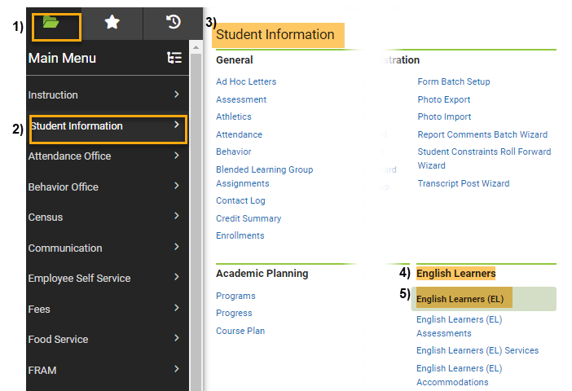

Adding LEP, NEP or FEP Status:

Under English Learner (EL):

Program Status: Select “EL” from the dropdown,

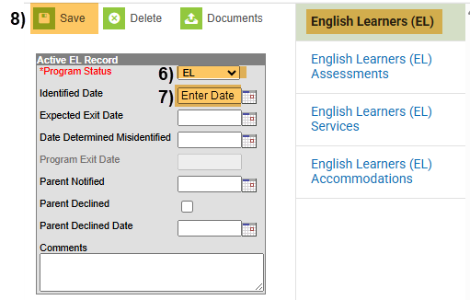
Identified Date: Use date that student was identified in the program based on WIDA/ACCESS scores.
- Save.

NOTE: Schools may choose to use all other fields on the EL page. These fields are not state reportable but recommended. See your school leader for school preferences.

State Reportable Fields
Under English Learner (EL) Services:
*Best practice is for schools to add a new service record for each school year.

Go to: EL Services,

Select: “New” Button,
- Start date: Use date that EL Service begins for the school year (or first day of school),
- End date: *Schools have 2 options but must be consistent each year for each student:
  - Leave the exit date blank each year. You will never add an exit date, but will add a new record each year with an updated start date and EL services.
  - Use June 30,XXXX of the current school year. Do NOT use the last day of school or student’s withdraw date. If you choose to use the exit date 6/30, be sure there is an exit date for each year’s record. IC has a know issue that if exit dates are added for all but one record, state reports will report the IC data from the record with the missing the exit date regardless of dates out of range.
- Service Type: Select Service Type from the dropdown, required for the Student Demographic (SD) file and populates on the file under Language Proficiency.*
- Language Instruction Program: Select Program Type from the dropdown, required for the SD file and populates on the file under Language Instruction Program for NEP, LEP, FEPM1 & FEPM2 only.*
- SAVE.

*(For Coding options for Service Type/Language Proficiency & Language Program - see SD File Layout: CSI OC Resource Webpage or CSI EOY Resource Webpage
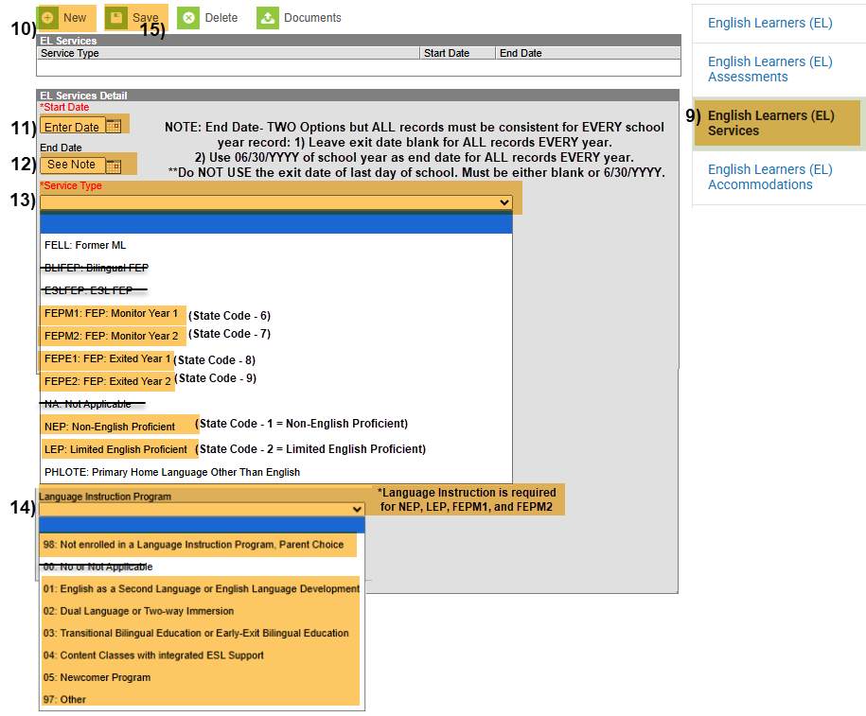

Adding PHLOTE Status:

Under English Learner (EL):

Program Status: Select “Not EL” from the dropdown.

IMPORTANT: If a student has a home language of anything other than ENG, then a blank Program status will default to Language Proficiency (4 = PHLOTE) on state reporting. Please be sure to update the Program Status after students have been tested and designated.

Identified Date: Use date that student was identified as PHLOTE based on WIDA/ACCESS scores.
- Save.
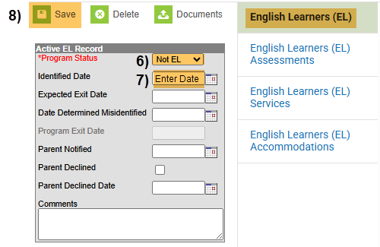

NOTE: Schools may choose to use all other fields on the EL page. These fields are not state reportable but recommended. See your school leader for school preferences.

NEW GUIDANCE 2/13/2026
State Reportable Fields
Under English Learner (EL) Services:

Go to: EL Services,

Select: “New” Button,
- Start date: Use date that the student was screened and identified PHLOTE,
- End date: Leave BLANK so the PHLOTE identification continues each year,
- Service Type: Select PHLOTE: Primary Home Language Other Than English,
- Language Instruction Program: Leave Blank OR Select 00:Not applicable.
- Save.

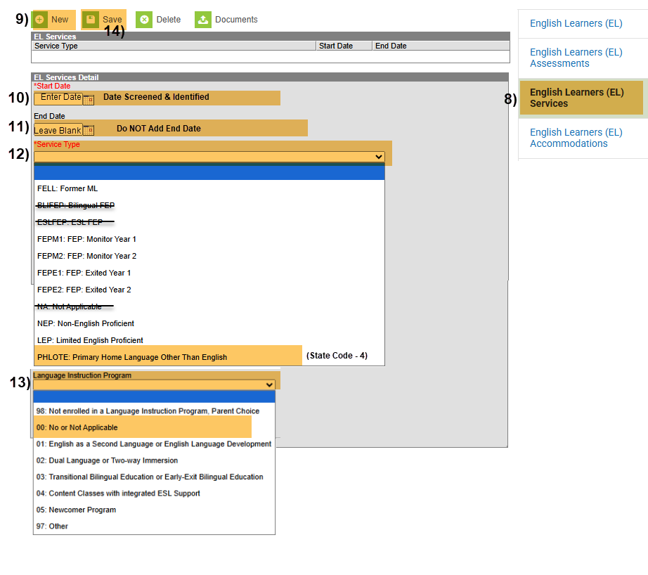

Adding FELL Status:

Under English Learner (EL):

Program Status: Select “Exited EL” from the dropdown,

Identified Date: Use date that student was identified into the EL program.

Program Exit Date: Use date that student exited out of the EL program.
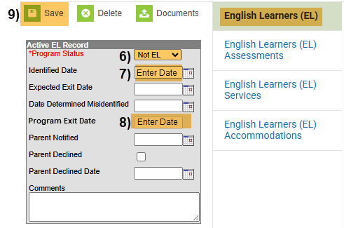
- Save.

NOTE: Schools may choose to use all other fields on the EL page. These fields are not state reportable but recommended. See your school leader for school preferences.

State Reportable Fields
Under English Learner (EL) Services:

Go to: EL Services,

Select: “New” Button,
- Start date: Use date that the student transitioned to FELL,
- End date: Leave BLANK so the FELL identification continues each year,
- Service Type: Select FELL: Former ML from Dropdown,
- Language Instruction Program: Leave Blank OR Select 00:Not applicable.
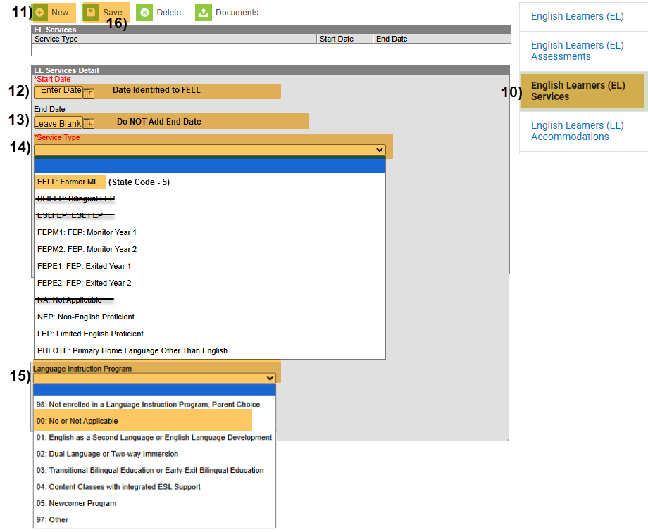
- Save.

For Home Language and ML data, please work closely with your Data Submission Contact, ML/EL Coordinator, and Head of School to determine your school’s best practice and procedures for who updates each Home Language and EL data and when the data is updated.

Access Home Language Data:

Search for Student: Select Student,

Go to: “Main Menu”,

Select: “Census”,

Select: “People”,

Select: “Demographics”.
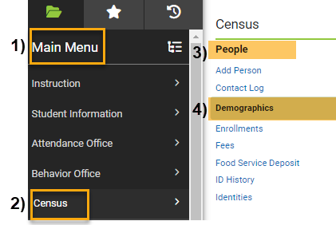

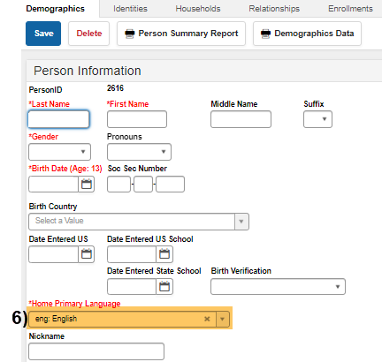
- Home Primary Language: Select from Drop Down.

CSI CONTACTS:
If you have any questions about coding, please reach out to submissions_csi@csi.state.co.us.
If you or your ML/EL coordinator have any questions about special student circumstances, program progression, etc., please reach out to CSI’s ML Development Coordinator, Rachel Franks at rachelfranks@csi.state.co.us.
Website Resources:
For ML information and details: https://resources.csi.state.co.us/multilingual-learners/
For Multilingual Coding Toolkit and Training: October Count: https://resources.csi.state.co.us/data-submissions/october-count/ or End of Year: https://resources.csi.state.co.us/data-submissions/eoy/

