

2025-2026 WIDA ACCESS

Student Biographical Data (SBD) Review Instructions for CSI Schools
Instructions for CSI Schools

Purpose of the ACCESS SBD Review
The WIDA ACCESS Student Biographical Data (SBD) Review is the final opportunity for schools to verify and correct student demographic and program data associated with WIDA ACCESS testing before scores are finalized.
Impact of the ACCESS SBD Review
Accurate data directly impacts student English language development (ELD) programming and placement decisions, accountability reporting, priority and focus school designations, and Title III funding allocations for LEP students.
All schools are required to complete the SBD review.
If you are new to SBD, please read this document in full before beginning.
Timeline & Deadlines

Task | Deadline
School review window opens | Tuesday, March 17
Final error-free files due to CSI | Monday, March 23 at 5:00 p.m.

Important Notes:
- Start early – multiple submission rounds may be needed.
- Spring Break does not exempt schools from review responsibilities.
- CSI cannot grant extensions, as the final deadline is set by CDE.

SBD Resources
All resources are available on the ACCESS SBD webpage:
- File Layout
- Instructions for Schools
- Business Rules

Background Information
The ACCESS SBD review differs from other data collections:
- Schools do not extract files from their SIS.
- Instead, CSI provides a pre-populated SBD file.
- Schools review and return the corrected file to CSI.
Schools that followed testing procedures typically have minimal corrections.

Key Reminders
Editable vs. Non-Editable Fields
- Not all fields can be changed – refer to the File Layout for details.
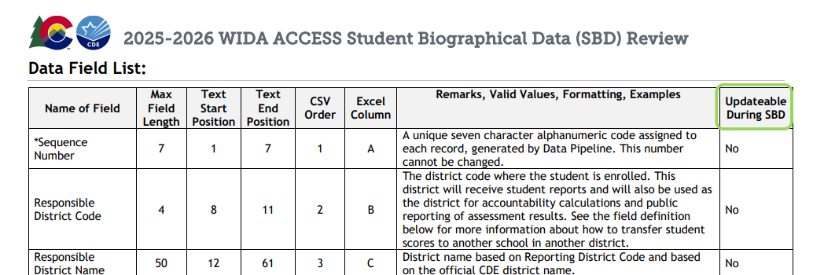

Duplicate Records
- If a student appears more than once:
  - Do not delete any records.
  - Ensure all records match (e.g., SASID, grade, demographics).
  - Records will be merged by DRC after SBD.
- Duplicates are often caused by mismatches between paper testing and WIDA AMS (e.g., incorrect SASID or grade bubbling).
Test Clusters
- ACCESS uses grade clusters, not individual grade levels.
- There are four cluster fields:
  - Listening
  - Reading
  - Speaking
  - Writing
- These fields reflect the test actually taken and cannot be changed
- If a cluster is blank:
  - Check for another record for the same student.
  - If none exist, the student likely did not complete that domain.
- If all four clusters are blank:
  - A Not Tested Reason must be entered.
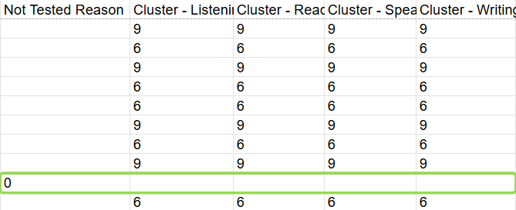

Step 1: Access Your SBD File
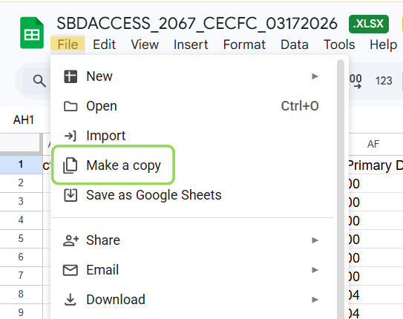
- Go to Google Drive:
Assessments > SBD > ACCESS > 25-26
- Locate your file:
  - SBDACCESS_schoolcode_schoolname_03172026.xlsx
- Download the file and make a copy before editing.

Step 2: Review Student Records
- Work row by row and verify that each student’s data matches your records.
Pay Close Attention To:
Grade & Cluster Alignment
- Grade must match the tested clusters.
- Incorrect alignment will result in score invalidation.
Cluster Fields
- If a domain is blank and no other record exists student likely did not complete that domain.
- If you believe a student did complete a missing domain contact CSI
Student Demographics
- SASID
- Name (first, middle, last)
- Date of birth
- Other identifying fields
Language Proficiency
- Valid values:
  - 1 = NEP
  - 2 = LEP
- Only NEP/LEP students will receive ACCESS score reports.
- If a student tested but is not coded 1 or 2, update Not Tested Reason = 11 (Data Error)
Language Instruction Program
- If a parent opted the student out use code 98.
- Do not leave blank or use 00 (will trigger errors).
Language Background
- Must be a valid three-letter code (e.g., SPA).
- ENG is not valid.
Not Tested Reason Codes
Code | Reason
00 | Absent
03 | Withdrew Before/During Testing
04 | Student Refusal
07 | Medical Exemption
08 | Part-Time Home School Student
10 | Did Not Attend
11 | Data Error (the student is not NEP or LEP)
- Only use these when a student did not start any domains.
- There is no Parent Excuse code for ACCESS.
- Do not use Not Tested Reason if the student completed any domain.
Step 3: Review Errors & Warnings
- If errors are detected, you will receive an error report in your folder:
  - SBDACCESS_schoolcode_schoolname_Error_Report_03172026.xlsx
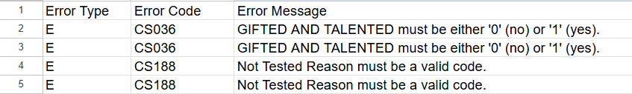
- Reference the Business Rules to understand error codes.
- Make corrections in the SBD file only – do not edit the error report.
- If no error report is generated, no system errors were found. However, you must still review all data for accuracy.
Step 4: Make Updates
- Use Excel filter tools to identify blanks in updateable columns.
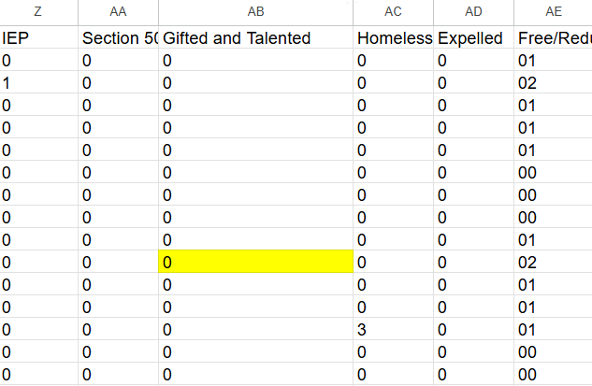
- When making corrections:
  - Only update allowed fields
  - Do not:
    - Add rows
    - Delete rows
    - Move columns
    - Rename columns
  - All edits must be highlighted (non-white fill). This is required so CSI can identify changes.
Step 5: Final Quality Check
Before submitting:
- Ensure all dates and codes are in the correct format.
- Verify that numeric and text fields were not accidentally reformatted.
- Save a copy for your records.
Step 6: Upload Your File
- Upload the corrected file to the same Google Drive folder.
- Rename your file to indicate corrections:
  - SBDACCESS_schoolcode_schoolname_corrected _03172026.xlsx
- Email CSI at kaliwinn@csi.state.co.us to confirm submission.
Your email must confirm:
- You uploaded a corrected/updated file OR
- You reviewed the file and made no changes
Your review is not complete until CSI receives this confirmation.

Final Checklist
- Download your SBD file from Google Drive
- Review all student records carefully
- Correct errors and inconsistencies
- Highlight all changes
- Upload corrected file by March 23 (5:00 p.m.)
- Email CSI (kaliwinn@csi.state.co.us) to confirm completion

