October Count & End of Year

Extracting the SSA Files in ALMA

Student School Association (SSA) File – Used for October Count and End of Year collections.
Note: The SSA file is titled: “School Association” in ALMA
Select: School View, choose schools that serve students in grades 6-12. (Include homebased programs if core courses are offered.)
- On Menu: Select “Reporting”,
- Select Tab: “Compliance Reporting”,

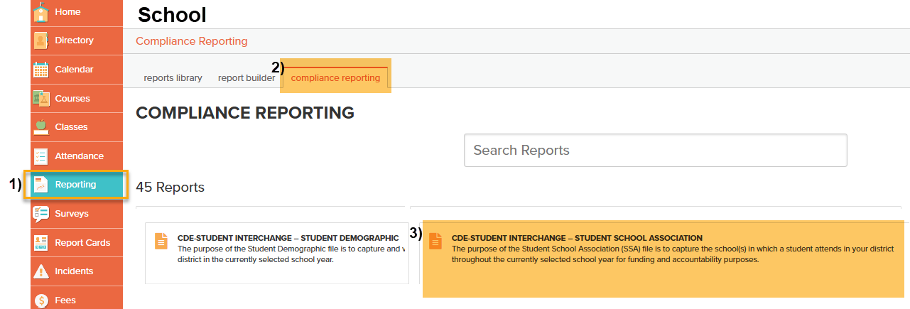
Scroll and Select: “CDE-Student Interchange – Student School Association”.

Under CDE-STUDENT INTERCHANGE – STUDENT SCHOOL ASSOCIATION Page:

Select: “Run Report”.

Under Run Report Popup:

Select School Year: Use Current School Year,

Through Date: Recommend using a general date that includes your school’s entire school year (ex. 06/30/YEAR),
- Click: SUBMIT.
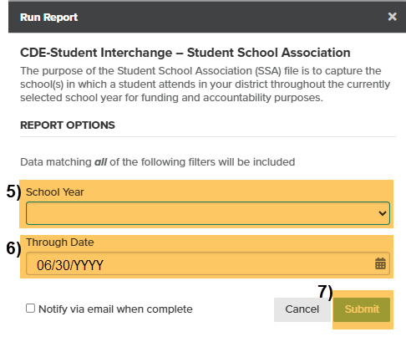

After File Runs:
- Under History: Select CSV Download.
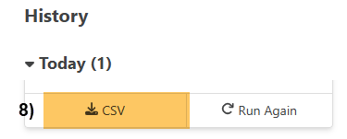

Important: When submitting files to CSI, do not open the downloaded file directly, as this will cause critical leading zeros to be dropped. Instead, save the file to your computer first, then open and/or submit the saved file.
However, If you are using a newer version of Excel, you will see a warning popup.
Select “Don’t Convert” to keep leading zeros.
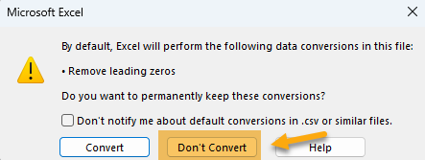

Submission Steps:
- Use the Record Check Tool (RCT) prior to an initial submission,
- Save file using the following format: SchoolCode_SchoolAbbreviation_SD_MMDDYYYY (no spaces),
- Upload to: G-Drive>Submissions>(Choose Collection Name)>(Choose Year)>Files to Run,
- Notify the Data Team of the submission by emailing: Submissions_CSI@csi.state.co.us.
Additional Resources:
For training on:
- Naming files: “Step 3: Extracting the Files and Submitting to CSI”,
- Converting CSV to Excel, Excel Filters, etc: “Excel for Data Submissions Contacts (Part 1)”, visit:
https://resources.csi.state.co.us/data-submissions/
For file details and validation resources:
- SD details: see the “Student Demographic File Layout”,
- SSA details: “Student School Association File Layout”,
- Title I details: “Title I File Layout” (for applicable schools),
- GG details: “Graduation Guidelines File Layout” (for high schools),
- Record Checker Tool (RCT) information: “Record Checker Tool”, visit:
https://resources.csi.state.co.us/data-submissions/october-count/ OR
https://resources.csi.state.co.us/data-submissions/eoy/

For More Quick Reference Guides (QRG):
https://resources.csi.state.co.us/data-submissions/october-count/ OR https://resources.csi.state.co.us/data-submissions/eoy/
- QRG – Extracting SD Files in ALMA
- QRG – Extracting Title I Files in ALMA
- QRG – Using the Record Checker Tool
- QRG – Extracting SSA Files in ALMA

