Teacher-Student Data Link (TSDL)

Extracting TSDL Files in ALMA

The following instructions are steps for extracting data from ALMA for State Reporting. This resource does not reflect all SIS capabilities and functions that schools may use or require for their own purposes and record keeping.

Although this report can include all students (PreK–12) and all courses for ease of extracting, the TSDL collection focuses on each student in grades 6-12 and their core courses, as well as all courses for migrant students in grades 8– 12.

NOTE: Schools should NOT exclude any courses from state reporting that are used for attendance for students in grades PreK–12. Because the TSDL collection runs concurrently with the EOY Attendance collection, it is critical that attendance data is collected for all students.

Extract TSDL File –
Select: School View, choose schools that serve students in grades 6-12. (Include homebased programs if core courses are offered.)
- On Menu: Select “Reporting”,
- Select Tab: “Compliance Reporting”,

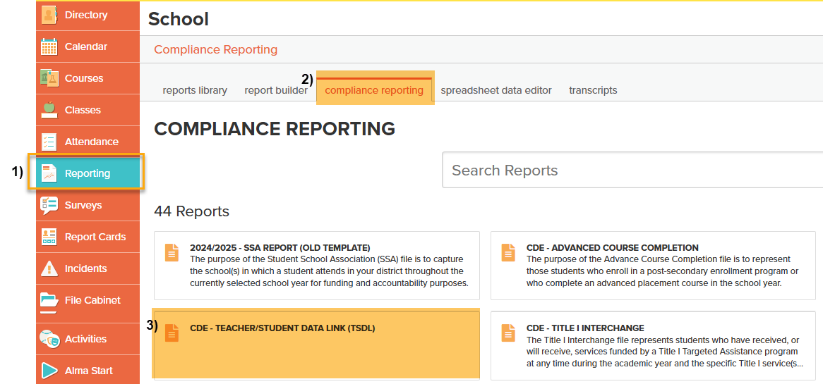
Scroll and Select: “CDE - Teacher/Student Data Link (TSDL)”.

Under TSDL Page:

Select: “Run Report”.
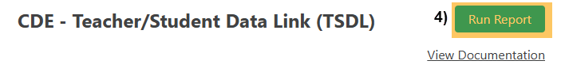

Under Run Report Popup:

Select School Year: Use Current School Year,
- Select Terms: Use ALL Terms for the Entire School Year. (CSI guidance to capture courses through the end of the school year minimizing data issues at the end of the school year),
- Select Grade Level: Check all grades 6th – 12th only,
Subject: Leave Blank.
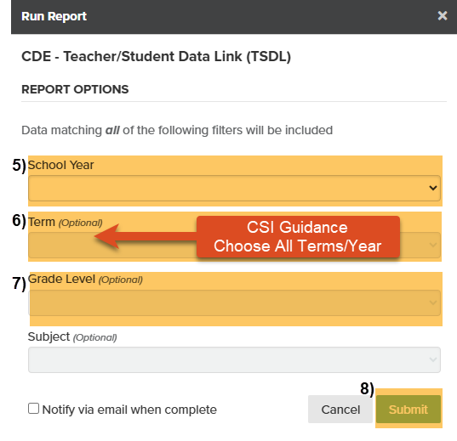
- Click: SUBMIT.

After File Runs:
- Under History: Select CSV Download.
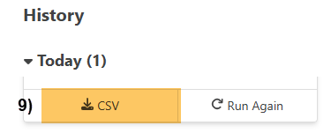

Important: When submitting files to CSI, do not open the downloaded file directly, as this will cause critical leading zeros to be dropped. Instead, save the file to your computer first, then open and/or submit the saved file.
However, If you are using a newer version of Excel, you will see a warning popup.
Select “Don’t Convert” to keep leading zeros.
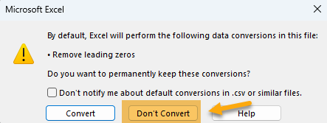

Submission Steps:
- Save file using the following format: SchoolCode_SchoolAbbreviation_TSDL_MMDDYYYY (no spaces),
- After saving, open the file and scroll through to ensure that fields are not blank or incorrect prior to submitting to CSI. Look for:
  - Column E (Course Level) – Not Blank
  - Column F (Credit) – Courses have accurate credit amounts.
  - Column H (Terms) – Not Blank
  - Column I (State Course Code) – Does not contain letters. Is a 5-digit code per state guide. See SCED Version 12 (or higher), located under “Additional resources” on https://resources.csi.state.co.us/data-submissions/tsdl/,
  - To correct Credits, Terms, State Codes and/or Core Credits Course in PS, see the Quick Reference Guide “Updating Course Information in PS” located under “Quick Reference Guides” on https://resources.csi.state.co.us/data-submissions/tsdl/
  - Column Z (Course Completion Status) – Numbers only - Does not contain letters
- Upload to: G-Drive>Submissions>TSDL>(Choose Year)>Files to Run,
- Notify the Data Team of the submission by emailing: Submissions_CSI@csi.state.co.us.

Other Resources:
- For TSDL details, “TSDL File Layout”: https://resources.csi.state.co.us/data-submissions/tsdl/
- SCED Version 12 for State Code: https://resources.csi.state.co.us/data-submissions/tsdl/
- For more on naming files:https://resources.csi.state.co.us/data-submissions/training/
- Training Submissions Process / “Step 3: Extracting the Files and Submitting to CSI”
- For converting CSV to Excel, Excel Filters, etc: https://resources.csi.state.co.us/data-submissions/training/: “Excel for Data Submissions Contacts (Part 1)”

For More Quick Reference Guides:
https://resources.csi.state.co.us/data-submissions/tsdl/

- TSDL – Updating Course Information in ALMA
- TSDL – Updating Core Credits Course in ALMA

