October Count

School Set Up

Title I - Targeted Assistance (TA) in Power School (PS)

# Title I Targeted Assistance (TA) - Used for the October Count and End of Year collections.

**Note:** Only for schools that qualify for Targeted Assisted (TA) Title I at specific grade levels. This is not used for School Wide (SW) Title I. The Title IA funds allocated to the school should be used to target interventions for the students most at risk of not achieving grade level standards.

## Go to: Current Calendar Year,

## Go to: “District Management”,

## Select: “District Setup”,

## Find Section: “School Info”,

## Find: Under Other Information/School-wide Title I Functionality

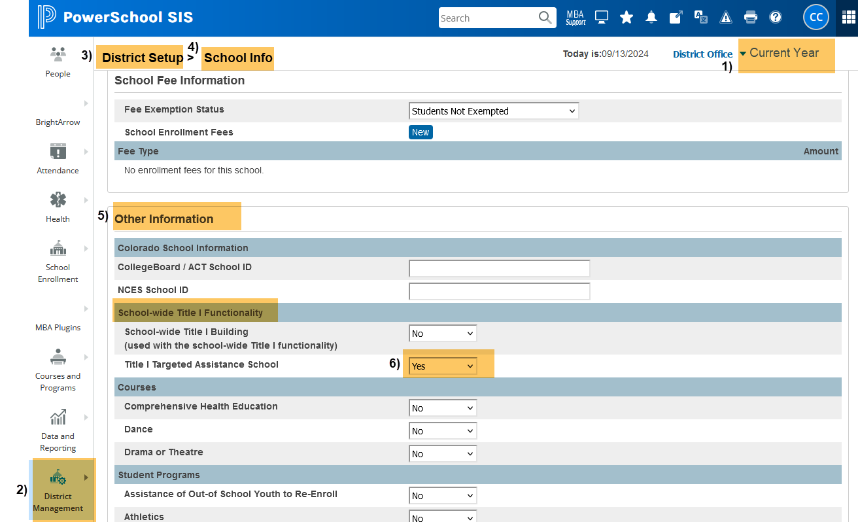

## Under Title I Targeted Assistance School:

## Select: “YES”,

## SAVE.

Additional resources:

* If you have questions about Title I and the process for identifying students, please have your Title I contact reach out to Kim Caplan at KimberlyCaplan@csi.state.co.us.
* For data or SIS questions related to Title I, please reach out to [submissions_csi@csi.state.co.us](mailto:submissions_csi@csi.state.co.us).

For More Quick Reference Guides (QRG):

[https://resources.csi.state.co.us/data-submissions/**october-count/**](https://resources.csi.state.co.us/data-submissions/october-count/) OR [https://resources.csi.state.co.us/data-submissions/**eoy**/](https://resources.csi.state.co.us/data-submissions/eoy/)

• QRG – Extracting Title I Files in PS

October Count & End of Year

Extracting the Title I Files in PowerSchool (PS)

# Title I File - Used for the October Count and End of Year collections.

**Note:** Only for schools that qualify for Targeted Assisted (TA) Title I. This is not used for School Wide (SW) Title I.

1. **Select School:** (Some schools will choose “District Office” if pulling data for multiple schools)
2. **Select the Calendar Year:** Select Appropriate Year,

## Go to: “Data and Reporting”,

## Select: “Reports”,

## Go to: “Compliance Reports”,

1. **Under Interchanges, Select:** “Title I Interchange”

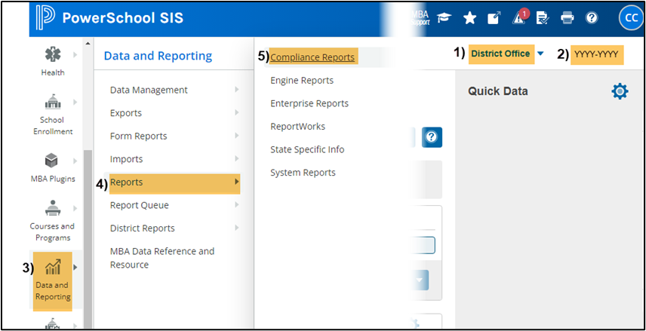

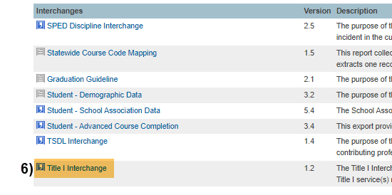

## Under Report Parameters:

## Select Schools: Choose school/s that you would like to include. Use “Shift /Click” to select multiple,

## Click: Submit

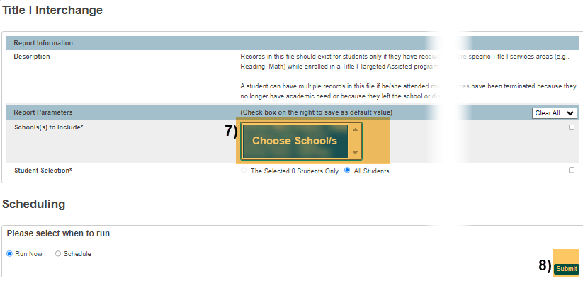

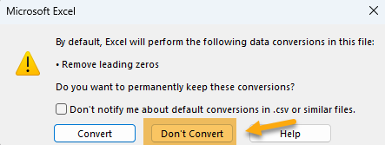**When submitting files to CSI, do NOT open the downloaded file directly and resave, or it will lose critical leading zeros! Instead, save the file first. Then open or submit the saved file. OR,** if using a newer Excel, you will receive a warning. **Choose “Don’t Convert”**

**Submission Steps:**

* **Use the Record Check Tool (RCT) prior to an initial submission,**
* **Save file using the following format:** SchoolCode_SchoolAbbreviation_TitleI_MMDDYYYY (no spaces),
* **Upload to:** G-Drive>Submissions>(Choose Collection Name)>(Choose Year)>Files to Run,
* **Notify the Data Team of the submission by emailing:** [**Submissions_CSI@csi.state.co.us**](mailto:Submissions_CSI@csi.state.co.us)**.**

Additional Resources:

For training on:

* Naming files: “Step 3: Extracting the Files and Submitting to CSI”,
* Converting CSV to Excel, Excel Filters, etc: “Excel for Data Submissions Contacts (Part 1)”, visit:

[https://resources.csi.state.co.us/**data-submissions**/](https://resources.csi.state.co.us/data-submissions/)

For file details and validation resources:

* SD details: see the “Student Demographic File Layout”,
* SSA details: “Student School Association File Layout”,
* Title I details: “Title I File Layout” (for applicable schools),
* GG details: “Graduation Guidelines File Layout” (for high schools),
* Record Checker Tool (RCT) information: “Record Checker Tool”, visit:

[https://resources.csi.state.co.us/data-submissions/**october-count**/](https://resources.csi.state.co.us/data-submissions/october-count/%20) OR

[https://resources.csi.state.co.us/data-submissions/**eoy**/](https://resources.csi.state.co.us/data-submissions/eoy/)

For More Quick Reference Guides (QRG):

[https://resources.csi.state.co.us/data-submissions/**october-count/**](https://resources.csi.state.co.us/data-submissions/october-count/) OR [https://resources.csi.state.co.us/data-submissions/**eoy**/](https://resources.csi.state.co.us/data-submissions/eoy/)

* QRG – Extracting SD Files in PS
* QRG – Extracting Title I Files in PS
* QRG – Using the Record Checker Tool
* QRG – Extracting SSA Files in PS
* QRG – Extracting GG File in PS **(EOY Only)**