**2025-2026 October Count**

**Audit Documentation Checklist**

# Overview

This document summarizes key dates and the audit documentation required to support funding claims for students in the October Count collection. This is designed as a checklist, not a detailed guidance document. Details are included in either the [25-26 CSI October Count Audit Handbook](https://resources.csi.state.co.us/wp-content/uploads/2025/08/25-26-CSI-October-Count-Audit-Handbook.docx) and / or the [CDE 2025-2026 Student October Count Audit Resource Guide](https://www.cde.state.co.us/cdefinance/2025_student_october_pupil_count_audit_resource_guide). These reference documents will be noted throughout.

All questions should be sent to <Submissions_CSI@csi.state.co.us>. Per CDE’s request, schools should **not** contact CDE directly. As your authorizer, CSI will either provide the answer to your question or work with CDE to find an answer.

## How to use this Checklist

* This is a Microsoft Word document. If you are unable to work with this in Microsoft Word format, please reach out and request a PDF version.
* Review the entire checklist and note which items apply to your school.
* Mark N/A for all items that do not apply to your school.
* Note dates when each documentation item is due.
* Run test reports ahead of time to ensure reports show data as expected.
* Review the ***CDE Audit Resource Guide,*** linked above, for additional documentation requirements.
* As documentation is collected and submitted, check off each item.
* Submit completed and signed checklist no later than November 6, 2025.

Sample of completed checklist section.

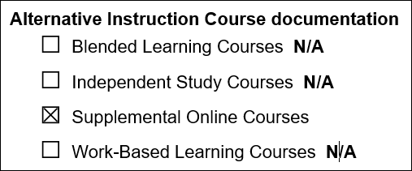

## Location for Documentation

Most audit documentation will be placed in the CSI Google Drive, **Submissions > October Count > 25-26 > OC Audit Documents**.

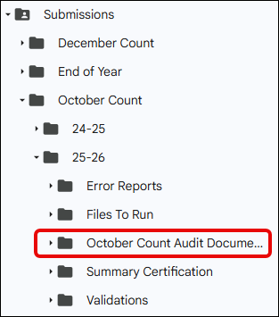

# Key Dates

* October 1 – individual student schedules for secondary students are due by the end of business on Count Day
* September 24 – October 8 – This new “*attendance documentation date range*” replaces the previous “11-Day Count Period Window”. Please ensure everyone involved in taking attendance (teachers, front office staff, etc.) is especially diligent to fully record attendance every day. At this point, it is also helpful to collect work samples – consistent with your school’s policy – to strengthen the documentation for an attendance claim.
* October 16 – Deadline to submit the majority of audit supporting documentation. See below for more details. If Fall Break starts before October 16, then documents must be submitted prior to leaving for Break.
* October 31 – Extended Attendance deadline. Students who were absent on Count Day (10/1/2025) must resume attendance *no later than 30 calendar days after Count Day* to qualify for funding. Run and submit Extended Attendance reports ONLY for students absent on Count Day. Reports are due no later than 11/03/2025.
* November 6 – After uploading all documentation, submit this checklist along with the signed Certification on the last page.

# Documentation Checklist

The majority of audit documentation listed below is due no later than October 16, 2025, unless a different due date is noted for a specific item.

## All schools

**Attendance** **reports,** see Appendix I of the ***CSI October Count Audit Handbook***

***Alert:*** *Attendance reports for Homeschool Enrichment Programs that only meet 1 day a week should be reviewed carefully for adequate attendance records. If October 1 is not a day students are scheduled to attend, then the report must reflect attendance for each student at least once before Count Day and once after Count Day. You may consider expanding the date range for HSE programs to September 17 – October 15.*

**Extended Attendance** (if applicable) Complete **only** for students absent on Count Day and did not resume attendance during the date range of the initial Attendance report. Due 11/3/2025

**Enrollment history**, see Appendix I of the ***CSI October Count Audit Handbook***

**Individual Student Schedules** Due at the end of Count Day – 10/1/2025

see Appendix I of the ***CSI October Count Audit Handbook***

* Brick-and mortar secondary students
* All online students
* Contractual education students (including home-school enrichment programs)

## Special school, program, course, or student types

Some schools will need to provide items in this section. Items are in the same order as the ***CDE Audit Resource Guide*** linked above. Using the *Table of Contents*, locate and review the applicable section for “Additional Documentation Requirements”. Send questions to: <Submissions_CSI@csi.state.co.us>.

**Alternative Instruction Course documentation**

Blended Learning Courses

Independent Study Courses

Supplemental Online Courses

Work-Based Learning Courses

**Postsecondary Courses and Programs**

*Some postsecondary course and program documentation may not be available until after 10/16/2025. Please note any documentation that will be submitted at a later date.*

ASCENT

Concurrent Enrollment

Dropout Recovery

Early College

TREP

**Unique Schools and Programs**

Alternative Education Campus (AEC)

Contractual Education

Compliance Assurances for Contracted Services (AUD-108) forms

Detention Centers

Facility Schools

Home-School Enrichment Programs

High School Equivalency Diploma Programs

Online Schools and Programs

P-TECH

**Unique Student Types**

Expelled Students

Foreign Exchange Students

Home-bound Students

Home-School and Private School Students

Individualized Education Program (IEP) Students

Kindergarten Students – Special Circumstances

Secondary Transition Students

Truant Students

## Free and Reduced Lunch Documentation

FRL documentation will be uploaded to the **FRL folder**, which is separate from the Submissions folder.

***Schools with a non-NSLP site,*** *not participating with a School Food Authority (SFA)*

Scanned copies of paper FEDS forms

***Schools participating with a School Food Authority other than Charter School Institute***

Eligibility report from the SFA Nutrition system as of end of business October 1, 2025

Eligibility report should show FRL status for **all enrolled** students.

After uploading all documentation, sign and date the certification statement. Upload the entire completed checklist to the CSI Google Drive: **Submissions > October Count > 25-26 > OC Audit Documents.**

Upload the full checklist, not just the signature page, so CSI can verify all items for each funded student scenario.

***The deadline to upload this signed document is November 6, 2025.***

**School Certification Statement for the**

**2025-26 October Count Audit Documentation**

I hereby certify that I have submitted all required supporting documentation and certify that the information provided is accurate, verifiable, and complete to the best of my knowledge.

Signature, Head of School Date

Signature, Data Submissions Contact Date