Infinite Campus System Setup Audit

The following guidance provides a starting point for ensuring key areas related to state reporting are appropriately set up. Schools should make use of the IC Knowledge Base through the links below and IC support for advance system set up questions.

CSI schools are expected to review their SIS at the start of each year to ensure the setup expectations outlined below, which impact state reporting, are met. CSI Data Submissions Team members may audit components of the SIS setup each year.

# School & District Codes

## District Code

School & District Settings > (District) District Information

District Code: 8001

*If you don’t see this option, ensure ‘All Schools’ is selected in the School dropdown for networks with multiple schools.*

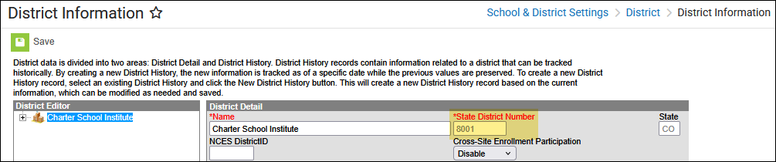

## School Code(s)

School & District Settings > (Schools) School Information

Click school name in list. Confirm the school number correctly matches the school’s state code.

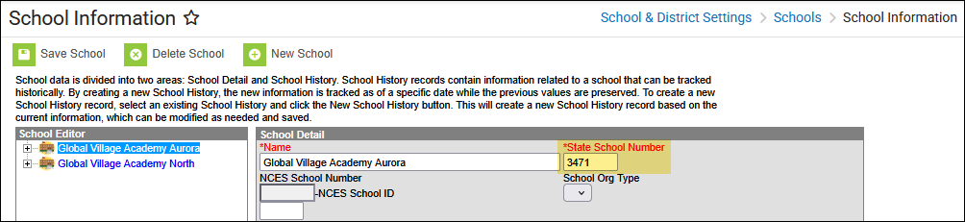

# Calendar

## Active Year

Scheduling & Courses > (Calendar Setup) > School Year Setup

Confirm the upcoming school year is marked as **Active**

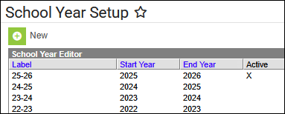

## Grade Level Setup

Scheduling & Courses > (Calendar Setup) Grade Level Setup

[*https://kb.infinitecampus.com/help/grade-levels*](https://kb.infinitecampus.com/help/grade-levels)

Confirm each grade is mapped to the correct **State Code**

**Check Against:**

Any expected Grade Level changes for the coming year. All expected grade changes should be confirmed with CSI in the Spring prior to the change taking effect.

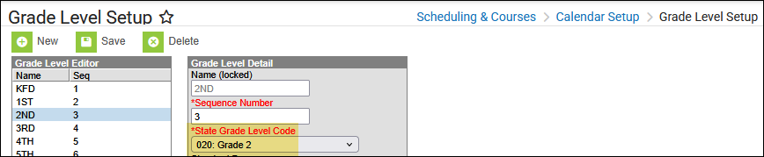

## Term Setup

Scheduling & Courses > (Calendar Setup) Term Setup

[*https://kb.infinitecampus.com/help/terms*](https://kb.infinitecampus.com/help/terms)

Verify term start and end dates

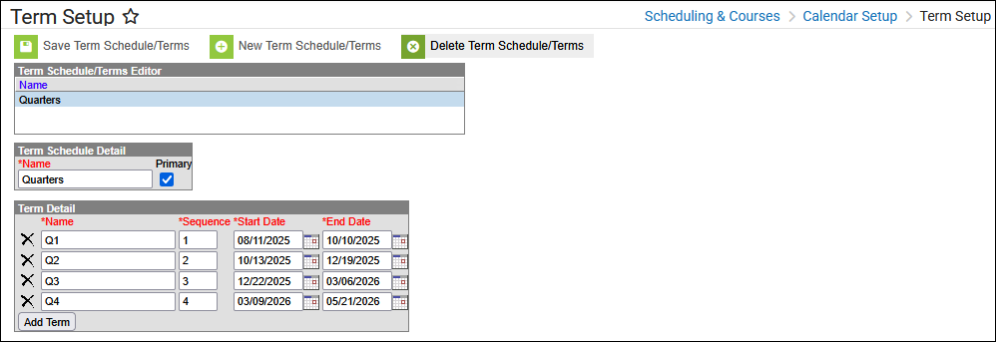

## Period Setup

Scheduling & Courses > (Calendar Setup) Period Setup

[*https://kb.infinitecampus.com/help/periods*](https://kb.infinitecampus.com/help/periods)

Verify Instructional Minutes, School Day Minutes

Verify Passing Periods

Periods that are non-instructional should be marked as such

Verify that Lunch is noted either in Lunch Time or as non-instructional

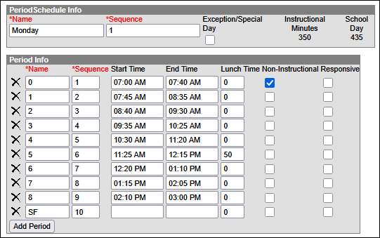

***References:*** *October Count Audit Guide*

* *Passing periods are defined as the time between two instructional periods, and from an instructional period* ***to*** *Lunch.*
* *Passing periods up to seven minutes may be included in the calculation of full- or part-time funding.*
* *Passing period between Lunch and the next instructional period may* ***not*** *be counted.*

## Number of Scheduled Days

Scheduling & Courses > (Calendar Setup) Day Setup

[*https://kb.infinitecampus.com/help/days*](https://kb.infinitecampus.com/help/days) (Print Calendar Days)

Click **Print** > PDF > Generate Report.

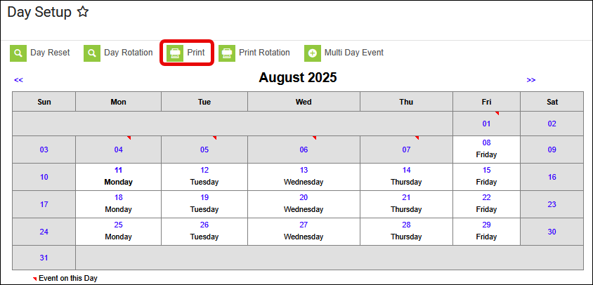

Review report to confirm alignment with School Calendar submitted in the spring.

Near the bottom of the report check the Total Instructional Days – generally 160-180 days.

Any schools with <160 days must be approved by the state. All schools operating <160 days should be confirmed with CSI in the Spring prior to the <160 days taking effect.

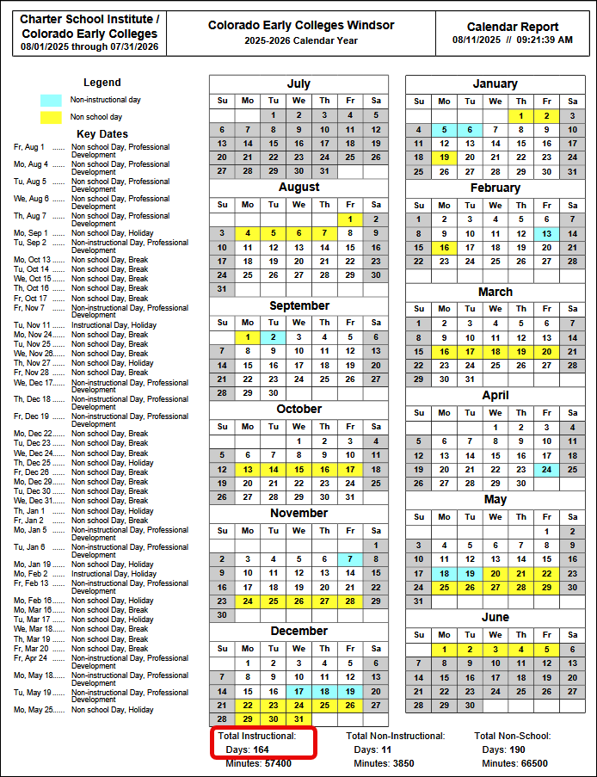

## Days

Scheduling & Courses > (Calendar Setup) Day Setup

[*https://kb.infinitecampus.com/help/days*](https://kb.infinitecampus.com/help/days)

Spot check a few days *(click on blue number for the day)*, both school days and known vacation days.

*Example: Labor Day will likely be a day off. Confirm that is the case on the calendar.*

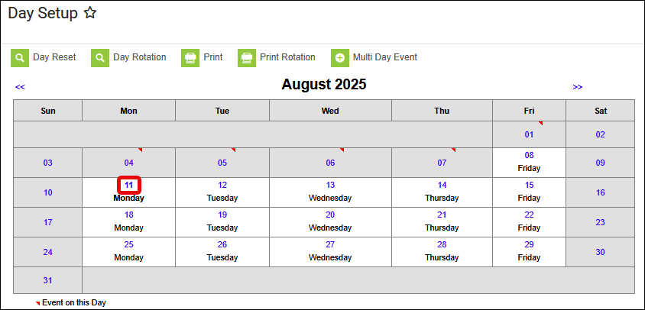 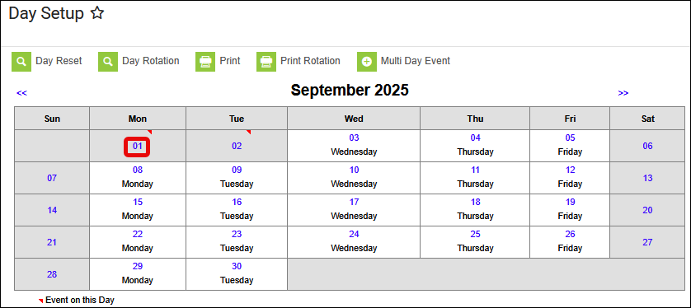

Instruction and Attendance should be unchecked if classes do not meet

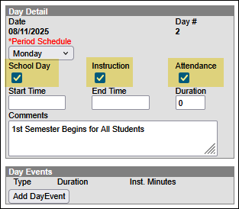 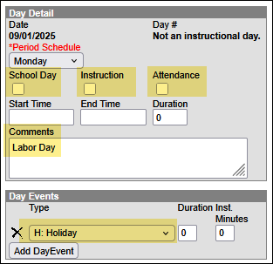

# Attendance

## Attendance Codes

Attendance Office > (Settings) Attendance Code Setup

[*https://kb.infinitecampus.com/help/attendance-admin*](https://kb.infinitecampus.com/help/attendance-admin)

*As expected: list of Attendance codes Concern: No Attendance Codes*

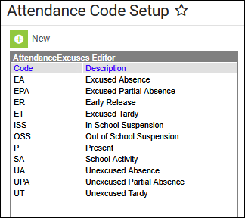 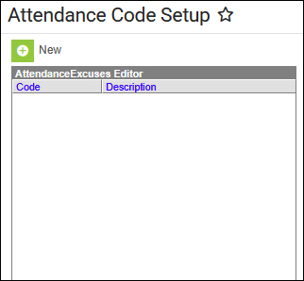

Verify **Status** and **Excuse** settings for *Absent Excused* and *Absent Unexcused*. If *Out of School Suspension* is an existing code, confirm it is Absent Excused.

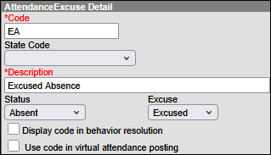 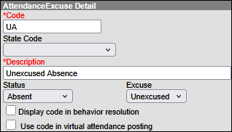 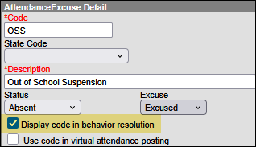

# Behavior

## Behavior Event Codes

Behavior Office > (Settings) Event Type Setup

[*https://kb.infinitecampus.com/help/event-types*](https://kb.infinitecampus.com/help/event-types)

*Note: Be sure you are in the* ***All Schools*** *dropdown in case the school has mapped state reportable events and resolutions at the district level.*

Verify that Event Types are set up for each state **Behavior Type**. There are 16 Discipline collection Behavior Type codes and 12 CRDC codes that must be set up in the system.

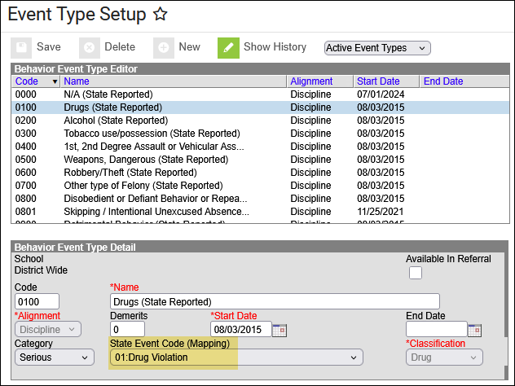

Reference document:

[2025-2026 Discipline Action File Layout and Definitions](https://www.cde.state.co.us/datapipeline/disciplineaction_filelayout_2026) to access a list of state reportable events

## Behavior Resolution Codes

Behavior Office > (Settings) Resolution Type Setup

[*https://kb.infinitecampus.com/help/resolution-types*](https://kb.infinitecampus.com/help/resolution-types)

Verify that Resolution Types are set up for each state **Discipline Action Type** code. In addition, there should be a Resolution Type for each **Unilateral Removal Type** (01, 02)

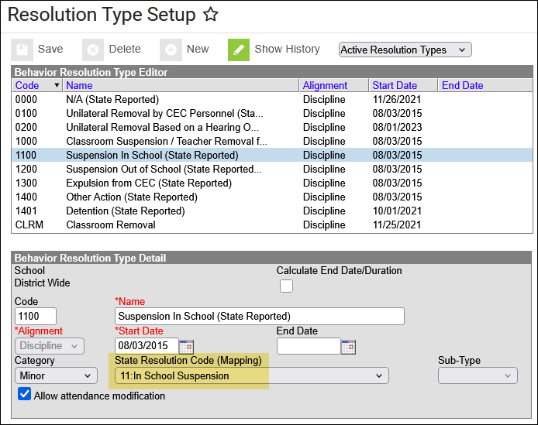

If ‘Allow attendance modification’ is checked, users can select from attendance excuse codes - see Attendance section above.

Reference document:

[2025-2026 Discipline Action File Layout and Definitions](https://www.cde.state.co.us/datapipeline/disciplineaction_filelayout_2026) to access a list of state reportable resolutions (00, 10-14) and Unilateral Removal Types (01, 02)

## PHD codes *(Prevent Harassment or Discrimination Investigation)*

*Check that all components required for reporting Prevent Harassment or Discrimination are set up correctly.*

Behavior Office > (Settings) Event Type Setup

[*https://kb.infinitecampus.com/help/prevent-harassment-or-discrimination-report*](https://kb.infinitecampus.com/help/prevent-harassment-or-discrimination-report%20)

Look for one Event Type named **Investigation** *(or similar)*

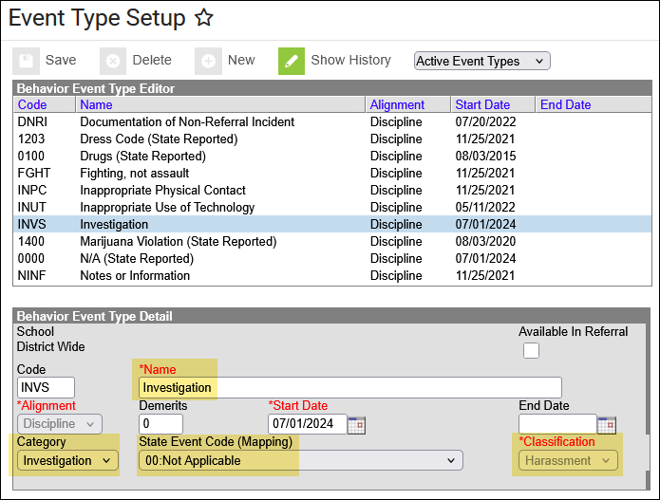

Behavior Office > (Settings) Resolution Type Setup

Look for one Resolution Type named **Investigation** *(or similar)*

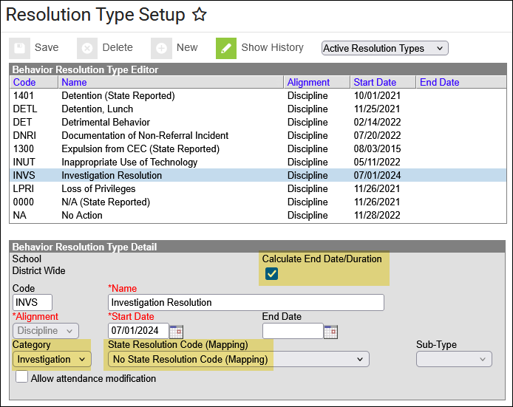

# Student Schedules

Scheduling & Courses > (Load Schedules) Student Gap Scheduler

[*https://kb.infinitecampus.com/help/student-gap-scheduler*](https://kb.infinitecampus.com/help/student-gap-scheduler)

Select only the Terms included in the first half of the year. **Generate Report** produces a PDF that is fast and easy to review. Confirm that students appear to be scheduled into courses for the first half of the year.

