October Count

Using the Record Checker Tool (RCT)

# Record Checker Tool (RCT) – Schools are expected to run files using the RCT and resolve and identified errors PRIOR to the initial file submission and throughout the submission process.

## FIRST: Download the RCT from the CSI Resource Website:

## <https://resources.csi.state.co.us/october-count/>

## Go to: “Data Validation Resources” Section,

## Then: “October Count Record Checker Tool”,

## Select One of Two Tools: “For CSV – No Leading Zeros” tool is for files without leading zeros OR

“For Excel – Includes Leading Zeros tool is for files with leading zeros.

Note:If one does not work and generates complete columns of data error, try to run the file using the other tool.

View instructions and webinar for more detailed information.

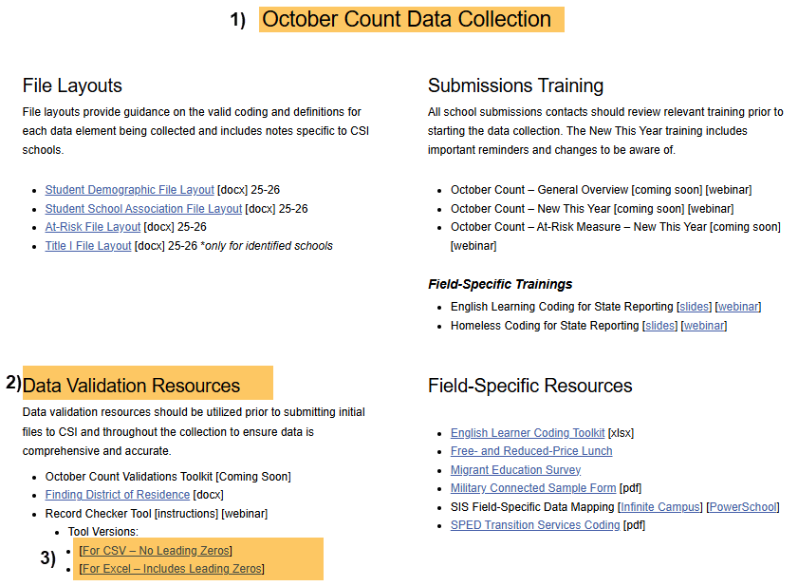

## SECOND: Read Instruction Tab

## Select: “Raw SD Data” or “Raw SSA Data” Tab on the RCT.

**NOTE:** You may need to click the “Enable Editing” and/or “Enable Content” button to use the RCT.

## THIRD: Extract SD and/or SSA files from your SIS: See Quick Reference Guides for instructions on extracting SD and SSA files.

## Open Downloaded SD and/or SSA File,

1. **Select All Cells of the Excel Spreadsheet:** Use “Ctrl + A” or Click Corner to the Left of “A” Column,
2. **Copy all data:** Use “Ctrl + C” on Keyboard or Right Click Mouse and Select “Copy”.

## Fourth: Return to the RCT File

## Click: Cell A:1,

## Paste All Data: Use “Ctrl + V” on Keyboard or Right Click Mouse and Select “Paste”,

1. **Notice: Highlighted Cells flag possible issues.**

**IMPORTANT: Fix flagged issues within your Student Information System (SIS), not on the file itself!** You will then extract a new file and run it again through the RCT. Repeat this as many times as necessary.

1. **Use the RCT Instruction Tab:** Gives guidance to help correct flagged issues.

**When highlighted cells have been resolved in the RCT, submit a new file to CSI.**

**Remember: When submitting files to CSI, send newly extracted files not used for the RCT. It is required that all submissions to CSI include leading zeros.**

**Submission Steps:**

* **Extract new file from your SIS,**
* **Save file using the following format:** SchoolCode_SchoolAbbreviation_FileAbbreviation_MMDDYYYY (no spaces),
* **Upload to:** G-Drive>Submissions>October Count>(Choose Year)>Files to Run,
* **Notify the Data Team of the submission by emailing:** [**Submissions_CSI@csi.state.co.us**](mailto:Submissions_CSI@csi.state.co.us)**.**

*See resources:

* For more on naming files:<https://resources.csi.state.co.us/data-submissions-library/>:
* Training Submissions Process / “Step 3: Extracting the Files and Submitting to CSI”
* For SD details: <https://resources.csi.state.co.us/october-count/>: “Student Demographic File Layout”
* For SSA details: <https://resources.csi.state.co.us/october-count/>: “Student School Association File Layout”
* For RCT: <https://resources.csi.state.co.us/october-count/>:“October Count Record Checker Tool”
* For converting CSV to Excel, Excel Filters, etc: <https://resources.csi.state.co.us/data-submissions-library/>: “Excel for Data Submissions Contacts (Part 1)”

For More Quick Guides:

<https://resources.csi.state.co.us/october-count/>

* October Count – Extracting SD Files in IC
* October Count – Extracting SSA Files in IC
* October Count – Extracting TitleI in IC

* October Count – Extracting SD Files in PS
* October Count – Extracting SSA Files in PS
* October Count – Extracting TitleI in PS