October Count & End of Year

Extracting the SD Files in Infinite Campus (IC)

# Student Demographic (SD) File – Used for the October Count and End of Year collections.

**Note:** The SD file is titled: “Student Layout” in IC

## Go to: “Main Menu”,

## Select: “Reporting”,

## Find Section: “CO Data Pipeline”,

## Select: “Student Interchange”.

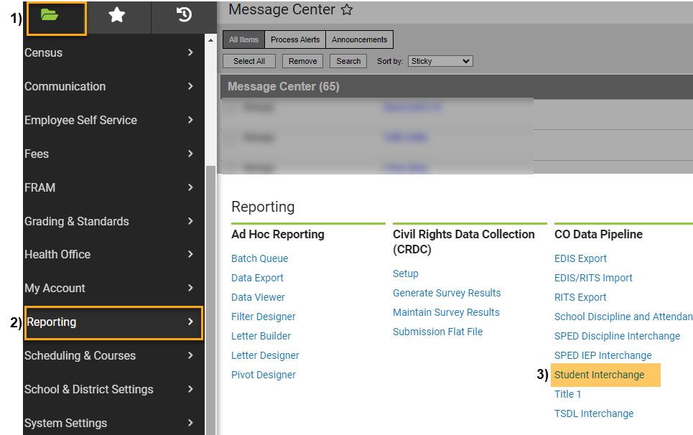You can do this from any calendar year.

## Under Extract Options:

## Report Type: Select “Student Layout” from the dropdown,

## Report Format: Select Accurate School Year Format,

## Ad Hoc Filter: Leave Blank,

## Effective Date: Leave as Default Date (Current Date),

## Report Legal Name: Check this Box,

## Format: Leave as Default “CSV”.

**Under Select Calendars:**

## Choose calendar/s that you would like to include. Use “Shift /Click” to select multiple,

1. **Click:** Generate Extract.

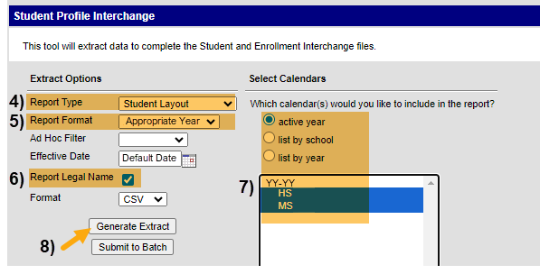

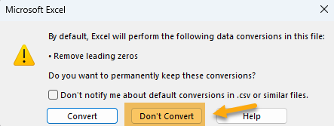**When submitting files to CSI, do NOT open the downloaded file directly and resave, or it will lose critical leading zeros! Instead, save the file first. Then you can open and/or submit the saved file. OR,** if using a newer Excel, you will receive a warning. **Choose “Don’t Convert”**

**Submission Steps:**

* **Use the Record Check Tool (RCT) prior to an initial submission,**
* **Save file using the following format:** SchoolCode_SchoolAbbreviation_SD_MMDDYYYY (no spaces),
* **Upload to:** G-Drive>Submissions>(Choose Collection Name)>(Choose Year)>Files to Run,
* **Notify the Data Team of the submission by emailing:** [**Submissions_CSI@csi.state.co.us**](mailto:Submissions_CSI@csi.state.co.us)**.**

Additional Resources:

For training on:

* Naming files: “Step 3: Extracting the Files and Submitting to CSI”,
* Converting CSV to Excel, Excel Filters, etc: “Excel for Data Submissions Contacts (Part 1)”, visit:

[https://resources.csi.state.co.us/**data-submissions**/](https://resources.csi.state.co.us/data-submissions/)

For file details and validation resources:

* SD details: see the “Student Demographic File Layout”,
* SSA details: “Student School Association File Layout”,
* Title I details: “Title I File Layout” (for applicable schools),
* GG details: “Graduation Guidelines File Layout” (for high schools),
* Record Checker Tool (RCT) information: “Record Checker Tool”, visit:

[https://resources.csi.state.co.us/data-submissions/**october-count**/](https://resources.csi.state.co.us/data-submissions/october-count/%20) OR

[https://resources.csi.state.co.us/data-submissions/**eoy**/](https://resources.csi.state.co.us/data-submissions/eoy/)

For More Quick Reference Guides (QRG):

[https://resources.csi.state.co.us/data-submissions/](https://resources.csi.state.co.us/data-submissions/october-count/)**[october-count/](https://resources.csi.state.co.us/data-submissions/october-count/)** OR [https://resources.csi.state.co.us/data-submissions/](https://resources.csi.state.co.us/data-submissions/eoy/)**[eoy](https://resources.csi.state.co.us/data-submissions/eoy/)**[/](https://resources.csi.state.co.us/data-submissions/eoy/)

* QRG – Extracting SD Files in IC
* QRG – Extracting Title I Files in IC
* QRG – Using the Record Checker Tool
* QRG – Extracting SSA Files in IC
* QRD – Extracting GG Files in IC **(EOY only)**