­­

CSI Unified Improvement Plan (UIP) Handbook: Updated Template

A guide for CSI schools completing the UIP.



Contents

Unified Improvement Plan (UIP) Overview 2

Using this Handbook 2

Getting Started 3

UIP Tool Logistics 3

UIP Assurances 4

Section 1: Evaluate 5

Section 2: Plan 8

Section 3: Implement 12

Additional Requirements 14

School Accountability Committee 14

Schools on Performance Watch 14

# Unified Improvement Plan (UIP) Overview

All Colorado public schools, including CSI charter schools, must submit an annual UIP for public posting. Schools which maintain a “Performance” rating on the state performance framework are eligible to submit every two years rather than annually if they so choose.

The UIP should represent a summary of the annual continuous improvement planning that every school engages in. To that end, CSI has developed a timeline that mirrors the typical annual planning process that occurs in schools.

**February-March:** Initial reminders and communication regarding UIP requirements for the next school year

**March-May**: Resources, training, and work sessions for completing UIP

**April-July:** Schools complete first draft of UIP

**September:** Optional first draft submitted for CSI review

**October 15 (CDE DEADLINE):** Deadline to finalize UIP in online tool (CSI submits to state)

## Using this Handbook

Both the traditional UIP template and the new “streamlined” UIP template will be covered in this handbook. The structure of the handbook will be broken into “***Evaluate, Plan, Act***”, following the Colorado Department of Education’s framework for improvement planning.

## Getting Started

Before starting your school’s UIP, be sure to have the following:

* Log-in credentials for the UIP system:
  + <https://www.cde.state.co.us/idm/uip>
* A PDF or hard copy of the [school’s prior UIP](https://www.cde.state.co.us/schoolview/frameworks/welcome#uip/)
* Most recent CARS report or [state SPF](https://www.cde.state.co.us/schoolview/frameworks/welcome/)
* Access to your school’s [CSI Equity Dashboard](https://resources.csi.state.co.us/equity-dashboard/)
* Current school-level data, for example:
  + Interim assessments
  + Attendance data
  + Teacher evaluation data
  + Survey data
  + Behavior data
  + Academic goals from your school’s strategic plan

## UIP Tool Logistics

**Order of completion**

The online system is designed to be edited in order from start to finish. Working in non-consecutive order through the tabs will result in loss of functionality. Be sure to work through the tabs in order as your complete your UIP.

**Save frequently**

This system does not automatically save as you complete each section. If you lose internet collection or accidentally click out of a tab, any work that has not been saved will be lost.

**“Continue Previous Plan” button**

Schools may begin their work on the UIP in the prior year UIP form. Once the state system rolls over in April, schools may use the “Continue Previous Plan” button to transfer either a) a previous year’s UIP or b) work started before the roll-over into the new blank UIP form. Pop-ups must be enabled to use this button.

**UIP as a public document**

Final draft UIPs are submitted to CDE for public posting each year. As such, when creating your UIP ***avoid*:**

* Reporting any achievement data for student groups smaller than 16 students (n<16) and growth data for student groups smaller than 20 students (n<20).
* Making any references that could be construed as negative about the student or family school population (i.e., “students lack motivation”, “parents failed to submit xxx documentation”).
* Focusing on any aspect or issue that is outside the control of the school and/or adult actions. For example, rather than focusing on the lack of academic readiness of incoming students, focus on improving systems that can remediate gaps in student learning.

## UIP Assurances

The UIP template contains assurances to satisfy requirements for data analysis and UIP completion. Confirm all assurances have been met by your school, check the appropriate boxes, and save.

# Section 1: Evaluate

The Evaluate section of the UIP should include a thorough review of your school’s current student data. This should include traditional measures of learning, such as interim assessment data and state assessment data, but should also include the data that your school leadership team reviews on a regular basis to adjust school programming.

**Priorities & Targets Tab**

Use the results of your school leadership tip’s data and evidence analysis to identify 1-3 student performance priorities. These should be outcome-focused, and based in the most urgent areas your team has identified for improvement. They may be related to academic programming (i.e. low growth scores in a traditional subject areas across specific grades; gaps in growth or achievement between subgroups of students, etc) or related to culture, engagement, and/or behavior (attendance or chronic absence scores, increase in behavioral incidents, etc).

For each student performance priority you create, be sure to completely fill out all sections:

1. Select a category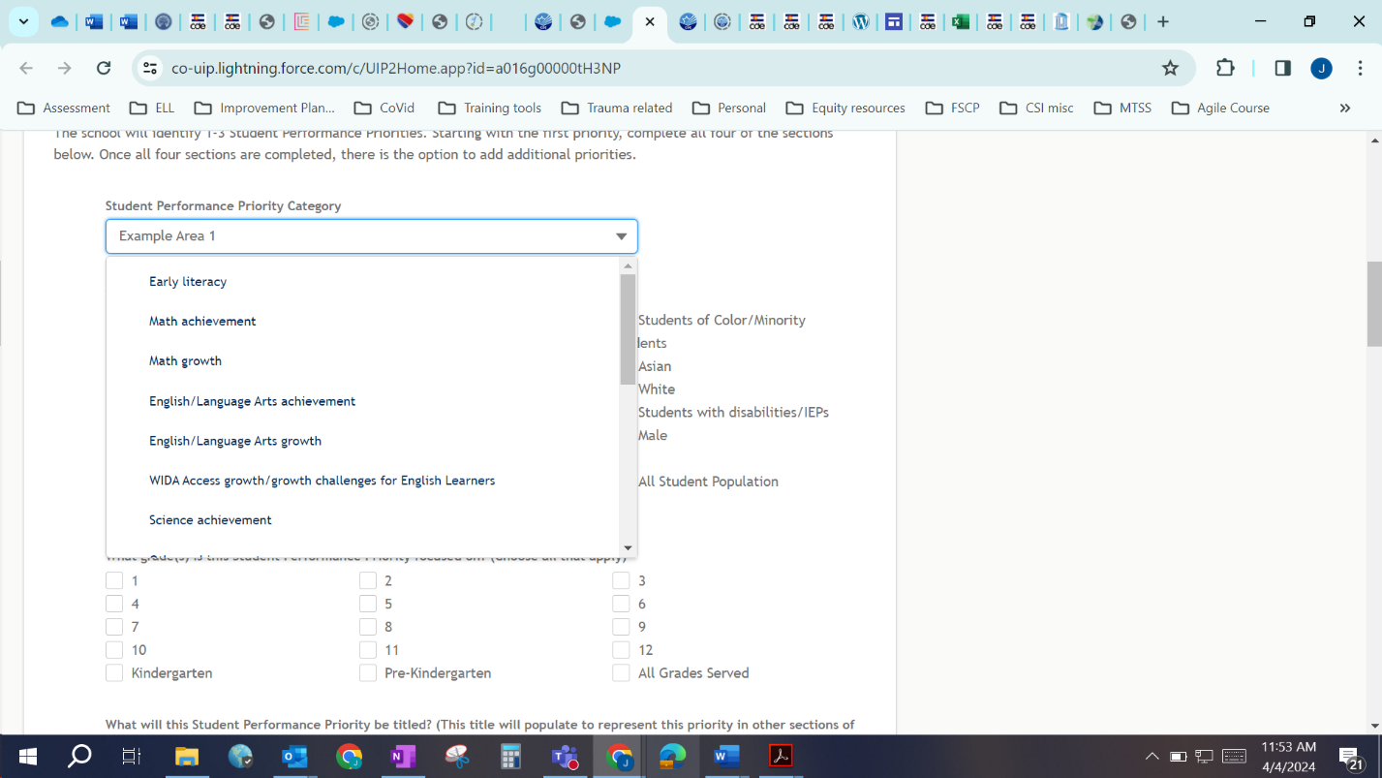
2. 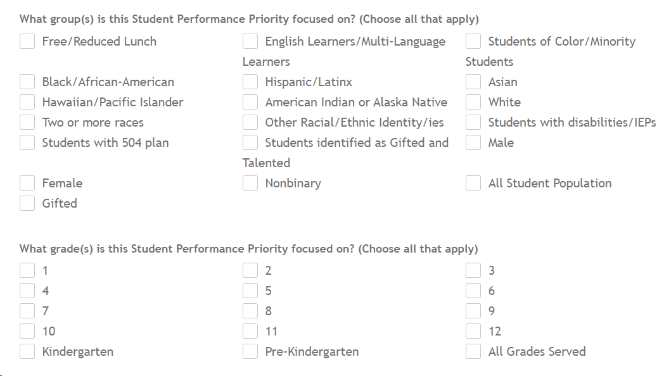Select the student represented in this performance priority.
3. Create a short, descriptive name

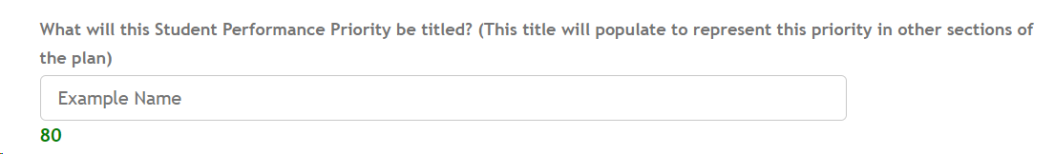

Adhere to character limits!

1. Set summative and interim targets for the performance priority.

Interim or short-term targets; set as many as needed

1 year goal

2 year goal

Current data related to priority

1. “*Evidence and Reasoning”*

Of all the areas you could focus on, why these ones? Provide a brief narrative summary of why these areas are priorities. This does not need to be an in-depth data sharing- remember that cool assurance you checked off on the first page? Rather, what’s your elevator pitch of why these are your school’s priority areas for the upcoming schools year?

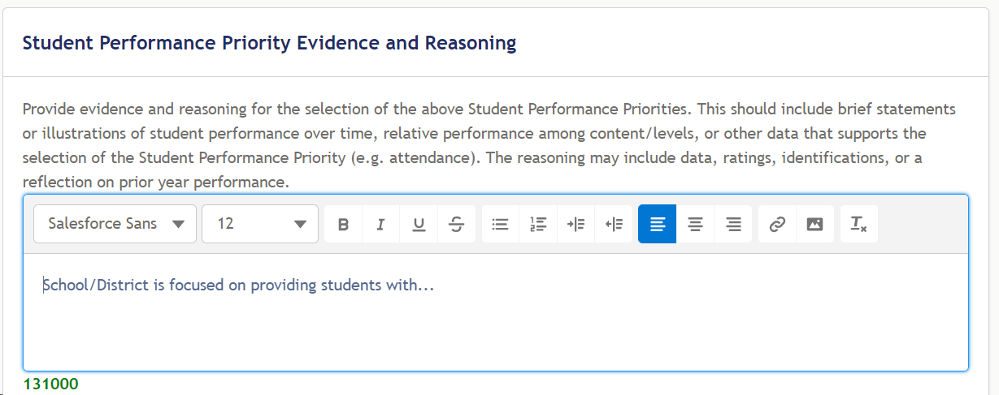

**CLICK SAVE!!!!!!!!!!!!!!**

# Section 2: Plan

Once your team has completed a review of current data and evidence, the next step includes developing a theory of action related to improving the identified student performance priorities. In a nutshell, why aren’t student outcomes where you expect them to be, and what is your team going to do about it?

**Root Causes & Strategies Tab**

There are several sections to complete on this tab. Start by assigning a root cause (at least 1, no more than 3) to each student performance priority you identified in the prior section.

Enter a clear, concise title for the root cause of the priority.

Performance priority auto-populates from prior tab

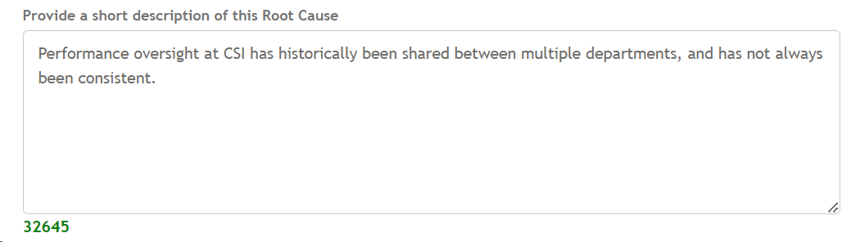

Add some detail- expand on the root cause.

What process did your team use for a root cause analysis? Make sure you are addressing a cause and not a symptom!

Select the best category for this root cause

Next, describe the plans your team has to address the identified root cause in the upcoming school year(s).

Expand on strategy title- what are the core components?

Name of strategy- as a strategy, there should be an action verb in here somewhere (Implement, align, update, restructure, etc)

Identify all general and categorical funding that will be used to support the implementation of this strategy; this may be fore staff time, purchased services, supplies, etc. This must align with your school’s Title Budget activities (submitted in late spring/early summer)

How do you know this will work?

If more than one root cause was identified, select the most relevant ones the strategy will address

Repeat as needed

# Section 3: Implement

In this section, describe your plan to ensure that implementation occurs with fidelity; this is where many plans fall apart, so consider using this document to keep your plan on track!

**IMPLEMENT** sections in ***updated UIP*** template:

**Implementation & Actions Tab**

This section is the clunkiest of the updated template. Here, you’ll outline your implementation plan. This includes both WHAT your team will do (actions) and HOW you will know it’s working (implementation milestones).

For the WHAT:

You have two options:

1. A close up of a box

   Description automatically generatedUpload an **existing action plan** that your team has developed for implementation. There are no current file limitations, so this may be a word document, a PDF, or an excel. ***Remember, this is a publicly available document, so proceed with caution.***

OR

1. Provide a summary of key actions directly in the template:



For the HOW:

This is about process, not outcomes

**Repeat for all additional Strategies.**

**You’re done!**

**Email CSI (**[**jessicawelch@csi.state.co.us**](mailto:jessicawelch@csi.state.co.us)**) to let us know you’ve completed a draft.**

**If you’d like to generate a PDF copy, click the “Visualize” tab OR click the Print UIP button from the landing page.**

# Additional Requirements

## School Accountability Committee

All CSI schools must have a School Accountability Committee. This group of family members, teachers, and administrators must be included in the creation/update of the school’s UIP and also must be updated regularly on implementation progress. For more information visit <https://resources.csi.state.co.us/school-accountability-committee-sac/>

## Schools on Performance Watch

For schools with a Priority Improvement or Turnaround (PI or T) rating, there are unique requirements in addition to the UIP requirements for all schools. These include:

• Schools with a PI or T rating must provide written notice to families of the school within 30 days of receiving the initial plan type assignment. This must include: o Type of plan required

o Performance results that led to the plan assignment

o Timeline for developing and adopting the required improvement plan

o Data, time, and location of the public meeting of the School Accountability Committee (SAC) to draft the plan

o Date, time, and location of the public hearing held by the school board to review the plan prior to adoption (this must be at least 30 days after the date on which the school provides written notice of hearing).

• Turnaround schools must selecting a state required strategy, and incorporating this strategy into the improvement plan.

• Schools with a PI or T rating will receive additional UIP review from the CDE State Review Panel. This may include required feedback that must be addressed prior to public posting.