2025-26 October Count Validations Toolkit



This toolkit consists of strategies for validating data for the Student Demographic (SD), Student School Association (SSA) and other submission files required for the October Count data collection.

The first section contains the **Validations Strategies Checklist** that provides a list of items to check for when reviewing your school’s data. The second section walks through how to use the **Record Checker** tool, which must be used by schools prior to submitting their initial files to CSI.

Each CSI school is **strongly encouraged** to use *both* validation tools provided here as part of its internal process for ensuring the completeness and accuracy of the October Count collection. It is best to use this document in tandem with the file layouts for each collection (available on the collection webpages of the CSI website). **Schools should also review both the October Count submissions and audit related trainings for the current year before using this toolkit so that they are aware of all possible changes to the collection.**

If you have any questions or would like to share your data validation strategies that can be added to this document, please email the CSI Data Submissions Team at [submissions_csi@csi.state.co.us](mailto:submissions_csi@csi.state.co.us).

PART I: Validation Strategies Checklist

Contents

Student Count (Enrollment, Attendance, Scheduling) 2

Funding Status 3

Home Based (Home School) Education 3

Early College 4

Free and Reduced Lunch Status 4

Program Data 4

English Learner 5

Foreign Exchange and Military Connected 5

Retention 5

File Submissions (SD, SSA, Title I) 6

PART II: Record Checker Tool 7

# Student Count (Enrollment, Attendance, Scheduling)

|  |
| --- |
| Helpful resources to consult while completing this section are listed below and can be found on the [CSI Audits webpage](https://resources.csi.state.co.us/data-submissions/audits/). October Count funding rules can be complex, depending on different student scenarios. **The checklist validation items in the list below are designed to flag primarily general reporting issues.**   * CSI October Count Audit Handbook * CDE Student October Count Audit Resource Guide * Confirm that the correct count date is being used (**October 1st for 2025**) unless your school has been approved for an alternative count date—alternate count day requests are due to CSI by **September 8, 2025**. |
| **October Count 2025-2026**  **Pupil Count Grades October Count Date**    PK-12 Wednesday, October 1st |
| * Confirm that all students are under the age of 21 as of the count date unless they are receiving services under an IEP and reach the age of 21 during the semester of the count date. * Confirm that students have *not* met the minimum school graduation requirements as of the count date. |
| **Multiple checkboxes below are very important to ensure that you are not reporting students who enrolled but are not actually attending your school this year, which creates many unnecessary data issues.**   * Confirm that students are enrolled with the school with an accurate entry date and entry type in your SIS. * Compare list of students with teacher rosters/seating charts. * Confirm all grade levels (preschool-12th grade, as applicable) are reported. * Confirm that all student schedules completely and accurately represent the classes each student is enrolled in and attending as of the count date. * Confirm that all students have the minimum courses necessary to qualify for part- or full-time funding   Schools are required to confirm that all students being counted for funding were:   * + Present for all, or any portion of, the applicable count date at your school (in any scheduled class)   **OR**   * + If absent or does not attend for any reason on the count date, were in attendance in any scheduled course prior to the count date in the current school year **AND** resumed attendance within 30 calendar days following Count Date   The student could not have withdrawn or transferred to another district between the Count Date and the date they resumed attendance.  *Extended proof of attendance for students absent on count day, but meeting the alternative general attendance proof must be submitted to CSI.* |

# Funding Status

By default, both PowerSchool and Infinite Campus identify students as eligible for full-time funding at the start of the school year. It is the school’s responsibility to adjust funding codes for each student according to whether they meet funding rules for the current year. See the section “Student Funding Eligibility – SIS Search” in the [CSI October Count Audit Handbook](https://resources.csi.state.co.us/data-submissions/audits/) for help on searching for students who do not meet full-time funding criteria.

* Confirm that all students have the correct funding code based on the number of courses/student-teacher contact time necessary to qualify for part- or full-time funding. If a student does not have enough time on the schedule or has exited out prior to count day, then confirm that the funding code has been changed to ‘**not eligible** to receive funding’ in your SIS.

**Full-Time Funding:** students must have a schedule as of the applicable count date that provides for at least 360 hours of instructional time in the semester of the pupil enrollment count date.

**Part-Time Funding:** students must have a schedule as of the applicable count date that provides for at least 90, but less than 360, hours of instructional time in the semester of the pupil enrollment count date.

Confirm that only a maximum of *part-time funding is being claimed for:

* + Kindergarten students attending a half day program
  + Homeschool students (regardless of services or instruction being offered)
  + Students with a class schedule between 90 and 359 hours of instructional time (in the semester of the count date)

\**Please know that these are the most obvious reasons for part-time funding, but there are more scenarios that occur.*

**Not Eligible/No Funding:** Students meet the enrollment criteria but may not meet the attendance requirement or may be scheduled, as of the applicable count date, for less than 90 hours of instructional time in the semester of the pupil enrollment count date.

# Home Based (Home School) Education

* Students who are home-based (home school) and ARE receiving educational services from the school should be coded in the SSA file with Home-based education = 1 AND funding code = 85.
  + Be sure you have created a home-based education school year calendar and individual student’s schedule and have provided those to CSI.
  + Students who are home-based and NOT receiving educational services from the school should not be included in your files to CSI. (Direct parents to complete an Intent to Homeschool form with the geographic district of residence. Your school may need to provide guidance to the family on completing the form)

# Early College

* Confirm that your school has not flagged students as Early College for the Postsecondary Program Enrollment field of the SSA file if they are not actually enrolled in concurrent enrollment courses. In other words, do not just code all students as early college because your school is a designated Early College.
* Verify whether your school has students enrolled in a post-secondary program or completed an advanced placement course during the school year.
  + If a student completed an AP course(s) in either semester during the school year, ensure that you are coding all course categories taken from the [Advanced Placement Course List](https://www.cde.state.co.us/postsecondary/grad-advanced).
  + If the student is taking postsecondary types of courses like ASCENT, Concurrent Enrollment, Dropout Recovery, Early College, or TREP ensure your school is meeting all of the audit requirements and be sure the student is accurately identified with the correct **Postsecondary Program Enrollment** field code in your SIS. (Extracts into the SSA interchange file)

# Free and Reduced Lunch Status

* For the October Count, be sure to complete the separate **Free and Reduced Lunch Eligibility Checklist** in the [**CSI October Count Audit Handbook**](https://resources.csi.state.co.us/data-submissions/audits/)**,** located on the CSI Audits webpage. The rules around FRL and At-Risk funding are very complex so it’s very important that you complete that checklist.
* Students who are homeless (you have a signed McKinney Vento form from CSI), foster, and migrant students should all be marked as free lunch eligible in your SIS.

# Program Data

# 

**Work with the program specific coordinators/liaisons at your school for each of these areas!**

* Compare Gifted/Talent with number of ALPs.
* Compare Primary Disability with number of IEPs.
* Compare 504 with number of 504s.
* Compare Language Proficiency values for EL students.
* Compare Homeless with number of McKinney Vento forms signed and approved by CSI (please do not mark a student as homeless until you have the signed form from CSI). **McKinney Vento forms are due to CSI by September 30th annually (or the prior Friday if the 30th falls on a weekend) in order to allow enough time for CSI to process them prior to count day.**
* Confirm that all students enrolled in post-secondary programs (i.e., concurrent enrollment, ASCENT, etc.) have been reported.

# English Learner

* Confirm that English Learner students are coded properly to reflect the re-designation from the prior spring assessment for returning students or new designation for newly enrolled students (if not using the designation from the prior school). There are 3 fields in the SD file tied to EL status: Language Proficiency; Language Background; and Language Instructional Program.
* Check that all students coded as EL have a Language Background of something other than English.
* Verify that all EL students also have both a Language Proficiency and Language Instruction Program that are non-zero filled and that they follow the logical EL progression based on how they were coded in the prior year unless there is strong evidence to not follow the progression.

Please see EL Coding Toolkit under the ‘Field-Specific Resources’ section of the October Count Resource page: <https://resources.csi.state.co.us/data-submissions/october-count/>

# 

# Foreign Exchange and Military Connected

* Confirm that Country of Parent’s Residence is not zero-filled.
* For October Count, proof of a J-1 visa is required to prove that the student is not paying tuition to attend your school and is therefore eligible for funding. Submit a copy of the J-1 visa or a copy of the passport if the visa type is listed to CSI.
* Ensure that only students who have a parent or guardian who is an active-duty member of the Armed Forces or full-time National Guard are coded with a “1” for military connected.

# Retention

* For October Count, verify that retention codes did not roll over from the previous year. This is a common issue in the October Count and is problematic! Simply run a check at the beginning of each school year and remove the retention codes that were assigned the prior year. Retention codes always indicate what will take place the next year (not the current year).

# File Submissions (SD, SSA, Title I)

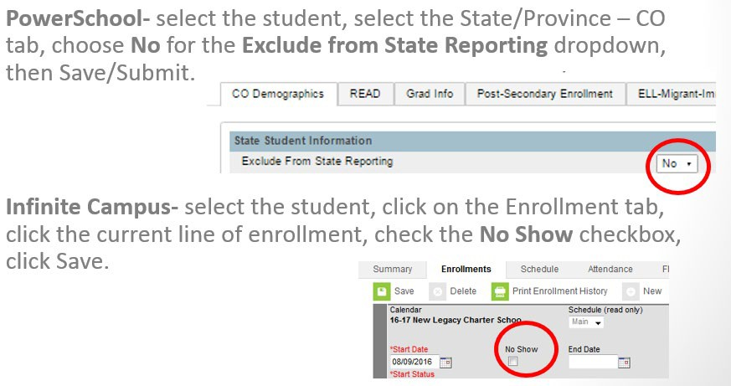

* Confirm that inaccurate duplicate enrollment records have been removed from your SIS. (However, mid-year grade reassignments and transfers in/out with an extended time between will require more than one record).
* Confirm that your school has reviewed all “Warnings” in your error reports (not just “Errors”). Warnings can often mean incorrect data in your SIS and many times will result in errors later in a collection or the next year. So, please take the time to review warnings!
* Confirm that all student enrollments are valid and all no-shows have been excluded (students who DID NOT complete the **24-25 school year** with you AND who have NOT attended in the **25-26 school year**). This will lead to more accurate data in the **25-26 End of Year** (EOY) collection (mobility rates will be incorrect if this type of no-show records are not excluded).
* You can also use ‘No Show’ for IC users. However, a student who attended for even half a day should be included in most state reports. CSI does not recommend using the PowerSchool “Exclude from State Reporting”.

# PART II: Record Checker Tool

The Record Check Tool has been updated for the 25-26 October Count. If you had downloaded the Record Checker Template for the EOY collection, you will need to download the updated Record Checker Template in order for the results to be accurate.

**Use this tool at least once prior to the October Count Initial Submission deadline. Detailed instructions follow below and you can also view a recorded training at** <https://resources.csi.state.co.us/data-submissions/october-count/>

* View the Record Checker Tool training.
* Download the Quick Reference Guide for “Using the Record Checker Tool”
* Follow instruction for running the tool.
* Reach out to CSI with any questions.