­­

2025-2026 CSI October Count

Audit Handbook

This document highlights instructions for all CSI schools to follow to meet the requirements of the CSI internal audit for the October Count collection for the current school year. It is not designed to replace the annual **CDE Student October Count Audit Guide** (see location below), which summarizes all state and federal requirements and required supporting documentation for the October Count audit process.

*Last updated August 28, 2025*



Contents

General Overview 2

Goals for CSI Internal Audit 2

CDE Student October Count Audit Resource Guide 2

Finance Rule Changes for SY25-26 2

Timeline 3

October Count Dates 3

Removal of 11-Day Count Period/Window 3

Alternative Count Date Requests 3

October Count Submission Deadlines 4

October Count Audit Deadlines 4

Supporting Documentation 5

Sharing Files within G-Drive 5

Attendance Reports 5

Student Schedules 6

Other Supporting Documentation 6

Resources 7

Appendix I: SIS Attendance, Enrollment, and Schedule Reports 8

Infinite Campus Report Extracts 8

Infinite Campus Report 1: Attendance 8

Infinite Campus Report 2: Enrollment Entry/Exit 10

Infinite Campus Report 3: Student Schedules 12

PowerSchool Report Extracts 16

PowerSchool Prep Step: Create Reporting Segment 16

PowerSchool Report 1: Attendance 17

PowerSchool Reports 2: Enrollment Entry / Exit 20

PowerSchool Report 3: Student Schedules 22

Appendix II: Crosschecking Funding Eligibility with Student Schedules 25

Infinite Campus Instructions 25

PowerSchool Instructions 28

Appendix III: Free and Reduced Lunch Eligibility Checklist 29

Appendix IV: Audit Documentation Checklist 33

# General Overview

The Colorado Department of Education (CDE) requires all school districts to maintain an internal audit process to ensure accurate reporting of eligible students and associated funding levels in the Student October Count data submission. This process also verifies that all required supporting documentation, as outlined in the [CDE Student October Count Audit Resource Guide](https://www.cde.state.co.us/cdefinance/auditunit_pupilcount)and provided by CSI schools, is complete and submitted on time.

The purpose of this Handbook is to guide CSI schools through the internal audit process for the Student October Count.

Please direct questions about this Handbook to [submissions_csi@csi.state.co.us](mailto:submissions_csi@csi.state.co.us).

## Goals for CSI Internal Audit

* Report accurate data
* Secure maximize potential funding
* Avoid repayment of funds back to the state
* Reduce burden on schools

## CDE Student October Count Audit Resource Guide

The CDE Guide summarizes all state and federal requirements and required supporting documentation for the October Count audit process. Schools should consult that resource for full audit requirements when needed. The links in this Handbook direct you to the main [CDE Pupil Count Audit webpage](https://www.cde.state.co.us/cdefinance/auditunit_pupilcount). From there, you'll find a link to the current year Guide as well as links to some prior year guides.

## Finance Rule Changes for SY25-26

In March 2024, the State Board of Education adopted significant changes to the Rules for the Administration of the Public School Finance Act (1 CCR 301-39), including the use of alternative instructional time in determining student funding. These changes substantially impacted the 2024 CDE Student October Count Audit Resource Guide and, in turn, required major revisions to CSI’s October Count Audit Handbook for the 2024–2025 school year.

For the 2025–2026 school year, updates on a smaller scale have been made to reflect clarifications and adjustments from CDE. While the overall audit process remains consistent with last year’s framework, schools must still carefully review this Handbook for changes, the [2025 CDE Student October Count Audit Resource Guide](https://www.cde.state.co.us/cdefinance/auditunit_pupilcount) to understand the funding rules and requirements for each unique student type and scenario, and other CSI resources and communications to ensure accurate reporting and timely submission of all required supporting documentation by the deadlines shared in this Handbook.

CSI will continue to support schools throughout the internal audit process and serve as the liaison with CDE. **Schools should send all audit related questions to CSI instead of reaching out to CDE.** *This is simply because CDE asks that questions come from the district office rather than from the school level. CSI can typically answer questions for you without the need to contact CDE.*

# Timeline

## October Count Dates

|  |  |
| --- | --- |
| **Pupil Count Grades** | **Pupil Count Date** |
| PK-12 | Wednesday, October 1, 2025 |

*Schools should report all enrolled PK in the October Count collection (regardless of UPK funding status).*

## Removal of 11-Day Count Period/Window

Beginning in the 2025-2026 school year, there will no longer be a reference to a 11-day count period/window. All students will be required to meet the enrollment and attendance requirements for funding.

* For audit purposes, districts will be required to provide attendance documentation that encompasses the “attendance documentation date range.” More detail on this is under the Attendance Reports section in this document.
* Schools still need to diligently record accurate attendance daily in their SIS throughout the entire school year and particularly during the week prior to the count date and the week after.
* CSI will continue to encourage schools to have a back up method of recording student attendance such as a dated sign in sheet or an assignment by class for the week prior and week after the count date.

## Alternative Count Date Requests

All schools need to use the official count date listed in the table above unless they have received advanced approval from CSI to use an **alternative count date**. CSI will email all schools with instructions in August with details on requesting an alternative count date.

Email requests to [submissions_csi@csi.state.co.us](mailto:submissions_csi@csi.state.co.us)

**No later than September 8, 2025**

*Include alternative count date and the rationale in the request.*

## October Count Submission Deadlines

For a list of intital file submission dates, error clearance deadlines, and summary report review phase deadlines, please see the **current year Data Submissions Calendar** found on the [Data Submissions Calendar webpage](https://resources.csi.state.co.us/data-submissions/calendar/).

## October Count Audit Deadlines

A few key audit dates will be listed in the Data Submissions Calendar. Additional audit-related dates are highlighted below, though they may be subject to change during the collection window. If a listed deadline falls on a weekend, the due date will typically be the preceding Friday.

|  |  |
| --- | --- |
| **Deadline Date** | **October Count Audit Event** |
| 9/4/2025 | Deadline to submit **initial audit documentation** (NEW) that includes work-based learning ICAP documentation. (Most of the other documents due will already have been submitted by schools like handbooks and calendars and bell schedules). |
| 9/8/2025 | Deadline to request alternative count date (see section above for details) and complete/submit compelted pupil count Questionnaires. |
| 9/15/2025 | Schools must post their Catalog of Courses to their websites by this date if offering Alternative Teacher-Pupil Instruction courses. |
| 9/23/2025 | ALP approval deadline for early access students.  *School Programs staff may suggest an earlier deadline to the audit deadlines to ensure adequate time for them to review/process forms.* |
| 9/26/2025 | Deadline to submit McKinney-Vento (homeless forms) to CSI for approval *prior* to count day *(While homelessness identified and approved by Count Day will be reflected in October Count Data, schools should continue submitting forms as new students are identified past this date to ensure accurate reporting throughout the school year.)*  *School Programs staff may suggest an earlier deadline to the audit deadlines to ensure adequate time for them to review/process forms.* |
| **10/1/2025** | **Count Day—Deadline to submit individual student schedules (for grades 6-12 *unless students follow an elementary schedule for 6-8*) by end of day.** |
| 10/16/2025 | Deadline to submit ***majority*** of audit supporting documentation, including attendance reports. |
| 10/31/2025 | 30 calendar day deadline for students who were absent on Count Day (10/1/2025) to resume attendance (to qualify for funding). |
| 11/4/2025 | Deadline to review the submissions summary report and submit the signed **October Count submissions certification** (schools must complete their data review and submit final data changes). |
| 11/6/2025 | Deadline to submit the signed **October Count audit certification**. |

# Supporting Documentation

As part of the annual CDE audits—encompassing the Pupil Count, At-Risk Count, EL Count, and SPED Count (NEW for 25-26)—along with the CSI internal October Count audit, all schools are required to submit supporting documentation to verify the funding levels claimed for students reported in the October Count collection. **This CSI Handbook focuses on supporting documentation needed for the Pupil Count audit only.**

All CSI schools must provide documentation on attendance and individual student schedules for all students reported as funded in the October Count.

Guidance on extracting electronic attendance, enrollment, and student schedule reports from the school SIS is available in the Appendices of this document.

## Sharing Files within G-Drive

Schools must upload supporting documentation to the appropriate audit subfolders in G-Drive under Submissions/October Count/XX-XX/OC Audit Documents. For any audit-related documents that do not have a clearly designated subfolder, schools can use the "Other" subfolder within the same file path and can create more subfolders below that level if they find that useful for their needs.

## Attendance Reports

Due 10/16/2025*

According to CDE with the removal of the 11-day count period/window in 2025-2026, schools will now be required to provide attendance documentation that, at a minimum, encompasses the “**attendance documentation date range**”. This range, defined in the **CDE Student October Count Resource Audit Guide**, includes the week prior to and the week following the official count date. For the 2025-2026 school year, with the October Count date set as **October 1, 2025**, schools must therefore provide attendance documentation covering **September 24, 2025 through October 8, 2025.**

* Students are considered to be in attendance if they are present for all (or any portion of) the applicable count date. If a student is absent on that date for

any reason, the student may meet the attendance requirement by establishing attendance during the current school year in any scheduled course both prior to the count date AND within 30 days following the count date.

* Attendance reports should be extracted from the school SIS (instructions for Infiinite Campus and PowerSchool are included in the Appendices within this document).
* Schools should ensure that submitted attendance documentation includes all students, even those participating in contracted education offerings such as homeschool enrichment programs. This includes attendance reports for students taking courses in a contractual environment. Schools must set up a process with the contractor to adequately record attendance and provide it to the school for audit purposes.
* **SCHOOLS MUST REVIEW THEIR OWN REPORTS FOR ACCURACY BEFORE SUBMITTING TO CSI! This step appears to often be skipped, leading to misreported students and much more work for CSI staff during their documentation reviews.**
* *For students absent on count day (or the alternative count day, if a school is approved for one), **extended** attendance reports must be provided to CSI as soon as possible but no later than the day after the deadline to resume attendance to confirm attendance criteria has been met.
* Schools should consult the [2025 CDE Student October Count Audit Resource Guide](https://www.cde.state.co.us/cdefinance/auditunit_pupilcount) for special student or program scenarios that could impact the type of attendance documentation required.

## Student Schedules

Due by end of **Count Day**, 10/1/2025

Schools are required to provide individual student schedules extracted from the school SIS for grades 6-12 (unless grades below 9th follow an elementary type of schedule where they do not change classrooms/instructors and have passing periods.) Check with CSI if you are not sure if schedules should be submitted for some grades for your school.

* **SCHOOLS MUST REVIEW THEIR OWN REPORTS FOR ACCURACY BEFORE SUBMITTING TO CSI! This step appears to often be skipped, leading to misreported students and much more work for CSI staff during their documentation reviews.**
* Individual student schedules must align with the school bell schedules in order for schools, CSI, and CDE to conduct audit reviews to determine whether funding levels reported for students in the October Count collection meet the instructional time requirements in statute. If that is not the case, then schools will need to also provide crosswalk documentation defining how the SIS student schedules align with the school bell schedules.
* Schools should consult the [2025 CDE Student October Count Audit Resource Guide](https://www.cde.state.co.us/cdefinance/auditunit_pupilcount) for special student or program scenarios that could impact the type of schedule documentation required.

## Other Supporting Documentation

Due 10/16/2025

Schools may need to submit other types of supporting documentation for special program and student scenarios offered and identified by CSI schools in the **Audit Questionnaire Survey.**

Schools should consult the [2025 CDE Student October Count Audit Resource Guide](https://www.cde.state.co.us/cdefinance/auditunit_pupilcount) for special student or program scenarios that could impact other types of required supporting documentation.

# Resources

Primary resources related to the October Count internal audit processes include the following:

* [CSI October Count Webpage](https://resources.csi.state.co.us/october-count/): Submissions related resources (recorded trainings, file layouts, validation documentation, and other helpful resources)
* [CSI Audits Webpage](https://resources.csi.state.co.us/data-submissions/audits/): Audit related resources based on data reported in the October Count collection (recorded trainings and other helpful resources)
* [CSI FRL Webpage](https://resources.csi.state.co.us/data-submissions/frl/): Free and reduced lunch determination guidance for schools
* CSI “Weekly Update” Emails: Please review each week for audit announcements and file submission status (sent to all school submissions contacts)
* [CSI Policy Guidance](https://resources.csi.state.co.us/legal-and-policy-library/): Legal requirements on topics like attendance, enrollment, data privacy, and home school
* [School Calendar and Instructional Hours Resources](https://resources.csi.state.co.us/calendar-and-instructional-hours/): Guidance documents on developing annual school calendar and bell schedules in compliance with state requirements
* [CDE October Count Webpage and Audit Resource Guide](https://www.cde.state.co.us/cdefinance/auditunit_pupilcount): Primary state resource focusing on comprehensive funding and audit rules for different student programs and scenarios for the October Count collection
* [CDE At-Risk Count Webpage and Audit Resource Guide](https://www.cde.state.co.us/cdefinance/auditunit_atrisk_freeandreduced): Primary state resource focusing on funding and audit rules around students reported as free or reduced lunch eligible
* [CDE ELL Count Audit Webpage and Audit Resource Guide](https://www.cde.state.co.us/cdefinance/auditunit_ell_count): Primary state resource focusing on funding and audit rules around students reported as limited English proficient

# Appendix I: SIS Attendance, Enrollment, and Schedule Reports

## Infinite Campus Report Extracts

The following instructions illustrate how to extract Attendance, Enrollment, and Student Schedule reports from Infinite Campus.

Even though some screenshots may not illustrate the current school year, they should still be applicable in a general sense and won’t be updated until they change significantly with the vendor. However, be sure to use the dates described in the steps rather than those in the screenshot if it is from a different year.

**REVIEW YOUR REPORTS FOR ACCURACY BEFORE SUBMITTING TO CSI**

### Infinite Campus Report 1: Attendance

*In Campus Community, the Help document for this report is under Attendance Office/Attendance Office Reports/Attendance Register.*

1. First select the applicable school calendar you wish to extract attendance for.

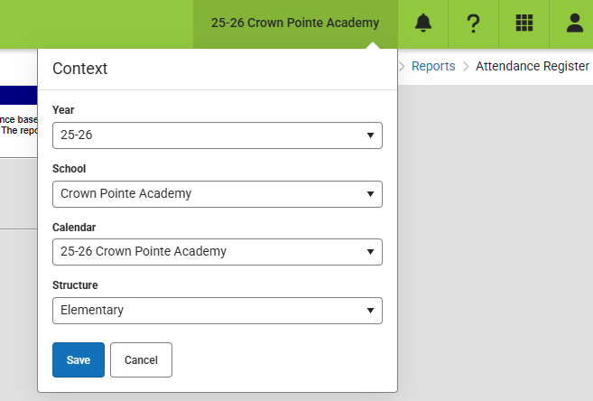

1. On the Main Menu IC screen go to **Attendance Office>Reports>Attendance Register.**

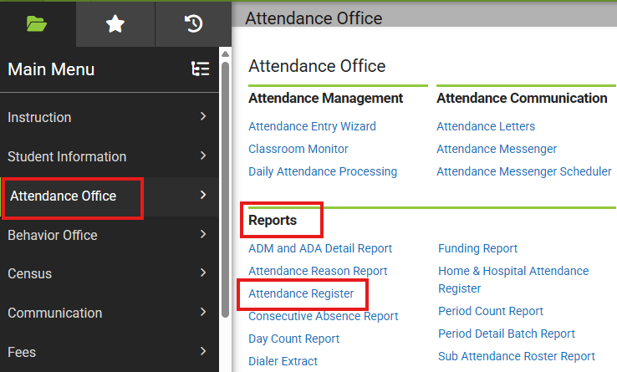

1. For **What report type would you like?** select Student Daily Attendance.
2. For the date range, select the **attendance documentation date range (new in 25-26)** of 09/24/2025 - 10/8/2025 for 25-26.

* *If your school is approved for an alternative count date, then use the seven days prior to and seven days after that date.*
* *To create a separate extended attendance report for students absent on count day (10/1/2025 or your approved alternative count day), use 7/1/2025 (or current school start date) - 10/31/2025.*

1. Select your choice of options for the report orientation and students to include.

* *Typically, a school would include all grades but you can run separate reports for each grade level, which can sometimes be easier to review.*

1. Leave the “Only include students actively enrolled on:” option blank for this report.

If you entered a date in this field it would return only students enrolled on that date.

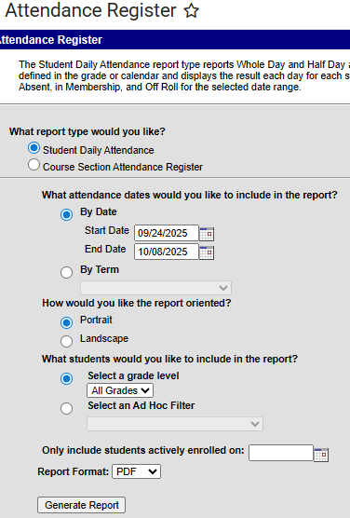

1. Click **Generate Report.**

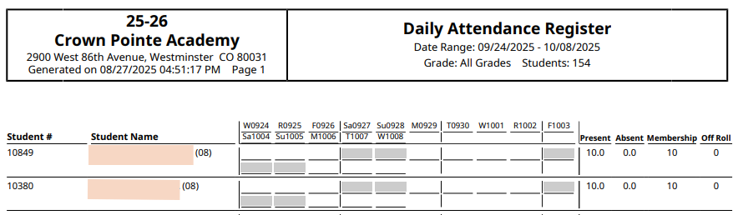

1. Schools should **always** review the resulting report to ensure accuracy and save it as a PDF (best option available for now) using the following naming convention: “*SchoolCode*_*School_*AttendanceOctCt_*CurrentDate*”.

Example: 2035_CPA_**Attendance**OctCt_10162025

### Infinite Campus Report 2: Enrollment Entry/Exit

*This should pull all students who entered this school year and exited prior to the end of the week following the count date. The results would change depending on the date entries used in the Add and Drop Date fields.*

*This report can be very useful for double checking your enrollment data. It is sometimes needed for audit purposes in some special student scenarios and programs.*

*In* ***Campus Community****, the Help document for this report is under Student Information/Student Information Reports/Enrollment Status Report.*

1. On the Main Menu IC screen go to **Student Information/Reports/Enrollment Status Report.**

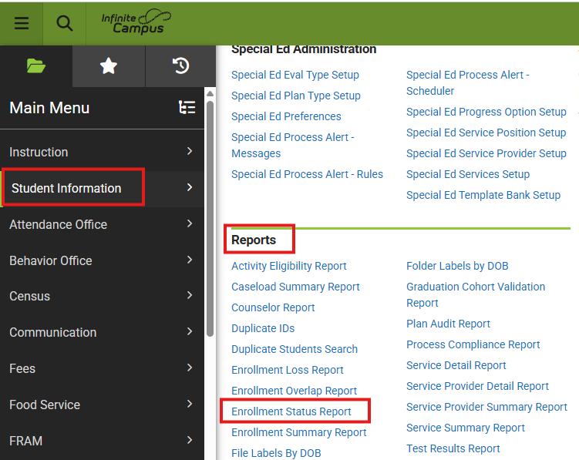

1. Choose **All Students** for grades to include in the report.
2. Choose **Active Year** for the calendar and pick the schooll calendar you wish to include (usually only needed if there are are multiple calendars listed).
3. For **Enrollment Add Date**, include July 1st through the Count Day (ex: 7/1/2025-10/1/2025).

* *If your school is approved for an alternative count day, then use that date.*

1. For **Enrollment Drop Date**, include July 1 through the day after the count date (ex: 7/1/2025-10/2/2025).

* *Out of district and out of state transfers are no longer allowed for funding, so using the day after count day should usually suffice.*

1. For **Display Options**, make sure both Start Date and End Date are checked.
2. Alpha is the preferred **sorting method** to select.
3. State Start/End Status is the default selection for **Enrollment Status** and should be used. Unless you are extracting a specific set of student scenarios, then ou can leave the selection on the “All” value for both the Start and End sections.
4. To extract a format that can be sorted easily, pick the CSV option in the **Report Format** box. If you are running this report for one or only a few students, then it is recommended to pick the PDF format.
5. Click **Generate Report.**

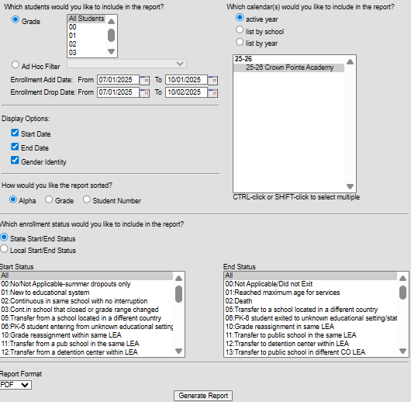

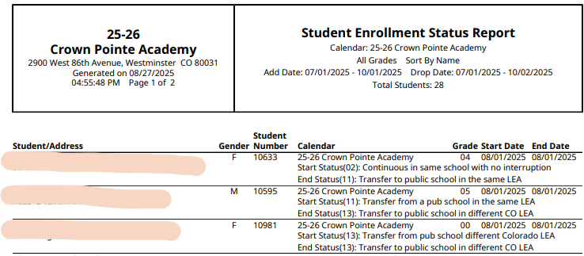

1. Schools should **always** review the entry report and exit report before submitting to CSI to ensure accuracy and save them using the following naming convention: “*SchoolCode_School*_EnrollmentOctCt_*CurrentDate*”

Example: 2035_CPA_**Enrollment**OctCt_10162025

Infinite Campus Report 3: Student Schedules(Typically, grades 6-12 where students move between classes and have passing periods)

**\*\*This report needs to be run by applicable schools on Count Day and uploaded to G-Drive by the end of the day**.**

*In* ***Campus Community****, the Help document for this report is under Scheduling & Courses/Scheduling & Courses Report/Schedule Batch Report.*

1. First select the applicable school calendar and terms you wish to extract schedules for. Only the **first semester** needs to be included for the schedule reports that need to be submitted to CSI.

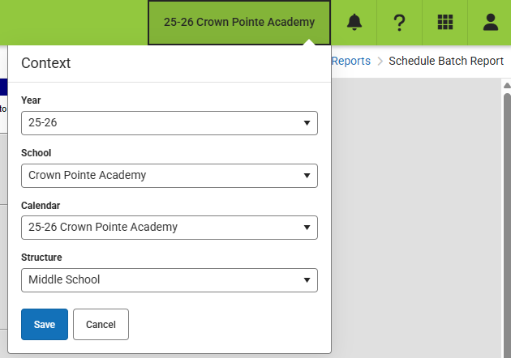

1. On the Main Menu IC screen go to **Scheduling & Courses/Reports/Schedule Batch Report.**

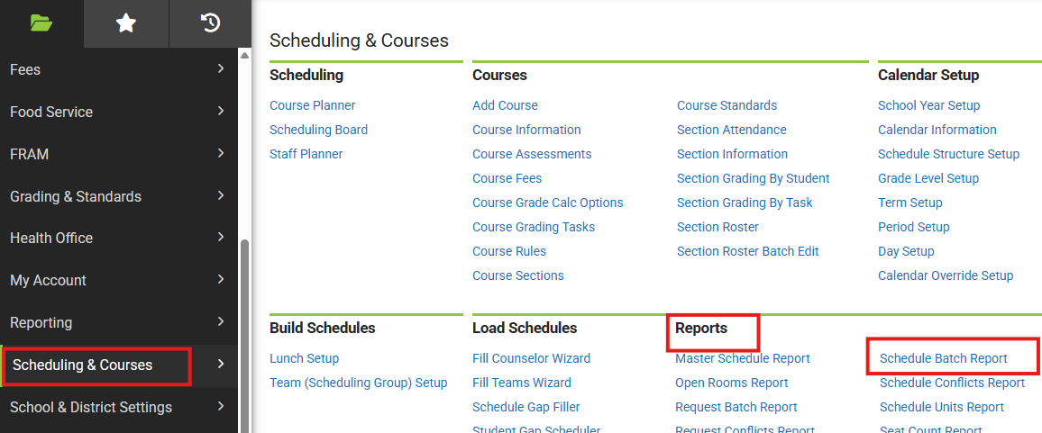

1. When the report opens pick the **Display Options**.in the first section.

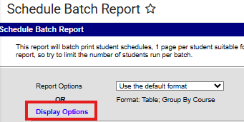

1. Leave the **Report Format, Group by**, and **Courses** selections as the default selections.
2. Leave **Term Options** for the first semester along with all instructional **Periods** that students could be taking courses in.
3. Under the **Mailing Label Options** select “No Mailing Label (Prints one copy per Student)”.
   * *This will prevent duplicate schedules from being included in the report based on multiple addresses a student has on record.*

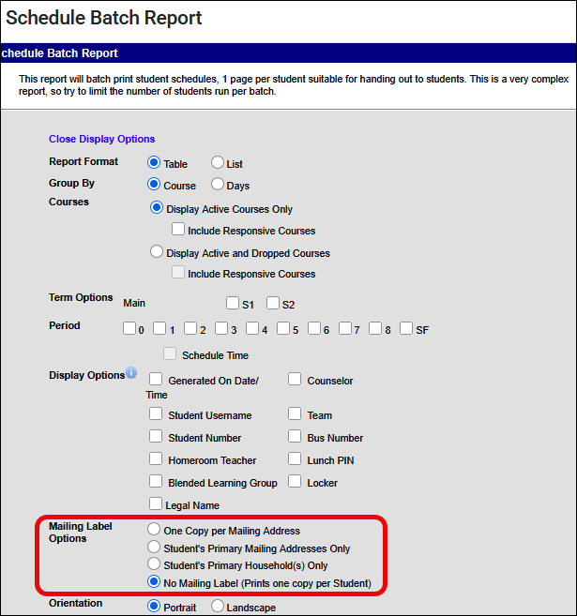

1. Leave **Orientation** as Portrait.
2. For **Grade**, choose All Students.
   * *You may also choose to create separate reports by grade, which is fine to submit to CSI.*
3. The **Enrollment Effective Date** defaults to the current date. Leave this as is when extracting on the count date so that the data extracts student schedule information as of the count date according to the required documentation proof by CDE.
4. *Choose Grade/Alpha for the* ***sorting option****.*
5. For **Report Format**, pick PDF (the best option at this time).
6. Click **Generate Report.**

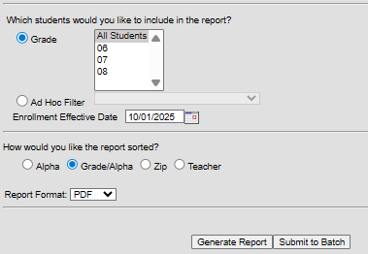

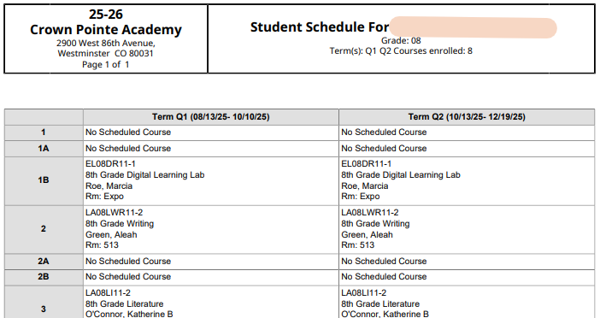

1. Schools should **always** review the student schedules export report to ensure accuracy and save it using the following naming convention:

“*SchoolCode_School*_StudentSchedulesOctCt_*CurrentDate”*

Example: 2035_CPA_**StudentSchedules**OctCt_10012025

## PowerSchool Report Extracts

The following instructions illustrate how to extract Attendance, Enrollment, and Student Schedule reports from PowerSchool.

Even though some screenshots may not illustrate the current school year, they should still be applicable in a general sense and won’t be updated until they change significantly with the vendor. However, be sure to use the dates described in the steps rather than those in the screenshot if it is from a different year.

**REVIEW YOUR REPORTS FOR ACCURACY BEFORE SUBMITTING TO CSI!**

### PowerSchool Prep Step: Create Reporting Segment

To create a report using the “**attendance documentation date range**” (new in 25-26; see Timeline section above), you must first create a Reporting Segment. These are predefined periods, like grading terms or semesters, that let reports reflect data for specific timeframes.

1. In the left hand menu, click on **System Management/Reports/System Reports/Reporting Segments**

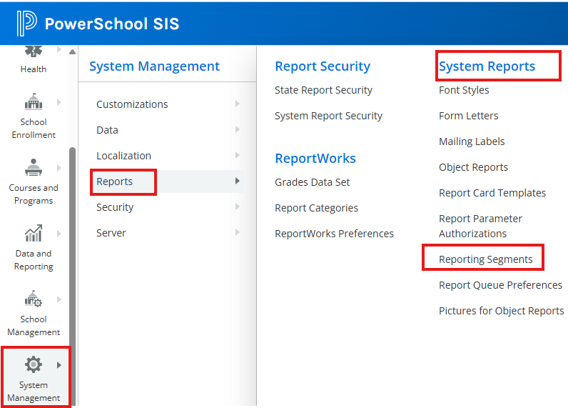

1. In the window that opens, first check to see if there is already a reporting segment built for the current school year. If not, then click the blue **New** button to create one.
2. For **Segment Name**, include a name like “October Count [YEAR]”
3. For **Start Date**, choose the start date of the week (7 days) prior to the count date (09/24/2025 or approved alternative count window date)
4. For **End Date**, choose the end date of the week (7 days) after the count date (10/08/2025 or approved alternative count window date)
5. You can leave the Sort Order as the default value.
6. Click **Submit.**

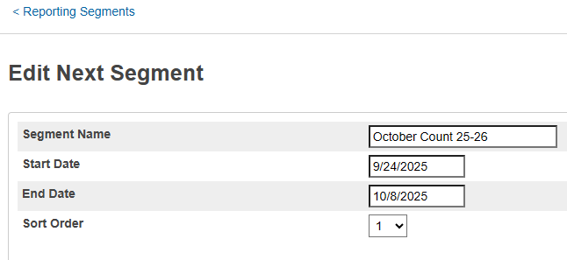

### PowerSchool Report 1: Attendance

***Before running this report, you’ll want to follow these steps to refresh your attendance.***

*In the* [***PowerSchool SIS Colorado***](https://ps-compliance.powerschool-docs.com/pssis-co/latest/?l=en)*website the Help documentation for refreshing attendance is under State Reporting Setup/Attendance Setup/Refresh Attendance Tracking Data.*

1. Make sure you have selected the school calendar that you wish to refresh attendance for.
2. In the left hand menu, click on **Attendance/Attendance Management/Refresh Premier Attendance View Data**

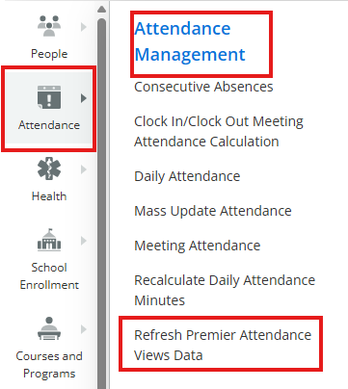

1. The **Refresh Attendance Views Data Report** screen appears.
2. Specify the **Students to include** in the refresh process (typically All students).
3. Specify the date range for which you wish to refresh the attendance views (typically the start of the school year for the **Beginning Date** and the last date you wish to include in any reports for the **Ending Date**—or leave as the default end of school year).
4. **Processing Options**: In Background Now.
5. **Specific Date/Time** can be left blank.
6. Leave **Data to filled** as the default Reset All and **Report Output Locale** as the default.
7. Click **Submit** (lower right). The report will begin to process in the report queue.

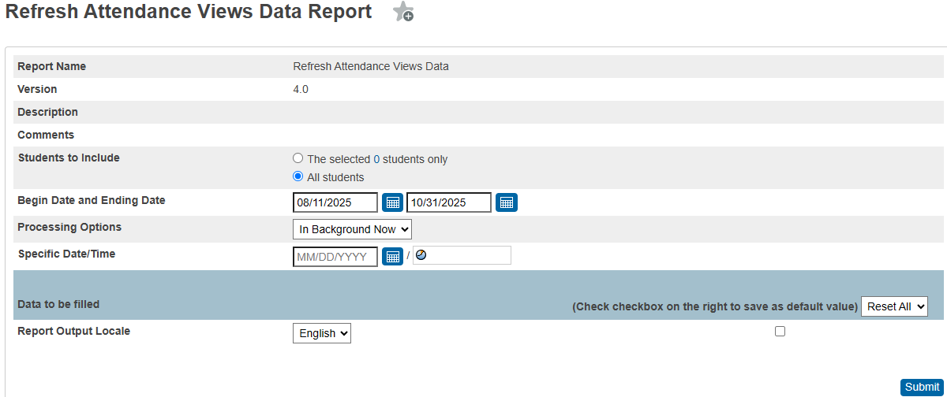

1. When the report is complete, click the View link to review the status of the refresh process. Move to the next section on generating an attendance report if the refresh process has completed.

***After you have refreshed your attendance, follow these steps to generate the attendance report.***

*In the* [***PowerSchool SIS Administrator***](https://ps.powerschool-docs.com/pssis-admin/latest/?l=en)*website the Help documentation for refreshing attendance is under* [*Data and Reporting*](https://ps.powerschool-docs.com/pssis-admin/latest/data-and-reporting)*/*[*Reports*](https://ps.powerschool-docs.com/pssis-admin/latest/reports)*/*[*System Reports*](https://ps.powerschool-docs.com/pssis-admin/latest/system-reports)*/*[*Attendance Reports*](https://ps.powerschool-docs.com/pssis-admin/latest/attendance-reports)*/Monthly Student Attendance Report..*

1. Make sure you have selected the school calendar that you wish to extract attendance for.
2. In the left hand menu, click on **Data and Reporting/Reports/System Reports.** 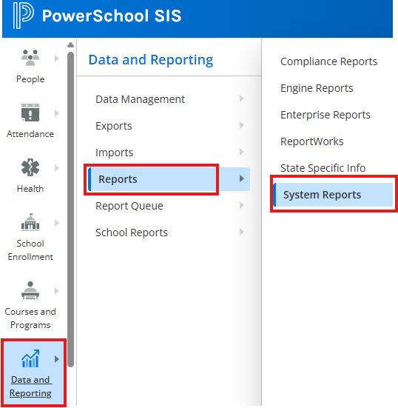
3. Click on **Monthly Student Attendance Report.**

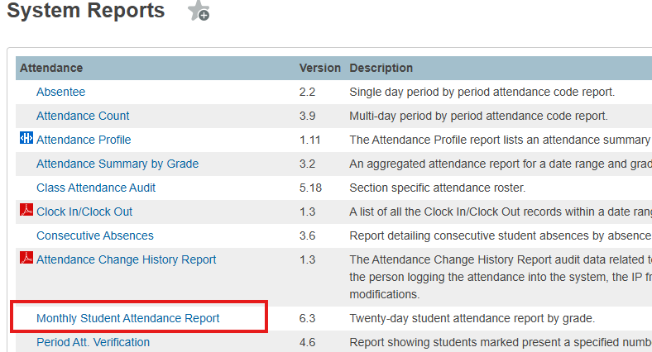

1. Select appropriate **Attendance Mode** and **Conversion** (typically, “Meeting” and “Period to Day”).
   * *Not all schools will use "Attendance Mode: Meeting" and "Attendance Conversion: Meeting to Day". Settings depend on how a school has set up Attendance.*
2. For **Students to Include**, select “All Students” (Unless you wish to run the report for a specific student or students you have filtered for on the main Start Page screen).
3. Leave **Grades** blank to include all if you wish to run a full grades report.
4. For **Reporting Segment,** select the date range from the dropdown that reflects the dates you used to set up your reporting segment earlier. If you do not yet have a reporting segment built, then you may instead enter the dates into the **Begin Date and Ending Date** option.
5. You may leave the **Processing Options** as In Background Now, **Specific Date/Time** blank, and Data to be filled as the default.
6. **Include Student Number** and **Include Partial Attendance** are optional.
7. For **The report will break to a new page for each:** choose “Reporting Segment” so that the attendance will not break by month across pages. This makes it much easier when reviewing the full window of dates for each student.
8. Click **Submit.**

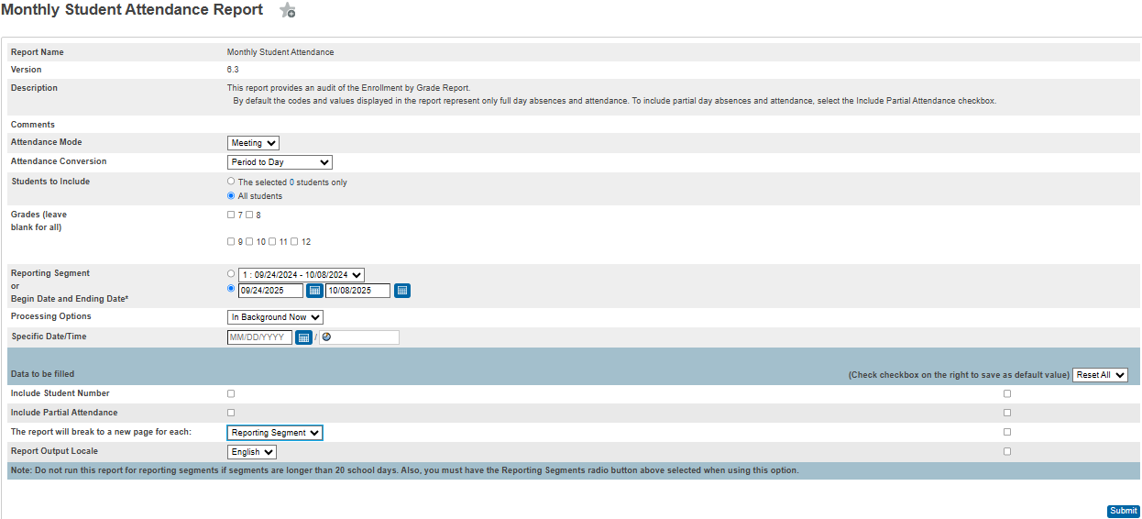

1. The screenshot below illustrates a correctly formatted PowerSchool attendance report from a prior year (the school and student identifiers have been masked (actual attendance codes may vary by school).

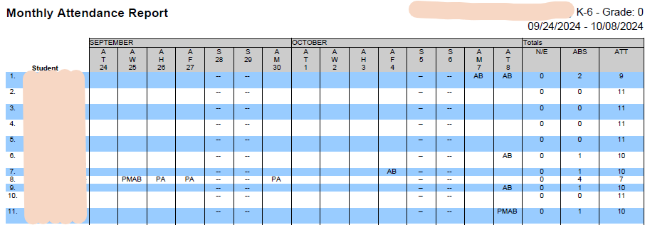

1. Schools should **always** review this report to ensure accuracy and save it as a PDF using the following naming convention: “*SchoolCode_School*_AttendanceOctCt_*CurrentDate*”

Example: 0075_AHS_AttendanceOctCt_10162025

*To create a separate extended attendance report for students absent on Count Day (10/1/2025 or your approved alternative count day), use 7/1/2025-10/31/2025.*

### PowerSchool Reports 2: Enrollment Entry / Exit

*This report can be very useful for double checking your enrollment data. It is only needed for audit purposes in some special student scenarios and programs.*

1. Select the school calendar that you wish to extract data for.
2. On the Start Page of PowerSchool, add the following into the Search bar:

/EntryDate>=7/1/2025;EntryDate<=10/8/2025

* *With the last entry date being a week (7 days) after the count date (official or approved alternative one).*

1. Click the search (magnifying glass icon).

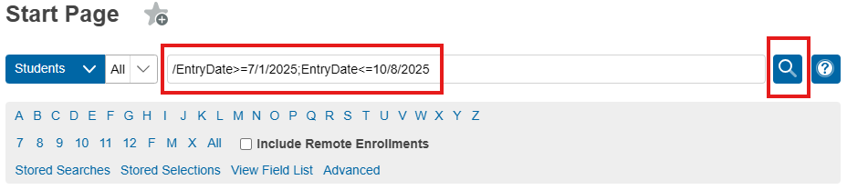

1. Click on the down arrow next to the **Select Action** button (bottom right at the end of the student list).
2. Select **Quick Student Export.**

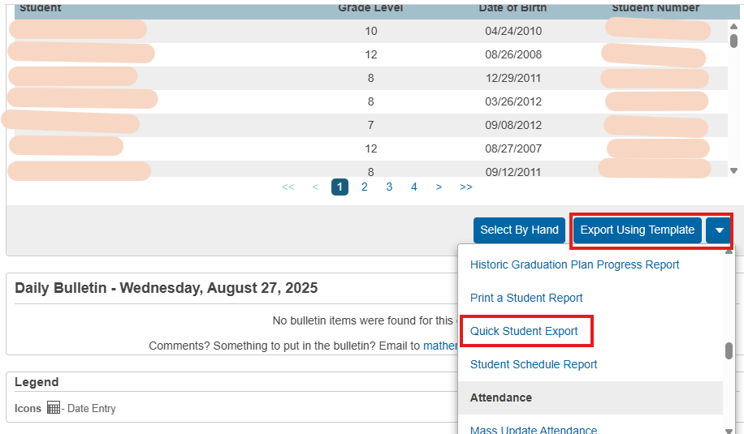

1. Type the following in the **Quick Student Export** screen

LastFirst

State_StudentNumber

grade_level

EntryCode

EntryDate

ExitCode

ExitDate

Enroll_status

1. Leave the other criteria options as the default values.
2. Click **Submit.**
3. You will be prompted to download a simple text file of the data results. Schools should **always** review the report to ensure accuracy.

Notes on Enroll Status Codes:

0 is active

-1 is PRE REGISTERED

2 is transferred out

1. Save this file using the following naming convention: “*SchoolCode_School*_EnrollmentOctCt_*CurrentDate*”

Example: 0075_AHS_**Enrollment**OctCt_10162025

PowerSchool Report 3: Student Schedules(Typically, grades 6-12, where students move between classes and have passing periods).

**\*\*This report needs to be run on Count Day and submitted to G-Drive by the end of the day**.**

1. Select the school calendar and terms that you wish to extract schedule data for. Only the **first semester** needs to be included for the schedule reports that need to be submitted to CSI. If your calendars are set up on quarters, then be sure to include Q1 and Q2.
2. To get a list of active students on Count Day, type the following in the search box on the Start Page:

**\*As_of=MM/DD/YYYY**

with MM/DD/YYYY being the count date (official or the approved alternative date).

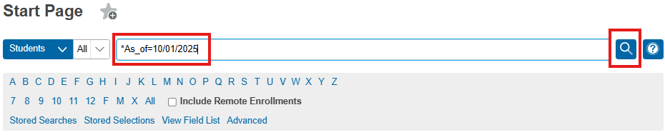

1. Click on the down arrow next to the **Select Action** button (bottom right at the end of the student list) and select **Export Using Template.** 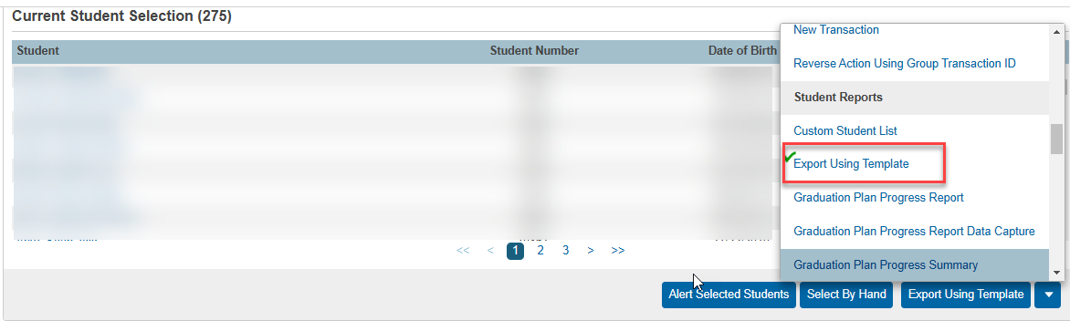
2. For **Type of Export**, choose “Student Schedules”.

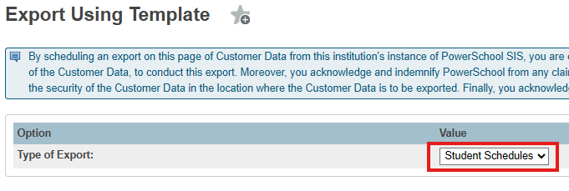

1. For **Export Template?,** choose “Oct 1 count” (this name could vary depending on how your template was created or imported).
   * **If your school is not showing an export template to pick from in your PowerSchool to extract schedules** (typically this is only schools new to **CSI**), then you will need to import a copy of the version that CSI has available.
     + Reach out to CSI at [submissions_csi@csi.state.co.us](mailto:submissions_csi@csi.state.co.us) to obtain a copy of the export template that you will then import to your PowerSchool.
     + If your school has a dedicated SIS management staff person that is not yourself, then you should check with them on managing the template import.
       - * Once CSI has shared the export template file with you, in PowerSchool navigate to Data and Reporting/Imports/Import Existing Report Template

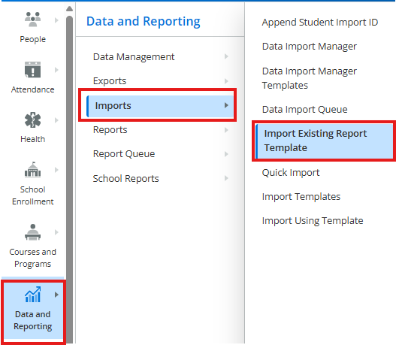

* + - * + On the window that pops up navigate to the file and import it. Once imported, then repeat the steps above to begin exporting your student schedule file.

1. For **Which Records?**, choose “Only schedules for the XXXX selected students”.
2. Click **Submit.**

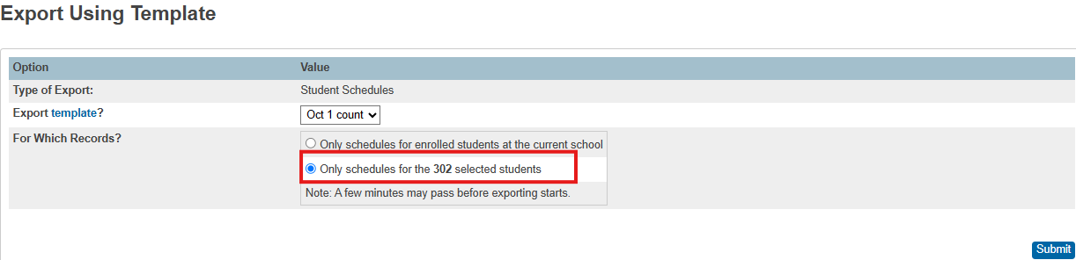

1. This will export a tab delimited text file of student schedule data (screenshot below) including student names, SASID, period, term, and course information.
   * You can import the text file to Excel to conduct an in depth review.
   * When considering instructional time to determine funding level, be sure to omit course records that are not allowed as they can sometimes be included in the export.
   * If you’ve included both semsters for Terms, then you should use only first semester records to determine funding level.

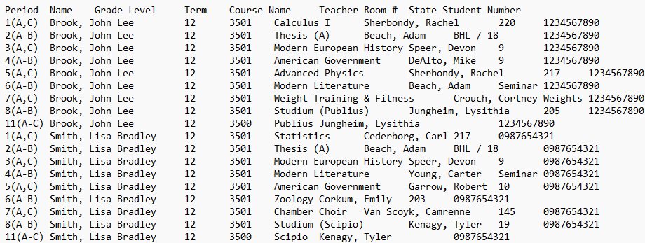

1. Schools should **always** review the student schedules export to ensure accuracy, then save it using the following naming convention: “*SchoolCode_School*_StudentSchedulesOctCt_*CurrentDate*”

Example: 0075_AHS_**StudentSchedules**OctCt_10012025

# Appendix II: Crosschecking Funding Eligibility with Student Schedules

**Schools should refer to the** [2025 CDE Student October Count Audit Resource Guide](https://www.cde.state.co.us/cdefinance/auditunit_pupilcount) **to** **accurately conduct calendar and bell schedule calculations in order to then evaluate each student schedule to ensure that each student is submitted with the appropriate funding level.**

By default, both Infinite Campus and PowerSchool have students identified as eligible for full-time funding. It is the school’s responsibility to adjust the funding code for each student based on eligibility criteria (enrollment, attendance, scheduled hours, etc.). The following instructions provide one way to use your SIS to find students who meet (or do not meet) schedule hour criteria to be eligible for part- or full-time funding.

The school is responsible for reviewing the students who don’t have the necessary number of courses to qualify for full time funding and either:

1. update the schedule so that on/before Count Day, the student has the required number of courses

**OR**

1. adjust the student’s funding status so that on/before Count Day, the funding status is accurate.

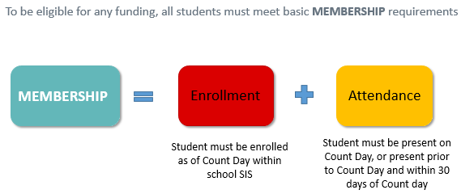

See the CSI webpage on [School Calendar and Instructional Hours](https://resources.csi.state.co.us/calendar-and-instructional-hours/) for resources on instructional hours and scheduling requirements for accreditation.

### Infinite Campus Instructions

Keep in mind that the following instructions work well for mainly simple bell schedules. If a school is using complicated block schedules such as where courses vary by day of the week or if students are enrolled in post-secondary types of courses where credits are used instead of seat time, then this check becomes much less useful.

**Student Gap Scheduler**

The Student Gap Scheduler tool is used to find students with holes in their schedule. This tool may be used to generate a report to show students with a hole in their schedule for staff to identify students who may not qualify for full time funding based on scheduled hours alone.

*In Campus Community, the Help document for this report is under Scheduling & Courses/Load Schedules/Student Gap Scheduler*

1. On the main IC screens, select the correct school calendar you wish to view this tool for.
2. Go to Scheduling & Courses/Load Schedules/Student Gap Scheduler.

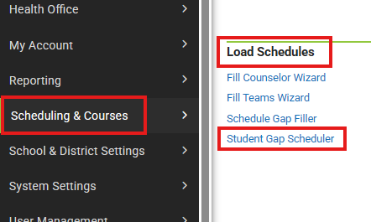

1. Select the students whose schedules you wish to analyze (by grade or Ad Hoc filter)
2. Select the enrollment effective date.

* Be sure the Enrollment Effective Date is a date within the school calendar selected; otherwise no results will be returned.
* Schools should run this report BEFORE Count Day to ensure students have accurate schedules.
* Schools should again run this report ON Count Day to ensure that students have the appropriate funding status claimed based on the Count Day schedule.

1. **Which report type would you like?** - The summary mode will list the empty periods each student has. The detail mode will print a mini schedule for the student, with an “X” indicating a scheduled course and gray shading indicating an empty period. *(Note: Detail report tends to be easier to skim to identify students with significant schedule gaps.)*

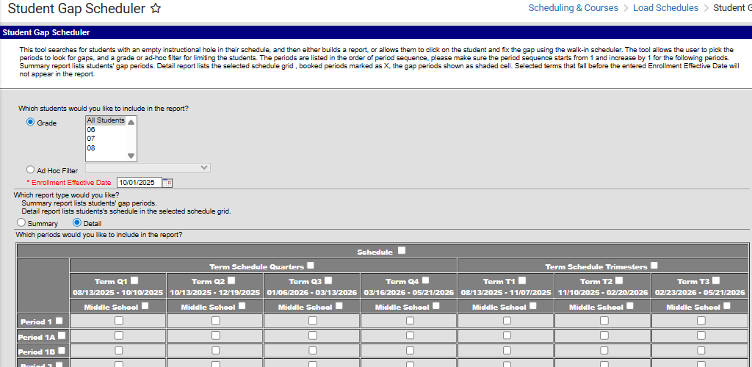

1. Select the terms/periods for analysis using the checkbox grid at the bottom.
   * Selecting the Schedule checkbox at the top of the grid will automatically check all term/period boxes.
   * Selecting (or deselecting) a term will check all boxes in that term.
   * Selecting (or deselecting) a period will check all boxes for that period.
   * *Note: Schools should select as many terms as needed in order to have half of the school year’s school days included. Ex: In a school with a semester schedule, checking first semester should suffice. In a school with a trimester schedule, check both first and second semester should suffice.*
2. Selecting Find Students will run a search and show students with a hole in their schedule in the search results. Generate report will create a PDF report that may be printed or saved as needed.
3. *Note: Schools can use the Generate Report option to print the mini schedules for students. Schools should then go through the report, identify any students with significant gaps (grey blocks) in the schedule.*

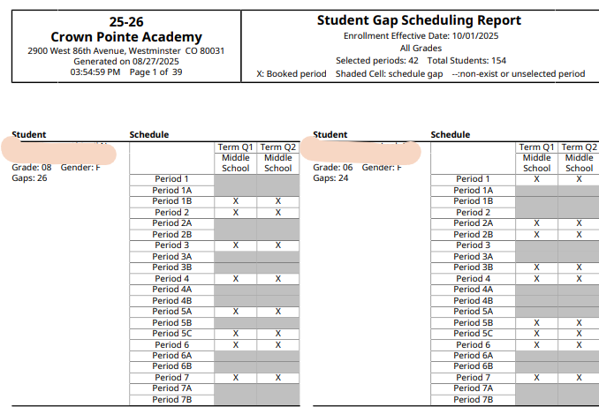

### PowerSchool Instructions

Keep in mind that the following instructions work well for mainly simple bell schedules. If a school is using complicated block schedules such as where courses vary by day of the week or if students are enrolled in post-secondary types of courses where credits are used instead of seat time, then this check becomes much less useful.

In the Search bar, type in ***\*number_of_classes<#***with # being the number of classes needed to qualify for full time funding. Then press ‘Enter” or click the magnifying glass icon to search.

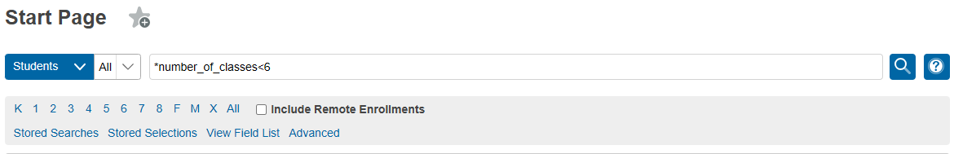

This search will result in a listing of any students with fewer than the number of classes necessary to qualify for full-time funding at this school based on scheduled hours alone.

# Appendix III: Free and Reduced Lunch Eligibility Checklist

Resources for determining FRL eligibility status as well as guidance on how to enter data into PowerSchool and Infinite Campus are available on the CSI [Free and Reduced Lunch Eligibility](https://resources.csi.state.co.us/free-and-reduced-lunch-eligibility/) webpage.

All schools are required to **have adequate documentation** that supports the free and reduced lunch eligibility for every student according to the **current** [CDE At-Risk Count Audit Resource Guide](https://www.cde.state.co.us/cdefinance/auditunit_atrisk_freeandreduced). Schools are responsible for updating their student information system (SIS) to include free and reduced lunch eligibility regularly throughout the year, and particularly before required state reporting deadlines (primarily the October Count, End of Year, and S-EBT collections).

Please know that it is the “eligibility” that must be recorded. It is not whether the student is actually receiving free or reduced meals.

If FRL eligibility status is not being maintained in the SIS (this would be unusual and not recommended), schools or the SFA should communicate with CSI about providing the updated FRL status before required state reporting deadlines for collections.

**Once the October Count data is finalized, it cannot be changed, so it is critical that your data is reported correctly. FRL status is used in accountability reports and also in determining At-Risk funding. It is the responsibility of each school to ensure that the data is correct in your October Count file submissions so that you don’t experience negative performance report outcomes, cuts to At-Risk funding from underreporting your FRL data, or audit exceptions during At-Risk state audits for students inaccurately reported as free or reduced lunch eligible.**

**Determining FRL eligibility:**

* For schools not participating with an SFA, you will need to have families fill out the state FEDS form to determine FRL eligibility status for each of your students for the current school year. Current year forms, instructions to provide to families, and the eligibility guidance have all been posted to the CSI [Free and Reduced Lunch Eligibility](https://resources.csi.state.co.us/free-and-reduced-lunch-eligibility/) webpage.
* For schools using an SFA this year, please be sure to encourage families to complete the federal meal plan application using the SFA nutrition system and work with the SFA on eligibility determinations in your SIS for all students. This includes schools using the CSI SFA.

**All schools are strongly encouraged to complete the following FRL checklist as part of the October Count collection and internal audit. Check off the following items as you complete them. A signature form is not included with this FRL checklist for the current year.**

**School is participating with an SFA:**

**The Healthy Meals for All program, which began in 23-24 allows public School Food Authorities (SFAs) participating in the National School Lunch and Breakfast programs to provide free meals to all students. For accountability purposes plus At-Risk, Summer Electronic Benefit Transfer (S-EBT) funding, and Title I funding, CSI schools still need to ensure they are collecting FRL eligibilities and storing that data in their SIS in order to extract the data for state collections during the year.**

Completed the current year CSI Organizational Submissions, **Additional Programs Survey** (section on food services) in Epicenter by the August deadline (*lets CSI know whether your school is participating with an SFA or not for the current year and which SFA*).

Current year **federal** meal benefit application instructions have been provided to all families.

* Very Important- these should not be completed and signed prior to July 1 or they are invalid!
* For the October Count collection, the forms must be signed between July 1 and count day (October 1st for 25-26).
* Continue to encourage families to complete the meal application on the SFA website. Work with your SFA on the exact process.

If getting families to complete the online federal meal benefit applications on there own is problematic, consider other methods (back to school event, before/after school, orientation event, zoom meeting, conference call, etc.).

Consider sending direct communications rather than general announcements to families encouraging them to complete the federal meal benefit application form.

An MOU, privacy statements, and all processing steps for file exchanges have been finalized with the SFA that your school is contracting with (your school is ready to begin exchanging data with the SFA).

All completed federal meal benefit application forms have been provided to the SFA (if on paper). Consider having a tracking sheet to ensure that all families have completed a form (both electronic and paper). Double check that paper forms if any are complete, accurate, and signed & dated before submitting to your SFA.

In the absence of current year FRL eligibility documentation (typically only for last minute enrollees before count date), you may **utilize carryover documentation** evidencing free lunch eligibility through the current year count day.

* You may use the carryover only if you do not have anything new for the current year eligibility status. In other words, you cannot use a free or reduced lunch status from the carryover just because there is a new status for the current year and the student is now not eligible.
* In cases where students transfer between districts on or before the count date, the USDA does allow for the transfer of lunch eligibility status from one district to another. In such cases, if the receiving school is able to include the student in the October Count the school can report the student’s lunch eligibility status from the prior district if it has documentation as to the student’s eligibility from the prior district. In the absence of such documentation, the receiving school must obtain new or updated documentation evidencing the student’s lunch eligibility.

All student records have an updated FRL eligibility status as of the October Count date in the school SIS.

**In 23-24, an additional FRL field named “FRL Eligibility Identification” was added to the Student Demographic file layout. This field is required for all students and must be populated in the school SIS with the applicable type of documentation the school used to identify the student as free lunch eligible.**

Student records have been updated to free lunch eligible where a CSI approved/signed McKinney-Vento form has been returned to the school (student is considered homeless). MKV form must have been signed by CSI by count day to report the student as homeless and free lunch eligible in the October Count collection.

Student records have been updated to free lunch eligible where a student shows up on the CDE **migrant** list. Schools should receive an error message in the October Count file submission if migrant students are not coded as free lunch eligible.

Student records have been updated to free lunch eligible where CSI has notified our school on a **foster** student. Schools should receive an error message in the October Count file submission if foster students are not coded as free lunch eligible.

Student records have been updated to free lunch eligible where **extended eligibility** to other students residing in the same household is allowable by direct certifications (SNAP/TANF or Medicaid). This is not allowable in the case of migrant or foster scenarios.

Schools must create a document noting the name of the school staff member who flagged the student, the date it was done, and retain that document in case the student is part of an At-Risk audit sample. See the **current** [CDE At-Risk Count Audit Resource Guide](https://www.cde.state.co.us/cdefinance/auditunit_atrisk_freeandreduced) for more detail on acceptable forms of documentation.

The SD file extract from your SIS has been reviewed to ensure that FRL statuses appear correct for all students prior to submission to CSI.

The FRL Counts within the October Count summary report (including trend data) have been thoroughly reviewed prior to the certification deadline (please do this as soon as you receive the summary report to allow plenty of time to correct data if needed).

**School is not participating with an SFA:**

Current year state FEDS forms and instructions have been provided to all families.

* For the October Count collection, the forms must be signed between July 1 and count day (October 1st for 25-26).
* Forms completed and signed prior to July 1 are invalid!
* Continue to provide FEDS forms to all new students as they enroll.

If it is difficult to get families to complete the FEDS forms, consider scheduling opportunities for families to complete the form at the school (back to school event, before/after school, orientation event, Zoom meeting, conference call, etc.).

Consider sending direct communications rather than general announcements to families encouraging them to complete the state FEDS form.

All state FEDS forms have been collected from families and processed to determine the FRL eligibility status for each student. Consider a tracking system to ensure all forms have been returned. Double check that the forms are complete, accurate, and signed & dated between July 1 and count day of the current school year.

In the absence of current year FRL eligibility documentation (typically only for last minute enrollees before count date), you may **utilize carryover documentation** evidencing free lunch eligibility through the current year count day.

* You may use the carryover only if you do not have anything new for the current year eligibility status. You cannot use a free or reduced lunch status from the carryover just because there is a new status for the current year and the student is now not eligible.
* In cases where students transfer between districts on or before the count date, the USDA does allow for the transfer of lunch eligibility status from one district to another. In such cases, if the receiving school is able to include the student in the October Count the school can report the student’s lunch eligibly status from the prior district if it has documentation as to the student’s eligibility from the prior district. In the absence of such documentation, the receiving school must obtain new or updated documentation evidencing the student’s lunch eligibility.

All student records have an updated FRL eligibility status as of the October Count date in the school SIS.

**In 23-24, an additional FRL field named “FRL Eligibility Identification” was added to the Student Demographic file layout. This field is required for all students and must be populated in the school SIS with the applicable type of documentation the school used to identify the student as free lunch eligible.**

Student records have been updated to free lunch eligible where a CSI approved/signed McKinney-Vento form has been returned to the school (student is considered homeless). MKV form must have been signed by CSI by count day to report the student as homeless and free lunch eligible in the October Count collection.

Student records have been updated to free lunch eligible where a student shows up on the CDE **migrant** list. Schools should receive an error message in the October Count file submission if migrant students are not coded as free lunch eligible.

Student records have been updated to free lunch eligible where CSI has notified our school on a **foster** student. Schools should receive an error message in the October Count file submission if foster students are not coded as free lunch eligible.

Student records have been updated to free lunch eligible where **extended eligibility** to other students residing in the same household is allowable by direct certifications (SNAP/TANF and Medicaid). This is not allowable in the case of migrant or foster scenarios.

Schools must create a document noting the name of the school staff member who flagged the student, the date it was done, and retain that document in case the student is part of an At-Risk audit sample. See the **current** [CDE At-Risk Count Audit Resource Guide](https://www.cde.state.co.us/cdefinance/auditunit_atrisk_freeandreduced) for more detail on acceptable forms of documentation.

The SD file extract from your SIS has been reviewed to ensure that FRL statuses appear correct for all students prior to submission to CSI.

The FRL Counts within the October Count summary report (including trend data) have been thoroughly reviewed prior to the certification deadline (please do this as soon as you receive the report to allow plenty of time to correct data if needed).

# Appendix IV: Audit Documentation Checklist

For 25-26, there will once again be an audit supporting documentation checklist that all schools will be required to complete and submit to CSI by **November 6, 2025**. The checklist will include a certification signature form.

Schools should download a copy of the checklist from the CSI [Audits webpage](https://resources.csi.state.co.us/data-submissions/audits/) where the link will be posted within the October Count Audit section under the CSI Resources header.