

25-26 Human Resources Data Collection Prep

# Overview of Collection

The goal of the Human Resources Collection is to track staff working at your school as of December 1st of the current collection year. This includes Special Education staff although the details of these staff are included in the December Count collection snapshot. Below list details on the staff this information is being collected on and where this information is being used:

* All General Education Staff information
  + Including Special Education staff (*pulled into December Count snapshot*)
* Contractors are included in this collection
* Official staff count date: December 1st, 2025
* Collected information is used for:
  + school staff demographics
  + average salaries by position and education level
  + highly qualified status for teachers and paraprofessionals
  + turnover rates
  + educator effectiveness ratings

# Educator Identifiers (EDIDs)

Each staff member employed at a public school in Colorado is required to have a unique identification number. This number is known as an EDID. The EDID follows the staff member throughout his or her public-school career and is required for several state data collections. It is the school’s responsibility to ensure each staff member employed at the school –including contractors --receives an EDID.

EDIDs can be requested at any point during the school year with updates to educator information possible at any time (i.e. Name, Date of Birth, Gender). CDE experiences a high volume of EDID requests particularly during the peak submission time for the Human Resource and December Count data collections, which can result in longer wait times causing delays in error clearance processing for CSI schools. Therefore, it is strongly encouraged that schools begin the EDID attainment process as soon as practicable following a staff hire (for an EDID request) or following a change in an educator’s identifying information (for an EDID update) to ensure that all staff members have EDIDs and accurate information tied to staff members prior to state reporting.

## Process Overview

1) New staff are hired and need an EDID – or – existing staff need updates to the information associated to their EDID. Updates can be made throughout the year. Be sure the staff person is searched for in EDIS to see if they have an existing EDID prior to continuing this process.

2) Schools provide staff member information in the EDID Template to CSI via a secure file transfer system (Google Drive); they send a notification email to Submissions_CSI@csi.state.co.us.

3) CSI verifies formatting in the template and uploads the staff information to CDE via the EDIS system.

4) CSI reports the results back to the school letting them know a results report is available in G-Drive OR CSI notifies school that they can look up newly assigned EDIDs in EDIS.

For more detailed instructions on the EDID process, see the **EDID Attainment and Update Guid**e on the CSI website. All resources can be found on the [CSI EDIDs page.](https://resources.csi.state.co.us/data-submissions/edids/)

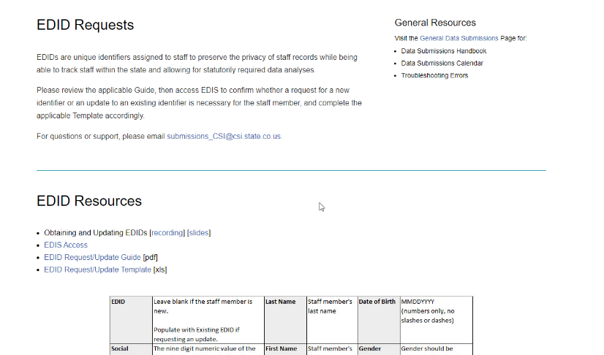

# Collection Specific Training

CSI provides all schools with collection-specific pre-recorded trainings designed to assist schools through the data submissions process. The Human Resources collection is no different and contains both a **New This Year** and General Overview training located on the [CSI HR Collection page](https://resources.csi.state.co.us/data-submissions/hr/).

* The **New This Year** training is intended for more experienced submissions staff and includes any updates or changes that have occurred for the current collection year.
* The **General Overview** training is designed for newer staff or staff who need a refresher and covers the 5 steps of the submissions process as it relates to HR. It also includes links to various resources that will be helpful as you work through the collection.

Some collections also contain other helpful trainings that are more specific to a process or resource. CSI has historically had a Data Collection Prep training for HR but this document is intended to replace that.

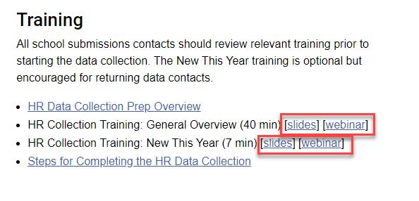

# Collection Specific Resources

In addition to the trainings, CSI provides several collection specific resources located on the [CSI HR Collection page](https://resources.csi.state.co.us/data-submissions/hr/) designed to assist with the initial submittal and error clearance processes along with ensuring the accuracy of the data that is being submitted. See below for some of the highlights of the resources that are provided:

* **Staff Profile** and **Staff Assignment** File Layout and Definition Documents – Provides a listing of all fields within each file along with a definition and the different coding options available
* **Staff Profile** and **Staff Assignment Templates** – Blank templates that schools new to CSI can use to begin adding their staff information. This is designed only for new schools that don’t receive Starting Point files
* The **HR Record Checker** – A tool that allows schools to paste in raw data and will highlight any potential errors. Can be used prior to initial submittal to clear as many initial errors as possible, leading to less submittals to error clearance
* The **HR Data Validations Strategies Checklist** – Provides a checklist to go through prior to initial submittal that checks for common issues and the overall accuracy of data.
* The **HR New Hire** and **IDEA Instructor forms** allow schools the opportunity to collect the appropriate information on staff at the time of hire to ensure they have the data necessary to complete the collection. Other forms or school paperwork can be collected in lieu of either of these forms if all information is obtained by the school.

This is just a few of the many resources available to our schools to help get the process started and ensure data is being entered accurately.

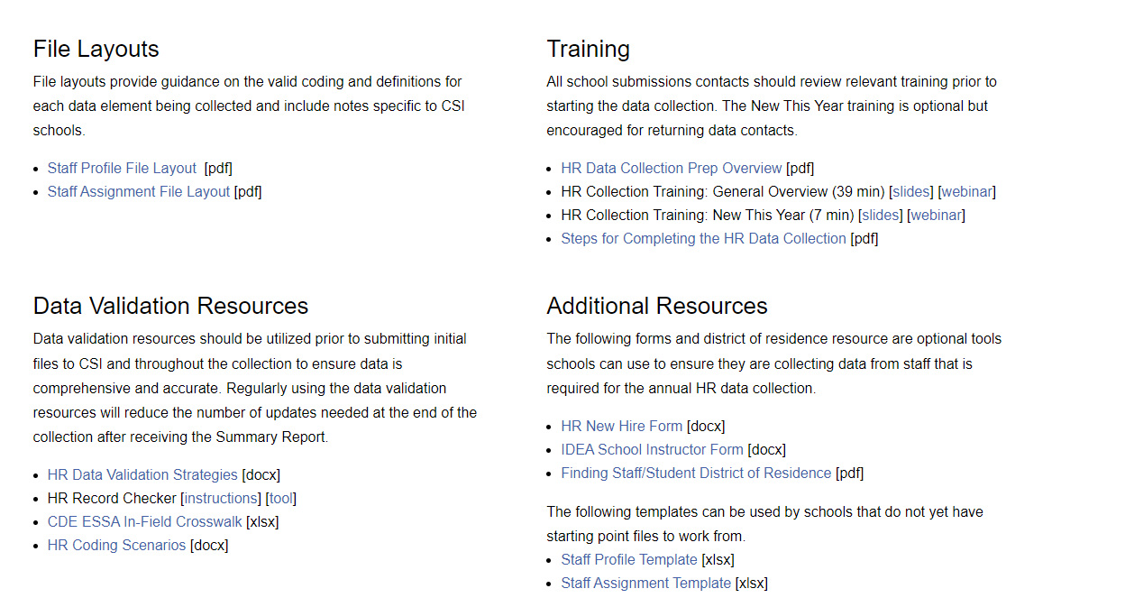

# Collection Prep Steps

This collection differs from several others in that schools should be using either the starting point files provided or the templates. All returning schools to CSI will have starting point files, but new schools will need to download, and manually enter details on the template. In most cases, schools will not be extracting files from their SIS as other collections unless an HR system in place is equipped to do this. More details on both of these processes are below.

# New Schools: Templates

As mentioned, schools new to CSI will need to access the CSI HR Page and download both the **Staff Profile** and **Staff Assignment** templates. These are essentially blank templates that contain the headers for each field. The second row of the templates provide tips and examples of how the data should look and should be deleted once the templates are complete in order for it to successfully process. It is highly recommended that schools used the previously mentioned Staff Profile and Assignment File Layouts to determine the correct formatting and coding of each field. Often files will have leading zeros or implied decimals within a particular field, so knowing the proper coding is essential to accurate data and less errors. Below list the steps that will ensure success:

* Download both the Staff Profile and Assignment Templates and review each field
* Open the File Layout and Definitions Documents for both files
* Enter data in the templates following the direction of the file layouts

## Staff Profile Template

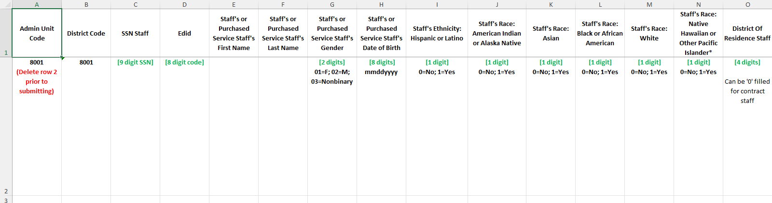

## Staff Assignment Template

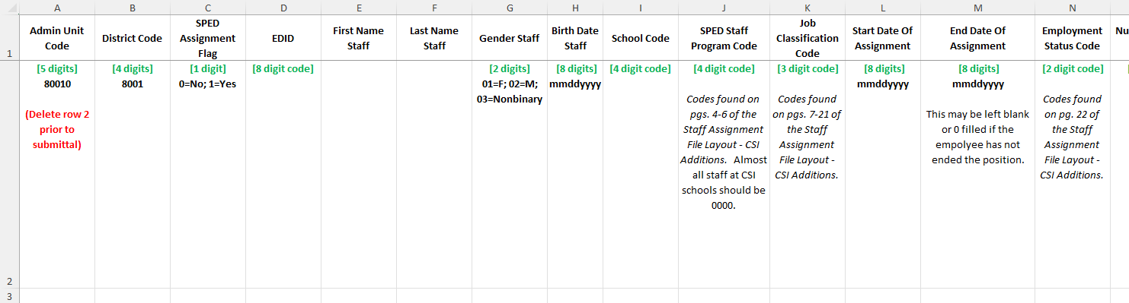

# Existing Schools: Starting Point Files

Schools who have completed the HR Collection previously will receive their Starting Point files to manually update. These files are essentially just your error free files from last year’s HR Collection (no Staff Eval records were added) that will need to be updated to reflect this year’s information. CSI has also made some general edits and updates to flag specific details that may need to change along with some updates to assist with the process. Further details on this will be below.

## Staff Profile Starting Point File

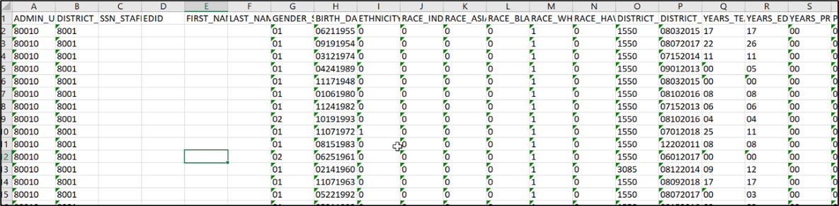

## Staff Assignment Starting Point file

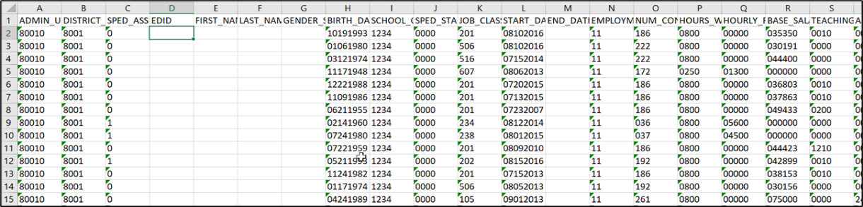

## Updates/Flags to Starting Point Files

**Staff Profile Updates/Flags**

* One year added to non-zero filled Years of Teaching Experience
* One year added to non-zero filled Years of Education Experience
* One year added to non-zero filled Years of Principal Experience

**Staff Assignment Updates/Flags**

* One year added to non-zero filled Years of Principal at School.
* Highlighted all SPED Staff Program Codes not coded as 0000.
* All Demonstrates In-Field Status rows where the Job Classification is not 201-206 are highlighted.

## Starting Point File General Editing Steps

* + Remove rows for staff that won’t be employed at the school in 2025-26.
  + Add rows for staff that are either new to the school or are taking on an additional role.
  + Change key fields (salary, assignments, etc.) for returning staff as appropriate.
  + Populate newly required/clarified fields.
  + Ensure all contract workers are included.
  + Do not update any field CSI has already updated for you.
  + Ensure all Funding Codes match the newly updated coding options. This has been streamlined in 25-26 to include options: 00-03.

# 25-26 Staff Profile and Assignment Changes

**Staff Profile:**

* No updates were completed on this file.

**Staff Assignment:**

* The Grant/Project Funding Source has been removed and replaced by the Funding Source. Include options 01-03 for any staff in the listed job codes: 201, 202, 206, 222, 223, 415, 416, and 419.

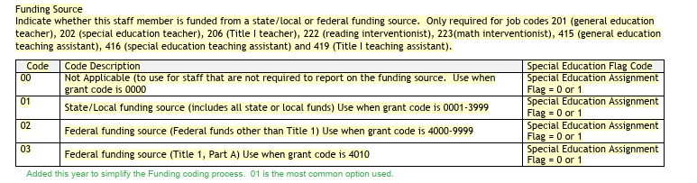

# Collection Tips/Best Practices

* + Begin working over the summer
  + Entering all new staff at time of hire
  + Reviewing file and update assignment or staff changes
  + Set aside time each week to work on this collection
  + Search EDIS System for EDID/request one if necessary