The New School Application is intended for applicants who wish to apply for authorization from the Charter School Institute (CSI) as a new charter school. An application may be submitted by one or more individuals, or by a nonprofit, governmental, or other entity or organization.



New School Application

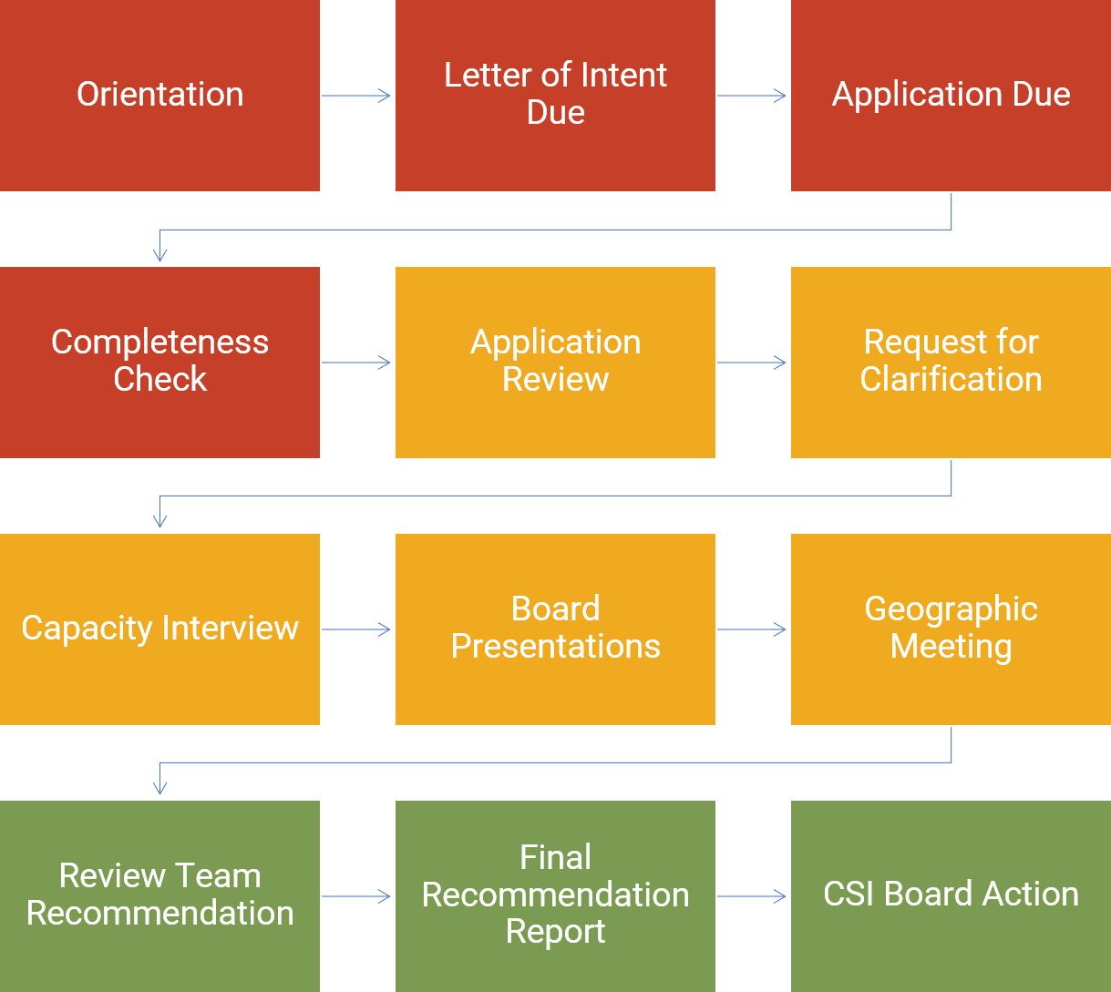

**Application Process Overview**

CSI’s mission is to foster high- quality education options, with a focus on serving all students and closing the opportunity gap. To this end, CSI prioritizes applicants proposing to serve similar or higher percentages of students eligible for free or reduced-price lunch, minority students, English learners, and students with special needs to that of local schools.

Applicants proposing to locate in districts that retain exclusive chartering authority should obtain a release from the geographic district prior to applying to CSI.

*For more information, email:* [*Authorization_CSI@csi.state.co.us*](mailto:Authorization_CSI@csi.state.co.us)

**New School Application Timelines**

|  |  |  |
| --- | --- | --- |
| **New School Application Process** | **Fall Cycle Timeline** | **Spring Cycle Timeline** |
| Orientation | ~2-6 months prior to LOI | ~2-6 months prior to LOI |
| Letter of Intent Due | Mid-July | Early March |
| Application Due | Early August | End of March |
| Geographic Meeting | August or September | April or May |
| Presentation to CSI Board Committee | Early September | Early May |
| Interview with CSI Review Team | August or September | April or May |
| CSI Board Committee  Discussion of Recommendation | Early October | Early June |
| CSI Board Action | Mid-October | Mid-June |

1525 Sherman St, B76 Denver, CO 80202 • P: 303.866.3299 • F: 303.866.2530 • [www.csi.state.co.us](http://www.csi.state.co.us/)

*Expanding Frontiers in Public Education*