Multilingual Learner Identification

**CSI Standardized Process**

## For students enrolled at the start of the school year, this process must be completed within 30 days. For students enrolling after the start of school, this process must be completed within 2 weeks.

1. Registrar collects registration paperwork from all students that includes the Home Language Survey (HLS).
2. Registrar provides all forms to ELD Coordinator for review.

ELD Coordinator reviews all HLS responses to determine a language influence other than English

Parent formally declines ELD services – signature required

School should never recommend opt-out

Monitor progress

Administer WIDA ACCESS annually

English proficient (meets cut scores) does not require ELD services

Registrar codes “4 – PHLOTE”

Registrar codes

“1 – Non-English Proficient (NEP)” or “2 – Limited English Proficient (LEP)”

Parent does not decline

Enroll NEP/LEP into ELD Services

Administer WIDA ACCESS annually

No language influence, not a Multilingual Learner

Registrar codes “0 – Not Applicable”

Written Parent Notification letter required

Not English Proficient

Requires ELD Services

ELD Coordinator reviews Screener scores and Body of Evidence (BOE)

ELD Coordinator administers Screener (Screener for Kindergarten or WIDA Screener for grades 1-12)

**WIDA SCREENER ADMINISTRATION TEST SELECTION**

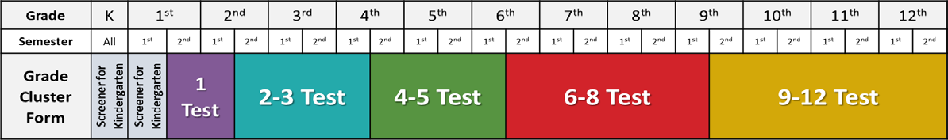

**SCREENER FOR KINDERGARTEN CUT SCORES & BODY OF EVIDENCE (BOE) OPTIONS**

|  |  |  |
| --- | --- | --- |
| Kindergarten First Semester  Administer Listening & Speaking  Oral Language Scores | Kindergarten Second Semester  Administer Listening, Speaking, Reading and Writing  Overall Scores | Body of Evidence (BOE) Options Supporting Screener Score |
| NEP: 1.0, 1.5, 2.0  LEP: 2.5, 3.0, 3.5  PHLOTE: > 4.0 | NEP: 1.0, 1.5, 2.0  LEP: 2.5, 3.0, 3.5  PHLOTE: > 4.0 | KSR Language or Literacy Domain < Meets  Diebels Below Benchmark  Teacher Observation  Family Interview |

**WIDA SCREENER CUT SCORES (1ST – 12TH) & BODY OF EVIDENCE (BOE) OPTIONS**

|  |  |  |
| --- | --- | --- |
| First Grade First Semester  Administer Listening, Speaking, Reading and Writing  Overall Scores | First Grade Second Semester through Grade 12 | Body of Evidence (BOE) Options Supporting Screener Score |
| NEP: 1.0, 1.5, 2.0  LEP: 2.5, 3.0, 3.5  PHLOTE: > 4.0 | NEP: 1.0 - 2.4 (Overall)  LEP: 2.5 – 3.9 (Overall)  PHLOTE: > 4.0 (Overall & Literacy) | Diebels Below Benchmark  NWEA MAP Reading < Meets  NWEA MAP Language Usage < Meets  iReady Reading < 3.0  STAR Below Benchmark  Accuplacer Reading Comprehension < 62  Accuplacer Sentence Skills < 70  Teacher Observation  Prior year ELA grades  Prior school reported NEP, LEP |

Last revised 2025-2026