Entering the Graduation Guidelines (GG) Files

In PowerSchool (PS)

Graduation Guidelines (GG) Data Entry: For grades 9th – 12th only.
Select School: (Some schools will choose “District Office” if pulling data for multiple schools)
Select the Calendar Year: Select Appropriate Year,

Search for Student,

Go to: “Academic Records”, “Academic Performance”,

Go to: “Test Results”,
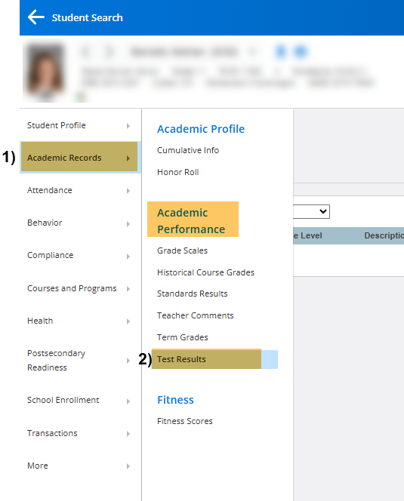

Under Report Parameters:

Enter New Test: Using Drop-Down, Select Test.

Click Submit.
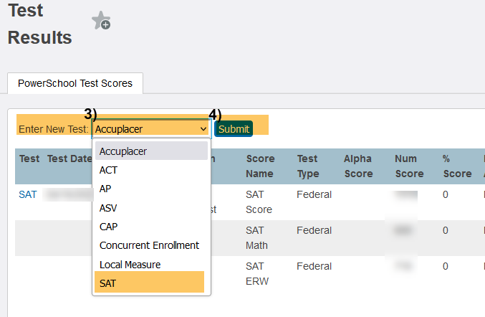

Date: Enter Test Date,

Grade Level: Confirm Grade Level at Time of Assessment,
- Click: Submit.
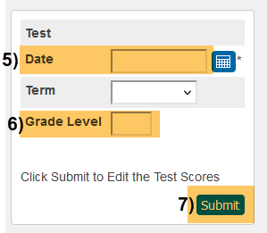
- Num Score: Add Num Score. This score will populate the Graduation Guidelines file and must be set up correctly in PS to include Guideline Name Code and score value found in the GG File Layout.
Include Accommodations if appropriate,
- Click: Submit.
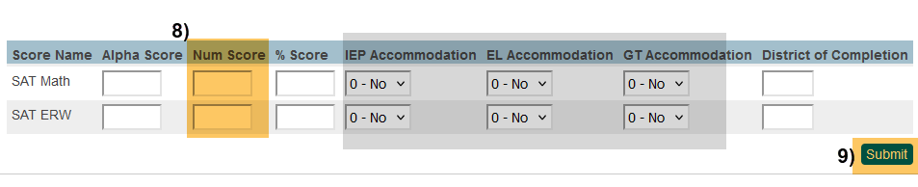

Please NOTE:
- The Graduation Guidelines file must contain at least two rows of data for each graduating student including at least one passing score in both English AND Math.
- Scores configured according to the “acceptable range” from the GG-Menu of College and Career-Ready Demonstrations and can be found on the GG File Layout.
- A student should have one record per guidelines they have completed.

Additional Resources:
- Extracting GG Files in PS,
- GG details: “Graduation Guidelines File Layout” (for high schools),
- GG – Menu of Options,
https://resources.csi.state.co.us/data-submissions/eoy/

For More Quick Reference Guides (QRG): https://resources.csi.state.co.us/data-submissions/eoy/

- QRG – Extracting SD Files in PS
- QRG – Extracting Title I Files in PS
- QRG – Using the Record Checker Tool

- QRG – Extracting SSA Files in PS
- QRG – Extracting GG Files in PS

