Entering the Graduation Guidelines (GG) Files

In Infinite Campus (IC)

# Graduation Guidelines (GG) Data Entry: Grades 9th – 12th only.

## Select School and Year,

## Search for Student,

## Main Menu,

## Go to: “Student Information”, “General”,

## Select: “Assessment”.

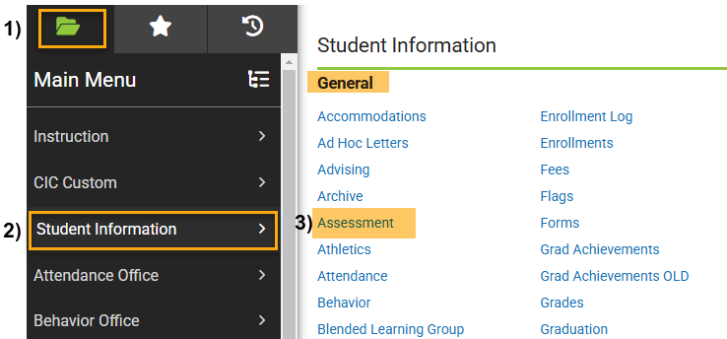

## Click: “New” Button,

## Click in box under “New Test”,

## Select: Test Name,

## 

1. **Enter Date:** Date of Test,
2. **Enter Scale Score:** Enter Score Value. This score will populate the Graduation Guidelines file and must be set up correctly in IC to include Guideline Name Code and score value found in the GG File Layout.
3. **Save.**

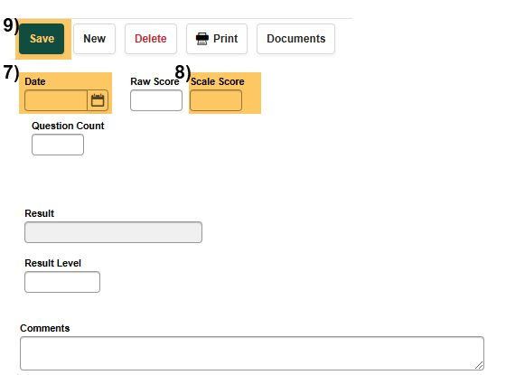

**Please NOTE:**

* The Graduation Guidelines file must contain at least two rows of data for each graduating student including at least one passing score in both English AND Math.
* Scores configured according to the “acceptable range” from the GG-Menu of College and Career-Ready Demonstrations and can be found on the GG File Layout.
* A student should have one record per guidelines they have completed.

Additional Resources:

* Extracting GG Files in IC,
* GG details: “Graduation Guidelines File Layout” (for high schools),
* GG – Menu of Options,

[https://resources.csi.state.co.us/data-submissions/](https://resources.csi.state.co.us/data-submissions/eoy/)**[eoy](https://resources.csi.state.co.us/data-submissions/eoy/)**[/](https://resources.csi.state.co.us/data-submissions/eoy/)

For More Quick Reference Guides (QRG): [https://resources.csi.state.co.us/data-submissions/](https://resources.csi.state.co.us/data-submissions/eoy/)**[eoy](https://resources.csi.state.co.us/data-submissions/eoy/)**[/](https://resources.csi.state.co.us/data-submissions/eoy/)

* QRG – Extracting SD Files in IC
* QRG – Extracting Title I Files in IC
* QRG – Using the Record Checker Tool
* QRG – Extracting SSA Files in IC
* QRG – Extracting GG Files in IC