Summer EBT (S-EBT)

Extracting S-EBT Files in PowerSchool (PS)

# Extract S-EBT File –

1. **Select School:** (Some schools will choose “District Office” if pulling data for multiple schools)
2. **Select the Calendar Year:** Current Year

## Go to: “Data and Reporting”,

## Select: “Reports”,

## Go to: “Compliance Reports”,

1. **Under Periodic Collections, Select:** “S-EBT Data Collection”

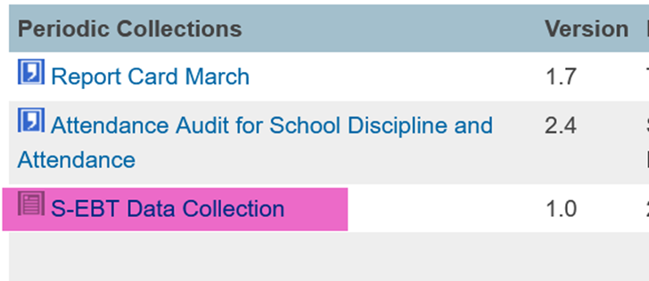

## Under Report Parameters:

## Select Schools to Include: Choose school/s that you would like to include. Use “Shift /Click” to select multiple,

## Select Students to Include: Leave as Default “All Students”,

## Source for Contacts: “Student Contacts”

## School Year: Use Current School Year,

1. **Click:** Submit

**When submitting files to CSI, do NOT open the downloaded file directly and resave, or it will lose critical leading zeros! Instead, save the file first. Then open or submit the saved file.**

**Submission Steps:**

* **Save file using the following format:** SchoolCode_SchoolAbbreviation_SEBT_MMDDYYYY (no spaces). Example: 1234_XYZ_SEBT_02032025
* **After saving, open and scroll through file to ensure that fields are not blank or incorrect prior to submitting to CSI. Look for:**
* **Upload to:** G-Drive>Submissions>S-EBT>(Choose Year)>Files to Run,
* **Notify the Data Team of the submission by emailing:** [**Submissions_CSI@csi.state.co.us**](mailto:Submissions_CSI@csi.state.co.us)**.**