Summer EBT (S-EBT)

Extracting S-EBT Files in Infinite Campus (IC)

# Extract S-EBT File –

## From any calendar year,

## Go to: “Index” tab, (New Look View-“Main Menu”)

## Select: “CO State Reporting” dropdown, (New Look View-“Reporting”)

## Select: “Data Pipeline” dropdown, (New Look View- “CO Data Pipeline”)

## Select: “S-EBT Interchange”.

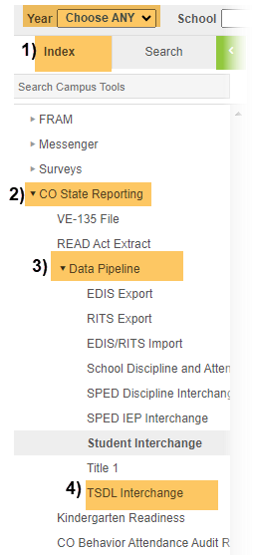Original View OR “NEW LOOK” View

## Under Setup:

## Show Active Year Only: on

## Select the school year and schools you need to submit

## Start Date: Start of School Year

## End Date: current date

## Report Legal Name: Check this Box

## Report Processing: Generate Now

## Format: CSV

1. **Click:** Generate Extract.

**When submitting files to CSI, do NOT open the downloaded file directly and resave, or it will lose critical leading zeros! Instead, save the file first. Then you can open and/or submit the saved file.**

**Submission Steps:**

* **Save file using the following format:** SchoolCode_SchoolAbbreviation_SEBT_MMDDYYYY (no spaces),
* **After saving, open and scroll through file to ensure that fields are not blank or incorrect prior to submitting to CSI.**
* **Upload to:** G-Drive>Submissions>S-EBT>(Choose Year)>Files to Run,
* **Notify the Data Team of the submission by emailing:** [**Submissions_CSI@csi.state.co.us**](mailto:Submissions_CSI@csi.state.co.us)**.**