October Count

Using the Record Checker Tool (RCT)

# Record Checker Tool (RCT) – Schools are expected to run files using the RCT and resolve and identified errors PRIOR to the initial file submission and throughout the submission process.

## FIRST: Download the RCT from the CSI Resource Website:

## <https://resources.csi.state.co.us/data-submissions/october-count/>

## Go to: “Data Validation Resources” Section,

## Then: “October Count Record Checker Tool”,

## Select: “Tool” to download the Excel file.

View instructions and webinar for more detailed information.

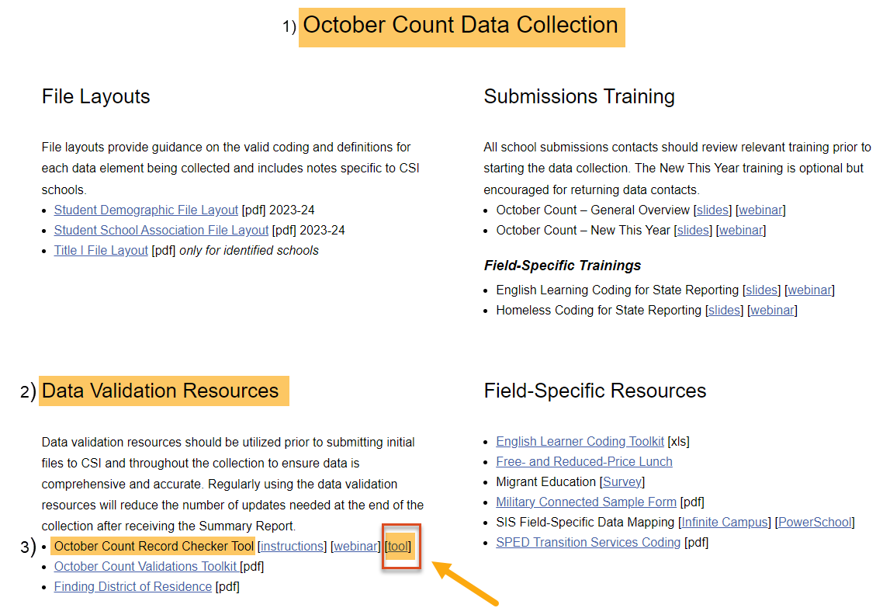

## SECOND: Read Instruction Tab

## Select: “Raw SD Data” or “Raw SSA Data” Tab on the RCT.

**NOTE:** You may need to click the “Enable Editing” and/or “Enable Content” button to use the RCT.

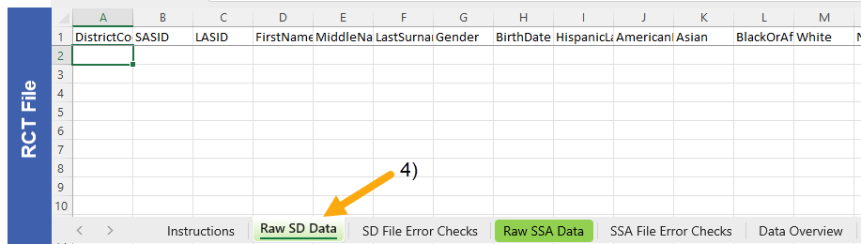

## THIRD: Extract SD and/or SSA files from your SIS: See Quick Guides for Instructions on Extracting Files found on the webpage: <https://resources.csi.state.co.us/data-submissions/october-count/>

**\*IMPORTANT NOTE:** Unlike when you submit file to CSI and keep leading zeros, **RCT files must be in CSV format WITHOUT the leading zeros.**

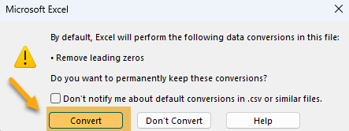**To do this open the downloaded file directly.** For newer Excel version users, you will receive a warning. **Choose “Convert”.**

## Open Downloaded SD and/or SSA File,

1. **Select All Cells of the Excel Spreadsheet:** Use “Ctrl + A” or Click Corner to the Left of “A” Column,
2. **Copy all data:** Use “Ctrl + C” on Keyboard or Right Click Mouse and Select “Copy”.

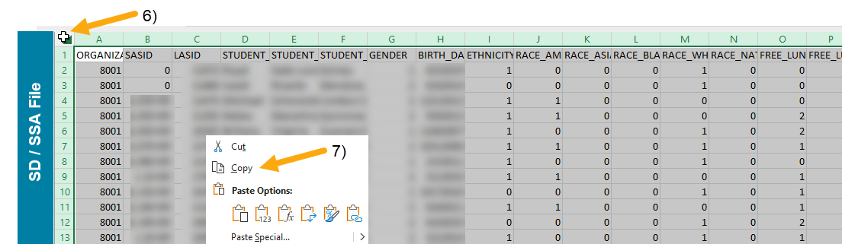

## Fourth: Return to the RCT File.

## Click: Cell A:1,

## Paste All Data: Use “Ctrl + V” on Keyboard or Right Click Mouse and Select “Paste”,

1. **Notice: Highlighted Cells will flag possible issues.**

**IMPORTANT: Fix flagged issues within your Student Information System (SIS), not on the file itself!** You will then extract a new file and run it again through the RCT. Repeat this as many times as necessary.

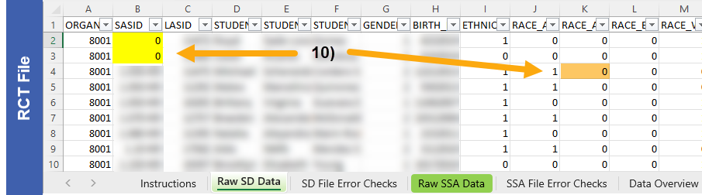

1. **Use the RCT Instruction Tab:** Gives guidance to help correct flagged issues.

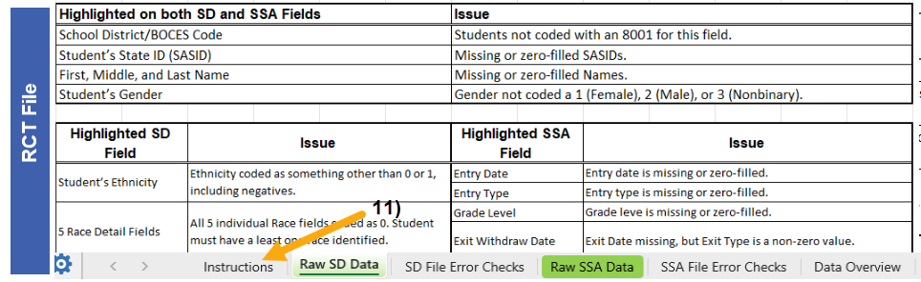

**FINAL: When highlighted cells have been resolved in the RCT, extract a NEW file and submit the new file to CSI. *DO NOT USE THE FILE THAT WAS USED FOR THE RCT.**

The RCT does not need to be sent to CSI and is for your information and data validation purposes only.

Additional Resources:

For training on:

* Submitting Files to CSI: “Step 3: Extracting the Files and Submitting to CSI”,

[https://resources.csi.state.co.us/**data-submissions**/](https://resources.csi.state.co.us/data-submissions/)

For validation resources:

* Record Checker Tool (RCT) information: “Record Checker Tool”, visit:

[https://resources.csi.state.co.us/data-submissions/**october-count**/](https://resources.csi.state.co.us/data-submissions/october-count/%20)

For More Quick Reference Guides (QRG): [https://resources.csi.state.co.us/data-submissions/](https://resources.csi.state.co.us/data-submissions/october-count/)**[october-count/](https://resources.csi.state.co.us/data-submissions/october-count/)**

* QRG – Extracting SD Files in IC
* QRG – Extracting Title I Files in IC
* QRG – Using the Record Checker Tool
* QRG – Extracting SSA Files in IC
* QRG – Extracting GG Files in IC **(EOY Only)**

For questions, please reach out to the Data Team of the submission by emailing: [Submissions_CSI@csi.state.co.us](mailto:Submissions_CSI@csi.state.co.us).