October Count & End of Year

Extracting the Title I Files in Infinite Campus (IC)

# Title I File - Used for the October Count and End of Year collections.

**Note:** Only for schools that qualify for Targeted Assisted (TA) Title I. This is not used for School Wide (SW) Title I.

## Go to: “Index” tab, (New Look View-“Main Menu”)

## Select: “CO State Reporting” drop down, (New Look View-“Reporting”, “CO Data Pipeline”)

## Select: “Title I”.

You can do this from any calendar year.

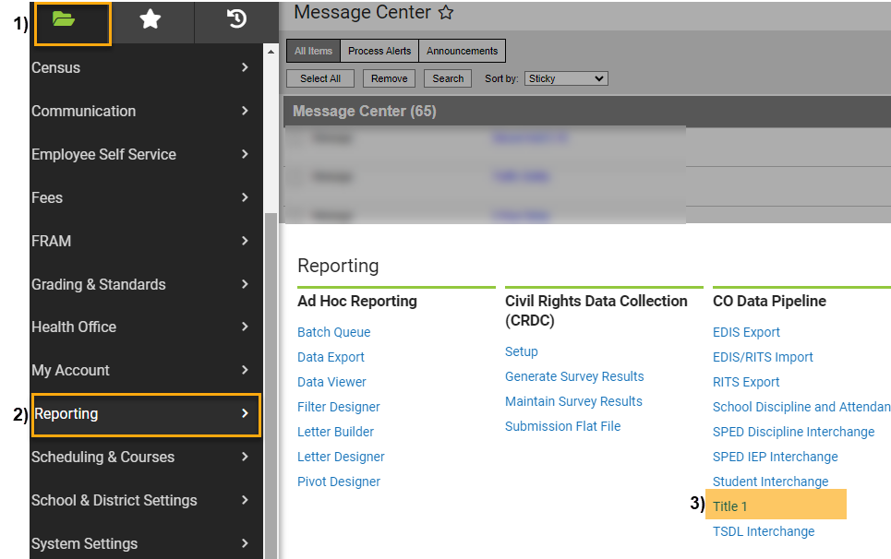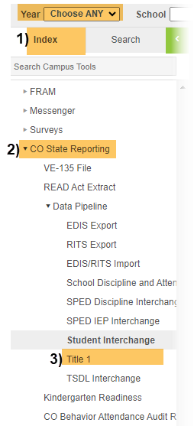IC Original View OR IC “NEW LOOK” View

## Under Extract Options:

## Report Legal Name: Check this Box,

## Format: Leave as Default “CSV”,

## Ad Hoc Filter: Leave Blank.

**Under Select Calendars:**

## Select Schools: Choose calendar/s that you would like to include. Use “Shift /Click” to select multiple,

1. **Select School Year:** Choose current year from drop down,
2. **Click:** Generate Extract.

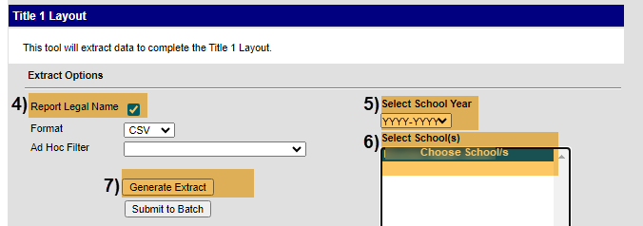

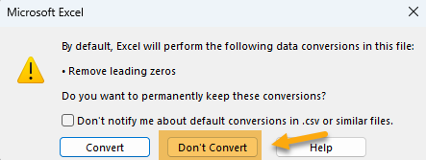**When submitting files to CSI, do NOT open the downloaded file directly and resave, or it will lose critical leading zeros! Instead, save the file first. Then you can open and/or submit the saved file. OR,** if using a newer Excel, you will receive a warning. **Choose “Don’t Convert”**

**Submission Steps:**

* **Use the Record Check Tool (RCT) prior to an initial submission,**
* **Save file using the following format:** SchoolCode_SchoolAbbreviation_TitleI_MMDDYYYY (no spaces),
* **Upload to:** G-Drive>Submissions>(Choose Collection Name)>(Choose Year)>Files to Run,
* **Notify the Data Team of the submission by emailing:** [**Submissions_CSI@csi.state.co.us**](mailto:Submissions_CSI@csi.state.co.us)**.**

Additional resources:

For training on:

* Naming files: “Step 3: Extracting the Files and Submitting to CSI”,
* Converting CSV to Excel, Excel Filters, etc: “Excel for Data Submissions Contacts (Part 1)”, visit:

[https://resources.csi.state.co.us/**data-submissions**/](https://resources.csi.state.co.us/data-submissions/)

For file details and validation resources:

* SD details: see the “Student Demographic File Layout”,
* SSA details: “Student School Association File Layout”,
* Title I details: “Title I File Layout” (for applicable schools),
* GG details: “Graduation Guidelines File Layout” (for high schools),
* Record Checker Tool (RCT) information: “Record Checker Tool”, visit:

[https://resources.csi.state.co.us/data-submissions/**october-count**/](https://resources.csi.state.co.us/data-submissions/october-count/%20) OR

[https://resources.csi.state.co.us/data-submissions/**eoy**/](https://resources.csi.state.co.us/data-submissions/eoy/)

For More Quick Reference Guides (QRG):

[https://resources.csi.state.co.us/data-submissions/**october-count/**](https://resources.csi.state.co.us/data-submissions/october-count/) OR [https://resources.csi.state.co.us/data-submissions/**eoy**/](https://resources.csi.state.co.us/data-submissions/eoy/)

* QRG – Extracting SD Files in IC
* QRG – Extracting Title I Files in IC
* QRG – Using the Record Checker Tool
* QRG – Extracting SSA Files in IC
* QRD – Extracting GG Files in IC **(EOY only)**