October Count & End of Year

Extracting the SSA Files in Infinite Campus (IC)

# Student School Association (SSA) File – Used for October Count and End of Year collections.

**Note:** The SSA file is titled: “School Association” in IC

## Go to: “Index” tab, (New Look View-“Main Menu”)

## Select: “CO State Reporting” drop down, (New Look View-“Reporting”, “CO Data Pipeline”)

## Select: “Student Interchange”.

You can do this from any calendar year.

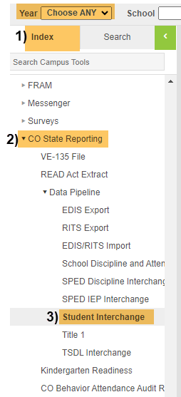IC Original View OR IC “NEW LOOK” View

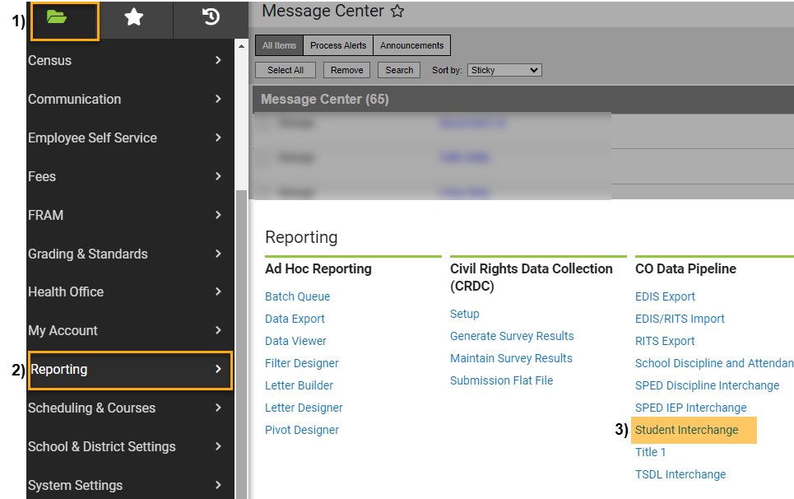

## Under Extract Options:

## Report Type: Select “School Association” from the dropdown,

## Report Format: Select Current School Year Format,

## Ad Hoc Filter: Leave Blank,

## Effective Date: Leave as Default Date (Current Date),

## Attendance Start Date: Recommend using a general date (ex. 08/01/YEAR) to include 1-Day Records,

## Attendance End Date: Recommend using a general date that includes your school’s entire school year (ex. 06/30/YEAR),

## Include Partial Enrollment: Check this Box,

## Report Legal Name: Check this Box,

## Exclude Attendance: Leave Empty,

## Format: Leave as Default “CSV”.

**Under Select Calendars:**

## Choose calendar/s that you would like to include. Use “Shift /Click” to select multiple,

1. **Click:** Generate Extract.

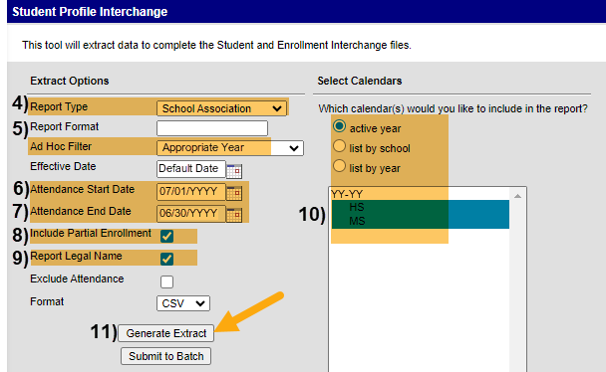

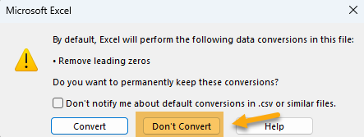**When submitting files to CSI, do NOT open the downloaded file directly and resave, or it will lose critical leading zeros! Instead, save the file first. Then you can open and/or submit the saved file. OR,** if using a newer Excel, you will receive a warning. **Choose “Don’t Convert”**

**Submission Steps:**

* **Use the Record Check Tool (RCT) prior to an initial submission,**
* **Save file using the following format:** SchoolCode_SchoolAbbreviation_SSA_MMDDYYYY (no spaces),
* **Upload to:** G-Drive>Submissions>(Choose Collection Name)>(Choose Year)>Files to Run,
* **Notify the Data Team of the submission by emailing:** [**Submissions_CSI@csi.state.co.us**](mailto:Submissions_CSI@csi.state.co.us)**.**

Additional Rresources:

For training on:

* Naming files: “Step 3: Extracting the Files and Submitting to CSI”,
* Converting CSV to Excel, Excel Filters, etc: “Excel for Data Submissions Contacts (Part 1)”, visit:

[https://resources.csi.state.co.us/**data-submissions**/](https://resources.csi.state.co.us/data-submissions/)

For file details and validation resources:

* SD details: see the “Student Demographic File Layout”,
* SSA details: “Student School Association File Layout”,
* Record Checker Tool (RCT) information: “Record Checker Tool”, visit:

[https://resources.csi.state.co.us/data-submissions/**october-count**/](https://resources.csi.state.co.us/data-submissions/october-count/%20) OR

[https://resources.csi.state.co.us/data-submissions/**eoy**/](https://resources.csi.state.co.us/data-submissions/eoy/)

For More Quick Reference Guides (QRG):

[https://resources.csi.state.co.us/data-submissions/**october-count/**](https://resources.csi.state.co.us/data-submissions/october-count/) OR [https://resources.csi.state.co.us/data-submissions/**eoy**/](https://resources.csi.state.co.us/data-submissions/eoy/)

* QRG – Extracting SD Files in IC
* QRG – Extracting Title I Files in IC
* QRG – Using the Record Checker Tool
* QRG – Extracting SSA Files in IC
* QRG – Extracting GG Files in IC **(EOY Only)**