October Count & End of Year

Extracting the SD Files in PowerSchool (PS)

# Student Demographic (SD) File – Used for the October Count and End of Year collections.

1. **Select School:** (Some schools will choose “District Office” if pulling data for multiple schools)
2. **Select the Calendar Year:** Select Appropriate Year,

## Go to: “Data and Reporting”,

## Select: “Reports”,

## Go to: “Compliance Reports”,

1. **Under Interchanges, Select:** “Student – Demographic Data”.

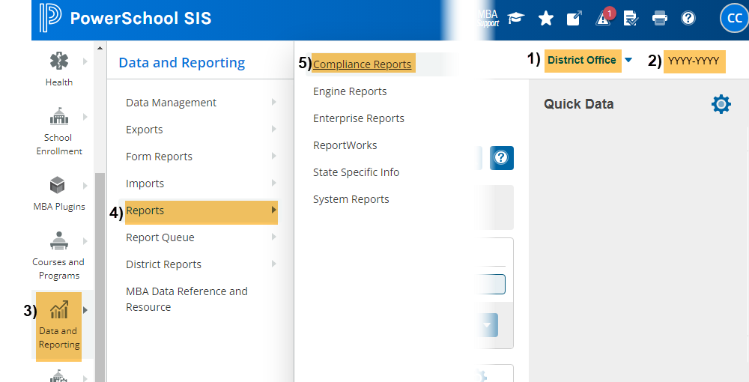

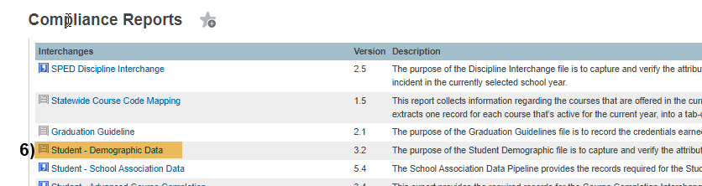

## Under Report Parameters:

## Select Schools: Choose school/s that you would like to include. Use “Shift /Click” to select multiple,

## Select Students: Leave as Default “All Students”,

## Point in Time Date: Leave Blank (No Date),

## Lunch Status Date: Leave Blank (No Date),

## Use Lunch History Data: Leave as Default “Yes”,

## Click: Submit

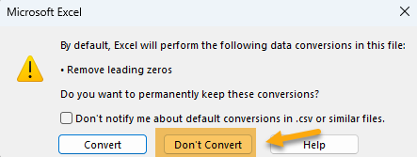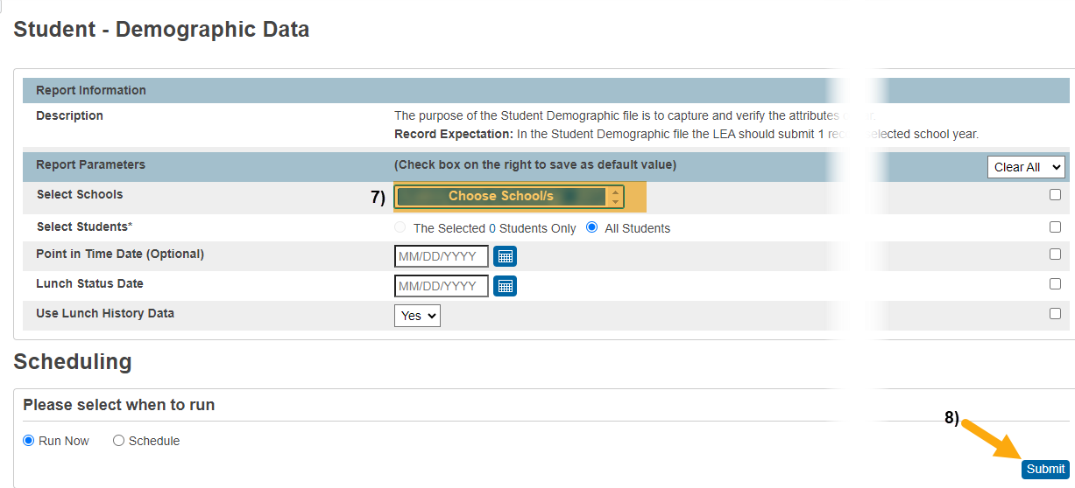**When submitting files to CSI, do NOT open the downloaded file directly and resave, or it will lose critical leading zeros! Instead, save the file first. Then open or submit the saved file. OR,** if using a newer Excel, you will receive a warning. **Choose “Don’t Convert”**

**Submission Steps:**

* **Use the Record Check Tool (RCT) prior to an initial submission,**
* **Save file using the following format:** SchoolCode_SchoolAbbreviation_SD_MMDDYYYY (no spaces),
* **Upload to:** G-Drive>Submissions>(Choose Collection Name)>(Choose Year)>Files to Run,
* **Notify the Data Team of the submission by emailing:** [**Submissions_CSI@csi.state.co.us**](mailto:Submissions_CSI@csi.state.co.us)**.**

Additional Resources:

For training on:

* Naming files: “Step 3: Extracting the Files and Submitting to CSI”,
* Converting CSV to Excel, Excel Filters, etc: “Excel for Data Submissions Contacts (Part 1)”, visit:

[https://resources.csi.state.co.us/**data-submissions**/](https://resources.csi.state.co.us/data-submissions/)

For file details and validation resources:

* SD details: see the “Student Demographic File Layout”,
* SSA details: “Student School Association File Layout”,
* Title I details: “Title I File Layout” (for applicable schools),
* GG details: “Graduation Guidelines File Layout” (for high schools),
* Record Checker Tool (RCT) information: “Record Checker Tool”, visit:

[https://resources.csi.state.co.us/data-submissions/**october-count**/](https://resources.csi.state.co.us/data-submissions/october-count/%20) OR

[https://resources.csi.state.co.us/data-submissions/**eoy**/](https://resources.csi.state.co.us/data-submissions/eoy/)

For More Quick Reference Guides (QRG):

[https://resources.csi.state.co.us/data-submissions/**october-count/**](https://resources.csi.state.co.us/data-submissions/october-count/) OR [https://resources.csi.state.co.us/data-submissions/**eoy**/](https://resources.csi.state.co.us/data-submissions/eoy/)

* QRG – Extracting SD Files in PS
* QRG – Extracting Title I Files in PS
* QRG – Using the Record Checker Tool

* QRG – Extracting SSA Files in PS
* QRG– Extracting GG Files in PS **(EOY Only)**