End of Year

Extracting the Graduation Guidelines (GG) Files

In PowerSchool (PS)

# Graduation Guidelines (GG) File:

1. **Select School:** (Some schools will choose “District Office” if pulling data for multiple schools)
2. **Select the Calendar Year:** Select Appropriate Year,

## Go to: “Data and Reporting”,

## Select: “Reports”,

## Go to: “Compliance Reports”,

1. **Under Interchanges, Select:** “Graduation Guidelines”

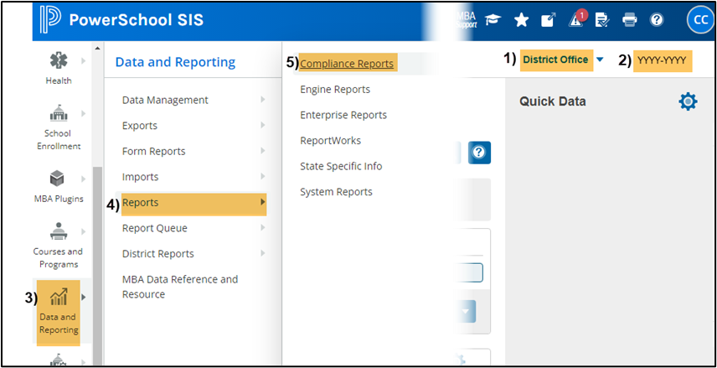

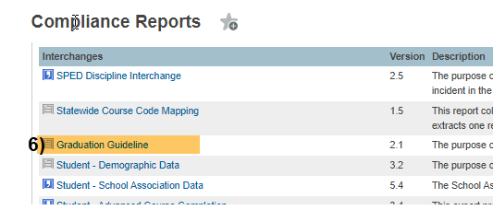

## Under Report Parameters:

## Select Schools: Choose school/s that you would like to include. Use “Shift /Click” to select multiple,

## Select Students: Leave as Default “All Students”,

## Begin Date: Use a general date that will encompass all graduating GG history, including 5-, 6-, and 7-year graduates. This date can be as far back as you choose and defaults to the first date of the selected term,

## End Date: Use a general date to capture the current year graduates, this value defaults to the last day of the selected term,

## Include Validation Columns: Uncheck, this should be OFF or the file will fail to process,

**Enrolled Students Only:** Leave as Default, unchecked,

1. **Click:** Submit

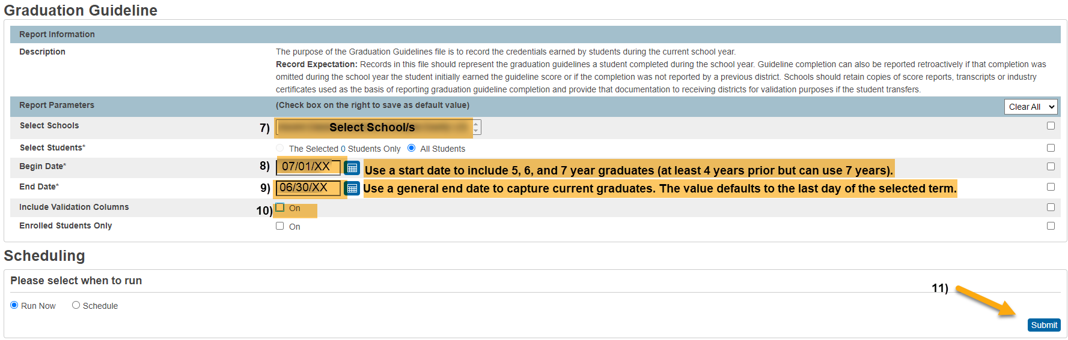

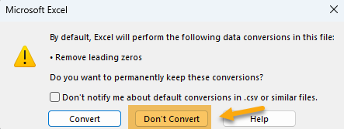**When submitting files to CSI, do NOT open the downloaded file directly and resave, or it will lose critical leading zeros! Instead, save the file first. Then open or submit the saved file. OR,** if using a newer Excel, you will receive a warning. **Choose “Don’t Convert”**

**Submission Steps:**

* **Use the Record Check Tool (RCT) prior to an initial submission,**
* **Save file using the following format:** SchoolCode_SchoolAbbreviation_GG_MMDDYYYY (no spaces),
* **Upload to:** G-Drive>Submissions>End of Year>(Choose Year)>Files to Run,
* **Notify the Data Team of the submission by emailing:** [**Submissions_CSI@csi.state.co.us**](mailto:Submissions_CSI@csi.state.co.us)**.**

Additional Resources:

For training on:

* Naming files: “Step 3: Extracting the Files and Submitting to CSI”,
* Converting CSV to Excel, Excel Filters, etc: “Excel for Data Submissions Contacts (Part 1)”, visit:

[https://resources.csi.state.co.us/**data-submissions**/](https://resources.csi.state.co.us/data-submissions/)

For file details and validation resources:

* SD details: see the “Student Demographic File Layout”,
* SSA details: “Student School Association File Layout”,
* Title I details: “Title I File Layout” (for applicable schools),
* GG details: “Graduation Guidelines File Layout” (for high schools),
* Record Checker Tool (RCT) information: “Record Checker Tool”, visit:

[https://resources.csi.state.co.us/data-submissions/**eoy**/](https://resources.csi.state.co.us/data-submissions/eoy/)

For More Quick Reference Guides (QRG): [https://resources.csi.state.co.us/data-submissions/**eoy**/](https://resources.csi.state.co.us/data-submissions/eoy/)

* QRG – Extracting SD Files in IC
* QRG – Extracting Title I Files in IC
* QRG – Using the Record Checker Tool

* QRG – Extracting SSA Files in IC
* QRG – Extracting GG Files in IC