Finding District of Residence

# Guidance on Searching for Districts of Residence for Students and Staff

Please follow the below steps to search for the correct District of Residence code to use if you have a student or staff member’s address and need to populate this information into a related field in your Student Information and/or Plan Management System. Schools should always use the geographic district the student/parent resides in and not 8001 for CSI.

1. Navigate to the Colorado Great Schools site at: https://www.greatschools.org/school-district-boundaries-map/
2. In the Search box near on the left type in the address of the student or staff member and hit **Search**.

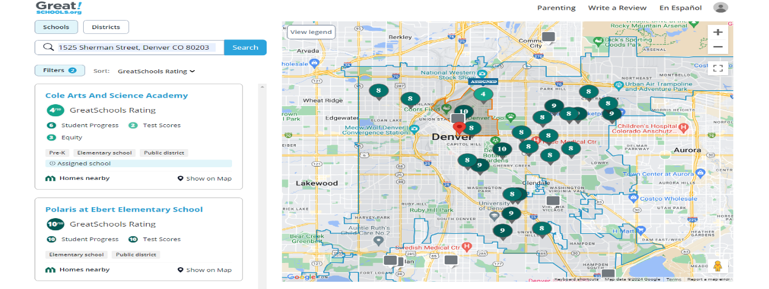

1. Enlarge the map near the pin of the address you typed in. Click on the pin for the closest school on the map to provide additional details. In our example, we have searched the CSI address and found that the Downtown Denver Expeditionary School is the closest school within District boundaries.

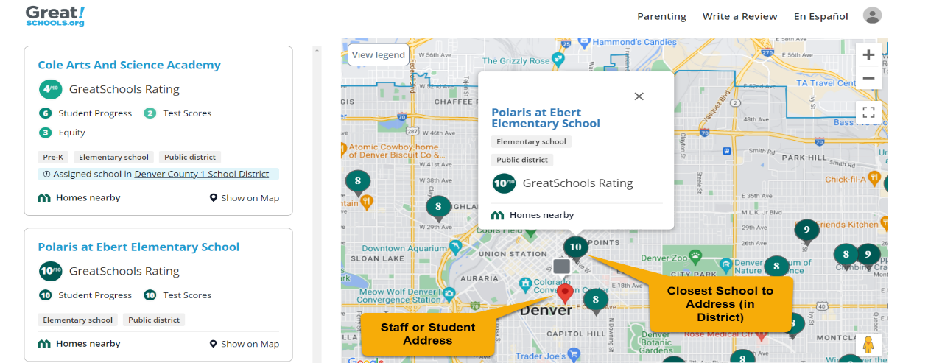

1. After clicking on that pin, a new tab will open providing details about the school. Near the top you will see which school district the school nearest to the searched address is associated with. In this case, Denver County 1 School District is the District of Residence for that student or staff.
2. Ensure you are using the map with boundaries rather than the schools listed on the left. In some cases, the address searched may exist near a School District boundary, so using the map will ensure you are selecting a school in the correct District.

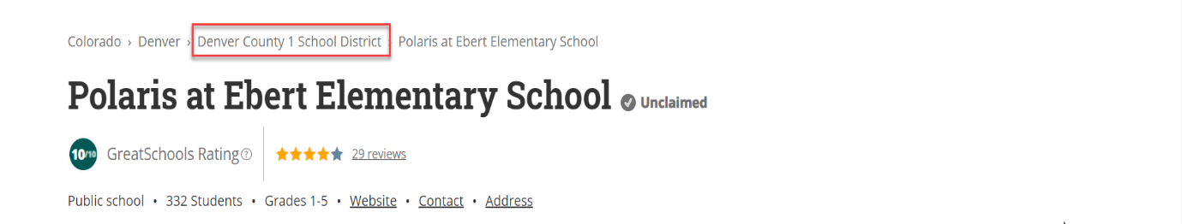

1. To find which code to use based off of the District found, navigate to <https://cedar.cde.state.co.us/edulibdir/Organization%20Codes-en-us.xlsx> and search for the district that was discovered to be the closest school to the address.
2. Column D will provide you with the District Code (Organization Code) that you will want to use in any collection where this information is collected. For the provided example, the District Code of 0880 should be used. This process can be Students District of Residence, Parents District of Residence, or Staff District of Residence fields on their corresponding collections.

