­­

2024-2025 CSI October Count

Audit Handbook

This document contains instructions for all CSI schools to follow to meet the requirements of the CSI internal audit for the October Count collection for the current school year.

*Last updated August 26, 2024*



Contents

General Overview 2

Goals for CSI Internal Audit 2

CDE Student October Count Audit Resource Guide 2

Finance Rule Changes for SY24-25 2

Timeline 3

October Count Dates 3

Alternative Count Date Requests 3

General Timeline for CSI Internal Audit 4

October Count Submission Deadlines 4

October Count Audit Deadlines 4

Supporting Documentation 6

Sharing Files with G-Drive 6

Attendance Reports 6

Student Schedules 6

Other Supporting Documentation 7

Resources 8

Appendix I: SIS Attendance, Enrollment, and Schedule Report 9

Infinite Campus Report Extracts 9

PowerSchool Report Extracts 12

Appendix II: Crosschecking Funding Eligibility with Student Schedules 18

PowerSchool Instructions 18

Infinite Campus Instructions 19

Appendix III: Free and Reduced Lunch Eligibility Checklist 21

# General Overview

The Colorado Department of Education (CDE) requires that all school districts have an internal audit process in place to ensure accurate reporting of eligible students and their corresponding funding levels in the Student October Count data submission. The internal audit process also ensures that all required supporting documentation as defined in the CDE Audit Resource Guide and as provided by CSI schools is complete and submitted on time.

Please direct questions about this Handbook to [submissions_csi@csi.state.co.us](mailto:submissions_csi@csi.state.co.us).

## Goals for CSI Internal Audit

* Report accurate data
* Secure maximize potential funding
* Avoid repayment of funds back to the state
* Reduce burden on schools

## CDE Student October Count Audit Resource Guide

The links in this Handbook direct you to the main [CDE Pupil Count Audit webpage](https://www.cde.state.co.us/cdefinance/auditunit_pupilcount). From there, you'll find a link to the current year's **CDE Student October Count Audit Resource Guide**, as well as a link to a webpage containing versions from previous years.

## Finance Rule Changes for SY24-25

In March of 2024, the State Board of Education adopted proposed changes by CDE to the Rules for the Administration of the Public School Finance Act (1 CCR 301-39) that included alternative instructional time in the determination for student funding. This resulted in substantial changes to the rules outlined for districts/schools in the [2024 CDE Student October Count Audit Resource Guide](https://www.cde.state.co.us/cdefinance/auditunit_pupilcount) which will impact both the submissions and audit related processes for reporting the 2024 October Count collection.

CSI schools must carefully review this CSI October Count Audit Handbook, alongside other CSI resources and communications, to ensure accurate student data reporting. This includes adhering to the new and modified funding rules and meeting supporting documentation requirements.

Given the substantial updates to the rules within the [2024 CDE Student October Count Audit Resource Guide](https://www.cde.state.co.us/cdefinance/auditunit_pupilcount), the content of this CSI Handbook has been revised for the 2024-2025 school year. Notably, the former Audit Supporting Documentation Checklist has been removed. Instead, schools will be required to complete an **Audit Questionnaire Survey** aimed at identifying the types of programs and special student scenarios that impact funding and the necessary supporting documentation that must be submitted to CSI.

Schools will need to take a direct role in consulting the [2024 Student October Count Audit Resource Guide](https://www.cde.state.co.us/cdefinance/auditunit_pupilcount) to understand the rules and requirements for each unique student type and scenario. All required supporting documentation must be submitted to CSI by the deadlines specified in this Handbook or communicated through other resources.

CSI's role is to support schools throughout this process and to serve as the liaison with CDE. **Schools should send all audit related questions to CSI instead of reaching out to CDE.** *This is simply because CDE asks that questions come from the district office rather than from the school level. CSI can typically answer questions for you without the need to contact CDE.*

# Timeline

## October Count Dates

|  |  |  |
| --- | --- | --- |
| **Pupil Count Grades** | **Pupil Count Date** | **11-Day Count Window** |
| PK-12 | Tuesday, October 1, 2024 | Tuesday, Sept 24 – Tuesday, Oct 8 |

*Schools should report all enrolled PK in the October Count collection (regardless of UPK funding status).*

## Alternative Count Date Requests

All schools need to use the official count date *and* count window dates listed above unless they have received advanced approval from CSI to use **alternative count dates**. CSI will email all schools with instructions in August with details on requesting alternative count dates.

Email requests to [submissions_csi@csi.state.co.us](mailto:submissions_csi@csi.state.co.us)

**No later than September 9, 2024**

*Include alternative count date and/or window and rationale.*

## General Timeline for CSI Internal Audit

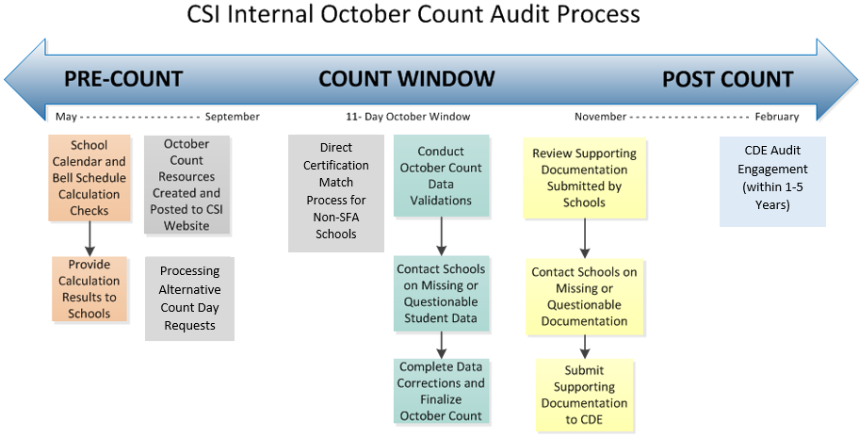

## October Count Submission Deadlines

For a list of intital file submission dates, error clearance deadlines, and summary report review phase deadlines, please see the **current year Data Submissions Calendar** found on the [Data Submissions Calendar webpage](https://resources.csi.state.co.us/data-submissions/calendar/).

## October Count Audit Deadlines

A few key audit dates will be listed in the Data Submissions Calendar. Additional audit-related dates are highlighted below, though they may be subject to change during the collection period. If a listed deadline falls on a weekend, the due date will typically be the preceding Friday.

|  |  |
| --- | --- |
| **Deadline Date** | **October Count Audit Event** |
| 9/9/2024 | Deadline to request alternative count date and/or window (see section above for details) |
| 9/23/2024 | ALP approval deadline for early access students.  *School Programs staff may suggest an earlier deadline to the audit deadlines to ensure adequate time for them to review/process forms.* |
| 9/27/2024 | Deadline to submit McKinney-Vento (homeless forms) to CSI for approval *prior* to count day *(While homelessness identified and approved by Count Day will be reflected in October Count Data, schools should continue submitting forms as new students are identified past this date to ensure accurate reporting throughout the school year.)*  *School Programs staff may suggest an earlier deadline to the audit deadlines to ensure adequate time for them to review/process forms.* |
| **10/1/2024** | **Count Day—Deadline to submit individual student schedules (for grades 6-12 *unless students follow an elementary schedule for 6-8*) by end of day** |
| 10/16/2024 | Deadline to submit ***majority*** of audit supporting documentation, including attendance reports |
| 10/31/2024 | 30 calendar day deadline for students who were absent on Count Day (10/1/2024) to resume attendance |
| 11/4/2024 | October Count submissions summary report signed certification deadline (schools must complete their data review and submit final data changes) |
| 11/6/2024 | Deadline to submit the **NEW** Audit Questionnaire Survey. This replaces the Audit Checklist required in prior years. |

# Supporting Documentation

As part of the annual CDE audits—encompassing the Pupil Count, At-Risk Count, and EL Count—along with the CSI internal October Count audit, all schools are required to submit supporting documentation to verify the funding levels claimed for students reported in the October Count collection. **This CSI Handbook focuses on supporting documentation needed for the Pupil Count audit only.**

Schools must provide documentation on attendance and individual student schedules for all students reported as funded in the October Count.

Guidance on extracting electronic attendance, enrollment, and student schedule reports from the school SIS is available in the Appendices of this Handbook.

## Sharing Files with G-Drive

Schools must upload supporting documentation to the appropriate audit subfolders in G-Drive under Submissions/October Count/XX-XX/OC Audit Documents. For any audit-related documents that do not have a clearly designated subfolder, schools can use the "Other" subfolder within the same file path.

## Attendance Reports

Due 10/16/2024*

Schools are required to provide, **at a minimum**, attendance records that include the **entire** 11-day count period. Attendance reports should be extracted from the school SIS.

Schools should ensure that submitted attendance documentation includes all students, even those participating in contracted education offerings such as homeschool enrichment programs. This includes attendance reports for students taking courses in a contractual environment. Schools must set up a process with the contractor to adequately record attendance and provide it to the school for audit purposes.

**REVIEW YOUR REPORTS FOR ACCURACY BEFORE SUBMITTING TO CSI!**

*For students absent on count day (or the alternative count day), if a school is approved for one, extended attendance reports must be provided to CSI as soon as possible but no later than the day after the deadline to resume attendance to confirm attendance criteria has been met.

*Schools should consult the* [*2024 CDE Student October Count Audit Resource Guide*](https://www.cde.state.co.us/cdefinance/auditunit_pupilcount) *for special student or program scenarios that could impact the type of attendance documentation required.*

## Student Schedules

Due by end of Count Day, 10/1/2024

Schools are required to provide individual student schedules extracted from the school SIS for grades 6-12 (unless grades below 9th follow an elementary type of schedule where they do not change classrooms/instructors and have passing periods.) Check with CSI if you are not sure if schedules should be submitted for some grades for your school. **REVIEW YOUR REPORTS FOR ACCURACY BEFORE SUBMITTING TO CSI!**

Individual student schedules must align with the school bell schedules in order for schools, CSI, and CDE to conduct audit reviews to determine whether funding levels reported for students in the October Count collection meet the instructional time requirements in statute. If that is not the case, then schools will need to also provide crosswalk documentation defining how the SIS student schedules align with the school bell schedules.

*Schools should consult the* [*2024 CDE Student October Count Audit Resource Guide*](https://www.cde.state.co.us/cdefinance/auditunit_pupilcount) *for special student or program scenarios that could impact the type of schedule documentation required.*

## Other Supporting Documentation

Due 10/16/2024

Schools may need to submit other types of supporting documentation for special program and student scenarios offered and identified by CSI schools in the **Audit Questionnaire Survey they must complete beginning in 24-25.**

*Schools should consult the* [*2024 CDE Student October Count Audit Resource Guide*](https://www.cde.state.co.us/cdefinance/auditunit_pupilcount) *for special student or program scenarios that could impact other types of required supporting documentation.*

# Resources

Primary resources related to the October Count internal audit processes include the following:

* [CSI October Count Webpage](https://resources.csi.state.co.us/october-count/): Both file submissions and audit resources (recorded trainings, file layouts, validation documentation, and other helpful resources)
* CSI “Weekly Update” Emails: Please review each week for audit announcements and file submission status (sent to all school submissions contacts)
* [CSI Policy Guidance](https://resources.csi.state.co.us/legal-and-policy-library/): Legal requirements on topics like attendance, enrollment, data privacy, and home school
* [School Calendar and Instructional Hours Resources](https://resources.csi.state.co.us/calendar-and-instructional-hours/)
* [CDE October Count Webpage and Audit Resource Guide](https://www.cde.state.co.us/cdefinance/auditunit_pupilcount) **(Significant changes beginning in 24-25!)**
* [CDE At-Risk Count Webpage and Audit Resource Guide](https://www.cde.state.co.us/cdefinance/auditunit_atrisk_freeandreduced)
* [CDE ELL Count Audit Webpage and Audit Resource Guide](https://www.cde.state.co.us/cdefinance/auditunit_ell_count)

# Appendix I: SIS Attendance, Enrollment, and Schedule Report

### Infinite Campus Report Extracts

The following instructions illustrate how to extract Attendance, Enrollment, and Student Schedule reports from Infinite Campus.

Even though some screenshots may not illustrate the current school year, they should still be applicable in a general sense and won’t be updated until they change significantly with the vendor. However, be sure to use the dates described in the steps rather than those in the screenshot if it is from a different year.

**REVIEW YOUR REPORTS FOR ACCURACY BEFORE SUBMITTING TO CSI!**

**Report 1: Attendance**

1. Go to **Attendance>Reports>Register**
2. For **What report type would you like?** Select Student Daily Attendance
3. For the date range, select the current 11-day window (09/24/2024 – 10/8/2024 for 24-25)

* *If your school is approved for alternative count window dates, then use those dates*
* *To create a separate extended attendance report for students absent on Count Day (10/1/2024 or your approved alternative count day), use 7/1/2024-10/31/2024 or you may use your school start date instead of 7/1/2024.*

1. Select your choice of options for the report orientation and students to include
2. Leave the “Only include students actively enrolled on:” option blank for this report.

If you entered a date in this field it would return only students enrolled on that date.

1. Click **Generate Report**
2. Schools should **always** review the resulting report to ensure accuracy and save it as a PDF using the following naming convention: “*SchoolCode*_*School_*AttendanceOctCt_*CurrentDate*”.

Example: 1633_CECA_**Attendance**OctCt_10162024

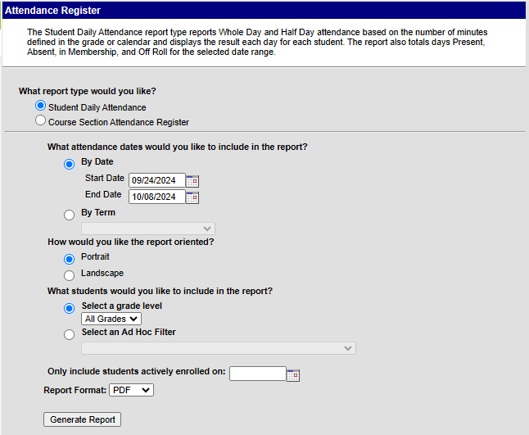

**Report 2: Enrollment Entry/Exit**

*This should pull all students who entered this school year and exited prior to the end of the count window. The results would change depending on the date entries used in the Add and Drop Date fields.*

*This report can be very useful for double checking your enrollment data. It is only needed for audit purposes in some special student scenarios and programs.*

1. Go to **Student Information/Reports/Enrollment Status**
2. Choose **All Students** for grades to include in the report
3. Choose **Active Year** for the calendar
4. For **Enrollment Add Date**, include July 1st through the Count Day (ex: 7/1/2024-10/1/2024)

* *If your school is approved for an alternative count day, then use that date*

1. For **Enrollment Drop Date**, include July 1 through the end of the 11-day window (ex: 7/1/2024-10/8/2024)

* *If your school is approved for an alternative count window, then use those dates*

1. For **Display Options**, make sure both Start Date and End Date are checked
2. Choose whatever sorting method you prefer
3. Click **Generate Report**
4. Schools should **always** review the entry report and exit report to ensure accuracy and save them as PDFs using the following naming convention: “*SchoolCode_School*_EnrollmentOctCt_*CurrentDate*”

Example: 1633_CECA_**Enrollment**OctCt_10162024

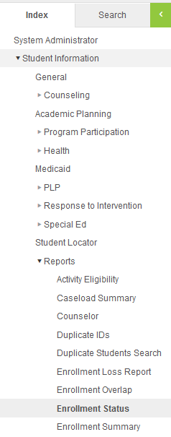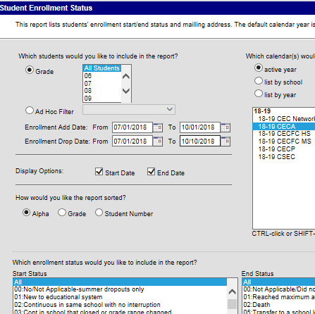

**Report 3: Student Schedules** (Typically, grades 6-12 where students move between classes and have passing periods)

**\*\*This report needs to be run on Count Day and submitted to G-Drive by the end of the day\*\***

1. Go to **Scheduling/Reports/Schedule Batch**
2. For **Report Options**, you can use the default format or choose from the display options
3. For **Grade**, choose All Students
4. Click **Generate Report**
5. Schools should **always** review the student schedules export to ensure accuracy and save it using the following naming convention:

“*SchoolCode_School*_StudentSchedulesOctCt_*CurrentDate”*

Example: 1633_CECA_**StudentSchedules**OctCt_10012024

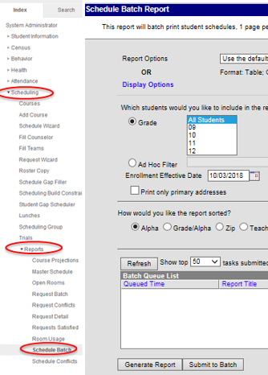

### PowerSchool Report Extracts

The following instructions illustrate how to extract Attendance, Enrollment, and Student Schedule reports from PowerSchool.

Even though some screenshots may not illustrate the current school year, they should still be applicable in a general sense and won’t be updated until they change significantly with the vendor. However, be sure to use the dates described in the steps rather than those in the screenshot if it is from a different year.

**REVIEW YOUR REPORTS FOR ACCURACY BEFORE SUBMITTING TO CSI!**

**Before Extracting any Reports First Create a Reporting Segment**

In order to create a report based on the 11-day window (5 days prior, Count Day, and 5 days after), you’ll need to first create a Reporting Segment.

1. In the left hand menu, click on **System Management/Reports/Reporting Segments (under System Reports)**
2. Click **New**
3. For **Segment Name**, include a name like “October Count [YEAR]”
4. For **Start Date**, choose the start date of the 11-day window (09/24/2024 or approved alternative count window date)
5. For **End Date**, choose the end date of the 11-day window (10/08/2024 or approved alternative count window date)
6. *To create a separate extended attendance report for students absent on Count Day (10/1/2024 or your approved alternative count day), use 7/1/2024-10/31/2024*
7. Click **Submit**

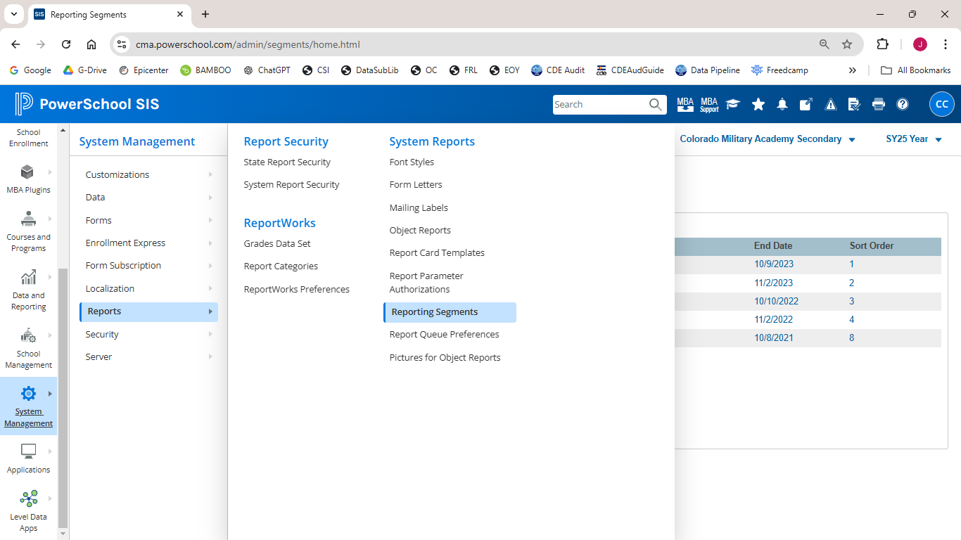

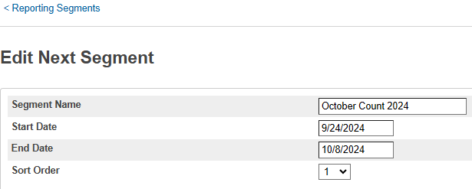

**Report 1: Attendance**

***Before running this report, you’ll want to follow these steps to refresh your attendance.***

1. In the left hand menu, click on **Attendance/Refresh Premier Attendance View Data (under Attendance Management header)**
2. The Refresh Attendance Views Data Report screen appears
3. Specify the students to be included in the refresh process
4. Specify the date range for which you wish to refresh the attendance views
5. Click Submit. The report will begin to process in the report queue
6. When the report is complete, click the View link to review the status of the refresh process

***After you have refreshed your attendance, follow these steps to generate the attendance report***

1. In the left hand menu, click on **Data and Reporting/Reports/System Reports**
2. Click on **Monthly Student Attendance Report**
3. Select appropriate **Attendance Mode** and **Conversion** (typically, “Meeting” and “Period to Day”)
4. For **Students to Include**, select “All Students”
5. For **Reporting Segment,** select the date range you created at the beginning of these instructions
6. For **The report will break to a new page for each:** choose “Month”
7. Click **Submit**
8. Schools should **always** review this report to ensure accuracy and save it as a PDF using the following naming convention: “*SchoolCode_School*_AttendanceOctCt_*CurrentDate*”

Example: 0075_AHS_AttendanceOctCt_10162024

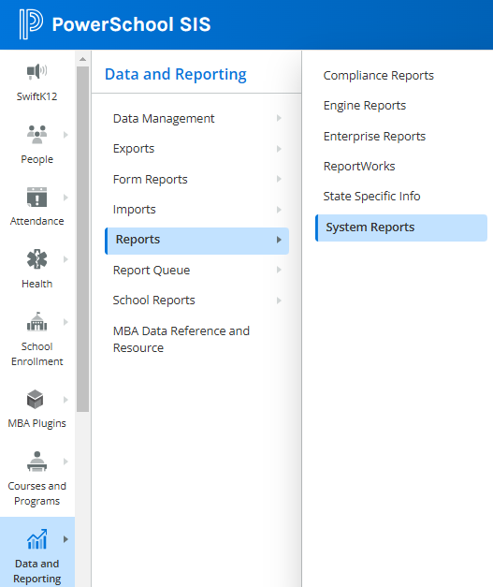

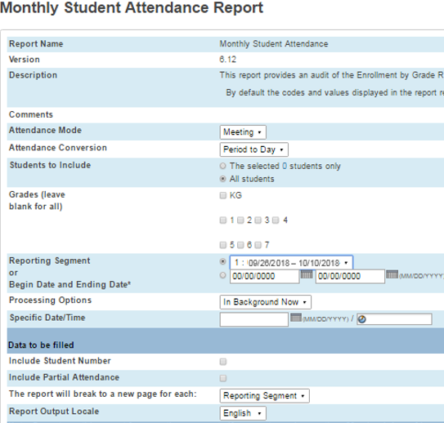

**Reports 2: Enrollment Entry / Exit**

*This report can be very useful for double checking your enrollment data. It is only needed for audit purposes in some special student scenarios and programs.*

1. On the Start Page of PowerSchool, add the following into the Search bar:

/EntryDate>=7/1/2024;EntryDate<=10/8/2024

With the last entry date being the last day of your school’s 11-day window.

1. Click the search (magnifying glass icon)
2. Click on the down arrow next to the **Select Action** button (bottom right at the end of the student list)
3. Click on **Quick Student Export**
4. Type the following in the **List Students** screen

LastFirst

State_StudentNumber

grade_level

EntryCode

EntryDate

ExitCode

ExitDate

Enroll_status

1. Leave the other criteria options as the default values
2. Click **Submit.**
3. A file will download. Schools should **always** review the report to ensure accuracy.

Notes on Enroll Status Codes:

0 is active

-1 is PRE REGISTERED

2 is transferred out

1. Save this file using the following naming convention: “*SchoolCode_School*_EnrollmentOctCt_*CurrentDate*”

Example: 0075_AHS_**Enrollment**OctCt_10162024

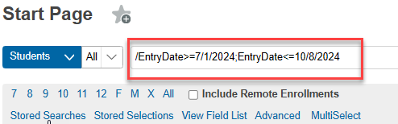

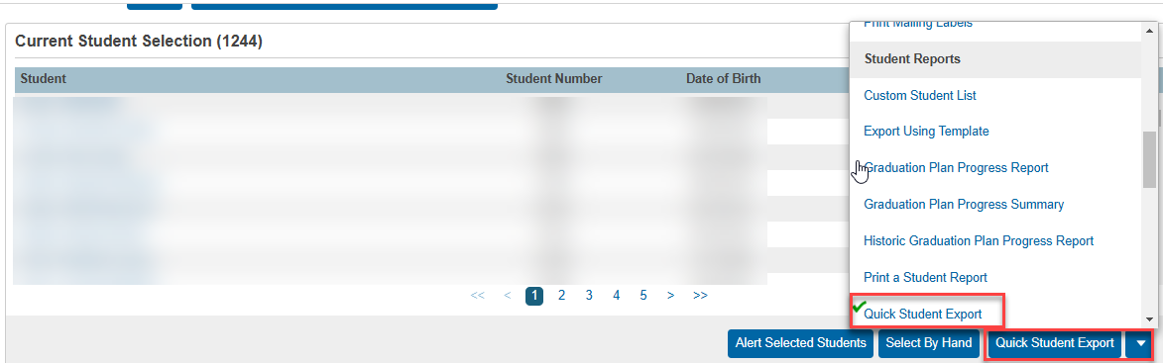

**Report 3: Student Schedules** (Typically, grades 6-12, where students move between classes and have passing periods)

**\*\*This report needs to be run on Count Day and submitted to G-Drive by the end of the day\*\***

1. To get a list of active students on Count Day, type the following in the search box on the Start Page:

**\*As_of=MM/DD/YYYY**

with MM/DD/YYYY being the date of Count Day

1. Click on the down arrow next to the **Select Action** button (bottom right at the end of the student list) and select **Export Using Template**
2. For **Type of Export**, choose “Student Schedules”
3. For **Export Template?,** choose “October Count” (this name could vary depending on how Reporting Segment was named)
4. For **Which Records?**, choose “Only schedules for the XXXX selected students”
5. Click **Submit**
6. You will get an Excel file listing students by name and period. You will want to sort by name so each student’s classes are grouped together.
7. Schools should **always** review the student schedules export to ensure accuracy, then save it using the following naming convention: “*SchoolCode_School*_StudentSchedulesOctCt_*CurrentDate*”

Example: 0075_AHS_**StudentSchedules**OctCt_10012024

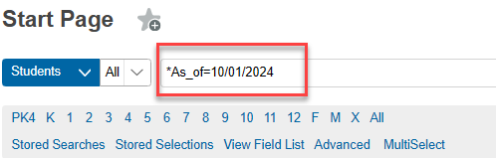

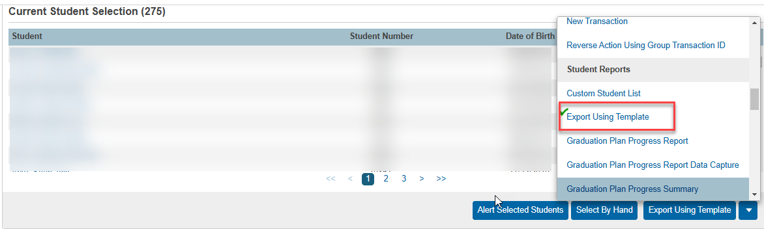

# Appendix II: Crosschecking Funding Eligibility with Student Schedules

**Schools should refer to the** [2024 CDE Student October Count Audit Resource Guide](https://www.cde.state.co.us/cdefinance/auditunit_pupilcount) **to** **accurately conduct calendar and bell schedule calculations in order to then evaluate each student schedule to ensure that each student is submitted with the appropriate funding level.**

By default, both PowerSchool and Infinite Campus have students identified as eligible for full-time funding. It is the school’s responsibility to adjust the funding code for each student based on eligibility criteria (enrollment, attendance, scheduled hours, etc.). The following instructions provide one way to use your SIS to find students who meet (or do not meet) schedule hour criteria to be eligible for part- or full-time funding.

The school is responsible for reviewing the students who don’t have the necessary number of courses to qualify for full time funding and either:

1. update the schedule so that on/before Count Day, the student has the required number of courses

or

1. adjust the student’s funding status so that on/before Count Day, the funding status is accurate.

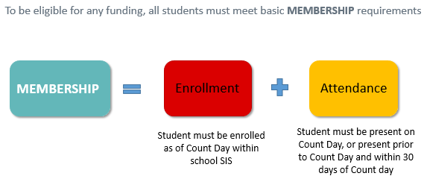

See the CSI webpage on [School Calendar and Instructional Hours](https://resources.csi.state.co.us/calendar-and-instructional-hours/) for resources on instructional hours and scheduling requirements for accreditation. The [CDE Calendar and Instructional Hours Guidance](https://resources.csi.state.co.us/cde-calendar-and-instructional-hours-guidance/)​ document is particularly important.

### PowerSchool Instructions

Keep in mind that the following instructions work well for mainly simple bell schedules. If a school is using complicated block schedules such as where courses vary by day of the week or if students are enrolled in post-secondary types of courses where credits are used instead of seat time, then this check becomes much less useful.

In the Search bar, type in ***\*number_of_classes<#***with # being the number of classes needed to qualify for full time funding. Then press ‘Enter” or click the magnifying glass icon to search.

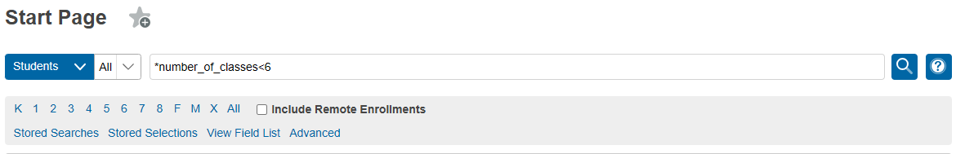

This search will result in a listing of any students with fewer than the number of classes necessary to qualify for full-time funding at this school based on scheduled hours alone.

### Infinite Campus Instructions

Keep in mind that the following instructions work well for mainly simple bell schedules. If a school is using complicated block schedules such as where courses vary by day of the week or if students are enrolled in post-secondary types of courses where credits are used instead of seat time, then this check becomes much less useful.

**Student Gap Scheduler**

The Student Gap Scheduler tool is used to find students with holes in their schedule. This tool may be used to generate a report to show students with a hole in their schedule for staff to identify students who may not qualify for full time funding based on scheduled hours alone.

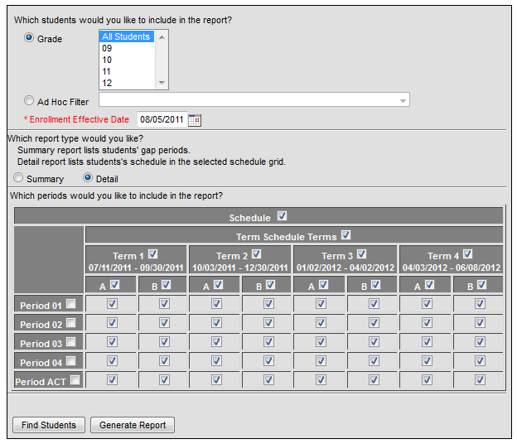

1. Go to: Scheduling > Student Gap Scheduler
2. Select the students whose schedules you wish to analyze (by grade or Ad Hoc filter)
3. Select the enrollment effective date.

Be sure the Enrollment Effective Date is a date within the calendar selected; otherwise no results will be returned. (*Note: Schools should run this report BEFORE Count Day to ensure students have accurate schedules. It should also be run ON Count Day to ensure that students have the appropriate funding status selected based on the Count Day schedule.*)

1. If running the report, select the type of report. The summary mode will list the empty periods each student has. The detail mode will print a mini schedule for the student, with an “X” indicating a scheduled course and gray shading indicating an empty period. *(Note: Detail report tends to be easier to skim to identify students with significant schedule gaps.)*
2. Select the terms/periods for analysis using the checkbox grid at the bottom.
   * Selecting the Schedule checkbox at the top of the grid will automatically check all term/period boxes.
   * Selecting (or deselecting) a term will check all boxes in that term.
   * Selecting (or deselecting) a period will check all boxes for that period.
   * *Note: Schools should select as many terms as needed in order to have half of the school year’s school days included. Ex: In a school with a semester schedule, checking first semester should suffice. In a school with a trimester schedule, check both first and second semester should suffice.*
3. Selecting Find Students will run a search and show students with a hole in their schedule in the search results. Generate report will create a PDF report that may be printed or saved as needed.
4. *Note: Schools can use the Generate Report option to print the mini schedules for students. Schools should then go through the report, identify any students with significant gaps (grey blocks) in the schedule.*

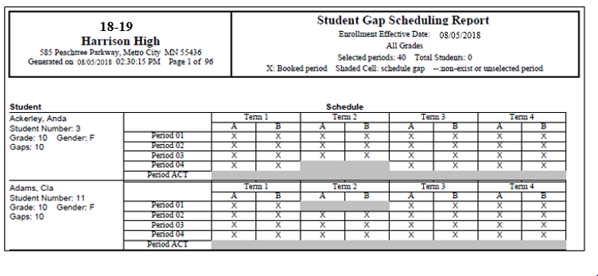

# Appendix III: Free and Reduced Lunch Eligibility Checklist

Resources for determining FRL eligibility status as well as guidance on how to enter data into PowerSchool and Infinite Campus are available on the CSI [Free and Reduced Lunch Eligibility](https://resources.csi.state.co.us/free-and-reduced-lunch-eligibility/) webpage.

All schools are required to **have documentation** that supports the free and reduced lunch eligibility for every student. Schools are responsible for updating their student information system (SIS) to include free and reduced lunch eligibility regularly throughout the year, and particularly before required state reporting deadlines (most importantly for October Count).

Please know that it is the “eligibility” that must be recorded. It is not whether the student is actually receiving free or reduced lunches.

If FRL eligibility status is not being maintained in the SIS (this would be unusual and not recommended), schools or the SFA should communicate with CSI about providing the updated FRL status before required state reporting deadlines, particularly the October Count data collection.

**Once the October Count data is finalized, it cannot be changed, so it is critical that your data is reported correctly. FRL status is used in accountability reports and also in determining At-Risk funding. It is the responsibility of each school to ensure that the data is correct in your October Count file submissions so that you don’t experience negative performance report outcomes, cuts to At-Risk funding from underreporting your FRL data, or audit exceptions during At-Risk state audits for students inaccurately reported as free or reduced lunch eligible.**

**Determining FRL eligibility:**

* For schools not participating with an SFA, you will need to have families fill out the state FEDS form to determine FRL eligibility status for each of your students for the current school year. Current year forms, instructions to provide to families, and the eligibility guidance have all been posted to the CSI [Free and Reduced Lunch Eligibility](https://resources.csi.state.co.us/free-and-reduced-lunch-eligibility/) webpage.
* For schools using an SFA this year, please be sure to have families complete the federal meal plan application using the SFA nutrition system and work with the SFA on eligibility determinations in your SIS for all students. This includes schools using the CSI SFA.

**All schools are strongly encouraged to complete the following FRL checklist as part of the October Count collection and internal audit. Check off the following items as you complete them. A signature form is not included with this FRL checklist for the current year.**

**School is participating with an SFA:**

**The Healthy Meals for All program, which began in 23-24 allows public School Food Authorities (SFAs) participating in the National School Lunch and Breakfast programs to provide free meals to all students. For accountability purposes plus At-Risk and Title I funding, CSI schools still need to ensure they are collecting FRL eligibilities and storing that data in their SIS in order to extract the data for state collections during the year.**

Completed the current year CSI Organizational Submissions, Food Service Participation Survey by the August deadline (*lets CSI know whether your school is participating with an SFA or not for the current year*).

Current year federal meal benefit application and instructions have been provided to all families.

* Very Important- these should not be completed and signed prior to July 1 or they are invalid!
* For the October Count collection, the forms must be signed between July 1 and count day (October 1st for 24-25).
* Continue to provide forms to all new students as they transfer in. Work with your SFA on the exact process because this may be automated.

Consider scheduling opportunities for families to complete federal meal benefit application or at the school (back to school event, before/after school, orientation event, zoom meeting, conference call, etc.).

Consider sending direct communications to families encouraging them to complete the federal meal benefit application form.

An MOU, privacy statements, and all processing steps for file exchanges have been finalized with the SFA that your school is contracting with (your school is ready to begin exchanging data with the SFA).

All completed federal meal benefit application forms have been provided to the SFA (if on paper) Consider having a tracking sheet to ensure that all families have completed a form. Double check that the forms are complete, accurate, and signed & dated before submitting to your SFA.

In the absence of current year FRL eligibility documentation (typically only for last minute enrollees before count date), you may **utilize carryover documentation** evidencing free lunch eligibility through the current year count day.

* You may use the carryover only if you do not have anything new for the current year eligibility status. In other words, you cannot use a free or reduced lunch status from the carryover just because there is a new status for the current year and the student is now not eligible.
* In cases where students transfer between districts on or before the count date, the USDA does allow for the transfer of lunch eligibility status from one district to another. In such cases, if the receiving school is able to include the student in the October Count the school can report the student’s lunch eligibly status from the prior district if it has documentation as to the student’s eligibility from the prior district. In the absence of such documentation, the receiving school must obtain new or updated documentation evidencing the student’s lunch eligibility.

All student records have an updated FRL eligibility status as of the October Count date in the school SIS.

**In 23-24, an additional FRL field named “FRL Eligibility Identification” was added to the Student Demographic file layout. This field is required for all students and must be populated in the school SIS with the applicable type of documentation the school used to identify the student as free lunch eligible.**

Student records have been updated to free lunch eligible where a CSI signed McKinney-Vento form has been returned to the school (student is considered homeless). MKV form must have been signed by CSI by count day to report the student as homeless and free lunch eligible in the October Count collection.

Student records have been updated to free lunch eligible where a student shows up on the CDE **migrant** list. Schools should receive an error message in the October Count file submission if migrant students are not coded as free lunch eligible.

Student records have been updated to free lunch eligible where CSI has notified our school on a **foster** student. Schools should receive an error message in the October Count file submission if foster students are not coded as free lunch eligible.

Student records have been updated to free lunch eligible where **extended eligibility** to other students residing in the same household is allowable by direct certifications (SNAP/TANF or Medicaid). This is not allowable in the case of migrant or foster scenarios.

Schools should create a document noting the name of the school staff member who flagged the student, the date it was done, and retain that document in case the student is part of an At-Risk audit sample.

The SD file extract from your SIS has been reviewed to ensure that FRL statuses appear correct for all students prior to submission to CSI.

The FRL Counts within the October Count summary report (including trend data) have been thoroughly reviewed prior to the certification deadline (please do this as soon as you receive the summary report to allow plenty of time to correct data if needed).

**School is not participating with an SFA:**

Current year state FEDS forms and instructions have been provided to all families

* For the October Count collection, the forms must be signed between July 1 and count day (October 1st for 24-25).
* Forms completed and signed prior to July 1 are invalid!
* Continue to provide FEDS forms to all new students as they enroll

Consider scheduling opportunities for families to complete the state FEDS form at the school (back to school event, before/after school, orientation event, Zoom meeting, conference call, etc.).

Consider sending direct communications to families encouraging them to complete the state FEDS form.

All state FEDS forms have been collected from families and processed to determine the FRL eligibility status for each student. Consider a tracking system to ensure all forms have been returned. Double check that the forms are complete, accurate, and signed & dated between July 1 and Count Day of the current school year.

In the absence of current year FRL eligibility documentation (typically only for last minute enrollees before count date), you may **utilize carryover documentation** evidencing free lunch eligibility through the current year count day.

* You may use the carryover only if you do not have anything new for the current year eligibility status. You cannot use a free or reduced lunch status from the carryover just because there is a new status for the current year and the student is now not eligible.
* In cases where students transfer between districts on or before the count date, the USDA does allow for the transfer of lunch eligibility status from one district to another. In such cases, if the receiving school is able to include the student in the October Count the school can report the student’s lunch eligibly status from the prior district if it has documentation as to the student’s eligibility from the prior district. In the absence of such documentation, the receiving school must obtain new or updated documentation evidencing the student’s lunch eligibility.

All student records have an updated FRL eligibility status as of the October Count date in the school SIS.

**In 23-24, an additional FRL field named “FRL Eligibility Identification” was added to the Student Demographic file layout. This field is required for all students and must be populated in the school SIS with the applicable type of documentation the school used to identify the student as free lunch eligible.**

Student records have been updated to free lunch eligible where a CSI signed McKinney-Vento form has been returned to the school.

Student records have been updated to free lunch eligible where a student shows up on the CDE **migrant** list. Schools should receive an error message in the October Count file submission if migrant students are not coded as free lunch eligible.

Student records have been updated to free lunch eligible where CSI has notified our school on a **foster** student. Schools should receive an error message in the October Count file submission if foster students are not coded as free lunch eligible.

Student records have been updated to free lunch eligible where **extended eligibility** to other students residing in the same household is allowable by direct certifications (SNAP/TANF and Medicaid). This is not allowable in the case of migrant or foster scenarios.

Schools should create a document noting the name of the school staff member who flagged the student, the date it was done, and retain that document in case the student is part of an At-Risk audit sample.

The SD file extract from your SIS has been reviewed to ensure that FRL statuses appear correct for all students prior to submission to CSI.

The FRL Counts within the October Count summary report (including trend data) have been thoroughly reviewed prior to the certification deadline (please do this as soon as you receive the report to allow plenty of time to correct data if needed).