The following guidance provides a starting point for ensuring key areas related to state reporting are appropriately set up. Schools should make use of the PowerSchool Colorado webpage and PowerSchool support for advance system set up questions. PowerSchool SIS Start of Year Guide located in the PowerSchool Community is an excellent comprehensive resource.
CSI schools are expected to review their SIS by August 1st each year to ensure the setup expectations outlined below, which directly impact state reporting, are met. Schedules for secondary school students (grades 7-12) should be set up in the SIS by September 1st each year. CSI Data Submissions Team members may audit components of SIS setup each year.
 | DISTRICT LEVEL CHECKS
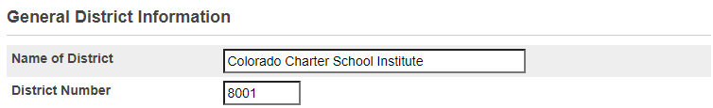  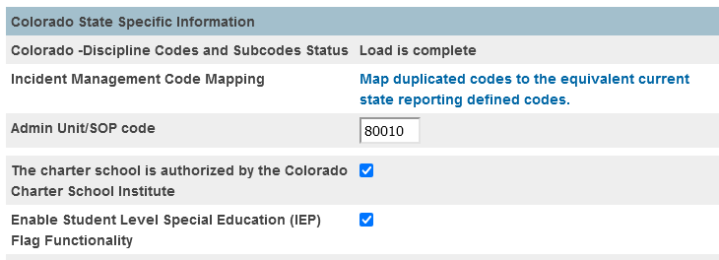 | DISTRICT INFO  District Office > District Management > District Setup > District Info  - Verify that District Number = 8001  - Verify that Admin Unit/SOP code = 80010  - Verify This charter school is authorized by the Colorado Charter School Institute checkbox is checked so records are not duplicated in the SD files of students transferred between two CSI schools in one school year.  - When this box is checked PS will remove any student with an Exit Type code of 11 from the SD file. This simply cuts down on SP149 Errors.  - The IEP flag check box is highly recommended as well.  This is a priority for new schools.
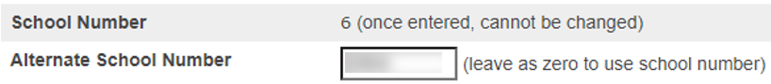 | SCHOOL INFO  District Office > District Management > District Setup > School Info  - Click name of school in list  - Verify School Number = state code for school  - If School Number does not show the state code for school, then  - Verify Alternate School Number = state code for school
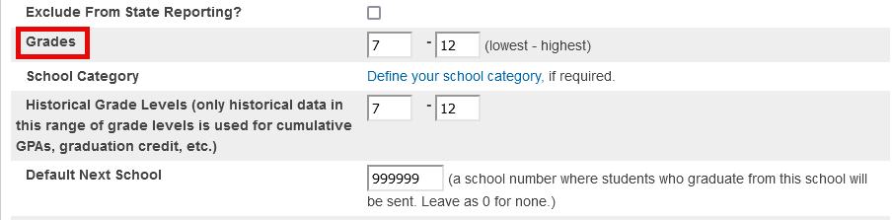 | GRADE LEVELS  Same page as above  - Verify that the grade levels are mapped to the correct State Grade Level  Check Against:  Any expected Grade Level changes for the coming year. All expected grade changes should be confirmed with CSI in the Spring prior to the change taking effect.  This is a priority for new schools and schools with grade level changes.
 | SCHOOL LEVEL CHECKS – check each school on the server
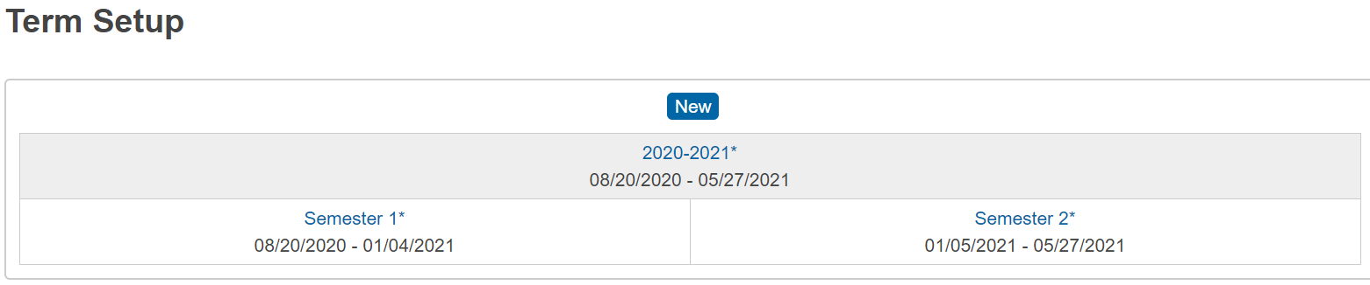  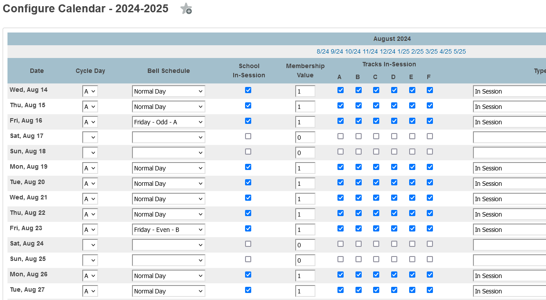  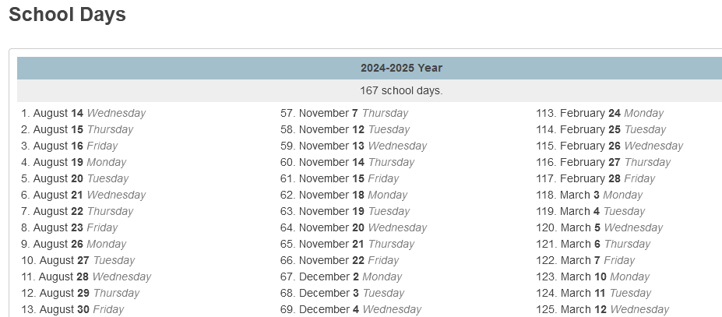 | TERMS & CALENDARS  School Management > Scheduling > Years and Terms  - Click Edit Terms for current school year  Check Against:  Calendars submitted in May  School Management > Scheduling > Configure Calendar  - Check that days “In-Session” have: Cycle Day, Bell Schedule and Membership Value  - Check whether there are >160 days  Scroll to bottom of page and click “Verify # of school days in the current term” (confirm you are in the full year for the school - upper right corner in PS). You will get a report that lists each day flagged as In Session with a total count at the top.  Any schools with <160 days must be approved by the state. All schools operating <160 days/4 day weeks should be confirmed with CSI in the Spring prior to the <160 days/4 day week taking effect.  References: CRS 22-33-104 1(b)  A school or schools shall not be in session for fewer than one hundred sixty days without the specific prior approval of the commissioner of education.  Resources:  System Help: Calendar
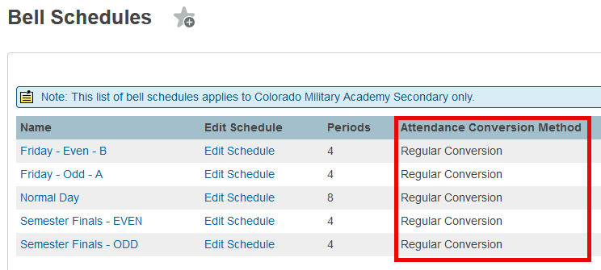  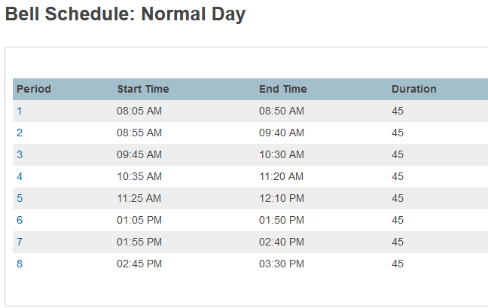 | SCHEDULES & PERIODS  School Management > Scheduling > Bell Schedules  - Verify that each bell schedule is assigned an attendance conversion method.  School Management > Scheduling > Bell Schedules > Edit Schedule  - Verify Instructional Minutes, School Day Minutes  - Verify passing periods  - Determine which periods will occur in each bell schedule.  - Determine which periods count towards ADA calculations.  Check Against:  Bell Schedules submitted in May  References: October Count Audit Guide  - Passing periods are defined as the time between two classes, and between a class and a lunch period  - Passing periods up to seven minutes may be included in the calculation of full-time or part-time funding.
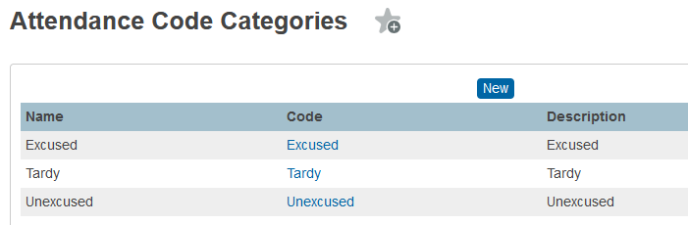  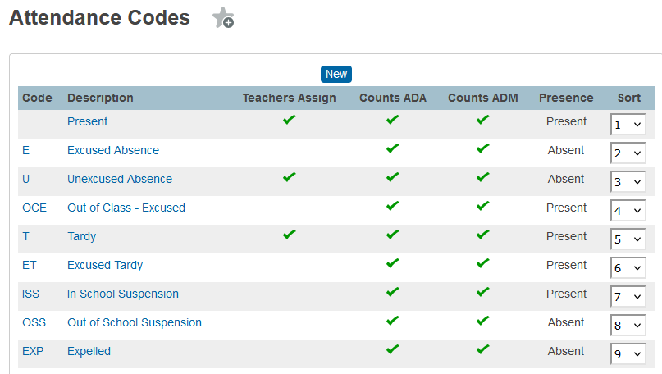 | ATTENDANCE  When creating a new year term, PowerSchool copies the attendance codes and categories from the previous school year, eliminating the need to recreate attendance codes and code categories from scratch.  School Management > Attendance > Attendance Code Categories  - Only 3 attendance categories are needed: Tardy, Excused, Unexcused.  School Management > Attendance > Attendance Codes  - Confirm that Expulsion and Suspension codes are marked as Excused Absence.  References: 1 CCR 301-78  - Absences due to suspension or expulsion of a child must be considered excused absences.  - For Department reporting purposes, a student who is absent more than 50 percent of any Attendance Period during a scheduled school day shall be considered absent for that entire recorded and reported period.  - For Department reporting purposes, a student who is present 50 percent or more of any Attendance Period during a scheduled school day shall be considered present for that entire recorded and reported period.  Resources:  - Community How It Works: Attendance Codes  - Colorado State Reporting Setup: PowerSchool Colorado Attendance Setup
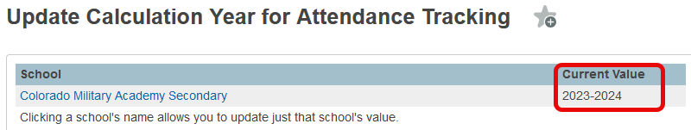 | District Management > Attendance > Update Calculation Year for Attendance Tracking  Ensure the Calculation Year is set for each school. This must be updated each year! Failure to do so may lead to students meeting the definition of truant but not showing up as truant in the SSA file.
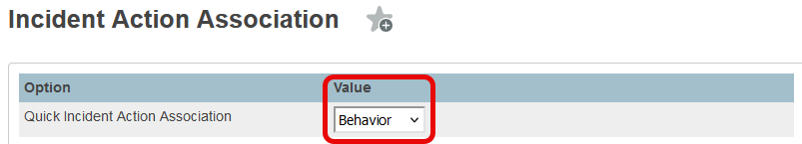 | BEHAVIOR SETUP  District Management > Behavior > Incident Action Association  - Verify that Quick Incident Action Association is set to Behavior
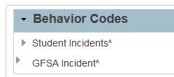  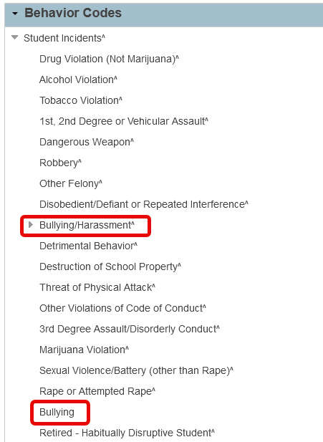 | BEHAVIOR CODES  District Management > Behavior > Incident Codes and Subcodes > Behavior Codes  - Scroll to bottom of page and open Behavior Codes > Student Incidents  - Verify that Behavior Codes are set up for each State Behavior Type  - Confirm that both Bullying/Harassment AND Bullying are in list  Check Against:  State reportable Behavior Type in Discipline Action File Layout.  CAUTION: It is best to not modify this list. Updates to Compliance Reporting are pushed out regularly by PowerSchool.  References: Discipline Action File Layout  - To access a list of state reportable Behavior Codes
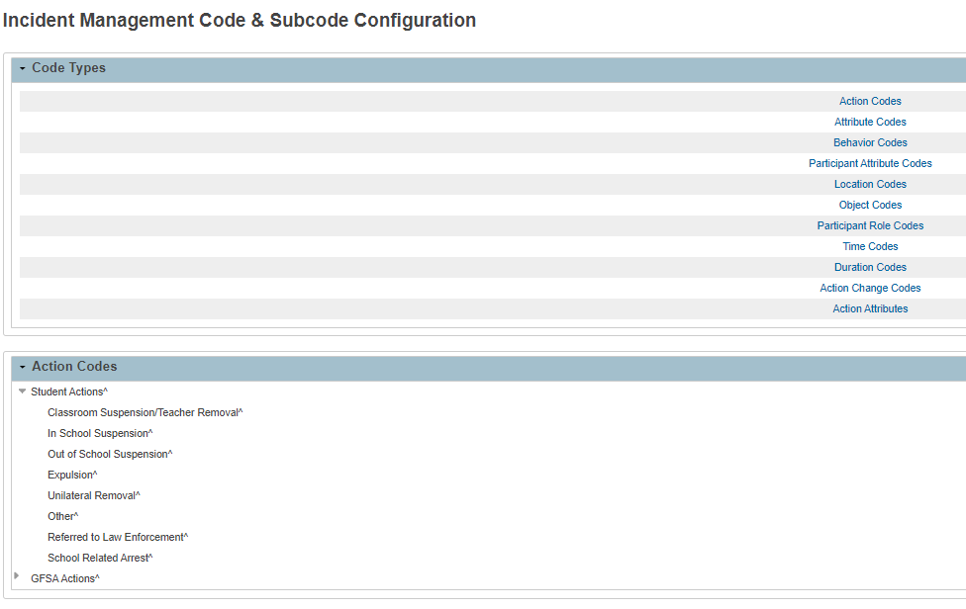  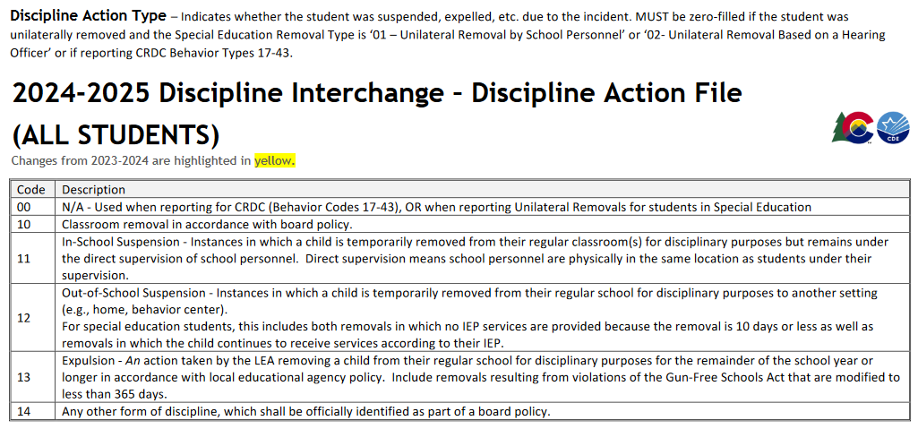 | ACTION CODES  District Management > Behavior > Incident Codes and Subcodes > Action Codes  - Scroll to bottom of page and open Action Codes > Student Actions  - Verify that action codes are set up for each State Discipline Action Type  Check Against:  State reportable Action Type in Discipline Action File Layout.  References: Discipline Action File Layout  - To access a list of state reportable Action Codes  NOTE:  The State Resolution coding options changed in 23-24 in order to align with HB22-1376. There are 6 main Coding options available in the Discipline Action field and are listed on the Discipline Action File Layout . These start with 00, which is used for CRDC purposes and then 10-14. This includes Classroom Removal, ISS, OSS, Expulsion and Any Other Form of Discipline. Other fields on the file capture additional resolutions, including arrests, restraints, seclusion, and handcuffed status.  The best option to ensure all are included is to open the Action Codes in PowerSchool along with some retired options. Review all non-retired options with a carat (^) to ensure they match up with the listed options on the file layout. PowerSchool generally does a good job of keeping these updated and available for usage as long as you are on the most current version. All options PS adds will be listed options available to you, but just ensure all action types are included in the code and subcode setup.
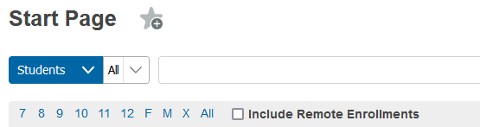  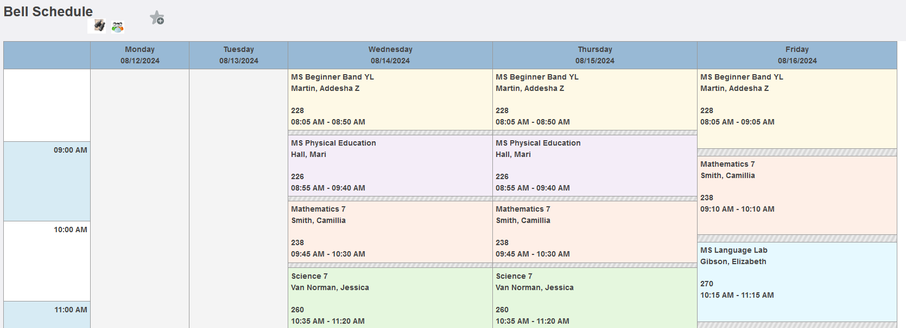 | STUDENT SCHEDULES  Schedules for secondary school students (grades 7-12) should be set up in the SIS by September 1st each year.  Select a School > Start Page  - Select a group of secondary students by clicking on one grade level or the word All to display a list of students.  - Click on a student name.  - If Bell Schedule is not the default screen, select Courses and Programs > Bell Schedule.  - Check that the view shows the student listed in some classes like the example to the left.  - Navigate through students using the left / right arrows in the upper left corner.  Confirm that students generally look scheduled into courses for the first half of the year (i.e., Q1-2 OR Sem 1, OR Tri 1-2). If all students (or an anomalous number of them) have zero classes scheduled, then reach out to the school to see why.

