The following guidance provides a starting point for ensuring key areas related to state reporting are appropriately set up. Schools should make use of the IC Knowledge Base through the links below and IC support for advance system set up questions.
CSI schools are expected to review their SIS by early August each year to ensure the setup expectations outlined below, which impact state reporting, are met. CSI Data Submissions Team members may audit components of SIS setup each year.
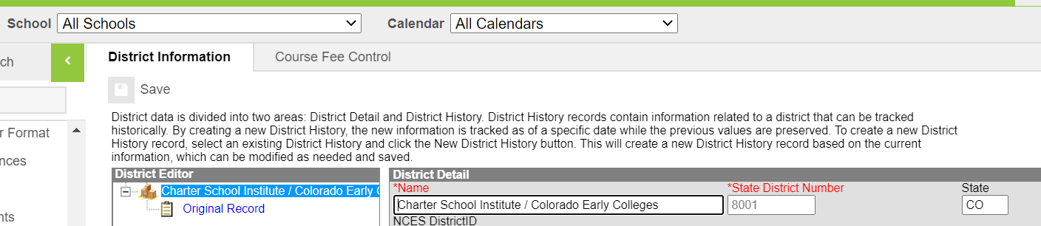 | DISTRICT INFO  System Administration>Resources>District Information  If you don’t see this option, ensure ‘All Schools’ is selected in the School dropdown for networks with multiple schools on a system.  Check for 8001 district code
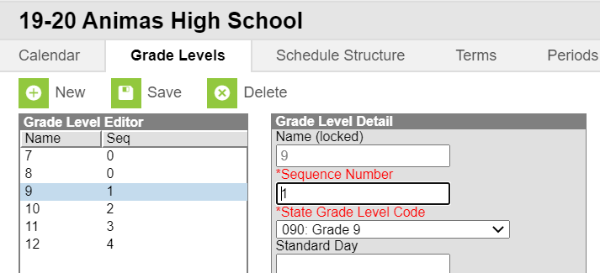 | GRADE LEVELS  System Administration>Calendar>Calendar>Grade Levels  Verify that the grade levels are mapped to the correct State Grade Level  Check Against:  Any expected Grade Level changes for the coming year. All expected grade changes should be confirmed with CSI in the Spring prior to the change taking effect.  https://kb.infinitecampus.com/help/grade-levels
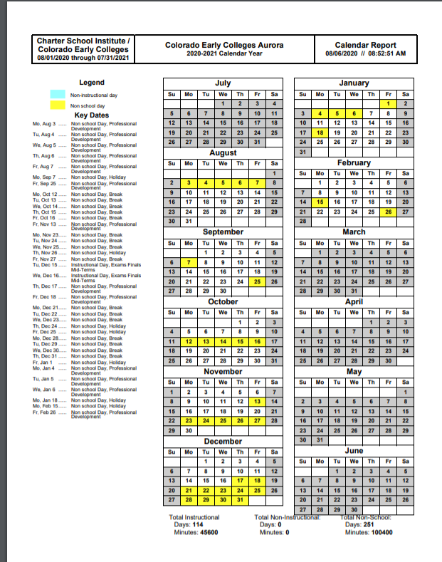 | CALENDAR  System Administration>Calendar>Calendar>Days>Print  Check whether there are >160 days  For reference, schools generally have 160-180 days instructional days. Schools with significantly more or less may have set up issues.  Any schools with <160 days must be approved by the state. All schools operating <160 days/4 day weeks should be confirmed with CSI in the Spring prior to the <160 days/4 day week taking effect.  References: CRS 22-33-104 1(b)  A school or schools shall not be in session for fewer than one hundred sixty days without the specific prior approval of the commissioner of education.  https://kb.infinitecampus.com/help/days (Calendar Days Report)
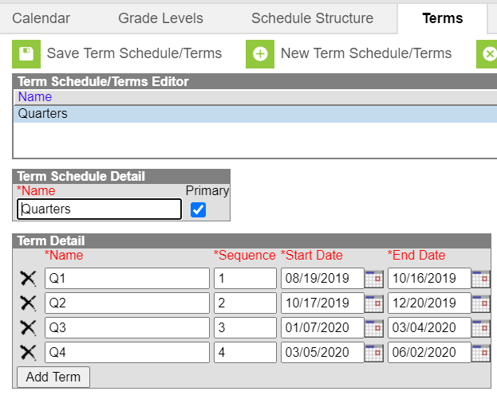 | TERMS  System Administration>Calendar>Calendar>Terms  Verify term start and dates  https://kb.infinitecampus.com/help/terms
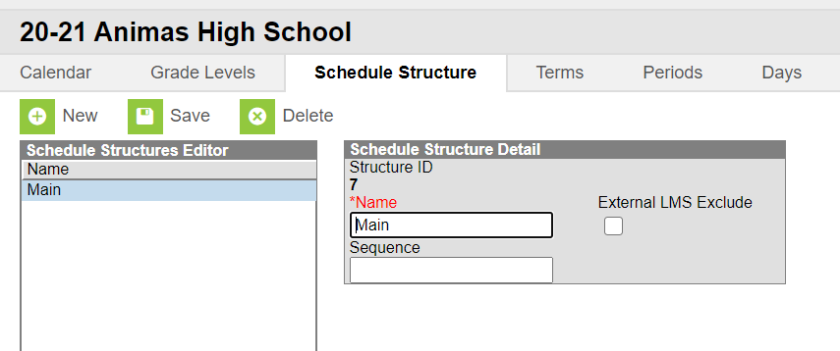 | SCHEDULES  System Administration>Calendar>Calendar>Schedule Structure  Click the schedule dropdown to view each schedule.  Consider whether there may need to be one for elementary, middle, high, homeschool.
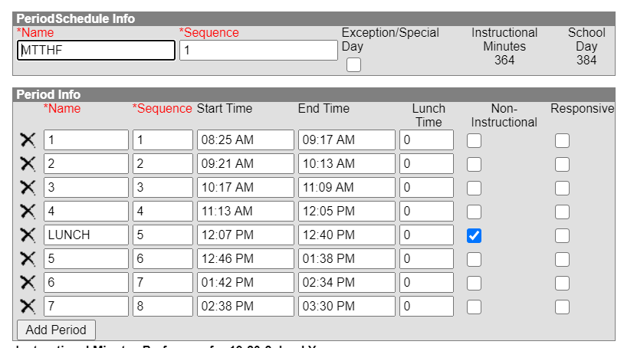 | PERIODS  System Administration>Calendar>Calendar>Periods  Verify Instructional Minutes, School Day Minutes  Verify passing periods  Periods that are non-instructional should be marked as such  Verify that lunch is noted either in lunch time or as non-instructional  References: October Count Audit Guide  - Passing periods are defined as the time between two classes, and between a class and a lunch period  - Passing periods up to seven minutes may be included in the calculation of full- or part-time  funding.  https://kb.infinitecampus.com/help/periods
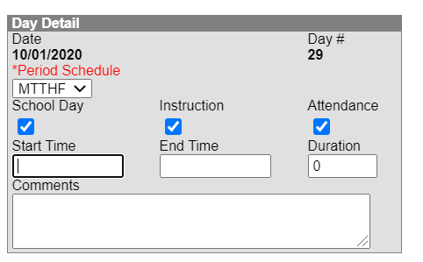 | DAYS  System Administration>Calendar>Calendar>Days  Use Period Schedule dropdown to change view if needed  Spot check a couple days, both school days and known vacation days (ex: Labor Day will likely be a day off-confirm that’s the case on the calendar).  Instruction and Attendance should be unchecked if classes do not meet  https://kb.infinitecampus.com/help/days
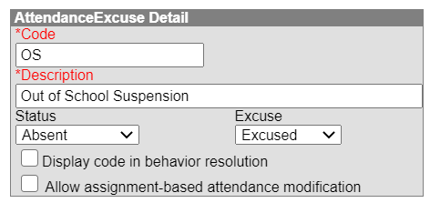  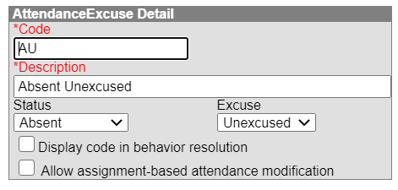  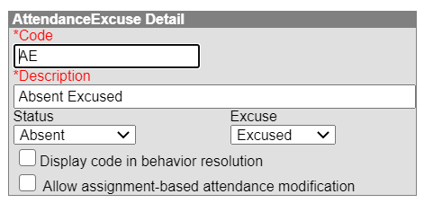  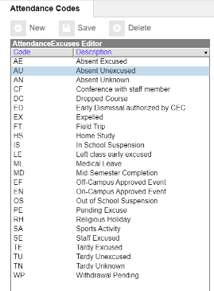 | ATTENDANCE  System Administration> Attendance> Attendance Codes  Excuse Codes  Verify ‘Status’ and ‘Excuse’ settings for Absence Excused, Absence Unexcused. If Suspension is an existing code, check that it’s Absent Excused.  ‘Display code in behavior resolution’ allows user to Update attendance when assign behavior resolutions  References: 1 CCR 301-78  - Absences due to suspension or expulsion of a child must be considered excused absences.  https://kb.infinitecampus.com/help/attendance-admin
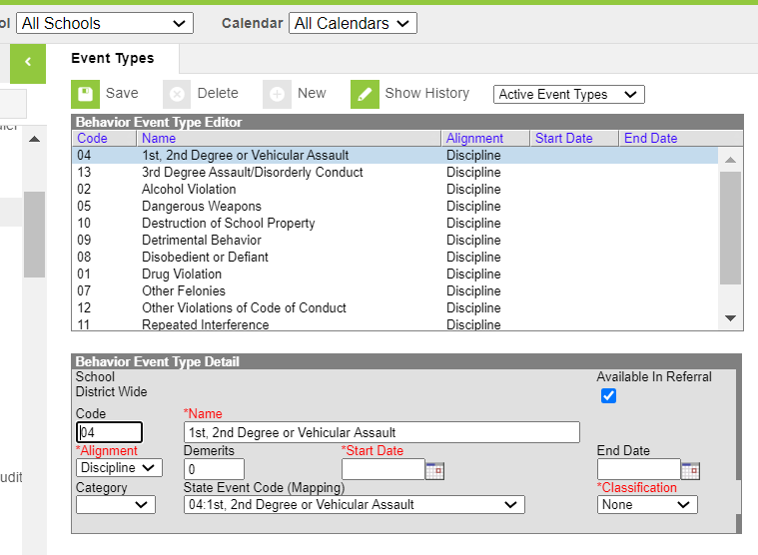 | BEHAVIOR EVENT CODES  Behavior >Admin>Event Types  Note: Be sure you are in the All Schools dropdown in case the school has mapped state reportable events and resolutions at the district level  Verify that event types are set up for each ‘State Event Code’. There are 16 Discipline Collection event codes and 12 CRDC codes that must be set up in the system.  Check Against:  State reportable Behavior Type codes in Discipline data collection.  References: Discipline Action File Layout  - To access a list of state reportable events  https://kb.infinitecampus.com/help/event-types
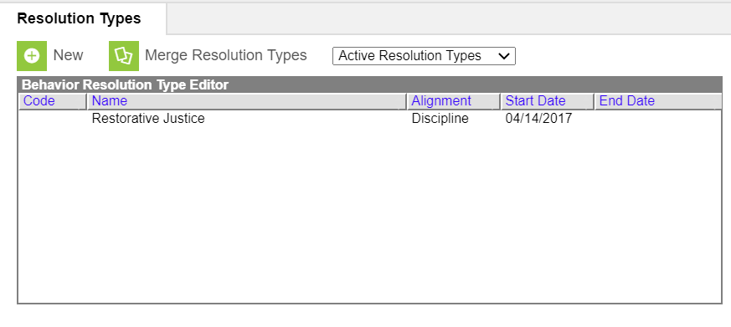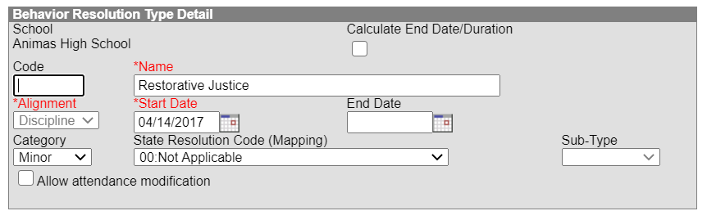 | BEHAVIOR RESOLUTION CODES  Behavior>Admin>Resolution Types  Note: Be sure you are in the All Schools dropdown in case the school has mapped state reportable events and resolutions at the district level  Verify that resolution types are set up for each ‘State Resolution Code’  If ‘Allow attendance modification’ is  Checked, users can select from attendance  excuse codes - see Attendance section above  References: Discipline Action File Layout  - To access state reportable resolutions (10-14).  https://kb.infinitecampus.com/help/resolution-types
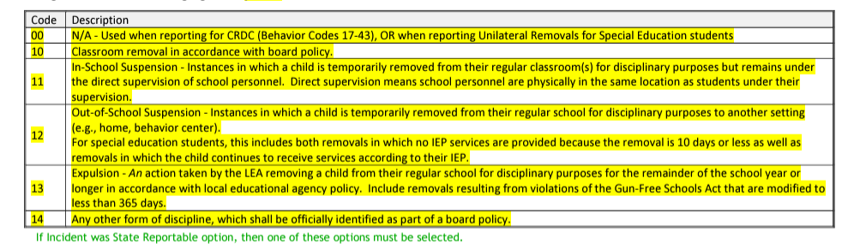  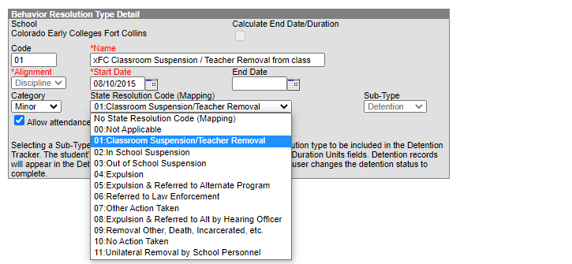 | Behavior>Admin>Resolution Types  There are six options as it relates to resolution coding (Discipline Actions), 00-14. This has been updated in 23-24 to streamline the process and align the changes with HB22-1376. In addition to these, there are other field options, including details on restraint, law enforcement, and seclusion.  With the changes to IC, it appears that they did not update the State Resolution Code (Mapping). The best option to ensure all are included is to open a resolution in IC and click on the State Resolution Code (mapping) dropdown. You will see in this list all the new coding options that should be added and mapped in your Behavior Resolution setup. You can compare those with the Discipline Action File Layout fields. If the mapping needs to be adjusted, go to Admin>Resolution Types. Click on each type and update the State Resolution Code (Mapping) field.  Ensure all the options are available in the Resolution Types administration section.
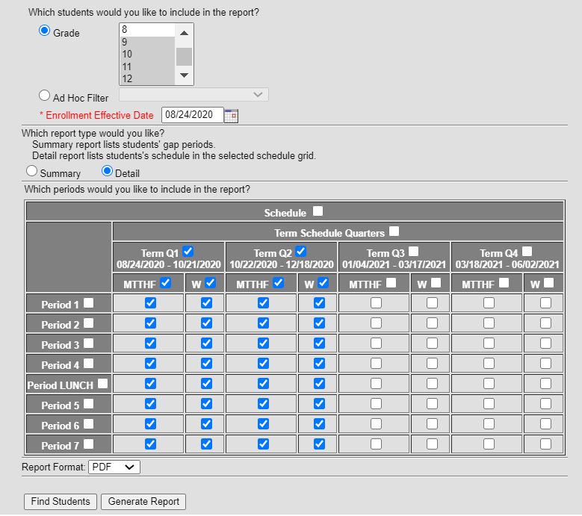 | STUDENT SCHEDULES check between September 1st-15th  Scheduling>Student Gap Scheduler  Confirm that students generally look scheduled into courses for the first half of the year (i.e., Q1-2 OR Sem 1, OR Tri 1-2)  https://kb.infinitecampus.com/help/student-gap-scheduler

