- Apply online at https://linqconnect.com/ beginning July 15, 2024

Completing the 2024-2025 Free and Reduced Lunch Application
- Register to create an account OR click “Free & Reduced Meal Application ”
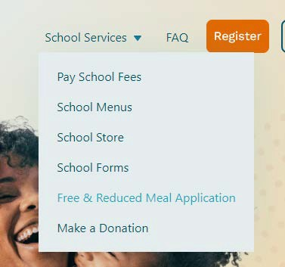
- Choose your school as your School District
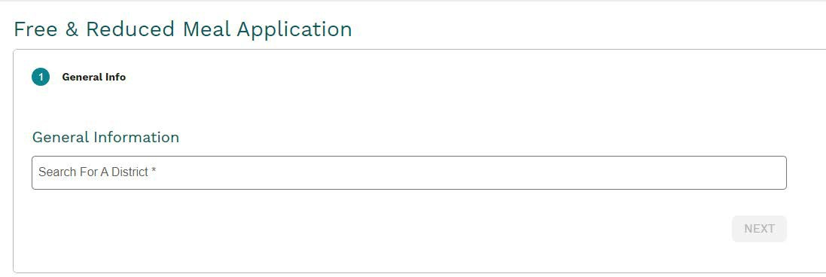
- Fill out your information and click “Submit”

Next Steps
CSI will process information within 10 operating days of receiving your application. Your status will be emailed to you if you provide an email address otherwise, it will be mailed to you. For more information on your application contact MaggieNecaise@csi.state.co.us

