Educator Identifier (EDID) Attainment and Update Process

Contents
EDID Attainment Request Process 3
Overview and Resources 3
Process Overview 3
School’s Role 3
CSI’s Role 3
EDID Process for Schools 4
Accessing and Using EDIS (to Identify Staff Needing EDID) 4
Logging into EDIS 4
Searching for Staff in EDIS 5
Follow CDE’s Best Practices 6
Determining Next Steps 6
Requesting New EDIDs 8
EDID Template Requests 8
Template Submission Instructions 8
Update Existing EDIDs 9
EDID Template for Updates 9
Template Submission Instructions 9
Submitting & Retrieving EDID Requests and Updates 10
Google Drive 10
To submit files to CSI through G-Drive 10
Retrieving completed EDIDs 11
Final Steps – EDIDs and SIS Updates 12
Checking EDIS for Generated EDIDs 12
Update Systems as Appropriate 12

EDID Attainment Request Process

Overview and Resources
Each staff member employed at a public school in Colorado is required to have a unique identification number. This number is known as an EDID. The EDID follows the staff member throughout his or her public-school career and is required for several state data collections. It is the school’s responsibility to ensure each staff member employed at the school –including contractors --receives an EDID.

EDIDs can be requested at any point during the school year with updates to educator information possible at any time (i.e. Name, Date of Birth, Gender). CDE experiences a high volume of EDID requests particularly during the peak submission time for the Human Resource and December Count data collections, which can result in longer wait times causing delays in error clearance processing for CSI schools. Therefore, it is strongly encouraged that schools begin the EDID attainment process as soon as practicable following a staff hire (for an EDID request) or following a change in an educator’s identifying information (for an EDID update) to ensure that all staff members have EDIDs, and accurate information tied to staff members prior to state reporting.

Process Overview
- New staff are hired and need an EDID – or – existing staff need updates to the information associated to their EDID. Updates can be made throughout the year.
- Schools provide staff member information in the EDID Template to CSI via Google Drive (G-Drive - secure file sharing resource); they send a notification email to Submissions_CSI@csi.state.co.us. Refer to the email section of this document for instructions.
- CSI verifies formatting in the template and uploads the staff information to CDE via the EDIS system.
- CSI reports the results back to the school via G-Drive and sends an email back to the school OR CSI notifies school that they can look up newly assigned EDIDs in EDIS.

School’s Role
At the time of hire, each school is responsible for searching for their own educators in EDIS to see if they have existing EDIDs. If the staff member doesn’t have an existing EDID, the school can request them from CSI. If the educator does have an existing EDID, the school can use that EDID and/or request any necessary updates.

CSI’s Role
CSI is the go-between for the schools and CDE. CSI submits EDID requests to CDE for every school in its portfolio. If there are any issues with EDIDs, the school first contacts CSI, who works with CDE on their behalf.
**Please Note:
- CSI processes most requests within 1-2 business days. If there are errors or troubleshooting is needed, the processing time may be longer. Processing times may also be longer at the beginning of the school year due to the volume of submissions.
If EDID template is not completed correctly (i.e., educator information is not populated in the right format or information is missing), CSI may request that the school correct all errors and then resubmit via G-Drive.

EDID Process for Schools

Accessing and Using EDIS (to Identify Staff Needing EDID)

The Educator Identification System (EDIS) is the statewide system that assigns each staff member a unique identification number (EDID). The purpose of accessing the EDIS system is to determine whether a staff member already has an EDID assigned to them or whether a new EDID needs to be requested.

Logging into EDIS
Each school submissions contact will receive access to view the EDIS system by CSI staff. If you are the RITS contact and do not have a login, please email submissions_CSI@csi.state.co.us to request access.
- Access EDIS via CDE single sign-on page https://www.cde.state.co.us/idm/edis
- Type in your username and password then click Login.
- Important note: After 3 attempts to login with the wrong password, users are locked out. After 20 minutes, the system will unlock, and you can try to login again.
If you need to reset your password, please use the “Forgot your password” function

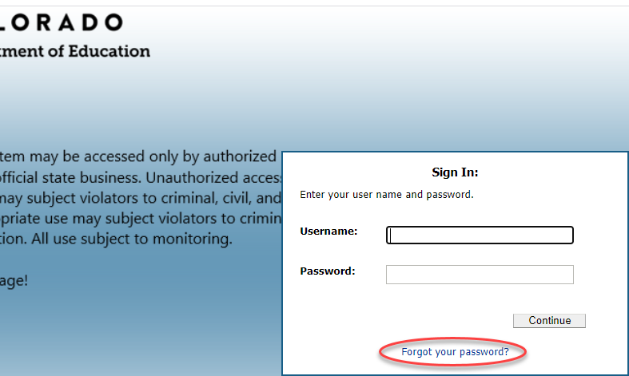

Searching for Staff in EDIS
- Click “Educator Search / Update” in the left column
- Once on the Educator Search screen, use the best practices as you add information to the fields – then click “Search”.
- Please note that you do NOT need to include information in every field of this search screen, and it is encouraged to start removing data from one or more fields if you do not receive any search results as discussed below.

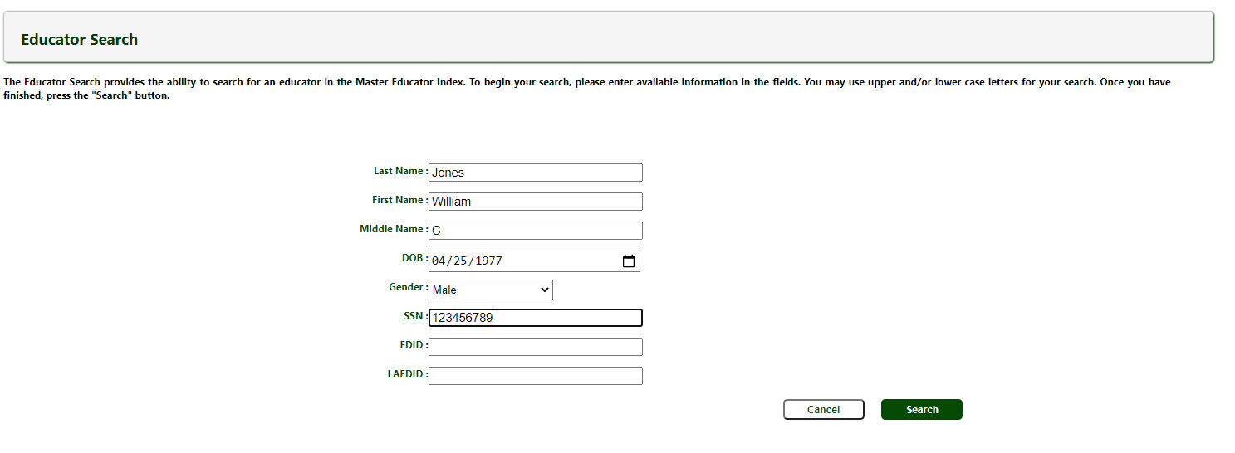

Follow CDE’s Best Practices
Data Submissions Contacts should consider the suggested strategies below when searching for a staff member:
- If a staff member has a hyphen in their last name and isn’t showing up in the search results, try searching for them without the hyphen or by each part of the name separately (example: staff John NMN Rogers-Smith, search by John Rogers-Smith, John Rogers Smith, John Rogers, and John Smith)
- If a staff member isn’t showing up in the search results, try searching for them without their first or middle name or only add the middle initial.
- Alternately, try searching for them by only their SSN or without their Date of Birth. Several combinations should be tried before confirming the staff person does not have an EDID.

Determining Next Steps
- If one educator comes up in the search results, then use the EDID included in the search results for the staff member in question.
- If multiple educators come up in the search results, then review each record result carefully to find the correct record. If you cannot find a matching record, you’ll need to request an EDID for this staff member as described below.

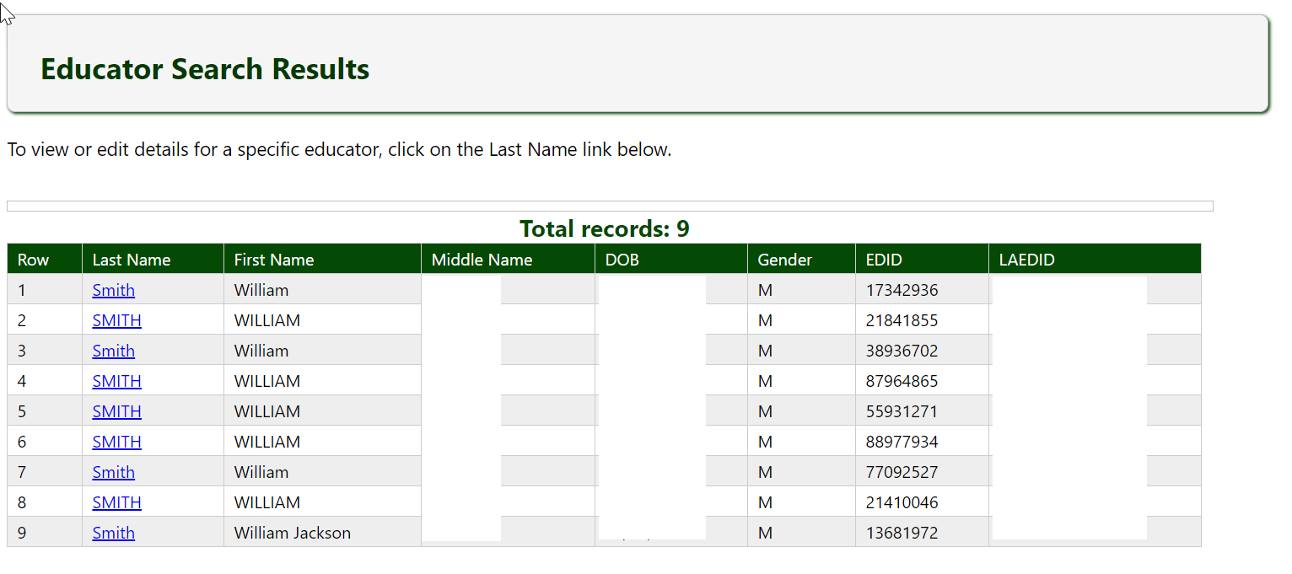
- If no educators come up in the search results, then you should begin removing data from one or more fields. (For example, date of birth may have been hard to read on the registration paperwork and 04/05/1989 was entered instead of 04/06/1989. By removing date of birth from your search, you may be able to find the staff member in question and identify any errors you may have.) If, after adjusting your search using the strategies described above, no educators come up in the search results, you’ll need to request an EDID for this staff member as described below.
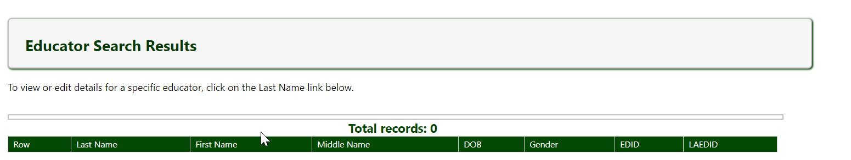

Requesting New EDIDs

EDID Template Requests
Access and download the current EDID Request Update Template. CSI does make changes to the template as needed, but the main structure will remain intact. Should CDE make any changes, CSI will notify the schools.

Template Submission Instructions
- File names must contain the following components: school code, school name/acronym, submission type and date, for example: 2067_CECFC_EDID_Request_date.
Save the file as an Excel Worksheet (.xlsx). **Please keep in mind: No spaces are allowed in the filename (use underscores, hyphens or periods)
- If you submit more than one file on any given day, include the version number after the date. Example: 2067_CECFC_EDID_Request_datev2
- Do not remove or edit the header in the first row.
- Ensure that your completed template is formatted such that leading zeroes are retained. Click here for instructions for
how to add/retain a leading zero in Microsoft Excel. Additionally, click here for instructions for converting CSV files to Excel.
- By hovering over the upper right corners of the Template cells, you’ll see helpful information regarding how the cell should be populated.
Please see screenshot and related descriptions below for reference.
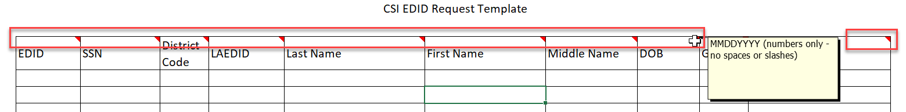
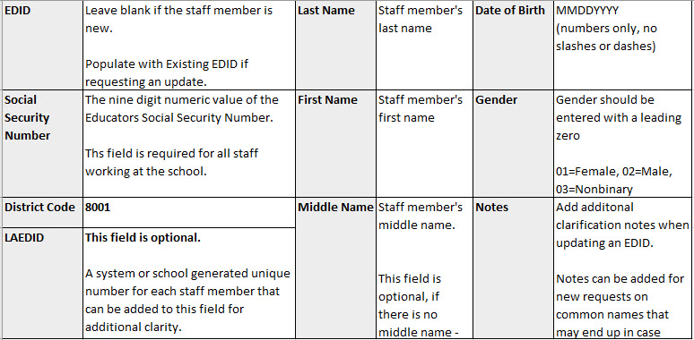

Update Existing EDIDs

EDID Template for Updates
Access and download the same EDID Request Update Template used for EDID requests. This template is designed to complete both EDID requests and EDID updates. If updates or changes are made by CDE, CSI will notify schools.

Template Submission Instructions
- File names must contain the following components: school code, school name/acronym, submission type and date, for example: 2067_CECFC_EDID_Update_date.
Save the file as an Excel Worksheet (.xlsx). **Please keep in mind: No spaces are allowed in the filename (use underscores, hyphens or periods)
- If you submit more than one file on any given day, include the version number after the date. Example: 2067_CECFC_EDID_Update_datev2
- Add all the details of the staff person that you currently need an EDID update for. This includes EDID, SSN, Name, Date of Birth, etc.
- Complete and highlight the change on the field that needs to be updated. Highlighting shows CSI which field needs to be updated in the system.
- The Notes field can also be used to further clarify which field needs to be updated along with any additional details.
- Ensure all the same formatting rules described in the EDID request section are followed, including keeping header row, leading zeros, and no spaces in the name.

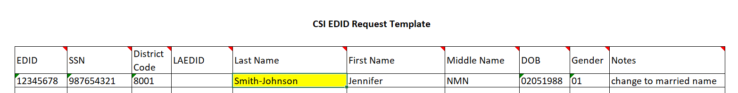

Submitting & Retrieving EDID Requests and Updates

Google Drive
Schools securely submit all completed EDID Requests/Update Templates to CSI via Google Drive (G-Drive). (For additional details about this process, please refer to the Data Submissions Handbook on the CSI website.
If your school does not have access to G-Drive, please send a request email to Submissions_CSI@csi.state.co.us.

To submit files to CSI through G-Drive
Moving completed Submission requests files to G-Drive:
- Drag the file from your school network folder to the designated G-Drive folder.
- Ensure you are dragging the file to the EDIDs folder located within the Submissions folder
- Once it has been processed, the original file and results can be moved to the Completed Requests folder.
- Files uploaded to G-Drive do not need to be password protected.

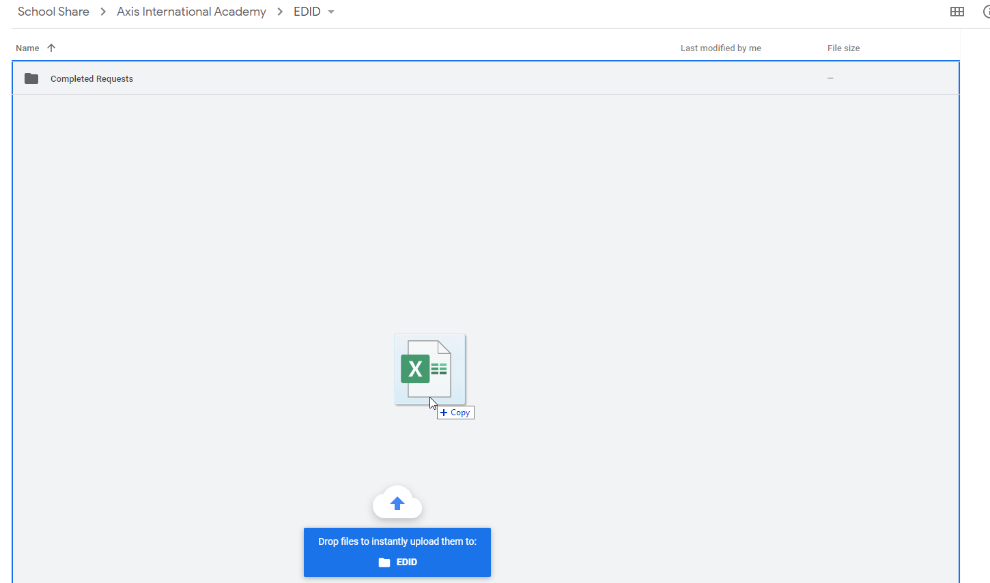

Once you have submitted your file to G-Drive, then notify CSI by sending an email to Submissions_CSI@csi.state.co.us

Subject Line: “EDID Request” or “EDID Update”
Email: Contains the name of the file. For example: “I uploaded an EDID request to G-Drive: ABC_EDID_Request_10-30-2024”

**NEW vs UPDATES** Schools should submit separate templates for EDID requests vs. updates. These are processed differently in CDE’s system

Retrieving completed EDIDs
- After the submitted file has been processed, CSI will notify you via email and may upload a results file to G-Drive as time permits. It is ultimately up to the school to search EDIS for newly added EDIDS.
- The results file will have the same name as the initial file, except that it will say "Results” instead of “Request”.
- Schools will utilize this file for newly assigned EDIDs or to see if a request is pending due to case review, etc. If an EDID was not immediately assigned, it is the school’s responsibility to access EDIS (typically within 24-48 hours) after submitting the spreadsheet to look up the EDIDs of the staff who are in the review process.

Final Steps – EDIDs and SIS Updates

Checking EDIS for Generated EDIDs
To find the EDID in EDIS, follow the steps outlined above for searching for a staff member.
- If your search comes up with one staff member, the staff’s full record will display on the screen and the assigned EDID will be the first field in the top left corner.
- If your search comes up with multiple staff, the EDID will be in the last column, and you will need to click on the Last Name field if you wish to see the full record.
- If the EDID field is still blank, please check the EDIS system again later in the day or the next day. If the educator is not included in EDIS after 3 days, please follow up with CSI staff. (Please note that the closer to HR Collection, the longer EDID requests may take.)
- The above-mentioned reports can also be used to check if an EDID has been assigned or is still under case review.

Update Systems as Appropriate
Please be sure to update your HR files, student information system, and/or plan management system with the generated EDID.

