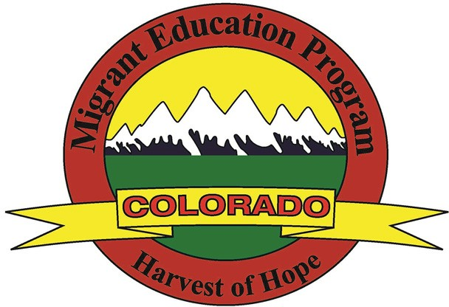
Colorado MEP Occupational Survey

Your child may qualify to receive supplemental educational services at no cost, such as tutoring, transportation, school supplies, and other services. Please answer the following questions to assist in determining your child’s eligibility. Once completed, please return this form to the school and the school will submit the form to the Colorado Charter School Institute.

CHILD’S FIRST NAME: | CHILD’S LAST NAME: |  |  | BIRTHDATE:
SCHOOL: |  |  |  | GRADE:
PARENT/GUARDIAN NAME: |  | How many children under the age of 22 live with you in your household?
HOME ADDRESS: |  | TODAY’S DATE:
CITY: |  | STATE: | ZIP CODE:
TELEPHONE (WITH AREA CODE):
BEST DAY AND TIME TO CALL: |  | PREFERRED LANGUAGE:

- In the past three years, has your family moved to another state, city, school district, and/or county?
  - YES ☐ NO

- Do you or anyone in your immediate family currently work, or have worked, in the past three years, in any of the following occupations related to agricultural or fishing work?
  - YES ☐ NO

CIRCLE all that apply below, even if the work was only for a short period of time.

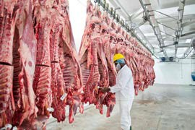
Processing & Packing (fruit, vegetables, chicken, eggs, pork, beef, lamb or other livestock)

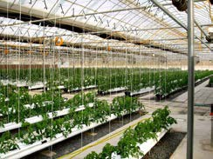
Nursery or Greenhouse (planting, potting, pruning, watering, harvesting)
Agriculture or Field Work (planting, picking, sorting crops, soil preparation, irrigation, fumigation)

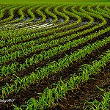
Forestry (soil preparation, planting, growing,
cutting trees)
Dairy & Cattle Raising (feeding, milking, rounding up)

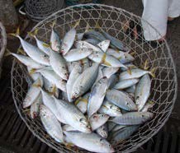
Fishing & Fish Processing (catching, sorting, packing, transporting fish)

This form and the data recorded within are protected to maintain family and child confidentiality. If you have any questions, please contact:
Colorado Charter School Institute
Rachel Franks – rachelfranks@csi.state.co.us
720-788-4730

