School Data Submissions Handbook

2024-25

CSI Data Submissions Team
Charter School Institute

This handbook is a tool for CSI school data submission contacts, compiled by the CSI Data Submissions Team. It covers the general process and resources for data collections, with specific trainings provided before each collection opens.

Please note that this is NOT a comprehensive resource. As all school offices operate differently, this resource guide may not include every aspect of working with CSI on submissions for state and federal collections. If you have specific questions pertaining to any of the information located in this handbook or need further resources, please contact the data submissions team at submissions_CSI@csi.state.co.us.

CSI seeks to ensure its resources are as accessible as possible. If you experience any difficulty in accessing a resource, please reach out to Communications_CSI@csi.state.co.us.

Thank you and we hope you find this handbook helpful. We also welcome suggestions for improving the content.

Contents
CSI Data Submissions 3
Data Submissions Contacts 4
The Role of the CSI Data Submission’s Team 4
The CSI Data Submissions Team 4
Your Role as a School Data Submissions Contact 5
Resources 6
Weekly Update Email (WU) 6
Website Resources 6
Tiered Supports 8
The Data Submissions Process 10
Step 1: Collection Prep 10
Step 2: Data Collection, Entry and Initial Review Processes 11
Step 3: File Extraction & Submission to CSI 16
Step 4: Troubleshoot and Resolve Data Errors 17
Step 5: Review and Certify Data 19
Data Collection Timeline 20
CSI Data Submissions Calendar 21
Data Privacy and Security 21
Google Drive (G-Drive) 21
Records and Documentation Retention 22
Appendix 23
I: Purpose and Use of Data Collections Quick Reference 23
II. Forms to Support in Data Collection 24
III: Student Information System Resources 24
IV: School Collaboration by Data Collection Worksheet 26
V: Overview of Data Collection Files and Error Reports 27
VI. Sample Data System Tasks 28
VII. Excel Skills 28

CSI Data Submissions

All public schools are legally required to report data through various state and federal data collections throughout the year. Several of the collections have funding implications (like October Count and December Count) or are used for compliance monitoring purposes (like End of Year and Special Education End of Year) at the federal, state, and local (CSI) levels. In fact, data from most data collections are used by CSI staff for the CSI Annual Review of Schools (CARS), Equity Screener, determination of tiered supports, and/or compliance monitoring.

See the Appendix for a Purpose and Use of Data Collections table for a quick reference.
For a comprehensive list of the legislation behind and uses for each mandatory data collection, please see CDE’s Mandatory Data Pipeline Collections: Legislation, Uses and Resources.

Data Submissions Contacts

The Role of the CSI Data Submission’s Team

The CSI Data Submissions Team helps schools submit data accurately and on time for state and federal requirements. They act as a liaison between CSI schools and the Colorado Department of Education (CDE), providing training, technical assistance, and resources. All state data submissions are made by CSI through the CDE's Data Pipeline system.

The CSI Data Submissions Team

Below is a list of the CSI Data Submissions Team members. Schools should send data submission requests, error troubleshooting, and audit questions to submissions_CSI@cde.state.co.us. A team member will respond within 48 business hours.

CSI Staff |  | Key Responsibilities | Email | Phone
Janet Dinnen, Chief of Staff |  | Team lead | janetdinnen@csi.state.co.us | 720-357-7435
Ryan Hartung, Data Specialist |  | Data processing, error troubleshooting for DC, SPED EOY, HR, EDID requests | ryanhartung@csi.state.co.us | 720-471-6553
Cherish Trammell, Data Specialist |  | Data processing, error troubleshooting for OC, TSDL, CRDC, EOY, SASID requests | cherishtrammell@csi.state.co.us | 720-498-0840
Sheila Sellers, Data Quality & Audit Specialist |  | October Count/At-Risk Audit and data validations, discipline | sheilasellers@csi.state.co.us | 720-908-3742
Amber Anderson, Data Specialist |  | Support for At Risk collection, S-EBT, CEP data management, discipline | amberanderson@csi.state.co.us | Coming soon!
Julie Eddy, Data Specialist |  | Support for processing, audit, data validations, RCM, AEC | julieeddy@csi.state.co.us | 720-417-6870

Your Role as a School Data Submissions Contact

School leaders must designate a main Data Submissions Contact before the school year starts using the annual School Contact Identification form in June/July. They may also appoint separate HR and SPED contacts for sensitive data. Schools can request an additional submissions contact for specific collections, such as the Special Education December Count and End of Year collections, by contacting the CSI Data Submissions Team.

A member of the Data Submissions Team will schedule an onboarding meeting with new school data submission contacts. The onboarding process will include:
- an overview of the collection process, including upcoming collection deadlines
- a review of resources and training materials available
- ensuring the submissions contact has access to all relevant systems needed during the data submissions process
‘Data integrity’ is the combined accuracy, consistency, and validity of data over its lifecycle.
Each school is responsible for the data integrity and the submission process of school data through:
- Detailed set up and maintenance of SIS
- Regular extraction and submission of data files
- Meeting CSI submission deadlines
- Updating SIS to correct for reporting errors
- Using and referencing CSI resources and troubleshooting documentation
- Reading the Weekly Update email (for current submissions statuses and important announcements)

The main Data Submissions Contact at each school is the expert on the data submissions process and must collaborate with other content experts. This includes working with staff in Special Education, English Learners, Gifted & Talented, homeless, 504, and School Lunch/Nutrition to ensure data accuracy. The Data Submissions Contact is responsible for engaging these staff members and other stakeholders.

Schools should identify and connect with key stakeholders early to ensure data is correctly collected, entered, and regularly updated in the system.

Example: October Count Staff Engagement

While the main Data Submissions Contact will be the primary point of contact during the duration of the collection and submission process, it is expected that they will work with the various content experts (EL, GT, homeless, 504 coordinators, etc.) at the school before and during the data collection to ensure data is accurate, including participation in the summary report review and signature assurance process.

See the Appendix for a School Collaboration by Data Collection worksheet to help you identify the necessary school-level content experts for each data collection.

Resources

Key resources for data submissions are highlighted below for schools to use in successfully completing each collection. For additional support, contact CSI’s Data Submissions Team to connect via email, phone, or screen share options. In-person meetings can be arranged if needed.
We aim to equip school staff with the knowledge, skills, and resources to minimize error correction time, enhance data accuracy, and meet deadlines.

Weekly Update Email (WU)
The CSI Data Submissions Team sends a weekly email to all Data Submissions Contacts. This email includes a status table for each school, showing the progress of active data collections, initial submission receipts, Level 1 & 2 errors, and certification due dates.

The email also contains updates and reminders about data collections and announcements. New information is highlighted in yellow for easy review.

Note: Schools can request additional recipients by emailing the CSI’s Data Submissions Team.
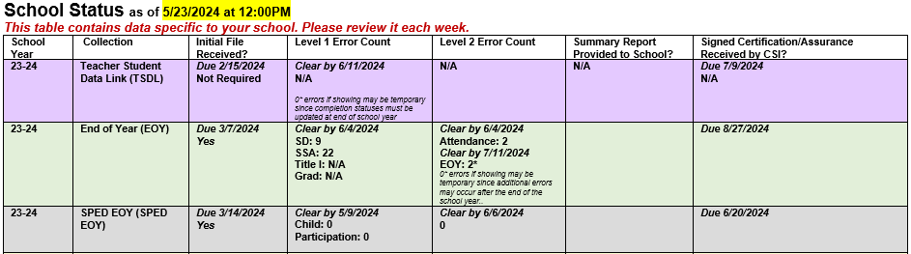

Website Resources
The Data Submissions Library is broken into sections based on information type.

- General Resources – includes information on Audits, Student Information Systems, and Plan Management Systems, along with a Training page, where onboarding resources are housed.
- School Collections – collections that require the submission of school-level data
- Socioeconomic Collections – collections that require the submission of student-level data related to free- and reduced-price eligibility
- Special Education Collections – collections that require the submission of special education-related student and staff level data
- Staff Collections – collections that require the submission of staff-level data
- Student Collections – collections that require the submission of student-level data

General Resources: The following, general resources can be found on our Data Submissions Library webpage:

- CSI Data Submissions Handbook (this very document).

- CSI Data Submission Calendar – Contains main collection deadlines, including Initial Submissions, Level 1 and 2 Error Clearance, and Signed Summary Certifications among other important dates. Be sure to print this two-page document and mark important dates on your work calendar.
Note: deadlines are also included on CSI’s online calendar (where events can be exported to a user’s own calendar).

- Troubleshooting Errors Spreadsheet – This is one of the best tools available when reviewing and correcting errors listed in collection Error Reports. This document outlines most Level 1 & 2 Errors for every CSI collection and includes potential solutions to many errors. Check the tabs at the bottom to navigate through collections and refer to this document often as you progress through a collection. Use CTRL+F to search for specific Error Codes or keywords.

More details about the CSI Data Submissions Calendar and Troubleshooting Errors Spreadsheet are included later in this handbook.

Collection Specific Resources:
The following resources are available for each of the main data collection webpages:

- Trainings – Recorded training resources (some are tailored to covering only what is new for the year and others are more detailed) will be posted for most collections. Some collections that are smaller in size and/or scope may have guidance in just an electronic document.

- File Layouts with CSI Additions – These documents are a strong resource and should be referenced before each data collection begins and throughout the entire submissions process, especially when troubleshooting errors. The file layouts with CSI additions include specific instructions on how data needs to be formatted, what information to include, how data should be coded, and what field lengths are valid. It also includes any required data codes, code definitions, and scenarios on when to use these codes.

- Templates – Most collection data should be extracted directly from a school’s SIS. However, there is occasionally a need or convenience to manually enter data (such as the HR or RCM collections). Templates are provided as a starting point for schools manually entering data.

- Data Validation Resources – These resources typically include a Record Checker Tool to flag potential errors in data files prior to submission to CSI as well as a check list to double-check and verify your data before submission. Using this will help to keep errors low, making the submission process smoother.

- Coding Scenario Documents – To further help in the reduction of errors, the Data Submissions Team has created coding scenario documents to help School Data Submission Contacts understand which coding options to use for specific scenarios. Two examples are the Quick Reference: Entry/Exit Fields document found on the EOY website and the Special Education (SPED) Participation File Coding Scenarios with Supplemental Guidance found in SPED EOY.

- Data Management Systems – Though not always referenced separately on each collection webpage, schools are encouraged to consult the technical help documentation for their particular SIS vendor and Plan Management System.

Tiered Supports
To best serve School Data Submission Contacts, CSI’s Data Submissions Team follows a tiered support process. CSI’s Data Submissions Team uses the tiering process to provide additional supports and interventions to schools that are newer to the data collection process as well as schools that have persistent issues related to submission quality or submission timeliness for key data collections.

All schools receive standard support from CSI’s Data Submissions Team for each data collection. Types of supports include:
- Handbook and Resources:
  - A comprehensive handbook outlining data submission procedures, requirements, and best practices.
  - Online resources, templates, and guides for common data submission issues.
- Calendar and Reminders:
  - A centralized calendar with key submission deadlines and important dates.
  - Automated reminders through emails.
- Training Modules:
  - Online training modules covering basic data submission procedures and common errors.
  - Accessible video tutorials and webinars for self-paced learning.
- Troubleshooting Guidance:
  - General troubleshooting guides addressing common errors and issues.
  - Frequently Asked Questions (FAQs) and Quick References for quick problem-solving.

Some schools receive additional, Tier 2 supports. Tier 2 supports are collection-specific and may include:
- Proactive, Individualized Check In Emails:
  - Sending an individualized email to schools prior to key deadlines to check in and offer support
- Earlier Deadlines and Checkpoints:
  - Setting (or encouraging) earlier deadlines for struggling schools to provide additional time for error correction.
  - Regular checkpoints and progress reviews to identify issues early on.
- Scheduled Support Calls:
  - Regularly scheduled support calls with dedicated support staff to address specific concerns.
  - Opportunities for schools to ask questions, seek clarification, and receive personalized guidance.
- Advanced Training Workshops:
  - Specialized workshops covering more advanced topics, tailored to the needs of Tier 2 schools.
  - Hands-on sessions addressing specific challenges faced by this group.
Tier 2 supports are available to schools with:
- New Data Contacts: Schools with recently appointed or new data contacts, who may require additional support and training.
- Historical Missed Deadlines: Schools with a history of missing deadlines or struggling with timely data submissions.
- Recurring Common Errors: Schools consistently making common errors in data submissions despite access to Tier 1 resources.
- Feedback from Tier 1 Support: Schools identified through feedback channels indicating the need for more targeted assistance.
- Transition of Data System: Schools that have recently transition from one data system to another and indicate the need for additional assistance.

Tier 2 supports are collection-specific and determined annually. A school may be receiving Tier 2 supports for October Count, for example, but not for December Count. Similarly, a school may receive Tier 2 supports for October Count this year, and based on strong performance this year, would not be required to receive Tier 2 supports for October Count next year. Tier 2 supports continue for the duration of a data collection.

Some schools receive additional, Tier 3 supports. Tier 3 supports are collection-specific and may include:

- On-Site Support Visits:
  - On-site visits by expert support teams to work directly with staff facing persistent challenges.
  - In-person training sessions and real-time problem-solving.
- Dedicated Support Team:
  - Assigning a dedicated support team to Tier 3 schools, offering personalized assistance.
- Customized Training Plans:
  - Tailored training plans that address the unique needs and challenges of Tier 3 schools.
  - Individualized learning paths based on the specific issues identified.
- Progress Monitoring and Feedback:
  - Regular progress monitoring, with detailed feedback on areas for improvement.
  - Collaborative problem-solving meetings to discuss feedback and strategize solutions.

Tier 3 supports are available to schools with:
- Persistent Challenges: Schools that continue to face persistent challenges despite Tier 2 interventions.
- High Volume of Complex Errors: Schools dealing with a high volume of complex errors that require specialized assistance.
- Low Progress despite Tier 2 Support: Schools that show minimal progress or improvement in data submissions despite Tier 2 support.
- High-Stakes Consequences: Schools facing high-stakes consequences (e.g., funding implications) due to data submission issues.
- Direct Request for Tier 3 Assistance: Schools that specifically request and express a need for more intensive support.

The Data Submissions Process

The data submissions process can be summarized as a five-step iterative process. Steps 2 through 4 are repeated until a school is error free.

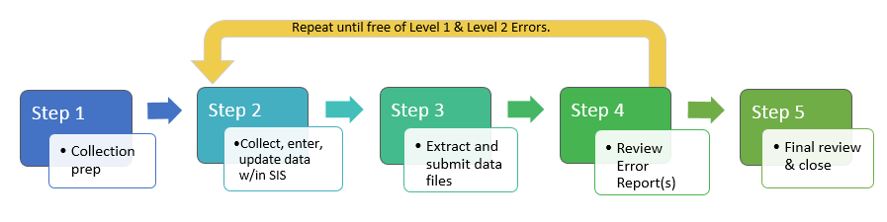

Step 1: Collection Prep
CDE requires about 12 data collections annually, and requirements can change yearly.

To start preparing for a data collection:
- Visit the collection-specific page on the CSI Data Submissions Library webpage.
- Browse the resources, and open unfamiliar ones to understand their content.
- Review and mark all collection deadlines on your calendar. Some schools schedule data collection work time or set earlier internal deadlines.

Be sure to review the File Layout(s) – CSI Additions resource as that will save time and reduce errors. This resource details:
- Data being captured
- Required data formatting
- Definitions of data fields and codes
- Removed fields (red strikethrough)
- New or changed fields and codes (highlighted in yellow)

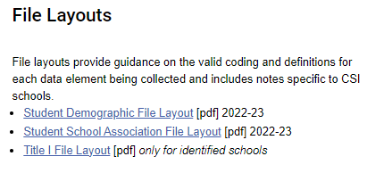
An example of File Layouts for the October Count Data Collection.

For a quick tutorial on how to use the File Layout and Definition document, review the File Layout Resource Overview found on the Training webpage.

Most collection pages have a Data Validation Resources section. It is always good to review all materials found in any collection’s ‘Data Validation Resources’ section before you submit your initial file and throughout the collection. The screenshot below is taken from the October Count collection resources page which contains a total of four data validation resources, including a toolkit and record checker tool.

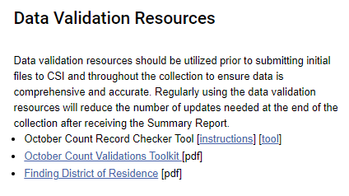
An example of Data Validation Resources for the October Count Data Collection

Step 2: Data Collection, Entry and Initial Review Processes
The next step in the data submissions process is for schools to collect, enter, and complete an initial review of their data prior to each data collection initial submission deadline. This step can be considerably less time consuming with proper SIS set-up, regular SIS maintenance, diligent data entry and update, and occasional SIS data audits.

Collecting Data

It is important to be consistent in how data is collected and entered to save time during the collection process. Data can be created in several ways:
- Internally, such as when Special Education staff create an IEP for a student.
- Self-reported by families (when parents identify student race and ethnicity in student enrollment paperwork)
- Identified by staff (when new hires identify their prior experience and qualifications in new employee paperwork).
- Externally, such as when the CDE generates a SASID number for a student new to the Colorado education system.

New data is collected and should be entered into your SIS and student plan management system (if different) when:
- A student enters, exits, or transfers
- A student was involved in an incident and discipline
- An IEP is created
- Accounting for daily attendance
- A course schedule is created for a student
- Grades are entered
If your school already has forms and procedures in place for data collection it would be best to check annually that the forms are aligned with state required fields and eligible codes and that you are collecting all required information.

CSI has several policy related resources to assist schools in following best practices with data entry. See the CSI Legal and Policy webpage under the Policy Guidance by Topic for information in areas such as Admissions and Enrollment, Attendance, Homeschool Guidance, among others.
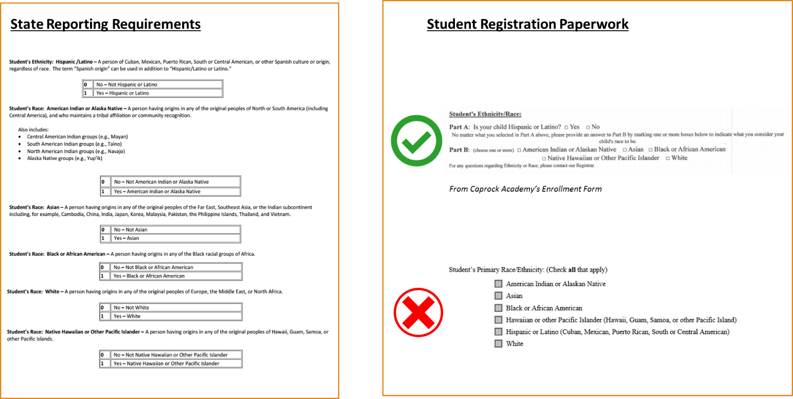
Example: Crosswalk State Reporting Requirements to Your School Forms

Following a crosswalk strategy to compare the data collection file layout document (left) with your school’s forms (right) can ensure your school is collecting the right information in the right way. In this example, the school compared the state-required race and ethnicity fields (left) with what was included on the school’s student registration paperwork. There are two examples of how schools collected race/ethnicity. The top example aligns with state requirements where the family must choose a response for Ethnicity and then has the option to check one or more race. The bottom example does not align with state requirements because it does not require the family to choose both ethnicity and one or more races.

See the Appendix for a listing of forms that aid in the data collection process for student and staff registration.

Requesting Student/Staff ID’s
As part of the data collection process, Data Submissions Contacts will need to confirm whether incoming students and staff have a unique state identification number (required for the key identifier in the student and staff collections).

The student identification number is known as a SASID (generated through RITS).
The staff identification number is known as an EDID (generated through EDIS).

Returning students and staff as well as students and staff who have attended or been employed at a public school previously should already have a unique state identification number. Those new to the Colorado public education system will require an identification number to be generated through the state systems.

To determine whether student or staff members already have a SASID or EDID, please access the CDE RITS system for students and the CDE EDIS system for staff. Be sure to search these systems thoroughly first before requesting new identifiers. Accounts for the RITS and EDIS systems will be created for school staff by CSI upon request. An account for the EDIS system typically requires permission from a school leader or their next in line approver.

Review the SASIDs and EDIDs webpages for guidance related to checking for, requesting, and updating student or staff ID numbers.

Data Entry
Once data has been collected, it needs to be entered into the school’s data management system(s). Data management systems commonly include:
- A Student Information System (SIS) like PowerSchool or Infinite Campus
- A Student Plan Management System like Enrich, or Infinite Campus

Resources on how to enter data into each data management system are available through CSI’s Data Systems webpage or directly through the data management system vendor.

Diligent, careful, and consistent data entry practices will significantly reduce errors in data and shorten time spent on a given data collection. Data entry staff should be aware of the valid and appropriate codes to use when entering data into the data management system(s). Data field codes for a specific collection are always found in the File Layout – CSI additions. Data fields and codes can change annually, so schools should always use the most current version posted on the CSI collection webpages.

Schools should access the following resources when seeking System support:
- Schools should utilize the SIS online community, trainings, and resources as the primary method for accessing support related to student information system set up and troubleshooting.
- Each SIS vendor provides troubleshooting support through a ticket system if the available resources do not address the specific issue you are experiencing.
- Additionally, CSI has posted several SIS resources in the CSI Data Submissions Library to address common questions or challenges related to state reporting.
- Finally, schools can reach out to the CSI Data Submissions Team with SIS questions related to state reporting.

See the following table below for helpful links to resources when using the main student information systems (SIS) used by CSI schools, which are Infinite Campus and PowerSchool. CSI can provide support in limited SIS-related issues. Therefore, schools should reach out directly to the SIS support team when troubleshooting an issue.

Data System Resource | Screenshot of Data Entry Resource
Infinite Campus: Campus Community  (login required) | Check the “Report Layout” table and refer to the “Campus Interface” column 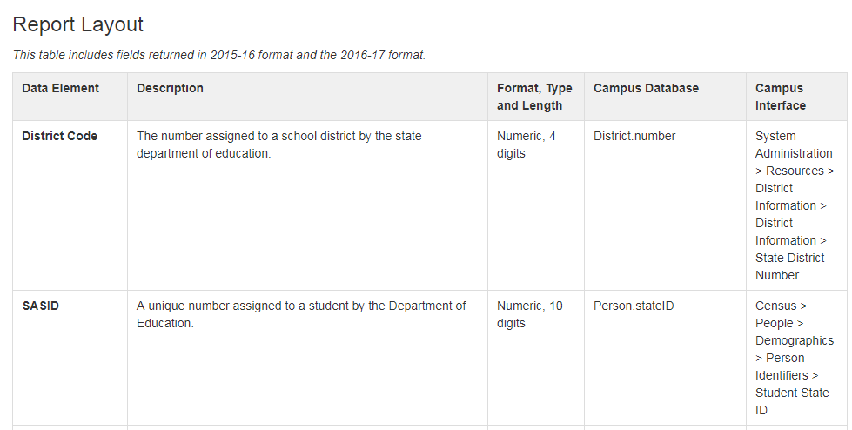
PowerSchool: Student Setup OR CSI PowerSchool/Data Collection Mapping Guide | PowerSchool’s Student Setup page identifies all student fields used for state reporting, where to find them in PowerSchool, and notes about the field.  Alternately, schools can use CSI’s PowerSchool Data Collection Mapping Guide for similar information.  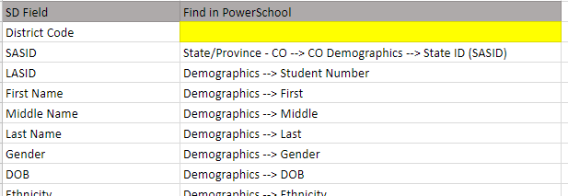

Data Review
Once data has been entered into the data management system(s), the school contact should do an initial review of data prior to any data collection initial submission deadlines for the year.

For each major data collection, the CSI Data Submissions Team has developed Data Validation Resources (including a Record Checker Tool) to support schools in reviewing and validating data prior to submission to CSI by automatically flagging data that may be inaccurate or incomplete.

For collections that do not have a Record Checker Tool, School Data Submissions Contacts should engage in an internal data review process that should include one or more of the following:

- Use the search/reporting features of the data system to search for blank fields, then fill the blanks in with appropriate data. This can help to reduce the number of errors you are having to address from the Data Pipeline error reports.

- Use the search/reporting features to search for certain fields/codes which may be set to a certain value by default. For example, full time funding code of 80 may be set by default (or roll over automatically from the prior year) so it would be up to school staff to adjust the funding status for students who are not eligible to receive full time funding.

- Use reporting features to pull enrollment counts by classroom, grade, etc. to ensure alignment with class rosters. Sharing the various SIS reports available with appropriate school staff can help to validate data further. For example, providing a class roster to the teacher can help validate its accuracy.

- Extract collection files and review: The final data review process prior to submittal is to extract the files and open them to review for missing information. Checking for anomalies or zero filled cells may help diagnose data entry issues.

A Tip on Timing
The time it takes to enter student data each year is dependent on several factors including number of new students, scheduling, changes to existing student information, etc. Similarly, the time it takes to enter staff data each year is dependent on the number of new staff, changes in existing staff assignments, etc.

Because schools are required to submit student level data for the October Count data collection in September, it is strongly recommended that schools allocate appropriate resources (staff, time) to ensure data is entered in a timely manner.

Step 3: File Extraction & Submission to CSI

Extracting Files from the Data System
Most of the required files can be created from your school’s data management systems (ex: Infinite Campus, PowerSchool, and Enrich).

Data System | Report Extract
Infinite Campus | Campus Community State Reporting Pages (login required) Infinite Campus’ Campus Community has a resource page for every state data collection, and each resource page includes step by step instructions for extracting files for state reporting. Typically, state reports can be extracted from Infinite Campus by clicking on CO State Reporting Data Pipeline then selecting the appropriate collection.
PowerSchool | PowerSchool Colorado Reports PowerSchool’s State Reporting Guide has a section for every state data collection, and each section includes step by step instructions for extracting files for state reporting. Typically, state reports can be extracted from PowerSchool by clicking on Data and Reporting > Reports > Compliance Reports then selecting the appropriate collection.
Enrich | Access to trainings, documents, and other resources can be found on the Enrich Learning Center page.

Please note that the accuracy of state reports generated by these systems depends on proper setup and accurate data entry. For instance, the Discipline report in PowerSchool reflects the setup of the system and data entered. Therefore, accurate data must be entered into the correct fields as per the vendor's specifications for the report to be reliable.

It is the responsibility of schools to ensure their student and plan management systems are updated to facilitate accurate state reporting. Schools should conduct a test data collection extract before the initial CSI submission deadline to verify data extraction and ensure the file is not empty.

SIS vendors typically notify schools' technical contacts via email about available updates required for state reporting. Schools must promptly install these updates and keep their technical contacts informed about updates from their SIS vendor. CSI will communicate necessary SIS updates through the Weekly Update (WU) email whenever possible
See the Appendix for a Student Information Systems Resources page to help you identify materials to ensure appropriate system setup.

Each main data collection includes a Data Validation Strategies Toolkit which outlines some types of data to check for accuracy prior to and during the submissions process. These can be found on each collection’s webpage.

A Tip on Extracting Files from your Data System
Schools should test the file extract from their data system before the CSI initial submission deadline for each data collection. This helps identify any issues with the extract or necessary system updates and flags any missing data fields that need updating before the initial submission. Doing this reduces the number of initial errors on your first error report. Additionally, schools should regularly use the Record Checker Tool to review and validate data before submitting to CSI.

Submitting Data to CSI
Schools are responsible for completing the following for each data collection:
- Extract the state reporting data files from your SIS
- Name the file(s) according to the CSI file naming format:
  - [schoolcode]_[schoolinitials]_[filetype]_[date]
  - Ex: 1234_CSI_ EOYSSA_06212019
  - No spaces are allowed in the file name – please use underscores (_) or dashes (-)
  - If you submit more than one file for the same collection within the same day, simply append it with a version number, such as v2, or v3
- Unless CSI staff instruct otherwise, upload files to the secure file share system (Google Drive, referred to G-Drive), placing in the applicable shared collection folder (see the Data Privacy and Security section below for more information)
- Email the CSI Data Submissions Team at submissions_CSI.state.co.us to inform them that files are have been uploaded for processing.

DO NOT email personally identifiable information (PII). This includes name, SSN, address, birthdate, and gender. Email is not a secure channel and a person’s privacy and data security could be compromised and should therefore not be used to transfer files containing PII of educators or students.

Once a member of the Data Submissions Team processes your files, they will place the error reports (if there are any) within the Error Reports shared folder and email the school data submissions contact that error reports are available. Please allow 24-48 hours (business days) for this process to be completed, but typically the wait time is shorter. During peak collection times or limited staff availability it may take longer for CSI to process files and provide error reports. CSI will inform schools when there may be an extended period between file submission and receiving an updated error report.

When a school has cleared all errors (and corrected invalid data indicated by warnings), then summary reports will be generated by CSI and placed in the Summary Certification shared folder in G-Drive for the school to review and sign off on by the deadline date assigned for each collection.

Step 4: Troubleshoot and Resolve Data Errors

Errors and Warnings
There are two levels of error clearance a school needs to pass for most collections. At each level an error report is generated for each file submitted.

Level 1 Errors
Level 1 errors are generated if data in an interchange file submitted does not meet one or more of CDE’s business rules for the file.

Errors can be caused by incorrect formatting (i.e. missing leading zeroes), missing information (i.e. blank cells), or data that does not follow the state’s business rules for a particular field (i.e. incorrect values). Example: Are student’s birthdates in line with grade level?

Level 2 Errors
Level 2 errors are generated after CSI runs a snapshot, which combines data from multiple interchange files within and sometimes across collections. Similar to Level 1 errors, an error would be generated if the data in the files submitted does not meet one or more of CDE’s business rules for the particular snapshot. Unlike Level 1 errors, Level 2 errors can be caused by interactions between data your school has submitted and data submitted by another CSI school. Some collections may not have a Level 2 error check.

Within each error report, there can be both Errors and Warnings.

Resolving Errors
It's uncommon for a data submission to pass both Level 1 and Level 2 errors on the first try. Therefore, there's no expectation that all errors will be fixed in one submission. However, schools are urged to address as many errors as possible in their initial report to minimize the need for multiple submissions to CSI to resolve all errors.

Schools should use the error report to identify data that needs to be reviewed and updated to ensure accuracy. Never change data manually on the Error Report or the data file. Data must be updated in the SIS and a new report extracted and submitted. There is an exception here for collections such as the Human Resources, sometimes the Report Card March, and sometimes the End of Year after rollover where you will update the data file/template itself.

For support on understanding the cause of an error and how/where to resolve it, please review the CSI Troubleshooting Errors resource in conjunction with the File Layout – CSI additions. The Troubleshooting Errors resource is a working document that provides detailed notes about what fields to review and how to resolve most errors. Find the collection from the tabs at the bottom. Schools can then search/filter this resource by ‘Error Code’ then review the ‘Troubleshooting Notes’ column for details on error cause and resolution. This is a working document updated as CSI encounters solutions to errors. If there is not an intuitive solution for your error, reach out to the CSI Data Submissions Team for assistance.
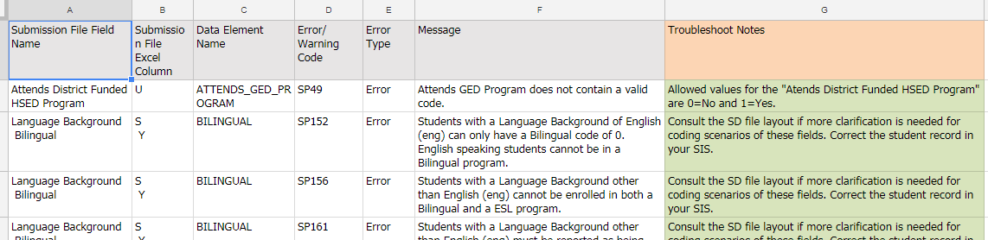
Screenshot of CSI Troubleshooting Errors Resource

Exception Requests
Errors almost always identify inaccurate data that needs to be updated. Sometimes, there is a unique situation in which the data is correct and the error needs to be overridden. In this case, an exception can be granted by CDE to ignore the error within the Data Pipeline. Schools should not be modifying data to clear errors if the modification is not accurate. If you are unsure on how to clear an error after exhausting the available collection resources, please reach out to the CSI Data Submissions Team for help. If an exception is needed, CSI will work with the school on an explanation to provide to CDE. Once CDE approves the exception, then the error will be ignored during the submissions process.

Step 5: Review and Certify Data
The final step in the data submissions process is for schools to review and certify their data before CSI submits the collection to CDE. After clearing Level 1 (Interchange) and Level 2 (Snapshot) errors, CSI provides a summary report with the final submitted data. This report may include raw data, aggregate data, trend data, and highlighted data for accuracy review.

The summary report features a certification (signature) tab, typically requiring signatures from multiple school contacts, including the school leader, to confirm the data's accuracy. For example, the October Count collection requires several school-level contacts to sign off. Schools should ensure all required staff are available to review and sign by the CSI deadline.

It's the school's responsibility to ensure all appropriate parties review and sign off on the certification. Schools benefit from having relevant parties review the summary data before receiving the CSI-created summary report to allow time for corrections if inaccuracies are identified.
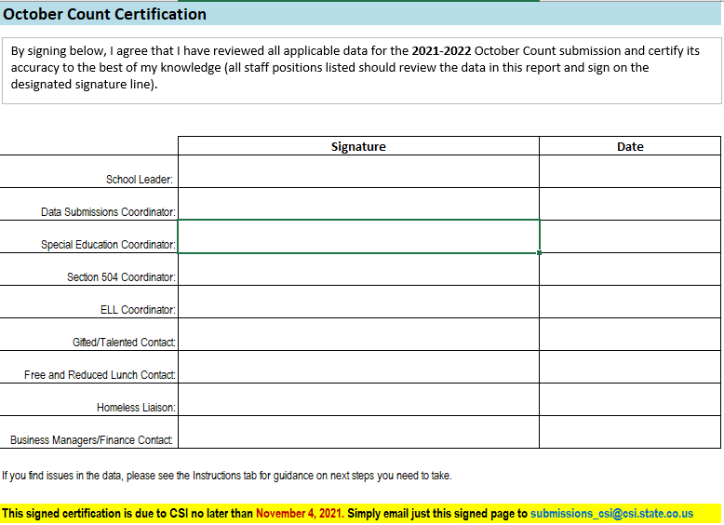
Screenshot of 2021 October Count Certification Tab

Data Collection Timeline
The CSI Data Submissions Team set submission deadlines ahead of CDE deadlines to allow schools adequate time for data review and validation. Deadlines for each collection are posted to the CSI Submission Calendar and to the CSI website calendar annually. The CSI Submission Calendar is updated annually and may not contain all the deadlines within some collections. When changes need to be made to deadlines, such changes are communicated via training resources and the Weekly Update email.

Most collections have the following types of dates associated with them (posted each year on the CSI Submissions Calendar). Schools need to strive to meet each collection deadline, but if there are extenuating reasons where you will not be able to meet a deadline, then please notify the CSI Data Submissions Team as soon as possible. Please know that missing deadlines interrupt the project flow for each collection and possibly lead to issues in completing needed data validation checks and with meeting state mandated deadlines.

The CSI Data Submissions Team welcomes schools to submit files earlier than the initial submission deadline and encourages schools to clear errors well in advance of the error clearance deadlines.

Additionally, some data collections extend over school breaks, including the summer. If a school would like to try to work around school breaks, please communicate in advance with the CSI Data Submissions Team and staff will do its best to accommodate such requests.

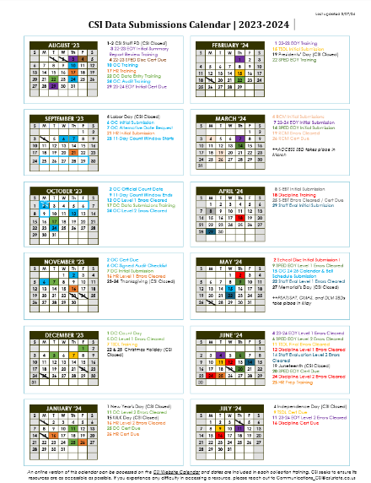
CSI Data Submissions Calendar

A printable version of the CSI Data Submissions Calendar can be found on the CSI Data Submissions Resource Library.

All deadlines are subject to change and CSI will sometimes revise the calendar midyear if changes are needed.

Each posted calendar version will show a last updated date; therefore, schools are advised to check the website for revised versions periodically throughout the year.

The CSI website calendar will also list each of the primary collection deadlines.

Data Privacy and Security
Schools should NOT email personally identifiable information (PII). This includes name, SSN, address, birthdate, and gender. Email is not a secure channel and a person’s privacy and data security could be compromised. Therefore, email cannot be used to transfer files containing personally identifiable information of educators or students.

Instead, schools should use CSI’s secure data share system described below to securely share files.

Google Drive (G-Drive)
CSI will share applicable folders within G-Drive for school Data Submissions Contacts identified on the School Contact Information Form that school leaders complete each summer. If the Data Submissions Contact at the school changes mid-year, please email the CSI Data Submissions Team so that CSI can adjust folder sharing permissions.

Schools should upload their files to the appropriate shared folders and then email the CSI Data Submissions Team to inform CSI staff of the files ready to be processed. Please do be sure to identify the collection you are referring to within emails to CSI as there are multiple collections taking place simultaneously throughout the year.

CSI will upload documents to the school (error reports, summary reports, other documents containing PII, etc.) to the appropriate shared folders and then notify the school.

Instructions for using the G-Drive secure file share system can be accessed on the CSI General Data Submissions Resources webpage under the Training Modules section within the Data Security topic.

Records and Documentation Retention
Schools should plan to keep records and documentation in alignment with the Records Management Manual for School Districts.

Specific guidance for the retention of data collected for the purposes of funding can be found in the state’s various Audit Resource Guides. Guidance essentially requires that schools retain any associated documents supporting certifications made to CDE or any data provided to CDE for the purposes of administering the Public School Finance Act of 1994 until audited by CDE, or until five years from any certification due dates, whichever comes first. CSI recommends retaining documents until after audits have been completed by CDE, and CSI will notify schools once an audit has been complete.

Documentation for Carryover Status
For the At-Risk audit on free and reduced-price lunch eligibility statuses reported in the October Count collection, if a carryover status from a prior year is used to report eligibility for the next year, then the documentation and forms (items such as federal meal applications, state FEDS forms, and McKinney-Vento forms, etc.) used to determine eligibilities in the prior year must be kept until the audit is complete for the next year. If there is any doubt about whether carryover status has been used into the next year, then schools should retain these types of documents an additional year beyond the last completed audit.

Appendix

I: Purpose and Use of Data Collections Quick Reference
The following collections are managed by the CSI Data Submissions Team.

COLLECTION | DESCRIPTION | MAIN PURPOSE/IMPACT
RITS | Collects basic student demographic information for assigning a student number (SASID) | Necessary for every student data collection
EDIS | Collects basic employee demographic information for assigning an employee number (EDID) | Necessary for the staff data collection and special education student data collections
October Count | Collects student demographic and enrollment information as of the pupil enrollment count date. | October Count determines a school’s per pupil revenue funding (PPR), At-Risk, and ELL Count funding for the year as outlined in the Public School Finance Act of 1994, as amended (22‐54‐101, C.R.S.). Data is also reported in the federal EDFacts system.
Human Resources | Collect information on all staff employed by each school as of December 1. | One of the primary purposes of this collection is to ensure that necessary staff is qualified and effective.
Report Card March | Collects characteristics of the school’s programming. | Data from this collection provided in CDE’s School View application, which can help inform guardians about school offerings as they determine which school students should attend.
Summer EBT | Collects student free lunch eligibility | Necessary for family of free-lunch eligible students (via direct certification or application) to receive summer benefits
School Discipline | Collects student -level details of discipline by student behavior (e.g., bullying or vandalism). | Data from this collection provided in CDE’s School View application, which can help inform guardians about school offerings as they determine which school students should attend.
End of Year | Collects student enrollment and attendance information throughout the school year. | Used to calculate dropout, graduation, and completion rates which are used in accreditation rating determination as well as attendance rates.
Teacher Student Data Link | Collects data on student performance in school courses. | CDE's educator identifier system links student data to educators for the purposes of supporting the continuous improvement of teaching and learning.
December Count | Gathers information on students with special needs and SPED teacher qualifications. | December Count is used to allocate federal funding for student special services.
Special Education End of Year | Collects all referrals, evaluations, and special education services offered by a school during a school year. | Information from this collection is used to monitor compliance in the provision of services to students with disabilities.
Civil Rights Data Collection | Collects data on key education and civil rights issues in our nation's public schools | Data from this collection achieves the federal Department of Education’s Office for Civil Right's overall strategy for administering and enforcing the civil rights statutes for which it is responsible. Information collected by the CRDC is also used by other ED offices as well as policymakers and researchers outside of ED.

II. Forms to Support in Data Collection
Data required for reporting is typically either self-reported by the student/staff or determined by experts at the school.

Data submissions contacts should connect with appropriate school staff to understand how/where the data is being collected, who is responsible for collecting the data at the school, entering the data into the data system, and updating the data as needed.

Student Data Collection

A majority of the fields on the Student Demographic interchange file and some fields on the Student School Association interchange file can be collected through the annual student registration process for new and returning students. Both of these interchange files are submitted for the October Count and End of Year collections. Please access the current year File Layout - CSI Additions documents to see a complete listing of the fields for each of these files (posted on the October Count and EOY collection webpages).

You can access a sample registration form in English and Spanish on the Admissions and Enrollment webpage.

Registration paperwork should include information from the sample form, including:
- Home Language Survey (More information about the English Learner identification process can be found on the CSI English Language Learners webpage.)
- Free and Reduced-Price Meal Eligibility
- McKinney Vento Form (Schools should use the McKinney-Vento Act Residency Form found on the McKinney-Vento Act webpage to assist in the identification of students experiencing homelessness at the school.)
- Migrant Education Program Form (Schools should use the Migrant Student Survey found on the Migrant Education Program webpage to assist in the identification of students who may be eligible.)

Internal Forms and Processes
Schools may have internal forms and processes for collecting student data that is provided by school staff (ex: the determination of English learner, gifted, special education status following an identification process).

Staff Data Collection

New Hire Paperwork
Most of the fields in the Staff Profile interchange file and some fields in the Staff Assignment interchange file can be collected through new hire forms. Both of these interchange files are submitted for the Human Resources collection. Please access the current year File Layout - CSI Additions documents on the HR collection webpage to see a complete listing of the fields for each of these files.

CSI offers an editable New Hire Form and editable IDEA School Instructor Form for schools to adapt for their own purposes (on the Human Resources collection webpage).

Internal Forms and Processes
Schools may have internal forms and processes for collecting staff data that is provided by school staff (ex: determination of a staff’s assignment, salary, and contract days for the year).

III: Student Information System Resources
Schools should access the following resources when seeking SIS support:
- Schools should utilize the SIS online community, trainings, and resources as the primary method for accessing support related to student information system set up and troubleshooting.
- Each SIS vendor provides troubleshooting support through a ticket system if the available resources to do not address the specific issue you are experiencing.
- Additionally, CSI has posted several SIS resources in the CSI Data Submissions Library to address common questions or challenges related to state reporting.
- Finally, schools can reach out to the CSI Data Submissions Team with SIS questions related to state reporting.

Several data systems are programmed to extract data in a way that aligns to state and federal reporting requirements. The following lists which common data systems can be used to extract the various state and federal reports.

Collection | System(s) to Generate Files | Resource
October Count | SIS (PowerSchool OR Infinite Campus) | PowerSchool Start of the Year Guide  PowerSchool Student Setup  Infinite Campus Beginning of the Year Process
December Count | Infinite Campus* OR Enrich | IC IEP
HR | Excel or HR System
Report Card March | Excel, PowerSchool or Infinite Campus | PowerSchool users can use the “Report Card March” state report extract.  Infinite Campus users will need to use the Excel file provided by CSI.
Teacher Student Data Link | SIS (PowerSchool OR Infinite Campus) | Up to date SCED version crosswalk codes must be entered for each course offering at a school. Course completion status is required for all student records. Schools will need to post final grades in their SIS for the status to be included in the file submissions for TSDL.
End of Year | SIS (PowerSchool OR Infinite Campus)
SPED End of Year | Infinite Campus* OR Enrich
School Discipline | SIS (PowerSchool OR Infinite Campus) | PowerSchool Incident Management Quick Entry Guide  Discipline Incident Setup  Infinite Campus Entering Behavior Events & Resolutions
Civil Rights Data Collection | SIS (PowerSchool OR Infinite Campus) and/or Excel | The majority of data will be prepopulated by CDE from multiple state collections. CSI will work with schools on obtaining missing or incorrect data.

IV: School Collaboration by Data Collection Worksheet
SCHOOL CONTACT LIST FOR EACH COLLECTION
Use this table to record the name of the staff person at your school that fulfills each of these roles. The Data Submissions Contact will be responsible for working with these content experts on the completion of each of these data collections.
Collection | Contacts | Suggested Fields to Review
October Count | English Learner (EL) Coordinator: | Language Background, Language Proficiency, Language Proficiency Program
 | Gifted & Talented (GT) Coordinator: | Gifted Fields (there are 14 of them)
 | Special Education (SPED) Coordinator: | Primary Disability, Special Education Transition, Alternate Assessment Participation
 | 504 Coordinator: | Section 504 Handicapped
 | Homeless Coordinator: | Homeless, Primary Nighttime Residence, Free/Reduced Price Lunch Eligible
 | School Food Authority Contact: | Free/Reduced Price Lunch Eligible, Free Lunch Eligibility Identification
 | Postsecondary Counselor/Advisors: | Innovative Learning Opportunities Pilot, Postsecondary Program Enrollment, Independent Study Course, Work-Based Learning Opportunity Course, Blended Learning Course, Supplemental Online Course
 | Business Manager: | Public School Finance Funding Status
 | Registrar: | Entry Date, Entry Type, Exit Withdraw Date, Exit Withdraw Type, Retention, Home Based Education  # of students per grade in data report vs. # on class rosters
 | Dean/Discipline Contact: | Expelled Education
 | Attendance Clerk: | Total Days Attended/Excused/Unexcused, Habitually Truant Status, Total Days Missed Due to Out of School Suspensions
Human Resources | Human Resources (HR) Contact:  SPED Coordinator: | All employees/contractors are included with accurate information  All special education employees/contractors are included with accurate information
December Count | SPED Coordinator:  HR Contact: | All special education students are included in the report with their service providers appropriately identified  All special education service providers are identified appropriately for each special education student
Report Card March | School Programs Contact: | All Fields
School Discipline | School Discipline Contact: | All Fields
End of Year | EL Coordinator: | Language Background, Language Proficiency, Language Proficiency Program
 | GT Coordinator: | Gifted Fields (there are 14 of them)
 | SPED Coordinator: | Primary Disability, Special Education Transition, Alternate Assessment Participation
 | 504 Coordinator: | Section 504 Handicapped
 | Homeless Coordinator: | Homeless, Primary Nighttime Residence, Free/Reduced Price Lunch Eligible
 | School Food Authority Contact: | Free/Reduced Price Lunch Eligible
 | Postsecondary Counselor/Advisors: | Postsecondary Program Enrollment
 | Dean/Discipline Contact: | Total Days Missed Due to Out of School Suspensions
 | Registrar: | Entry Date, Entry Type, Exit Withdraw Date, Exit Withdraw Type
 | Attendance Clerk: | Total Days Attended/Excused/Unexcused, Habitually Truant Status, Total Days Missed Due to Out of School Suspensions
Teacher Student Data Link | School Academic Counselor:  Teachers: | All 6-12th grade, tested subject courses are included
Special Education End of Year | SPED Coordinator: | All Fields

V: Overview of Data Collection Files and Error Reports
The following table lists the files required for each data collection as well as the various error reports a school can expect to receive in each collection.
Collection | System(s) to Generate Files | Files | Level 1 Error Report | Level 2
At-Risk | SIS (PowerSchool OR Infinite Campus) | At-Risk | At-Risk | N/A
October Count | SIS (PowerSchool OR Infinite Campus) | Student Demographic  Student School Association  Title I (if applicable) | SD Error Report  SSA Error Report  Title I Error Report (if applicable) | October Count Error Report
December Count | Infinite Campus* OR Enrich | Child  Participation  ** | Child Error Report  Participation Error Report | DC Staff Error Report (sent to HR contact—see below)  DC Student Error Report
HR | Excel or HR System | Staff Profile  Staff Assignment | Staff Profile Error Report  Staff Assignment Error Report | HR Error Report  DC Staff Error Report
Report Card March | Excel, PowerSchool or Infinite Campus | Report Card March | Report Card March Error Report | N/A
Teacher Student Data Link | SIS (PowerSchool OR Infinite Campus) | TSDL Interchange | TSDL Interchange | N/A
End of Year | SIS (PowerSchool OR Infinite Campus) | Student Demographic  Student School Association  Title I (if applicable)  Graduation Guidelines | SD Error Report  SSA Error Report  Title I Error Report (if applicable)  Graduation Guidelines | EOY Error Report  Attendance Report
SPED End of Year | Infinite Campus* OR Enrich | Child  Participation | Child Error Report  Participation Error Report | SPED EOY Error Report
Summer E-BT | SIS (PowerSchool OR Infinite Campus) | S-EBT | S-EBT | N/A
School Discipline | SIS (PowerSchool OR Infinite Campus) | Discipline Interchange File  Preventing Harassment or Discrimination Interchange File | Discipline Interchange Error Report | Discipline (School and SPED) Snapshot Error Reports
Civil Rights Data Collection | SIS (PowerSchool OR Infinite Campus) and/or Excel | 90+% of data is pre-populated by CDE so this collection is completed in an online system where schools can update data and access error reports directly.
*While Infinite Campus has the ability to maintain special education data and extract it for state reporting, please note that some schools may be using a separate plan management system to maintain special education data. Please confirm which system your school is using to maintain and extract special education data for state reporting.

VI. Sample Data System Tasks
Please reference your data management system’s resources for recommended tasks to complete throughout the school year. Typically, systems will have a beginning of the year process, end of year/roll over process, and processes for the end of each term.

VII. Excel Skills

While data management systems typically have multiple features to review data within the system, schools have the option to also use Excel (or a similar spreadsheet software) to review data prior to submission. Below are some of the most commonly used skills Data Submissions Contacts have used to streamline the submissions process and/or reduce the number of errors on their initial submission.

- Opening a .csv file without dropping leading zeroes
- Sorting and Filtering

Please visit the Trainings page on the Data Submissions section of website for trainings.

