Colorado School Nurse Licensing Requirements

Pathway for individuals who hold an RN license:

Apply for CDE Specialized Services Provider (SSP) License with School Nurse (ages 0-21) Endorsement.

Applicant Criteria:
- Bachelor’s or higher degree in nursing OR three (3) or more years of licensed, practical experience as an RN with school-aged children
- A valid license to practice in Colorado pursuant to the Nurse Practice Act (12-38-101, et. seq., C.R.S.) or a valid multi-state license and able to practice in Colorado pursuant to the nurse licensure compact (24-60-3802, C.R.S.)
- Successful completion of field experiences and a supervised practicum as prescribed by the preparing institution, including experiences with school-age children in a community health/public health or school setting
Nurses who meet the above criteria apply for the Initial Special Services License through Colorado Department of Education (CDE). Directions for application can be found on the CDE’s website.
Link to website for in-state applicants Link to website for out-of-state applicants
CDE will grant the Initial SSP School Nurse License to individuals who meet the above criteria. The license is valid for three years. During the three years, the school nurse must complete a state-approved Induction Program to advance their license to the Professional SSP School Nurse License. The Professional License is valid for seven years.
CSI offers a state-approved Induction Program for school nurses. Contact WillynWebb@csi.state.co.us

Pathway for individuals working on their RN license:
Apply for the CDE Temporary Eligibility (TEE) with a School Nurse (ages 0-21) Endorsement.
Applicant Criteria:
- bachelor’s or higher degree* (in any area); and
- enrollment in an approved preparation program for School Nursing
- may be renewed up to twice with ongoing progress toward meeting full licensure requirements
Individuals actively working toward completing a school nursing program who meet the above criteria apply for the TEE through the Colorado Department of Education. Directions for application can be found on the CDE’s website. Link to website for Temporary Educator Eligibility
CDE will grant a TEE to individuals who meet the above criteria and are employed by a public school. The TEE is valid for one year and can be renewed twice to allow the individual to complete the approved preparation program for school nursing. Once the program is completed, the individual can apply for the Initial SSP School Nurse License.

Application Process
- Create a COOL Account (CDE online application portal). You will need:
  - Complete legal name
  - Date of birth
  - Social Security Number
  - Personal email address (not your school email)
- Set up an appointment for Fingerprinting to submit a background check to CDE.
- Request that the registrar or certification officer of the college/university where you completed your nursing preparation program complete the Approved Program Verification Form.
- Login to COOL to complete the application within 30 days of completing fingerprinting. You will need:
  - A valid form of government-issued identification.
  - A copy of an official transcript for every college/university attended.
  - Of these transcripts, at least one must be an official, degree-conferred transcript from a regionally accredited college or university that demonstrates associate’s or higher degree in nursing.
  - Completed Approved Program Verification form.
  - A copy of your active Colorado DORA license. Those holding multi-state licenses issued by another state must apply for a Colorado DORA-issued RN license within 60 days, as per the Nurse License Compact.
- Apply for the Special Services License. You will select School Nurse as the endorsement from a dropdown list in the application.
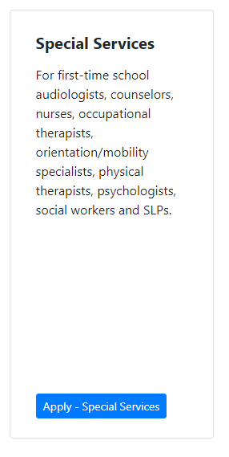

Upon Receipt of Initial License
- Sign up for the CDE School Nurse Listserv
- Sign up for CDE New School Nurse Training Notifications
- Email WillynWebb@csi.state.co.us to sign up for CSI SSP Induction (required).

