State Assigned Student Identifier (SASID)
Contents
SASID Request & RITS Update Process 3
SASID Overview 3
School’s Role 3
CSI’s Role 3
Legal Documentation 3
Resources 4
CSI Website 4
RITS (Record Integration Tracking System) 4
SASID Process for Schools 5
Search for Existing SASIDs 5
Searching for Students in RITS 5
Best Practices Search Tips 6
Search Results 6
Determining Next Steps 7
Requesting New SASIDs 8
Request New SASID Overview 8
Request New SASID Steps 8
Acceptable Coding (File Layout) 10
Retrieving completed SASIDS 10
SASID Mass Batch Request 11
Requesting SASID Batch Overview 11
Requesting SASID Batch Steps 11
SASID Request Template 11
Acceptable Coding Format (File Layout) 12
Submitting SASID Mass Requests 13
G-Drive 13
Submit the completed SASID Requests Templates to CSI via G-Drive. Each school has a SASID folder, where schools should upload Request files. Refer to the Data Submissions Handbook on the CSI website, if you are unfamiliar with this process. 13
If your school does not have access to G-Drive, please send a request email to Submissions_CSI@csi.state.co.us. 13
Requesting RITS To submit files to CSI through G-Drive 13
Requesting RITS Update 14
Requesting RITS Update Overview 14
Requesting RITS Update Steps 14
Final Steps 15
Add SASID Numbers into SIS 15

SASID Request & RITS Update Process

SASID Overview
Each student attending a public school in Colorado is required to have a unique identification number. This number is known as a SASID (State Assigned Student Identifier) and is created through the CDE Record Integration Tracking System (RITS). The SASID follows the student throughout their Colorado public school career and is required for state data collections. It is each CSI school’s responsibility to enters the SASID in the school’s Student Information System (SIS) and ensure each student enrolled at the school receives a SASID if they do not already have one.

School’s Role
At the time of enrollment and throughout the school year, schools are responsible for ensuring that every student has a SASID and that the information that comprises the SASID (student’s legal name, birthdate, gender, etc.) is accurate. Schools are responsible for viewing training and resources, staying up to date on changes, reaching out with questions, and requesting additional training if needed.

CSI’s Role
CSI will support schools with training and resources. If there are any issues with SASIDs communicated from CDE, CSI will contact the school by email. CSI will work with the school to verify information and then reply to CSI, who will then contact CDE to clear the issue. This can be a time-consuming process which is why searching RITS before making any SASID related requests is important.
CSI processes most updates within 1-2 business days. If there are errors or if troubleshooting is needed, the processing time may be longer. Processing times may be longer at the beginning of the school year due to volume of submissions.

Legal Documentation
CDE’s Guidance requires that all schools use the legal full name for students in the SASID record. Ensure you use the first, middle, and last name exactly as it is shown on the birth certificate (or legal name change document) for a student.
CSI schools need to use legal student names in their SIS (PowerSchool or Infinite Campus) in order for the names to extract correctly for state reporting. Please contact CSI if you need more information.

Resources
There are two available resources available to schools for SASID information and instruction.

CSI Website
For access to SASID resources including RITS access, SASID Request/Update Guide, Templates, and trainings, please visit the CSI SASID Resource website: https://resources.csi.state.co.us/sasid-edid-requests/.

RITS (Record Integration Tracking System)
Each school submissions contact will receive access the RITS system by CSI staff. If you are the RITS contact and do not have a login, please have your head of school email submissions_CSI@csi.state.co.us to request your access.
- Access RITS via CDE single sign-on page https://www.cde.state.co.us/idm/rits.
- Type in your username and password then click Login. (Only click one time and wait. Can take a few minutes.)
- Important note: After 3 attempts to login with the wrong password, users are locked out. After 20 minutes, the system will unlock and you can try to login again.
- If you need to reset your password, please use the “Forgot your password” function.
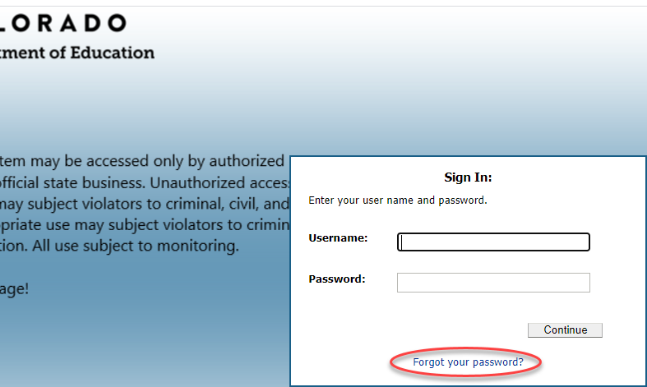

SASID Process for Schools

Search for Existing SASIDs
Using RITS to search for a student is the most important step in this process. When done properly, this step can avoid time consuming duplicate SASIDs.

Searching for Students in RITS
Prior to requesting a new SASID, always conduct a student search every time using the Best Practice Seach Tips below. Chances are good that your student already has a SASID in the system even if they are new to your school.
All incoming Kinder, Pre-K and students coming from another state or country should be search in RITS prior to a new request. These students have been found at times in the RITS system because of Colorado infant programs or previously enrolled but schools were not informed by parents.
- Log into RITS,
- Click “Student Search / Update” in the left column.
- Please do NOT include information in every field of this search screen. Instead follow the Best Practices Seach Tips below.
- Click “Search” Button.
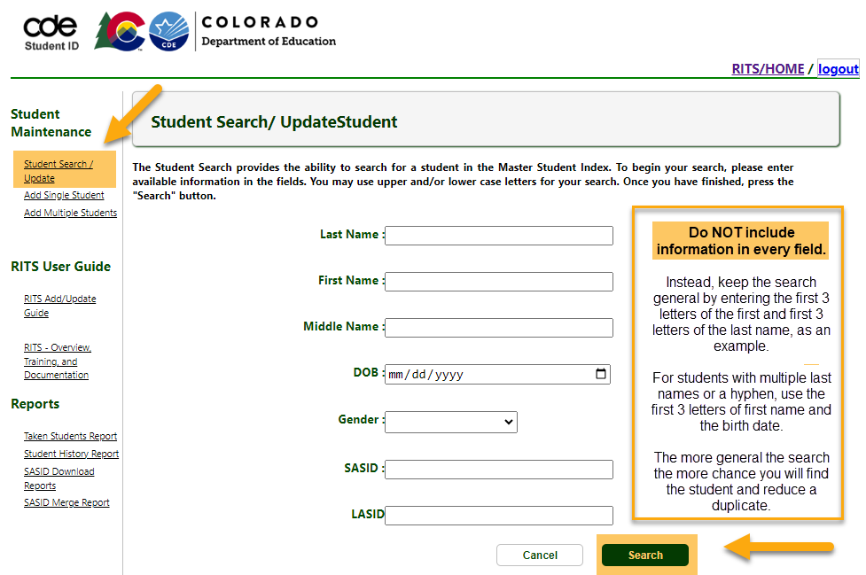

Best Practices Search Tips
For the best chances of finding a student already in RITS and avoid duplicates, please use a general search in case the student has incorrect information in RITS or search information is not entered correctly.
- Use the first 3 letters of the student’s first and last name ONLY to keep the search general.
- If a student has multiple last names or a hyphen in their last name, search using the birth date and first 3 letters of the student’s first name.

Search Results
The search should be general to allow for students with similar names.
- When searching for student:
Last Name-TEST, First Name-STUDENT, Date of Birth-02/28/2003.
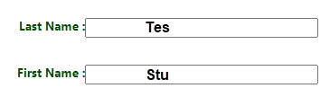
- Search results will yield:
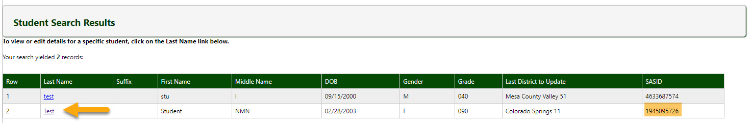
- After verifying that student on row two is your student by comparing other fields. You can copy the SASID from this page to paste in to your SIS.
- Or you can click on the Last name for the Student Detail Screen.
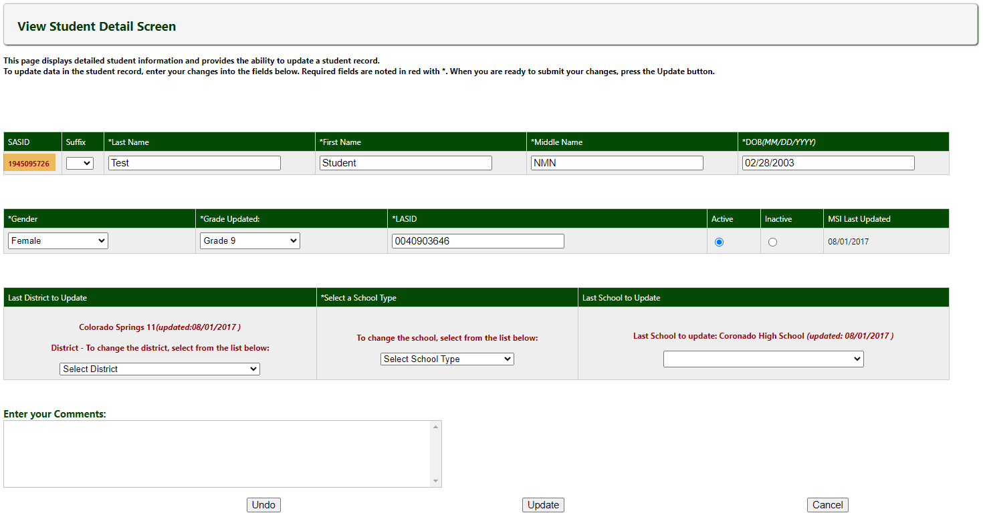
- From this screen you can copy the SASID to paste into your SIS.

NOTE: If the Last, First, Middle Name, DOB, or Gender are incorrect in RITS:
- Confirm that you are viewing the correct student.
- If you are viewing the correct student, follow the “Requesting RITS Update” instructions in the sections below.
- If you are not sure if the student is your student, create a spreadsheet or document with the details and place it in the G-Drive>SASID. If you believe that a merge is required, please include both SASID numbers and the guardian names of your student. Then email the Submissions_CSI@csi.state.co.us.

Determining Next Steps
- If the student comes up in the search results, use the SASID included in the search results and enter the SASID in your SIS.
- If no students match in the search results, then move to the next steps to Request New SASIDs.

Requesting New SASIDs

Request New SASID Overview
AFTER seaching thoroughly for a student in RITS, you can request a SASID by adding single student in RITS. Please NOTE: CSI has found that “adding multiple students” option often malfunctions, so it is recommended to add students individually. For schools that export mass student lists from their SIS, reference below the instructions for “SASID Mass Batch Request”.

Request New SASID Steps
For more details about the format needs in RITS and State Reporting, please refer to the ”Acceptable Coding (File Layout)” section below.
- After searching thoroughly for the student without a matching search result,
- Click “Add Single Student” in the left column,
- Using the student’s LEGAL documents (Birth certificate, passport, etc.), complete the request. All required fields are indicated by a asterisk *.
  - Last Name*: Use legal last name.
Only use letters, space, - dash, or ‘ apostrophe in RITS and SIS. Accents and other characters are not available at this time.
  - Suffix: Include if on legal documents.
  - First Name*: Use legal first name.
Only use letters, space, - dash, or ‘ apostrophe in RITS and SIS. Accents and other characters are not available at this time.
  - Middle Name*: Use legal middle name.
For students with no middle name, use NMN.
  - DOB*: Enter Date of Birth listed on legal documents.
  - Gender*: Enter the gender that the student identifies.
  - Grade*: Enter grade for the student.
  - LASID*: A 10-digit LASID is required.
This is a local student ID for your school only. Please utilize either a school/SIS generated ID number or enter a unique 10-digit code. (This code can start with leading zeros). Some schools choose the four-digit district code, followed by the four-digit school code, and three arbitrary numbers, typically in sequential order.
  - District*: Choose “Charter School institute”.
  - School Type*: Choose” Public/Detention Centers”.
  - School*: Choose your school.
  - Comments: Use this if the student is related and shares a birth date AND last name. You can type TWIN or TRIPLET for example. This will inform CDE Case Management that the request is not a duplicate.
- Double check your data is correct before submitting.
- Click “Add” Button.
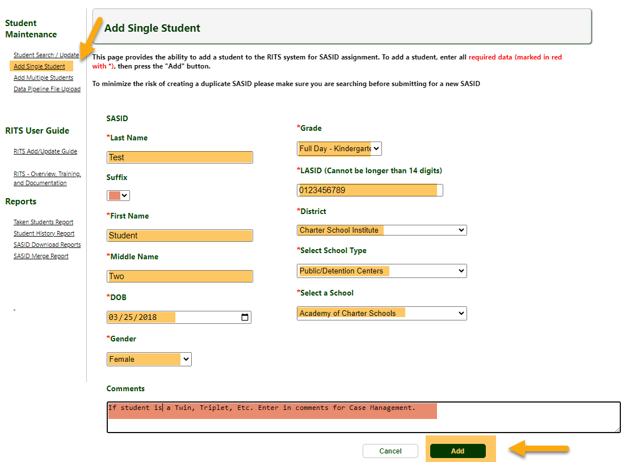
- Immediately after adding the student, a message with the new SASID will be displayed in a pop-up box. This number can be immediately copied and pasted into your SIS.
- If a SASID number is not yet available, a message will appear in a pop-up box letting you know that the request has been sent to CDE’s Case Management Team. When this occurs, please search for the student in RITS in a day or two for the updated SASID.
  - This message occurs regularly if the student has any matching information with another student already in the system. The matching information could be a matching first name and birthdate or first and last name for example.
  - Many times, this information is not a total match and Case Management will generate a new SASID after their review.
  - It is possible that the student that was entered is a duplicate, and CDE or CSI will reach out to you by email if this is the case.
  - If you have not heard back from CDE or CSI and a number has not been generated after a week, please email Submissions_CSI@csi.state.co.us so we can reach out to CDE to check on the progress.

Acceptable Coding (File Layout)
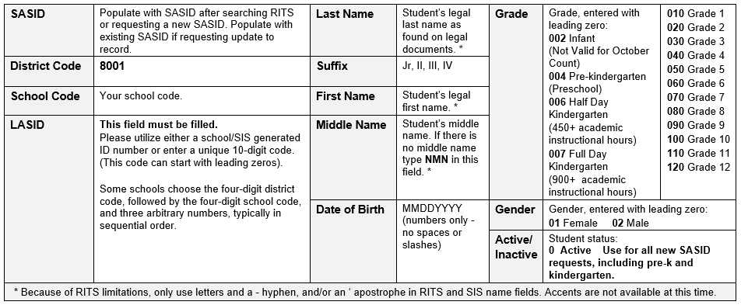

Retrieving completed SASIDS
- Once a new SASID is requested, a pop up will display either a SASID, which can be copied and pasted into your SIS, or a message stating that the request is in review with case management.
- Requests in review with Case Management simply means that the request has two or more fields that match another Colorado student in RITS. This does not necessarily mean that the request is a duplicate. Please check RITS by conducting a search in 1 – 2 business days to find the updated SASID result.
- If it has been 7 days or more and a result is not in RITS, please reach out to CSI through the CSI submissions e-mail and we will contact CDC to check on the request. These unanswered requests can mean that a duplicate was found.

SASID Mass Batch Request

Requesting SASID Batch Overview
For schools that use their SIS to export a mass batch list of student that are missing SASID numbers, CSI can help generate SASID numbers for these students. This is typical for schools during the pre-enrollment time and prior to the start of school. CDE does not allow schools access to the RITS Pipeline required to upload, so CSI will continue to support the schools that use this feature.

Requesting SASID Batch Steps
- Export a list from your SIS,
- Be sure that the export includes a header row, leading zeros, correct column order that follows the template below, and the correct field format that follows the file layout below.
The order and format are found on the SASID File Layout and SASID Request Template located on the CSI SASID Resource Webpage: https://resources.csi.state.co.us/sasid-edid-requests/ or on the screenshots included below.
- Rename the file without spaces: school code, school name/acronym, submission type and date.
Example: 2067_CILA_SASID_Request_mmddyyyy.
- Upload file to the G-Drive>SASID>Current Year>SASID Request
Refer to the Data Submissions Handbook on the CSI website, if you are unfamiliar with this process.
- Notify CSI of your submission by sending an email to Submissions_CSI@csi.state.co.us.
- Allow 48 business hours to process your files and return results.
- Results will be updated on your file and you will receive an email once the file is ready to view.

SASID Request Template
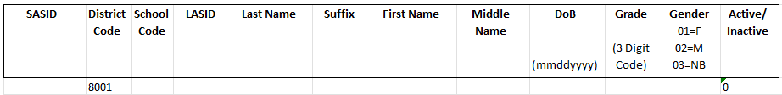

Acceptable Coding Format (File Layout)

Submitting SASID Mass Requests

G-Drive

Submit the completed SASID Requests Templates to CSI via G-Drive. Each school has a SASID folder, where schools should upload Request files. Refer to the Data Submissions Handbook on the CSI website, if you are unfamiliar with this process.

If your school does not have access to G-Drive, please send a request email to Submissions_CSI@csi.state.co.us.

Requesting RITS To submit files to CSI through G-Drive
- Drag the file from your computer into the SASID folder within G-Drive>”SASID Request” folder
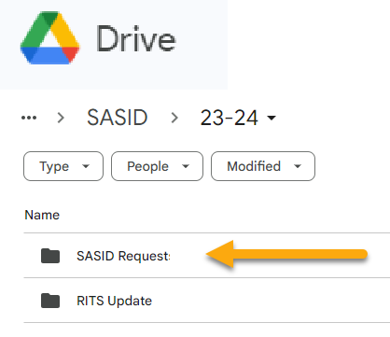
- Notify CSI of your submission by sending an email to Submissions_CSI@csi.state.co.us
  - Subject Line: “SASID Request”
  - Email: Contains the name of the file. For example: “I uploaded a SASID request to G-Drive: 8825_ABC_SASID_Request_05102021”
- Allow 48 business hours to process your files and return results.

Requesting RITS Update

Requesting RITS Update Overview
A RITS update is used when a school finds inaccurate information in RITS. This can be a misspelled name, incorrect names, incorrect birth date, a legal name change, a gender update, etc. A REITS update can be used when a schools SIS is correct, but RITS is incorrect and filds do not match. NOTE: It is important that schools compare inconsistancies with legal documents prior to requesting an update.

Requesting RITS Update Steps
- If inaccurate information is found in RITS, compare it with legal documents prior to sending an update request.
- Access the “RITS Update Request” running spreadsheet found in each school’s G-Drive>SASID>Current Year
NOTE: This form is for RITS updates only and not for requesting new SASIDS. Please refer to instructions above for Requesting New SASIDS.
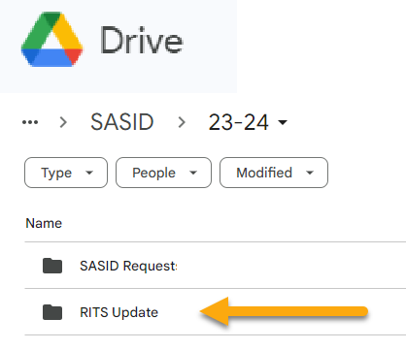
- Using the RITS Update Request, complete a row for each update request.
Note: This will be a running list for the year so you will not need to delete or make a copy of this file. Simply continue to add to the sheet as new updates arise. Each year a new sheet will be added to the G-Drive.
- Complete the SASID, name, date of birth, grade and gender fields with the data that is correct for the student.
- Highlight in YELLOW the cell/s that do not match RITS and need to be updated.
- Notify CSI of your completed update entry by sending an email to Submissions_CSI@csi.state.co.us.
- Allow 48 business hours to process your request.
- CSI will email once the update is complete and will add the completion status and date to the RITS Update Request sheet.
Upon completion, CSI will also make an additional copy that CSI will keep in case the sheet is ever lost.

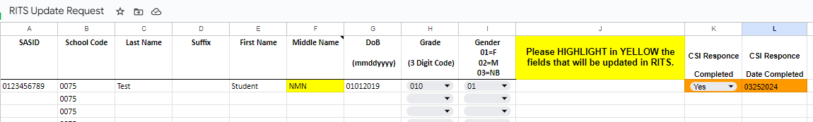

Final Steps

Add SASID Numbers into SIS
Update your student information system and/or plan management system with the generated SASID as soon as possible as submitting collection files with 0-filled SASIDs greatly increases your error count and can also delay data checks on CSI’s end.
Be careful that you do not copy and paste leading or trailing spaces when you copy over the SASIDs to your systems. This can cause state reporting issues later on if you do.

