PowerSchool File Extraction Process

Navigation, Validation, and Extraction
Schools using PowerSchool for their Student Information System must periodically extract the Discipline Action file from the system and submit it to CSI for the State required Discipline collection. Below outline the steps a school should take to extract files for data entered into the system.
- Navigate to the school’s instance of PowerSchool. Starting in 23-24, the SPED and School Discipline have merged into the Discipline Interchange. This means there are now level 1 and 2 errors for the collection and only one file to submit – the Discipline Action file.
- To Access the necessary Action file in the system, you must first click on System Reports and then the State tab. Under the Interchanges section, click on Discipline Action File.
  - PowerSchool schools using the new user interface can access reporting by going to Data and ReportingReportsCompliance Reports. The rest of this process should be the same.
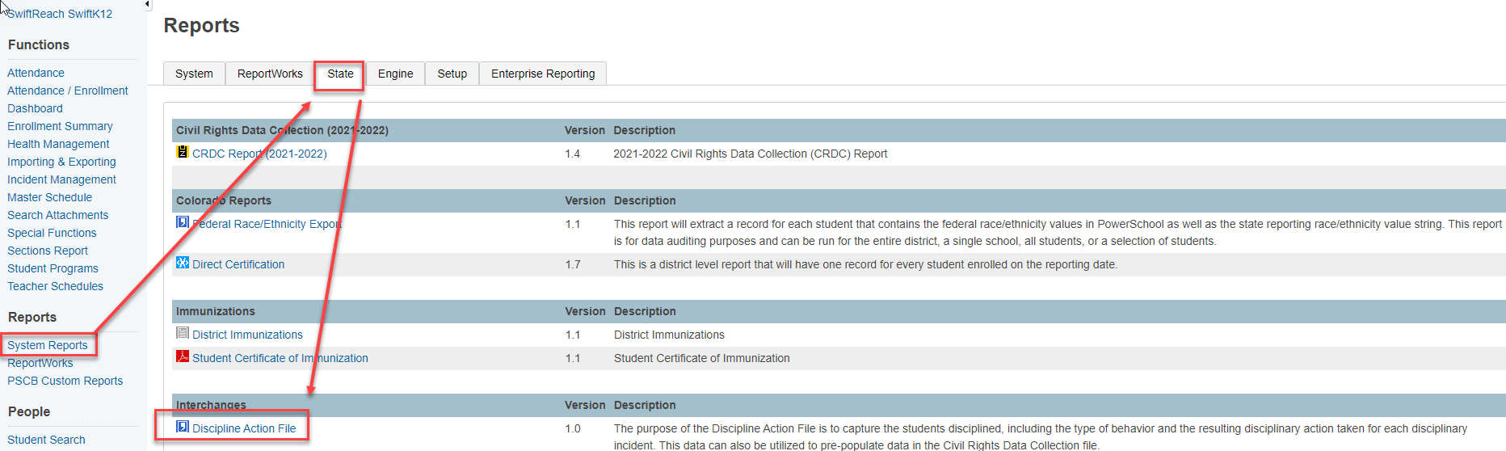
- Once on the Discipline Action File screen, there will be a series of prompts to complete in order to get the correct data. Ensure you are selecting your school under Schools to Include and use the appropriate dates for the current year. For example, I recommend using 07/01/2023 to 06/30/2024 for the 23-24 school year.
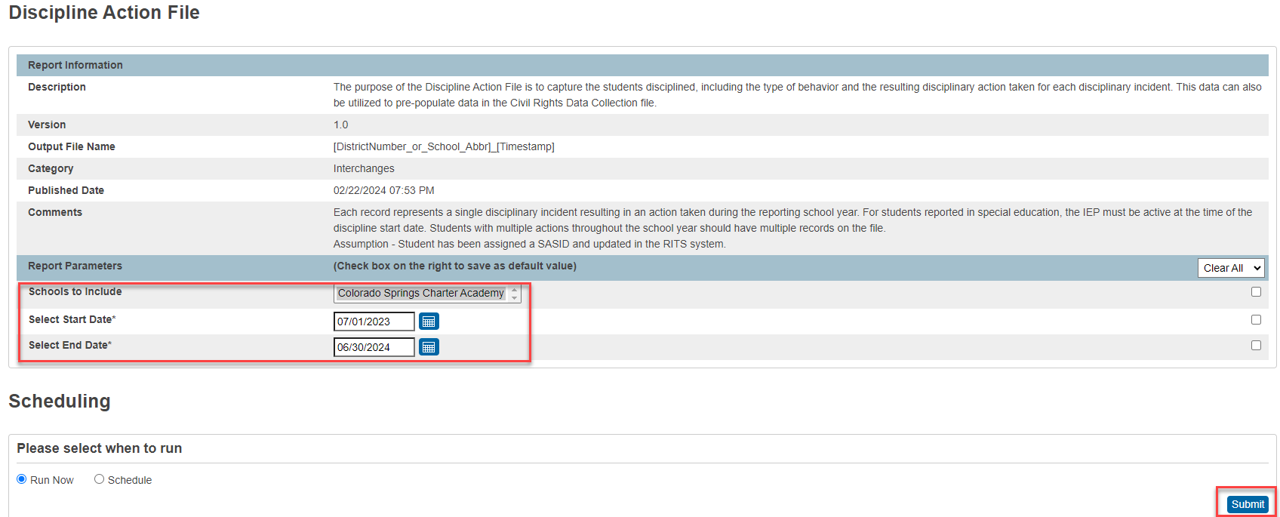
- Once the prompts are completed, click the Submit Button. The report may take a minute or two to process. You will see in the Reports Queue that the status will show running until it has been completed. You’ll have to keep clicking refresh until you get the complete status.
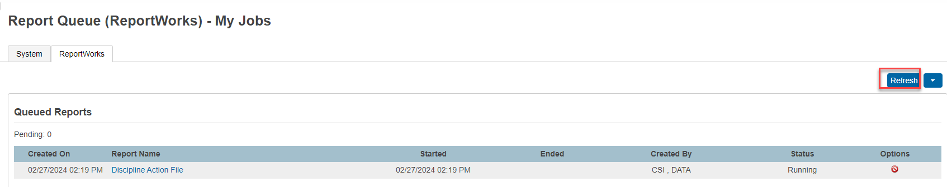

- After it has been completed, click on the word Completed and the file will automatically download to your downloads folder. You’ll want to save to a specific Files to Run folder on your computer set up for the collection. This should be done without opening. Opening the CSV file will cause the leading zeros to drop if you save within the file.
- Once saved, you can open it to review the file if it is closed without saving. This file can be submitted as is but running it through the record checker is the next recommended option prior to submittal. See the template and instructions on the School Discipline homepage.
- Once they are saved to the appropriate folder on your computer, you can rename them for submittal. Right click and select rename using the CSI standard format (schoolcode_abbreviation_filename_date). There should be no spaces in the file name for the files to process successfully.
Ex: 1791_CSCA_DisciplineAction_03052024

- Once the files are moved to your computer and renamed, they are ready to be submitted to CSI’s shared Google Drive. Be sure to email the submissions inbox (submissions_csi@csi.state.co.us) to let us know you have files ready to be processed!

