Staff Evaluation Collection Instructions

Overview
The intention of the Staff Evaluation Collection is to capture the current year final evaluation ratings for personnel at all Colorado School Districts. This collection was introduced in the 22-23 school year and CSI schools were not required to complete it given that all schools have the appropriate waivers to zero-fill the evaluation data. CDE has since determined that CSI must also complete this collection and capture any new Teachers, Specialized Service Providers, or Principals that have been hired since the close of the previous HR Collection. This would include the following Job Classifications Codes: 105, 106, 201, 202, 206, 211, 216, 222, 223, 231, 233-238, and code 242 from the File Layout. For schools who have new hires (or exits) in those Job Classifications, please follow the below steps.

Steps to Complete
- CSI has provided you with your starting point files within the newly created Staff Evaluation folder within HR (HR> Staff Evaluation> 23-24> Starting Point). The starting point file is essentially the last submitted, error free files your school provided CSI from 23-24 HR data collection.
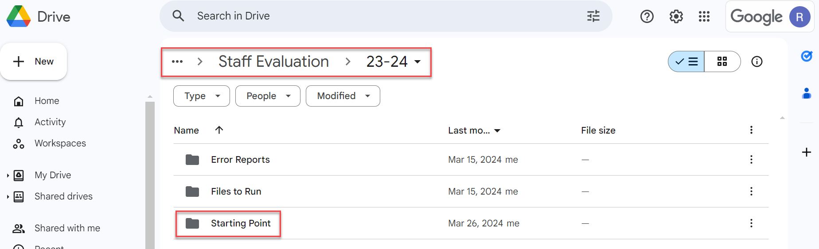

- Navigate to the bottom of the spreadsheet and complete all fields on the Staff Profile and all highlighted fields on the Staff Assignment for any newly hired staff.
- Ensure you are adding an exit date to anyone that is no longer employed.
- Rows that include any 1) new staff added or 2) existing staff data modified need to be highlighted.
- Return the updated files to the Staff Evaluation Files to Run folder (HR>Staff Evaluation>23-24>Files to Run).
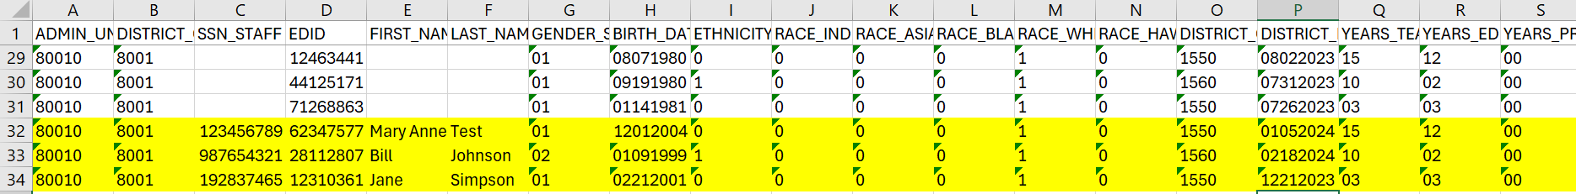

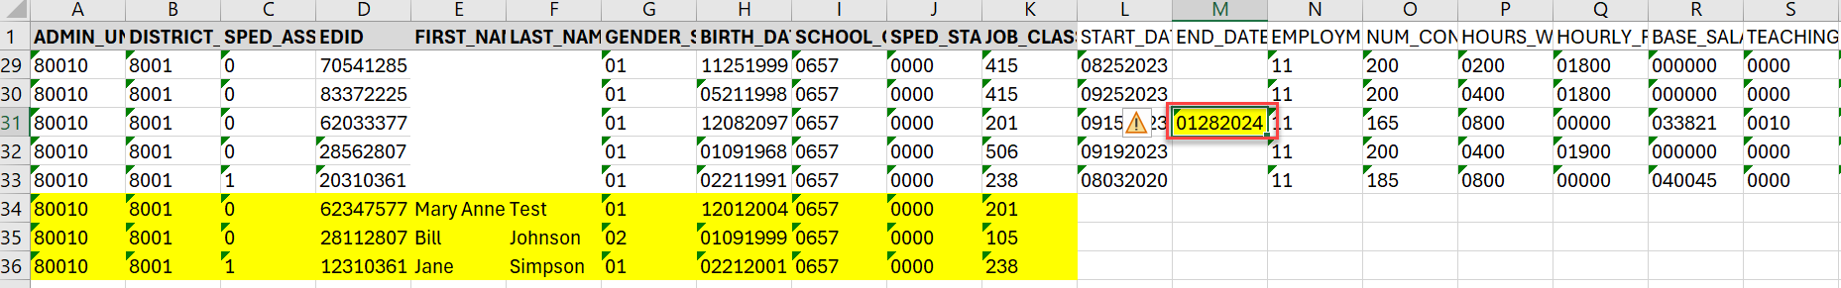
- - All PII data has been removed from the screenshots for privacy purposes.
CSI will then combine all new and updated records into one CSI-wide file for both the Staff Profile and the newly created Staff Evaluation file. These files will be processed, and error reports will be parsed out to schools and available in the Error Reports folder. Once the files are error free, a snapshot will be run, and schools will be provided with level 2 errors. All corrections should be made on your originally submitted files. Below lists all the deadlines for this collection. Dates are also available in the 23-24 CSI Data Submissions Calendar.

Lastly, please be sure to email CSI if you have not had any new hires within those Job Classifications since the 23-24 HR Collection.

23-24 Staff Evaluation Deadlines
- April 29th, 2024 – Initial Submittal Deadline
- May 22nd ,2024 - Level 1 error clearance deadline
- June 14th, 2024 – Level 2 errors cleared.

