Word Document Guidelines

Adapted from:
- CDE Documents and Accessibility
- WebAIM
- NWCG Guidelines for Creating Accessible Electronic Documents
- Microsoft Word Guidelines

Microsoft Word Document Creation 2
New Document Setup 2
Headings 2
Alternative Text for Images 3
Links 3
Lists & Columns 4
High-Contrast Colors 4
Other Tips 4
Accessibility Checker 5
Converting Documents to PDF 6
Acrobat Tab in Office 6
Creating fillable Word Document Forms 8

Microsoft Word Document Creation

New Document Setup
Document Properties, also known as metadata, are details about a file that describe or identify it, including title, author name, subject, and keywords identifying the document’s topic or contents.

Properties are important for documents posted on websites. Search engines use this information to identify documents users might want to examine.

- In Word, go to “File” → “Info” → “Properties” → “Advanced Properties”
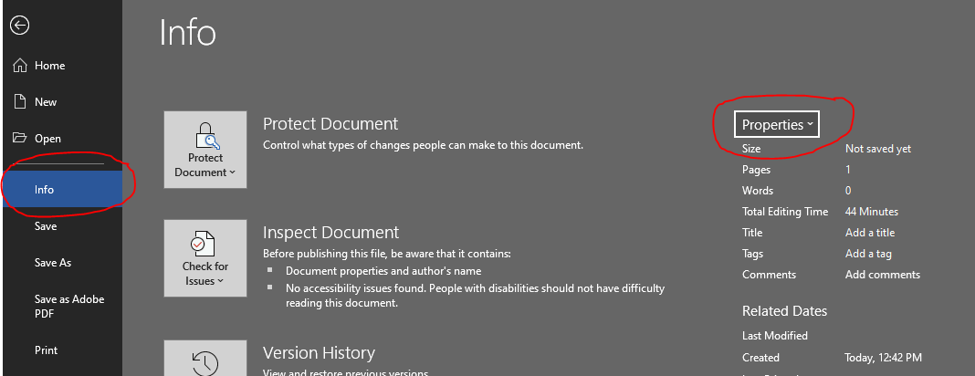
- In order of importance, categories are:
  - Required:
    - Title: Title of document
      - Ensure at minimum the title is filled in - it can match the title of your document or be more concise, as long as it is descriptive.
  - Optional:
    - Subject: Subject of document, i.e. “student enrollment”
  - Author: Your name
  - Keywords: can help with search functionality. Separate multiple keywords with commas, i.e. “504, special education”
  - Company: Colorado Charter School Institute (if created by you/CSI)

Headings
- Utilize Word’s Heading styles (do not just highlight/bold text)
- Heading levels should represent the structure of the document
- Do not skip Heading levels (i.e. using a Heading 4 after Heading 2)
- If converting to PDF, only use Headings 1-6 as Adobe does not recognize headings past 6
- CSI’s template will have these preset, but you can also preset your own

For more guidance on headings, check out How to Create Accessible Headings in Microsoft Word

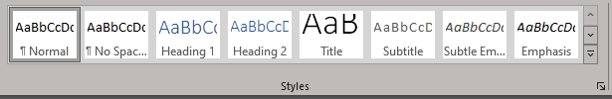

Alternative Text for Images
- Be sure to use alternative text for any images.
- Right click on the image and then click “View Alt Text”.
- Alternative text should be accurate and succinct. You do not need to use the phrase “image of” or “graphic of” as screen readers will identify that it is an image.
- If the image is purely decorative, you can mark it as such. 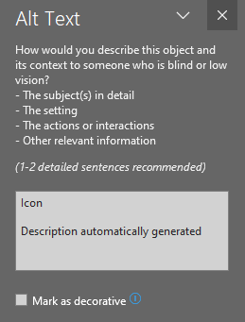

Links
- Follow these principles to create accessible links:
  - Use descriptive link text that does not rely on context from the surrounding text. Avoid ambiguous link text that is difficult to understand out of context (e.g., "click here").
  - Keep the amount of text in the link to a minimum.
  - For example, to create a link:
    - Type the descriptive text, i.e. “Special Education Handbook”
    - Highlight text, right click, and select “Insert Link”
    - Paste in link to content
    - Link should automatically change to a different color and underline

Lists & Columns
- If using a list structure, be sure to use bullet points or numbers (not just tab or differing margins as a screen reader will not pick up on those).

High-Contrast Colors
The text in your document should be readable in a high-contrast mode. For example, use bright colors or high-contrast color schemes on opposite ends of the color spectrum. White and black schemes make it easier for people who are colorblind to distinguish text and shapes.

- To show high-contrast color options, go to the “Home” tab
- Click the down arrow of the text or highlight color icon
- Turn on the “High-contrast only” toggle to view accessible high-contrast colors
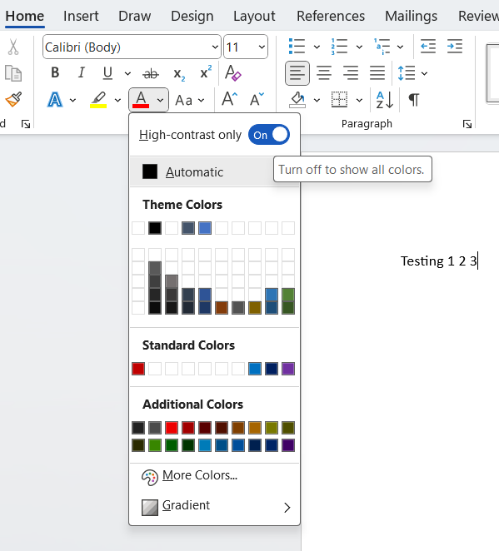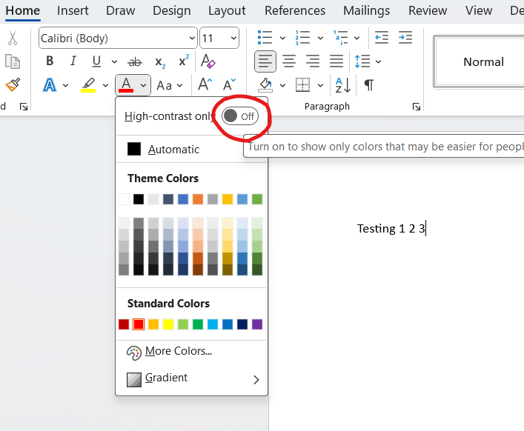

Other Tips
- Language: Use simple language. Test your language using the Hemingway App if you would like.
- Size: Ensure font size is a minimum of 11 point.
- Color: Do not use color as the only way to convey information. Provide sufficient contrast between text colors and background colors.
- Be careful with use of watermarks, which can impact readability.
- Provide a table of contents for long documents.

Accessibility Checker
Word has an Accessibility Checker for identifying and repairing many accessibility issues. In Word, go to the Review tab, then click “Check Accessibility”.

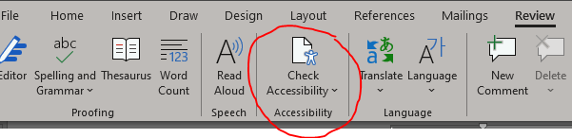

The checker's Inspection Results classifies accessibility issues into three categories:

- Errors: content that makes a document very difficult or impossible for people with disabilities to access.
  - Example: an image with no alt text.
- Warnings: content that in most—but not all—cases makes the document difficult for people with disabilities to access.
  - Example: a link with text that is not descriptive of its function.
- Tips: content that people with disabilities can access, but that might be better organized or presented.
  - Example: skipping from a first-level heading to a third-level heading.

Clicking an item in the results highlights the corresponding item in the document and displays the Additional Information section:

- Why Fix: explains why the issue impacts accessibility.
- How to Fix: suggestions for repairing the issue.

Converting Documents to PDF

Acrobat Tab in Office
- Prior to converting your Word document to PDF format, go to the “Acrobat” tab in Word and click “Preferences”.
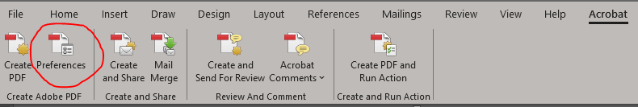

- Ensure “Enable Accessibility and Reflow with tagged Adobe PDF” is checked.
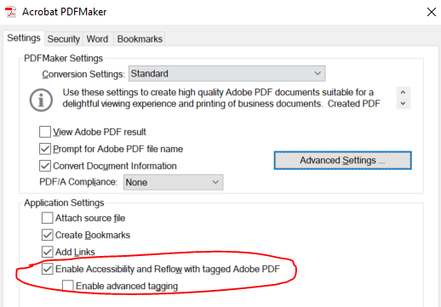

- Click “File” → “Save As” → Choose location → Save as type PDF → then click “Options”.

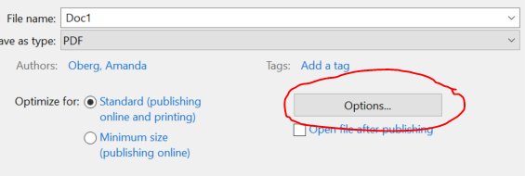

- Ensure “Document structure tags for accessibility” is checked.

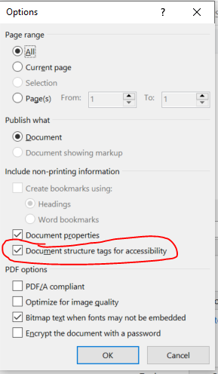

Creating fillable Word Document Forms

- Guidance for creating forms in Word
  - You must enable the Developer in Word to do so. This article gives guidance on how to enable Developer.

