Free & Reduced Lunch (FRL)

Manually Adding Eligibility in PowerSchool (PS)

*For schools that prefer to import, please reach out to CSI staff for relevant training/resources.
Student Demographic (SD) File –
- Select School: (Some schools will choose “District Office” if searching students for multiple schools)
- Select the Calendar Year: Current Year
Search: Search for Student
- Go to: “Administration”, (Enhanced UI View – “Student Profile”)
- Select: “Lunch”, (Enhanced UI View – “Lunch Program”)

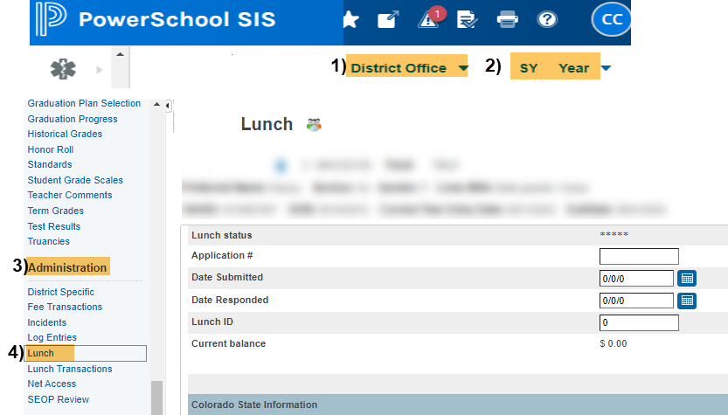
Original View Enhanced UI View
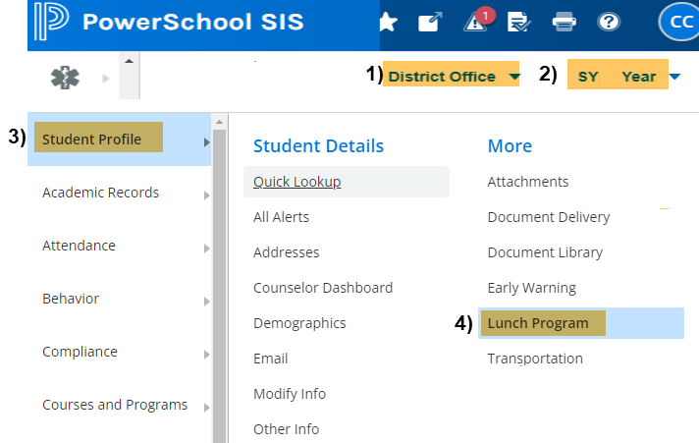

Under Lunch/Lunch Program:
Lunch Program Section: The fields in the top section are NOT state reportable. Schools should populate these fields as determined by your school and leadership. If lunch status is filled, this field should match the state reportable “Free or Reduced Lunch Eligibility” field under the Colorado State Information section (described below).

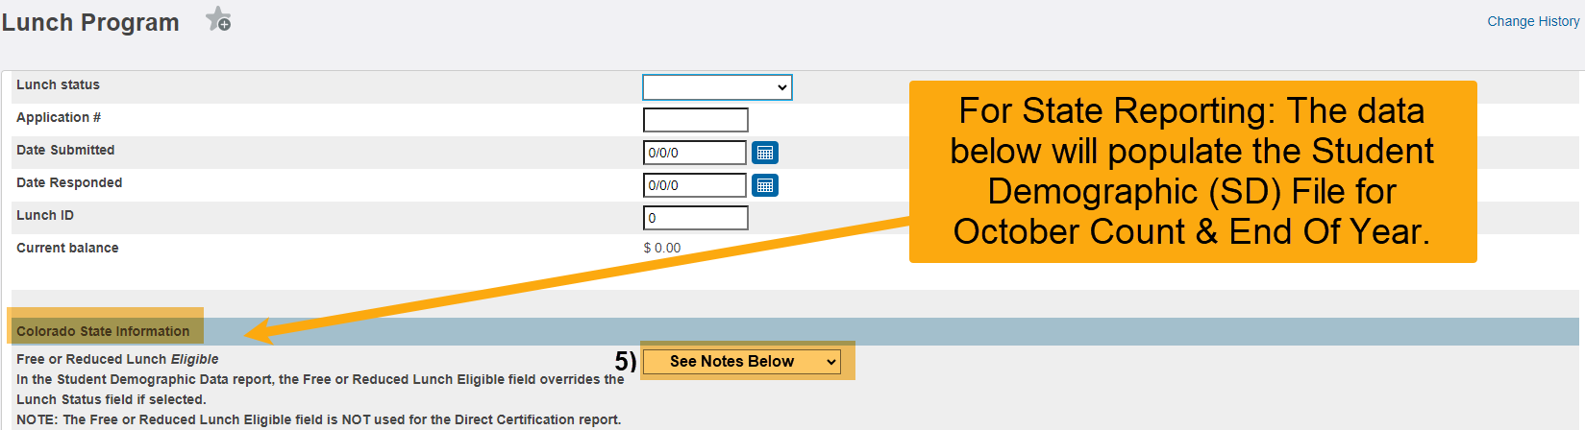
Navigate to: Colorado State Information Section

Free or Reduced Lunch Eligibility: Select Eligibility Type. Note: In the Student Demographic Data report, the Free or Reduced Lunch Eligible field overrides the Lunch Status field if selected.
- Free Lunch Eligible - The student is considered eligible to receive reimbursable meals at no charge. Populates state code 01.
- Reduced Lunch Eligible - The student is considered eligible and must pay a reduced price for reimbursable meals. Populates state code 02.
- Paid or Not Eligible - The student is not considered eligible and must pay student price for reimbursable meals. Populates state code 00.

Once Eligibility is Selected from Drop-Down, a Pop-Up will Appear: Lunch Status Change
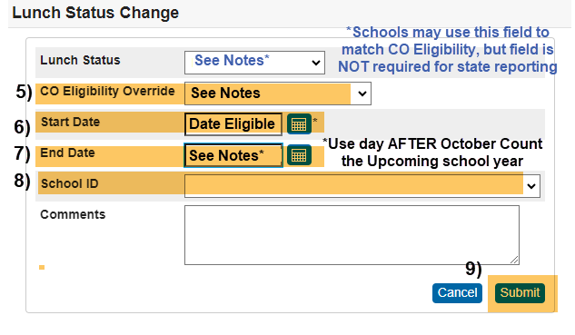

Start Date: Select First Date Eligibility is Active. Note: This will be the date the form was received by the district (on or between July 1 and the pupil enrollment count date),

End Date: Select Last Date Eligibility is Active. IMPORTANT: Because of carry-over, use the end date of the day AFTER October Count the upcoming school year. For instance, if the student is eligible 8/1/2024, then the end date will be 10/02/2025 UNLESS a new application or designation has been determined, in which case that determination will supersede the carry-over status,
- School ID: Select School from Drop-down,
- Select: Submit.

Navigate back to: Colorado State Information Section

Free Lunch Eligibility Identification: Select for “Free” lunch students only. Note: Leave blank OR select “(0) Not identified for Free Lunch” for Reduced or Paid lunch status.

Direct Certification: Indicates that the student qualifies for free meals due to Direct Certification files received from a state agency certifying that the child is a member of Medicaid, a SNAP, FDPIR or TANF household. All students identified as members of the household are categorically eligible for free meals. Populates state code 1-Direct Certification.
- Other Source Categorical: CSI approved McKinney-Vento (MKV) form, Migrant Education Program (MEPS) approved Migrant status, or CDE confirmed Foster student. Populates state code 2-Other Categorical.
- Application: Determining eligibility via State Application or FEDS form. Populates state code 3-Application.

P-EBT FRPL Eligibility Override: Leave Blank,

Select: Submit.

Note: If the newly added eligibility is not showing up under Lunch Changes, try to log out of PS and then log back in. Another option is to change the school view to “District” then back to the school. Reach out to CSI if more assistance is needed.

To Update the Start & End Date:

Under Lunch Change:

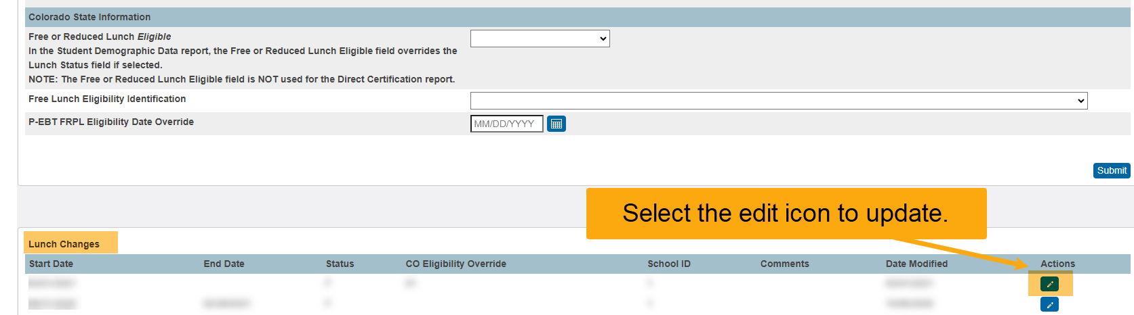
Actions: Click Edit Icon & follow steps 6 – 9 above.

*See resources:
For FRL eligibility information: https://resources.csi.state.co.us/free-and-reduced-lunch-eligibility/
For McKinny Vento information: https://resources.csi.state.co.us/mckinney-vento-homeless-act/
For Migrant information: https://resources.csi.state.co.us/migrant-education-program/

