Free & Reduced Lunch (FRL)

Manually Adding Eligibility in Infinite Campus (IC)

*For schools that prefer to import, please reach out to CSI staff for relevant training/resources.

Student Demographic (SD) File – Known in IC as “Student Layout”

After selecting a student,

Go to: “Index” tab, (New Look View-“Main Menu”)

Select: “FRAM” drop down,

Select: “Eligibility”,
- Click: “New”,
You can do this from any calendar year.
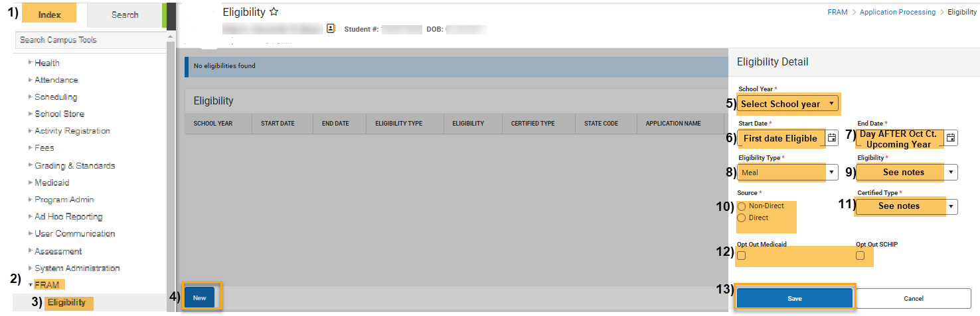
IC Original View

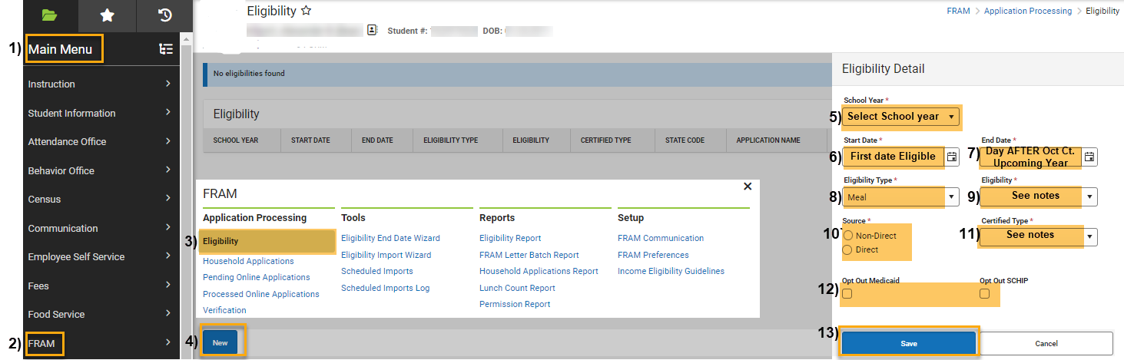
OR IC “NEW LOOK” View

Under Eligibility Detail:

School Year: Select School Year,

Start Date: Select First Date Eligibility is Active. Note: This will be the date the form was received by the district (on or between July 1 and the pupil enrollment count date.

End Date: Select Last Date Eligibility is Active. IMPORTANT: Because of carry-over, use the end date of the day AFTER October Count the upcoming school year. For instance, if the student is eligible 8/1/2024, then the end date will be 10/02/2025 UNLESS a new application or designation has been determined, in which case that determination will supersede the carry-over status.

Eligibility Type: Select “Meal”,

Eligibility: Select one of the following:
- Free - The student is considered eligible to receive reimbursable meals at no charge.
- Reduced - The student is considered eligible and must pay a reduced price for reimbursable meals.
- Paid - The student is not considered eligible and must pay student price for reimbursable meals.

Source: Check either Non-Direct or Direct,

Direct: This eligibility is “Free” and indicates that the student qualifies for free/reduced meals due to Direct Certification files received from a state agency certifying that the child is a member of Medicaid, a SNAP, FDPIR or TANF household.

Non-Direct: This eligibility is either “Free” or “Reduced”. Determining eligibility via FEDS application, CDE confirmation of Foster student, CSI approved McKinney-Vento (MKV) form, CDE approved Migrant Status, or runaway coordinator.

Certified Type: Select the determination reason. NOTE: In IC, the options are different depending on if “Direct” or “Non-Direct” Source is selected.

If Source is “Direct”: Select one of the following based on the direct certification file received from either from your SFA or from CSI:

Medicaid: Eligibility can be “Free” or “Reduced”. Type of approval based on the household receiving Medicaid benefits. All students identified as members of the household are categorically eligible for free meals. Populates state code 1-Direct Certification for “Free” only.

SNAP: Eligibility is “Free”. Type of approval based on confirmation from a local agency through direct certification that the household receives Supplemental Nutrition Assistance Program (SNAP) benefits. All students identified as members of the household are categorically eligible for free meals. Populates state code 1-Direct Certification.

TANF: Eligibility is “Free”. Type of approval based on confirmation from a local agency through direct certification that the household receives Temporary Assistance for Needy Families (TANF) benefits. All students identified as members of the household are categorically eligible for free meals. Populates state code 1-Direct Certification.

FDPIR: Eligibility is “Free”. Type of approval based on confirmation from a local agency through direct certification that the household receives Food Distribution Program on Indian Reservations (FDPIR). All students identified as members of the household are categorically eligible for free meals. Populates state code 1-Direct Certification.

If Source is “Non-Direct”: Select one of the following based on FEDS application, CSI approved McKinney-Vento (MKV) form, CDE approved Migrant Status, CDE confirmed Foster Status, or runaway coordinator.

Income: Eligibility can be “Free” or “Reduced”. Type of approval based on household income. Populates state code 3-Application.

Foster: Eligibility is “Free”. Type of approval based on CDE confirmation approving the student's foster status. Populates state code 2-Other Categorical.

Homeless: Eligibility is “Free”. Type of approval based on CSI MKV confirmation approving the student's homeless status. Populates state code 2-Other Categorical.

Migrant: Eligibility is “Free”. Type of approval based on confirmation approving the student's migrant status by the Migrant Education Program (MEP). Populates state code 2-Other Categorical.

Runaway: Eligibility is “Free”. Type of approval based on confirmation approving the student's runaway status. Populates state code 2-Other Categorical.
- Opt Out Medicaid/SCHIP: Check these boxes if opt-out is indicated on the application.
- Save.

*See resources:
For FRL eligibility information: https://resources.csi.state.co.us/free-and-reduced-lunch-eligibility/
For McKinny Vento information: https://resources.csi.state.co.us/mckinney-vento-homeless-act/
For Migrant information: https://resources.csi.state.co.us/migrant-education-program/

