Enrich File Extraction Process

Navigation, Validation, and Extraction
Schools using Enrich for their Plan Management System must periodically extract their Child and Participation files from the system and submit to CSI for State required collections, such as December Count and SPED EOY. Below outline the steps a school should take to extract files for collection submittal.
- Navigate to the school’s instance of Enrich. Starting by Spring of the 23-24 school year, all schools will have their own instance as file extraction was not possible on the combined system. Schools on the shared system may need to utilize starting point files until updated.
- Log in using your staff specific login details, which should take you to the homepage. Scroll down to the Special Education section and click on CDE Data Pipeline.
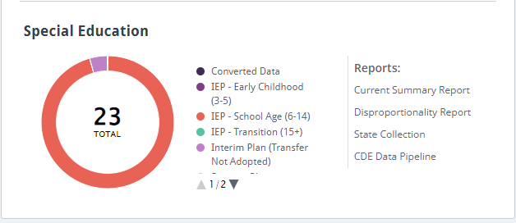
- The subsequent screen should provide you with a listing of years with two options for each year. The one listed as Child Count is for December Count while the End of Year option is for SPED EOY. Select the appropriate one based on which collection you are submitting.
- Near the top of the new screen, you will see a listing of options; including Collect Data Validation Report, Send to CDE Data Pipeline, Download Files, etc. First you want to click on the Collect Data option. This compiles all the latest data that was entered into the system.
- Selecting the Validation Report option allows schools to update their data and correct errors prior to extraction. The system is set up to assist schools in clearing many of the errors, but not all of them you will see once the data is submitted. Correcting data here will save time as it will be less errors to correct upon submittal.
- Once the Validation has run, it should show the error messages you will see along with a count of those errors. Clicking on the number will provide a listing of students with that error. The issue can be corrected directly on this screen.
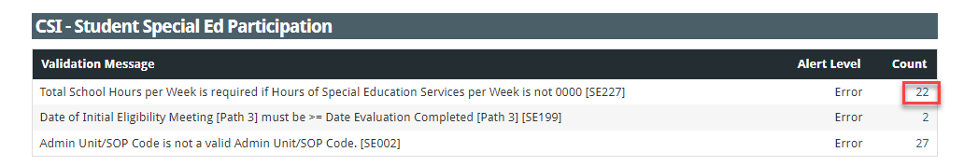
- To correct the issues, click on each student and then select Override Values. Make corrections and save. Complete this process for each student that is being impacted.
- Once completed, click on the Download Files option. Schools do not want to Send to CDE Data Pipeline as all data is processed by CSI.
- Once clicked, a popup will appear allowing you to download the Child and/or the Participation files along with the file format. Select Comma Separated Values (CSV) with Header Row and Click Download.
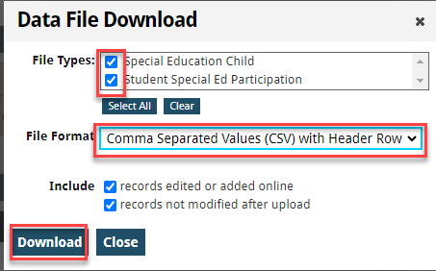
- The files will automatically go to your Downloads folder where you can access them. Be sure not to open the files and save them as that will cause a loss of leading zeros and formatting errors.
- Copy the files and paste them to a Files to Run folder directly on your computer where they can be renamed. Right click and select rename using the CSI standard format (schoolcode_abbreviation_filename_date). There should be no spaces in the file name for the files to process successfully.
Ex: 3326_CILA_Child_03012024
5957_MDM_Participation_03012024
- Once the files are moved to your computer and renamed, they are ready to be submitted to CSI’s shared Google Drive. Be sure to email the submissions inbox (submissions_csi@csi.state.co.us) to let us know you have files ready to be processed!

