End of Year

Using the Record Checker Tool (RCT)

Record Checker Tool (RCT) – Schools are expected to run files using the RCT and resolve and identified errors PRIOR to the initial file submission and throughout the submission process.

FIRST: Download the RCT from the CSI Resource Website:

https://resources.csi.state.co.us/end-of-year/

Go to: “Data Validation Resources” Section,

Then: “End of Year Record Checker Tool”,

Select: “Tool” to download the Excel file.
View instructions and webinar for more detailed information.
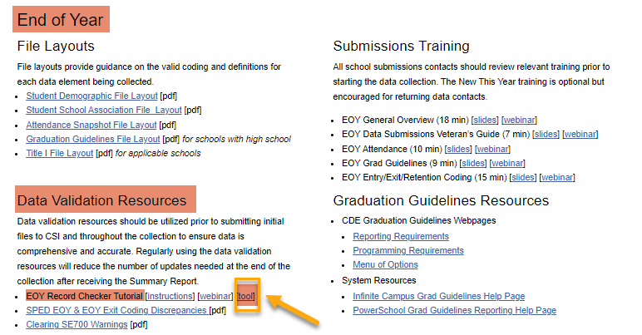

SECOND: Read Instruction Tab
NOTE: You may need to click the “Enable Editing” and/or “Enable Content” button to use the RCT.

Select: “Raw SD Data” or “Raw SSA Data” Tab on the RCT.
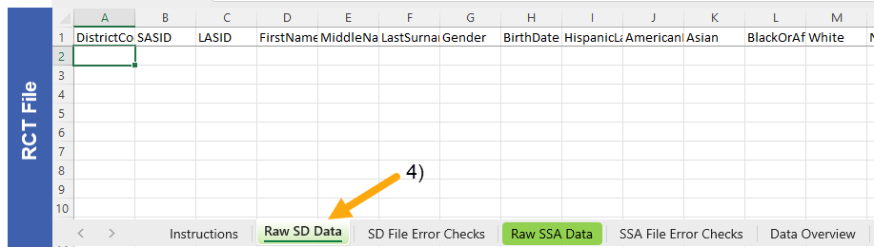

THIRD: Extract SD and/or SSA files from your SIS: See Quick Guides for Instructions on Extracting Files.
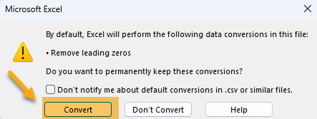
*IMPORTANT: Files must be in CSV format for RCT to read. For newer Excel versions, you will receive a warning. Choose “Convert” for CSV file.

- Open Downloaded CSV SD and/or SSA File
- Select All Cells of the Excel Spreadsheet: Use “Ctrl + A” or Click Corner to the Left of “A” Column,
- Copy all data: Use “Ctrl + C” on Keyboard or Right Click Mouse and Select “Copy”.
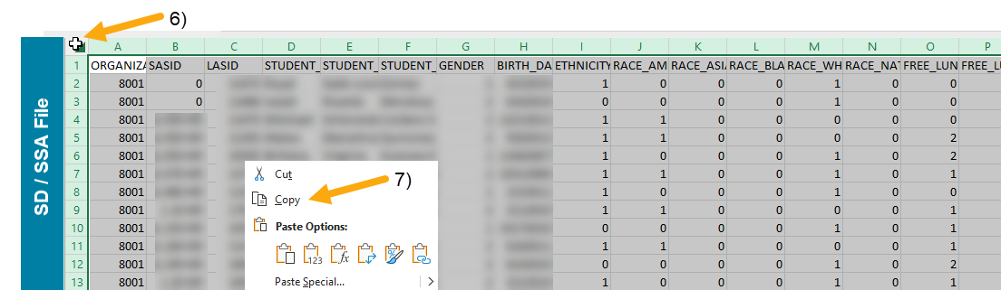

FOURTH: Return to the RCT File

Click: Cell A:1,

Paste All Data: Use “Ctrl + V” on Keyboard or Right Click Mouse and Select “Paste”,
- Notice: Highlighted Cells flag possible issues.
IMPORTANT: Fix flagged issues within your Student Information System (SIS), not on the file itself! You will then extract a new file and run it again through the RCT. Repeat this as many times as necessary.
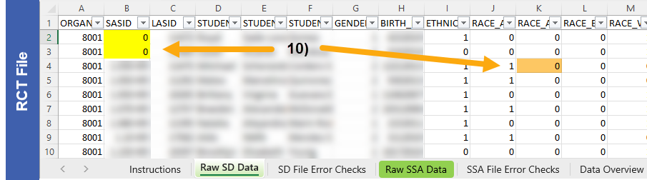
- Use the RCT Instruction Tab: Gives guidance to help correct flagged issues.
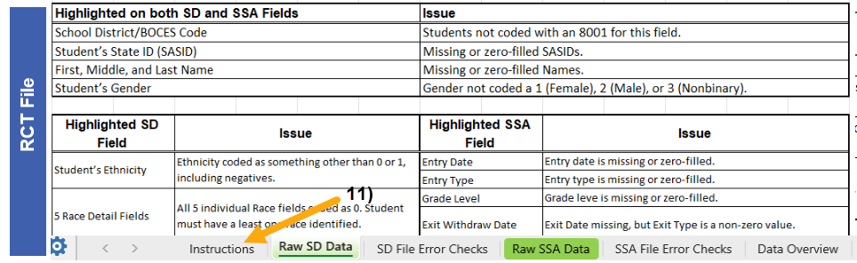

FIFTH: Update Date in Data Overview, Check Data, and Validations Checklist
- Update Last Day of School: Use your schools last day of school
- Verify Data in Data Overview
- Use Validations Check List
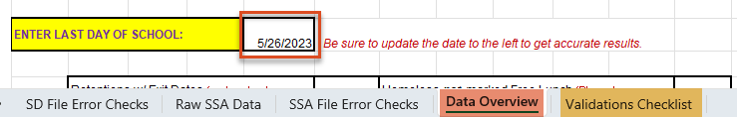

When highlighted cells have been resolved in the RCT, submit a new SD and SSA file to CSI. *Do not send the RCT file. This is for school use only.
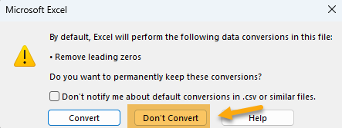
Remember: When submitting files to CSI, do NOT open the downloaded file directly and resave, or it will lose critical leading zeros! Instead, save the file first. Then you can open and/or submit the saved file. OR, if using a newer Excel, you will receive a warning. Choose “Don’t Convert”

Submission Steps:
- Extract new file from your SIS,
- Save file using the following format: SchoolCode_SchoolAbbreviation_FileAbbreviation_MMDDYYYY (no spaces),
- Upload to: G-Drive>Submissions>End of Year>(Choose Year)>Files to Run,
- Notify the Data Team of the submission by emailing: Submissions_CSI@csi.state.co.us.

*See resources:
- For more on naming files:https://resources.csi.state.co.us/data-submissions-library/:
- Training Submissions Process / “Step 3: Extracting the Files and Submitting to CSI”
- For SD details: https://resources.csi.state.co.us/end-of-year/:“Student Demographic File Layout”
- For SSA details: https://resources.csi.state.co.us/end-of-year/: “Student School Association File Layout”
- For RCT: https://resources.csi.state.co.us/end-of-year/:“EOY Record Checker Tool”
- For converting CSV to Excel, Excel Filters, etc: https://resources.csi.state.co.us/data-submissions-library/: “Excel for Data Submissions Contacts (Part 1)”

For More Quick Guides:
https://resources.csi.state.co.us/october-count/

- EOY – Extracting SD Files in IC
- EOY – Extracting SSA Files in IC
- EOY – Extracting TitleI in IC

- EOY – Extracting SD Files in PS
- EOY – Extracting SSA Files in PS
- EOY – Extracting TitleI in PS

