End of Year

Extracting the Graduation Guidelines (GG) Files

In Infinite Campus (IC)

Graduation Guidelines (GG) File:

Go to: “Index” tab, (New Look View-“Main Menu”)

Select: “CO State Reporting” drop down, (New Look View-“Reporting”, “CO Data Pipeline”)

Select: “Student Interchange”.
You can do this from any calendar year.
IC Original View OR IC “NEW LOOK” View
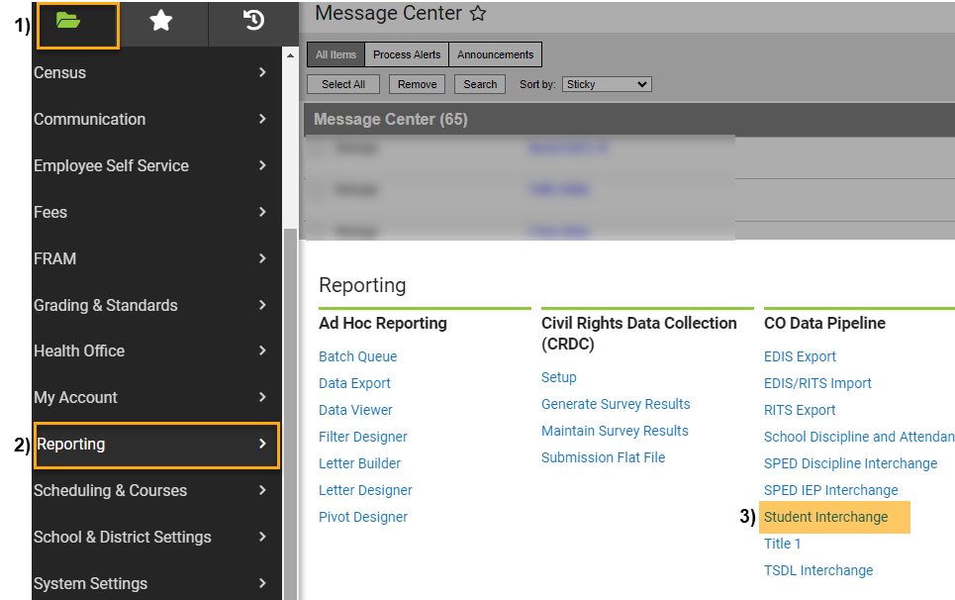
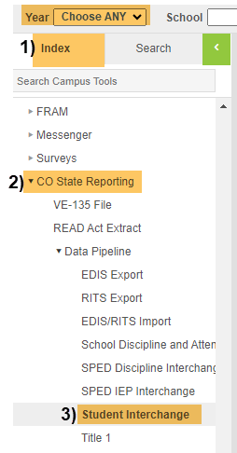

Under Extract Options:

Report Type: Select “Graduation Guidelines” from the dropdown,

Effective Date: Leave as Default Date (Current Date),

All Guidelines: Check this box,

Report Legal Name: Check this Box,

Zero-Fill School Code: Leave as Default, Not checked,

Format: Leave as Default “CSV”.

Under Select Calendars:

Choose calendar/s that you would like to include. Use “Shift /Click” to select multiple,
- Click: Generate Extract.

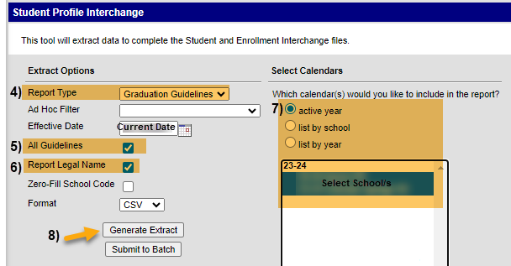
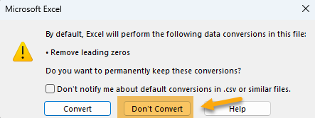
When submitting files to CSI, do NOT open the downloaded file directly and resave, or it will lose critical leading zeros! Instead, save the file first. Then you can open and/or submit the saved file. OR, if using a newer Excel, you will receive a warning. Choose “Don’t Convert”

Submission Steps:
- Use the Record Check Tool (RCT) prior to an initial submission,
- Save file using the following format: SchoolCode_SchoolAbbreviation_GG_MMDDYYYY (no spaces),
- Upload to: G-Drive>Submissions>End of Year>(Choose Year)>Files to Run,
- Notify the Data Team of the submission by emailing: Submissions_CSI@csi.state.co.us.
*See resources:
- For more on naming files:https://resources.csi.state.co.us/data-submissions-library/:
- Training Submissions Process / “Step 3: Extracting the Files and Submitting to CSI”
- For SD details: https://resources.csi.state.co.us/end-of-year/:“Student Demographic File Layout”
- For SSA details: https://resources.csi.state.co.us/end-of-year/: “Student School Association File Layout”
- For RCT: https://resources.csi.state.co.us/end-of-year/:“EOY Record Checker Tool”
- For converting CSV to Excel, Excel Filters, etc: https://resources.csi.state.co.us/data-submissions-library/: “Excel for Data Submissions Contacts (Part 1)”

For More Quick Guides:
https://resources.csi.state.co.us/end-of-year/

- EOY – Extracting SD Files in IC
- EOY – Extracting Title I Files in IC
- EOY – Using the RCT
- EOY – Extracting SSA Files in IC
- EOY – Extracting GG Files in IC

