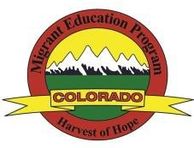

Migrant Education Program (MEP): Regional Directors
MEP REGION | NAME/ TITLE | ADDRESS | PHONE NUMBER | E-MAIL
Northern | Maria Castillo  Director | Centennial BOCES 2020 Clubhouse Dr. Greeley, CO 80634 | Office: 970-352-7404  ext. 1110  Cell: 970-405-4451 | mcastillo@cboces.org
Metro | Guillermo Barriga  Coordinator | 14261 E. 4th. Ave.,  Suite 6-125  Aurora, CO 80011 | Office: 303-365-5817  Cell: 720-810-6700 | gbarriga@aurorak12.org
Southeast | Manuel Calderon  Director | 24951 Hwy 50 East Pueblo, CO 81006 | Office: 719-295-6542  Cell: 719-671-4663 | mcalderon@district70.org
Southwest | Esmeralda Martinez  Director | Adams State University 1424 Second Street  Alamosa, CO 81101 | Office: 719-587-7635  Cell: 719-480-1015 | etmartinez@adams.edu
West Central | Koreeña Montoya Director | Basil T. Knight Center 596 North Westgate Dr. Grand Junction, CO  81505 | Office: 970-254-5495  X- 12114  Cell: 970-312-7763 | Koreena.Montoya@d51schools.org

