End of Year

Extracting the Title I Files in PowerSchool (PS)

Title I
- Select School: (Some schools will choose “District Office” if pulling data for multiple schools)
- Select the Calendar Year: Current Year

Go to: “Reports”, (NEW VERSION – “Data and Reporting”)

Select: “System Reports, (NEW VERSION – “Reports”)

Go to: “State” tab, (NEW VERSION – “Compliance Reports”)
- Under Interchanges, Select: “Title I Interchange”

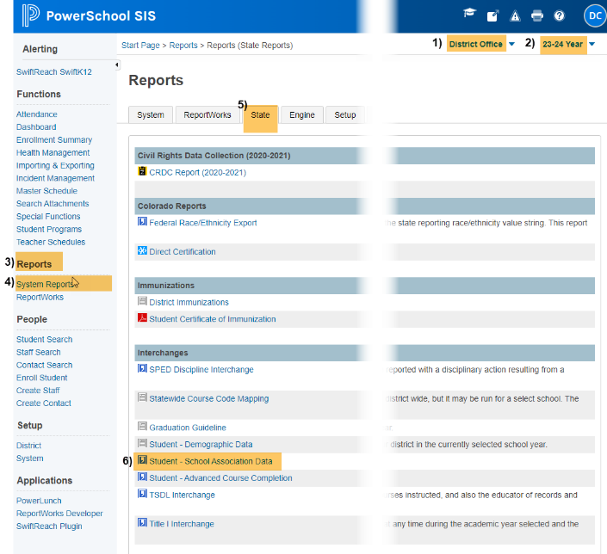
Original View New Version Update
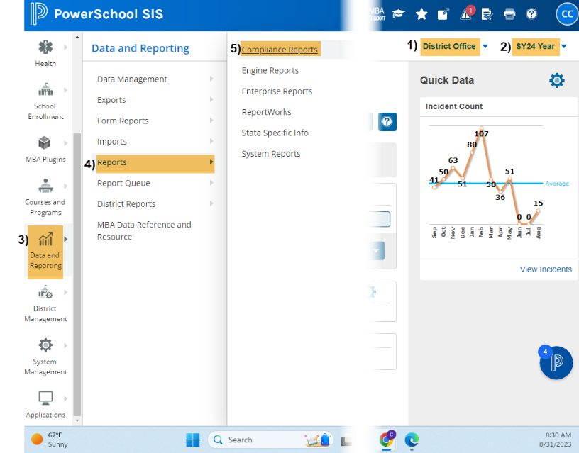

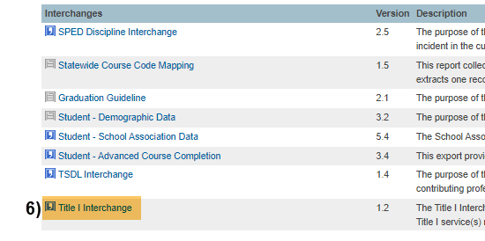

Under Report Parameters:

Select Schools: Choose school/s that you would like to include. Use “Shift /Click” to select multiple,

Click: Submit

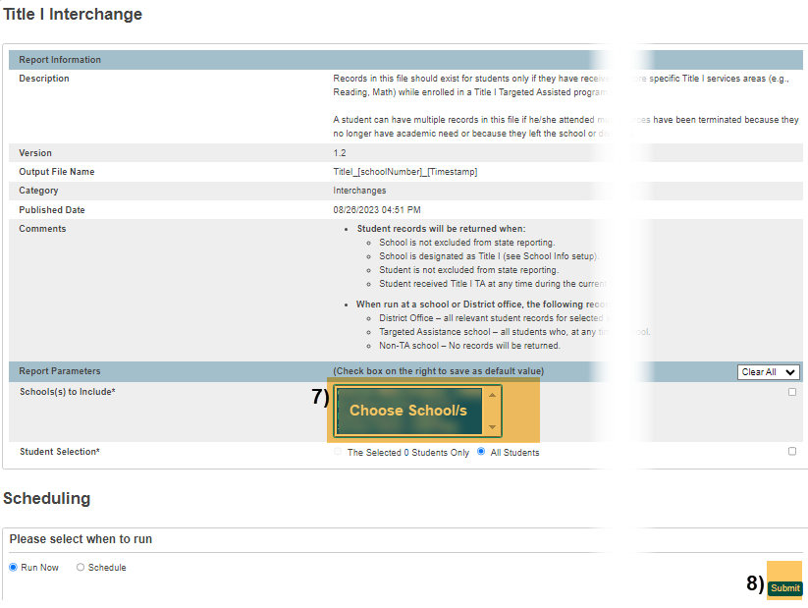
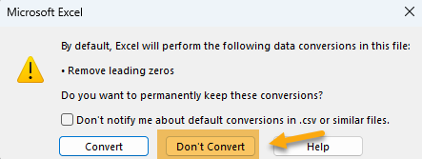
When submitting files to CSI, do NOT open the downloaded file directly and resave, or it will lose critical leading zeros! Instead, save the file first. Then open or submit the saved file. OR, if using a newer Excel, you will receive a warning. Choose “Don’t Convert”

Submission Steps:
- Use the Record Check Tool (RCT) prior to an initial submission,
- Save file using the following format: SchoolCode_SchoolAbbreviation_TitleI_MMDDYYYY (no spaces),
- Upload to: G-Drive>Submissions>End of Year>(Choose Year)>Files to Run,
- Notify the Data Team of the submission by emailing: Submissions_CSI@csi.state.co.us.
*See resources:
- For more on naming files:https://resources.csi.state.co.us/data-submissions-library/:
- Training Submissions Process / “Step 3: Extracting the Files and Submitting to CSI”
- For SD details: https://resources.csi.state.co.us/end-of-year/: “Student Demographic File Layout”
- For SSA details: https://resources.csi.state.co.us/end-of-year/: “Student School Association File Layout”
- For RCT: https://resources.csi.state.co.us/end-of-year/:“ Record Checker Tool”
- For converting CSV to Excel, Excel Filters, etc: https://resources.csi.state.co.us/data-submissions-library/: “Excel for Data Submissions Contacts (Part 1)”

For More Quick Guides:
https://resources.csi.state.co.us/end-of-year/

- EOY – Extracting SD Files in PS
- EOY – Extracting GG Files in PS
- EOY – Using the RCT
- EOY – Extracting SSA Files in PS
- EOY – Extracting TitleI Files in PS

