Purpose:

Title I Interchange

The Title I Interchange file represents students who have received, or will receive, services funded by a Title I Targeted Assistance program at any time during the
Title I Interchange

academic year and the specific Title I service(s) received (e.g., Reading, Math).

Dependencies:
Student has been assigned a SASID and been updated in the RITS system.
See explanation at the bottom of this page on approved Targeted Assistance programs at CSI schools.

Record exists in the Student School Association file matching the district, school and SASID for the student being loaded in the Title I interchange. School for the student being loaded must have a Title I Targeted Assistance program at the student’s grade level.

Record Expectation:
Records in this file should exist for students only if they have received, or are expected to receive, services funded by a Title I Targeted Assistance program at any time during the currently selected school year in one or more specific Title I services areas (e.g., Reading, Math) while enrolled in a Title I Targeted Assistance

program school.
Only students in grade levels approved in the Targeted Assistance program should be included in the file. Students in grade levels not approved in the program should not be included in the file.

A student can have multiple records in this file if he/she attended multiple Title I TA schools within the currently selected school year. Records should not be removed for students whose Title I resources have been terminated because they no longer have academic need or because they left the school or district. The only students who should ever be removed are those who were entered in error and never received Title I TA services.

Use Summary: (Fields from this file are used in the following CDE Collections which require LEA/AU effort):
Student October, Student End of Year

- Indicates Primary Key
Only CSI schools approved by CDE with a "Targeted Assistance" (TA) programs for the current school year are required to submit a Title I file for both the October Count and End of Year state collections. CSI schools with approved "Schoolwide" (SA) Title I programs should not submit a Title I file. CSI is aware of which CSI schools have approved Targeted Assistance programs each school year.
If you are in doubt if your school has one of those programs for the year then just send an email to submissions_csi@csi.state.co.us and CSI will let you know.
CSI school submissions contacts should work with their Intervention Programs, RTI, or MTSS staff to ensure that their SIS is updated correctly for the TA program students. Instructions on how to flag students in PowerSchool and Infinite Campus for Title I are at the end of this document.

Name of Field | Field  Length | Text Start  Position | Text End  Position | CSV  order | Excel  Column | Examples | Remarks
NOTE: ZERO-FILL ALL NON-APPLICABLE FIELDS
* Indicates required

You may name your file anything that works for you; however the system will not allow spaces in the file name.
When submitting CSV or Excel you must include a header row with titles in thefields.
School District/BOCES Code* | 4 | 1 | 4 | 1 | A2 | 0000 | Use 8001
School Code* | 4 | 5 | 8 | 2 | B2 | 0000
Student's State ID (SASID)* | 10 | 9 | 18 | 3 | C2 | 0000000000
Student's First Name* | 30 | 19 | 48 | 4 | D2 | Valid name
Student's Last Name* | 30 | 49 | 78 | 5 | E2 | Valid name
Student's Gender* | 2 | 79 | 80 | 6 | F2 | 01 or 02
Student's Date of Birth* | 8 | 81 | 88 | 7 | G2 | 12312013 | Format is MMDDYYYY
Instructional and Support Services: Mathematics | 1 | 89 | 89 | 8 | H2 | 0 – no or 1 - yes
Instructional and Support Services: Reading/Language Arts | 1 | 90 | 90 | 9 | I2 | 0 – no or 1 – yes
Instructional and Support Services: Science | 1 | 91 | 91 | 10 | J2 | 0 – no or 1 – yes
Instructional and Support Services: Social Studies | 1 | 92 | 92 | 11 | K2 | 0 – no or 1 – yes
Instructional and Support Services: Vocational/Career | 1 | 93 | 93 | 12 | L2 | 0 – no or 1 – yes
Instructional and Support Services: Other Instructional  Services | 1 | 94 | 94 | 13 | M2 | 0 – no or 1 – yes
Support Services: Health, Dental, and Eye Care | 1 | 95 | 95 | 14 | N2 | 0 – no or 1 – yes
Support Services: Supporting Guidance/Advocacy | 1 | 96 | 96 | 15 | O2 | 0 – no or 1 – yes
Support Services: Other Support Services | 1 | 97 | 97 | 16 | P2 | 0 – no or 1 – yes

NOTE: Zero-fill all non-applicable fields. No blanks are allowed.

School District/BOCES Code – A unique code assigned to a district by CDE. Refer to School District/BOCES Code table.
School Code – A unique code assigned by CDE to a school building. Refer to School Building Code Table.
8001 is the CSI 'District Code'

Student's State ID (SASID) – A unique ten digit number must be assigned to each student by CDE. If a student was included in the Student October report, the same SASID number must be used.
Student’s First Name – Name given to an individual at birth, baptism, or during another naming ceremony, or through legal change.
Student’s Last Name – The name borne in common by members of a family.
Student’s Gender - An individual's sex.

01 | Female
02 | Male
Student’s Date of Birth – The month, day, and year on which an individual was born (i.e. 09151989).

Instructional and Support Services: Mathematics – The student’s Mathematics education was directly affected by resources purchased in part or in full with Title I Targeted Assistance funds. (This could be educators, books, manipulatives, etc.)
0 | No – Targeted Assistance funds were not used
1 | Yes – Targeted Assistance funds were used
Instructional and Support Services: Reading/Language Arts– The student’s Reading or Language Arts education was directly affected by resources purchased in part or in full with Title I Targeted Assistance funds. (This could be educators, books, manipulatives, etc.)
0 | No – Targeted Assistance funds were not used
1 | Yes – Targeted Assistance funds were used
Instructional and Support Services: Science– The student’s Science education was directly affected by resources purchased in part or in full with Title I Targeted Assisted Program funds. (This could be educators, books, manipulatives, etc.)
0 | No – Targeted Assistance funds were not used
1 | Yes – Targeted Assistance funds were used

Instructional and Support Services: Social Studies– The student’s Social Studies education was directly affected by resources purchased in part or in full with Title I Targeted Assisted Program funds. (This could be educators, books, manipulatives, etc.)
0 | No – Targeted Assistance funds were not used
1 | Yes – Targeted Assistance funds were used
Instructional and Support Services: Vocational/Career - The student’s vocational or career based education was directly affected by resources purchased in part or in full with Title I Targeted Assisted Program funds. (This could be educators, books, manipulatives, etc.)
0 | No – Targeted Assistance funds were not used
1 | Yes – Targeted Assistance funds were used
Instructional and Support Services: Other Instructional Services - The student’s education was directly affected by resources purchased in part or in full with Title I Targeted Assisted Program funds. These are instructional services which are not covered in any of the above instructional elements (This could be educators, books, manipulatives, etc.)
0 | No – Targeted Assistance funds were not used
1 | Yes – Targeted Assistance funds were used
Support Services: Health, Dental, and Eye Care – The student benefitted from medical, dental or eye care which was partially or completely paid for with Title I Targeted Assisted Program funds.
0 | No – Targeted Assistance funds were not used
1 | Yes – Targeted Assistance funds were used
Support Services: Supporting Guidance/Advocacy - The student benefitted from guidance or advocacy which was partially or completely paid for with Title I Targeted Assisted Program funds.
0 | No – Targeted Assistance funds were not used
1 | Yes – Targeted Assistance funds were used
Support Services: Other Support Services - The student benefitted from support services which are not listed above and were purchased in part or full with Title I Targeted Assisted Program funds.
0 | No – Targeted Assistance funds were not used
1 | Yes – Targeted Assistance funds were used

Power School Users:
For selection criteria and report input/output specifications for the Title I specific to Colorado State Reporting go to https://docs.powerschool.com/USACO/colorado- reports-in-powerschool then navigate to Reports-->Title I Data Interchange.
To be included in the Title I report, students must be flagged in PowerSchool as receiving at least one Title I Instructional or Support Service at any time during the current school year. Only students in grade levels approved in the Targeted Assistance (TA) program should be flagged and included in the report. Students in other grade levels not in the approved TA program should not be flagged.

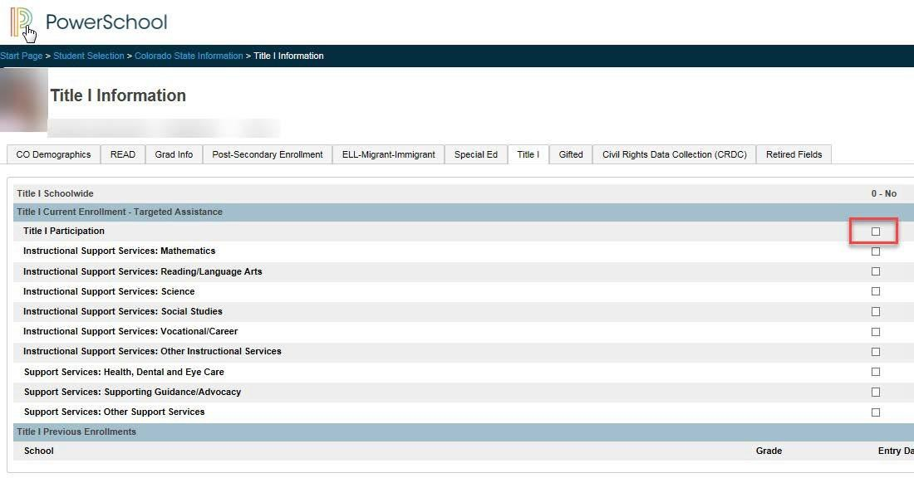
Students need to be flagged in PowerSchool as receiving TA funds on the Title I tab under Start
Page-->Student Selection--
>Colorado State Information-->Title I Information. First check the box identified with the red rectangle in the screenshot to the right to include the student in the Title I report extract. Next, check the boxes next to each Instructional Support or Support Services the student is receiving this school year.

It is possible that the Title I data has rolled over from a prior year. If that is the case for your school, then you will need to update each student record for the
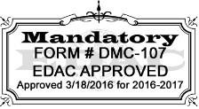
current school year. Title I entry/exit dates are tied to the enrollment entry/exit.

Infinite Campus Users:
For selection criteria and report logic for the Title I specific to Colorado State Reporting log into Campus Community and then go to https:// content.infinitecampus.com/sis/Campus.1841/documentation/title-1-extract-colorado/.
To be included in the Title I report, students must be flagged in Infinite Campus as receiving at least one Title I Instructional or Support Service at any time during the current school year. Only students in grade levels approved in the Targeted Assistance (TA) program should be flagged and included in the report. Students in other grade levels not in the approved TA program should not be flagged.
For IC, one record is reported for all students who have a Title 1 Service record associated with the school selected in the report editor and enrolled in the selected calendar year. If a student has more than one eligible Title 1 Service, only 1 record is reported.
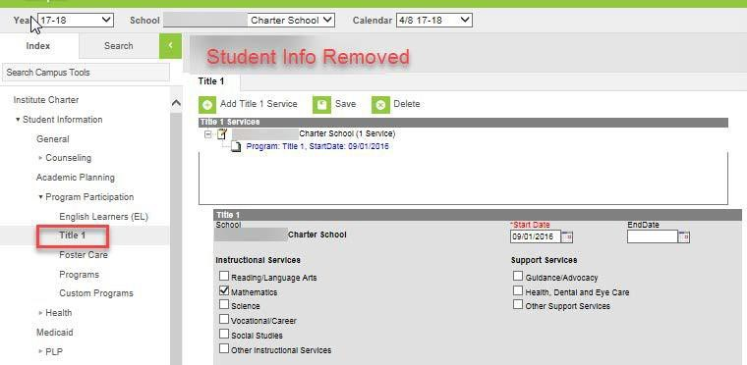
Students need to be flagged in IC as receiving TA funds under Student Information-->Program Participation-->Title I (noted in screenshot to the right by the red rectangle).

First click on "Add Title I Service" then fill in a Start Date and check the applicable Instructional Services and Support Services checkboxes for the current school year. Leave the End Date blank if you don't know what that will be.
However, it if End Date is left blank, it is possible that the record will roll over into the next year.

Page 6 of 6

CDE Last updated: June 11, 2019

CSI Last Revised 1/16/2024

