Teacher-Student Data Link (TSDL)

Updating Course Information in PowerSchool (PS)

Update Course Information –
- Select: School
- Select: Calendar Year (Current Year)

Under “Setup”, Select: “School, (NEW VERSION PS – “School Management”)

Scroll to: “Scheduling”, (NEW VERSION PS – “Courses and Programs”)
- Select: “Courses”

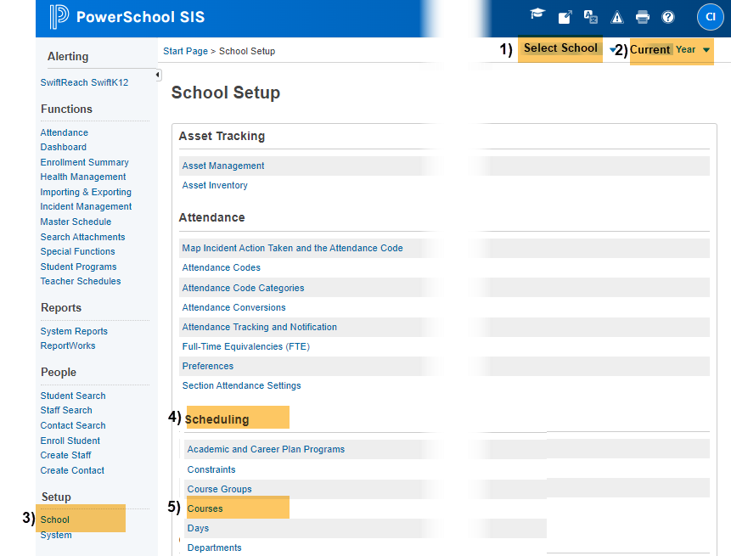
Original View New Version Update
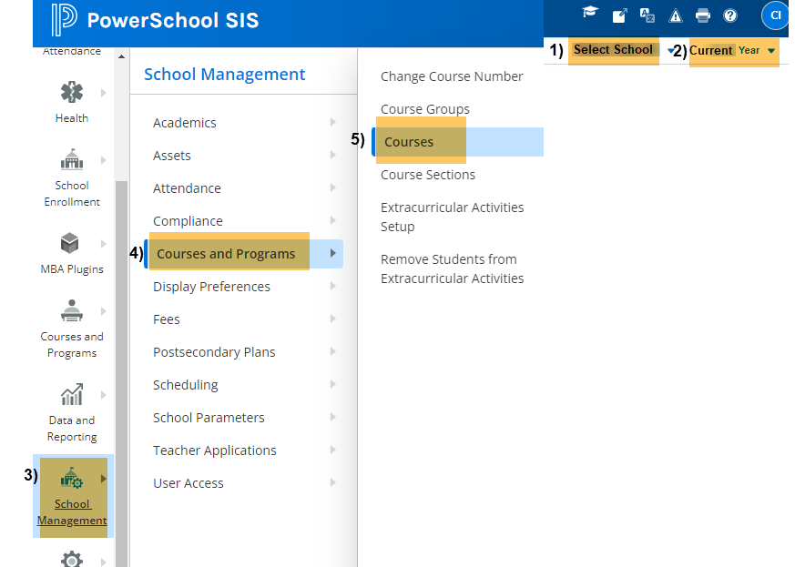

On Course Information Section to update STATE CODE, Credits, and Course Level:

Select: Course to update,
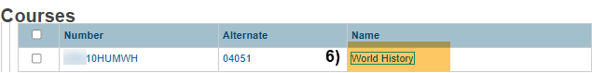
- Enter: State Code. This is a 5-digit State Approved Number (No letters). Find the State Code using SCED Version 11 (or higher) located under “Additional Resources” on https://resources.csi.state.co.us/teacher-student-data-link/,
- Enter: Credit hours. (Ex. 0.50, 0.25, 1.00),
- Enter: Course Level,
- Enter: Credits for high school classes defined by Carnegie Units (Ex. 0.50, 0.25, 1.00) OR Low and High grade offered Kinder – 8th. (ex KG05 for K – 5),
- Click: SUBMIT.
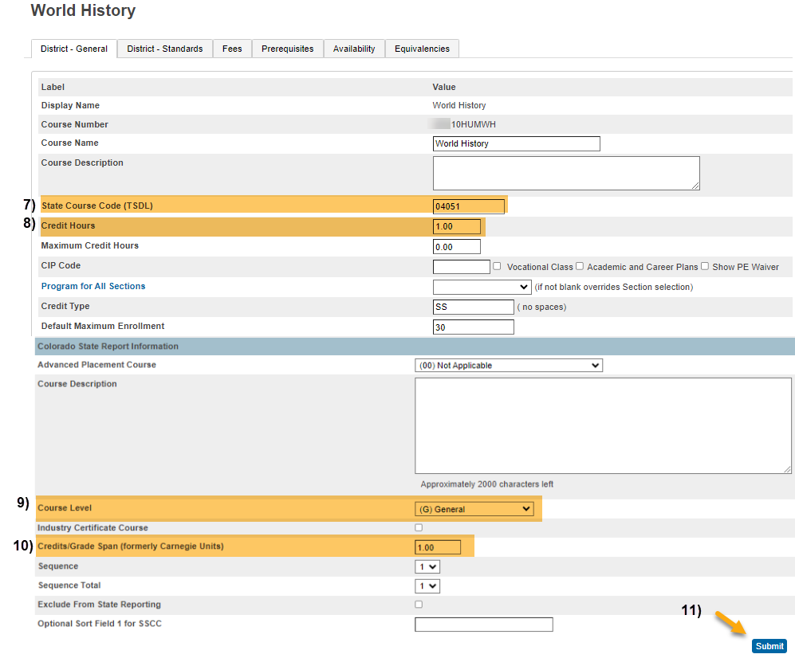
Other Resources:
- For TSDL details, “TSDL File Layout”: https://resources.csi.state.co.us/teacher-student-data-link/
- SCED Version 11 for State Code: https://resources.csi.state.co.us/teacher-student-data-link/

For More Quick Reference Guides:
https://resources.csi.state.co.us/teacher-student-data-link/

- TSDL – QR Extract TSDL Files in PS

