Teacher-Student Data Link (TSDL)

Updating Course Information in Infinite Campus (IC)
ORIGINAL View in IC

Update Course Information –

Choose: Current Year, School, & Calendar,

Go to: “Search” Tab,

Select: “Course/Section” from dropdown,
- Click: “Go”.
ORIGINAL View
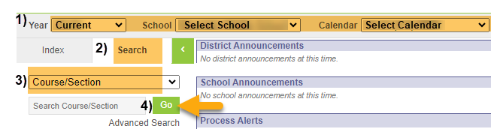
Under Course Information Section to update STATE CODE, Grade Level, Credits, and Course Level:

Select: Course to update,
- Enter: State Code. This is a 5-digit State Approved Number (No letters). Find the State Code using SCED Version 11 (or higher) located under “Additional Resources” on https://resources.csi.state.co.us/teacher-student-data-link/,
- Enter: SCED Subject Area. This is the first 2 digits of the 5-digit State Approved State Code,
- Enter: SCED Course Identifier. This is the last 3 digits of the 5-digit State Approved State Code,
- Enter: Lowest and highest grade offered for this course,
- Enter: Credits for high school classes defined by Carnegie Units,
- Enter: SCED Course Level,
- Click: SAVE.
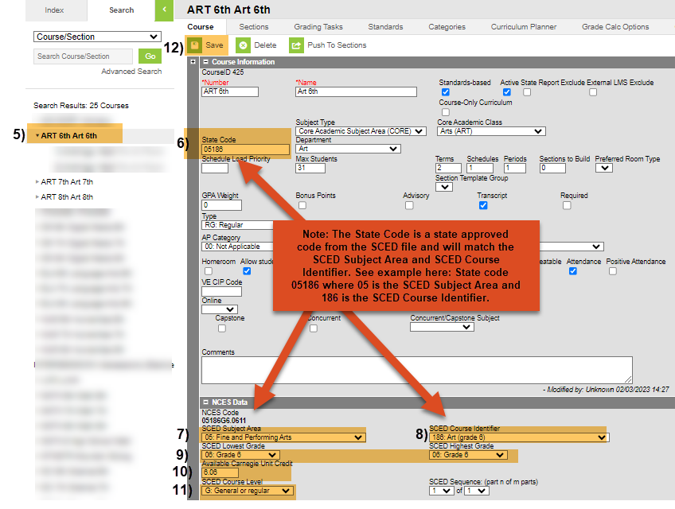
Under Sections to update TERMS:
- Click the course arrow to expand sections for each course,
- Click: Section to update,
- Select: Appropriate Term,
- Click: SAVE.
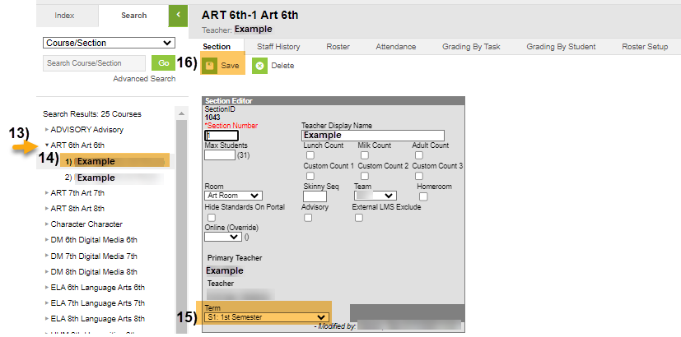

Other Resources:
- For TSDL details, “TSDL File Layout”: https://resources.csi.state.co.us/teacher-student-data-link/
- SCED Version 11 for State Code: https://resources.csi.state.co.us/teacher-student-data-link/

For More Quick Reference Guides:
https://resources.csi.state.co.us/teacher-student-data-link/

- TSDL – QR Updating Course Info in IC – NEW LOOK View in IC
- TSDL – QR Extract TSDL Files in IC

