Teacher-Student Data Link (TSDL)

Updating Course Information in Infinite Campus (IC)
“NEW LOOK” View in IC

Update Course Information –

Choose: Current School & School Year,

Go to: Main Menu Folder,

Select: “Schedule & Courses”,
- Select: “Course Information”.
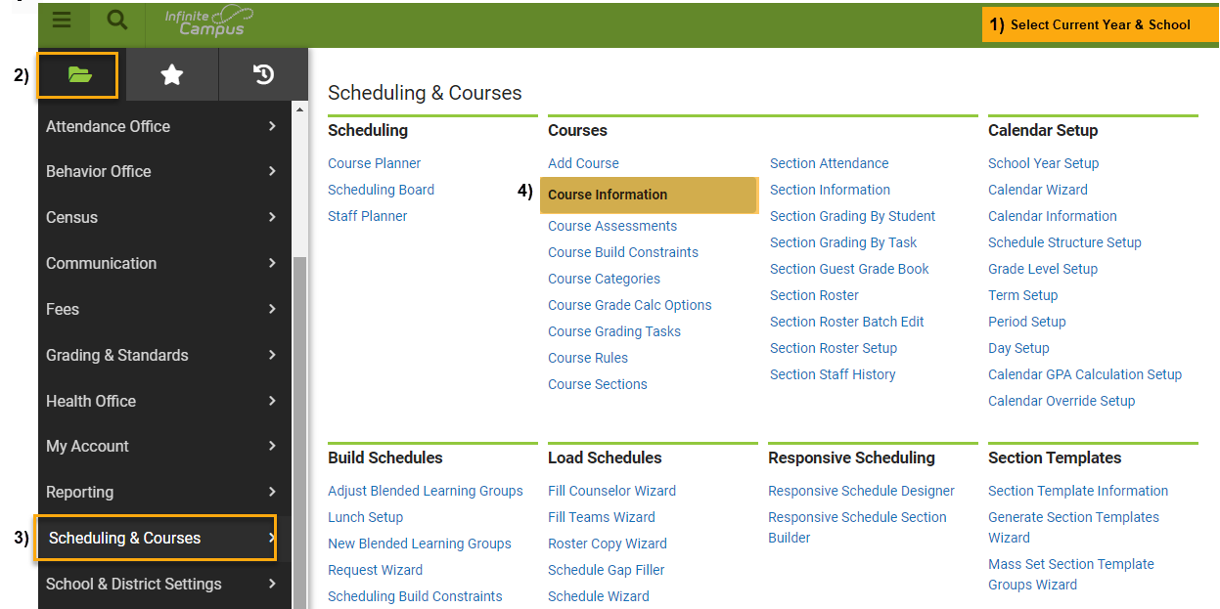
“NEW LOOK” View

Under Course Information:

Click: “Open Course Search”,
- Click: Search Magnify Glass Icon
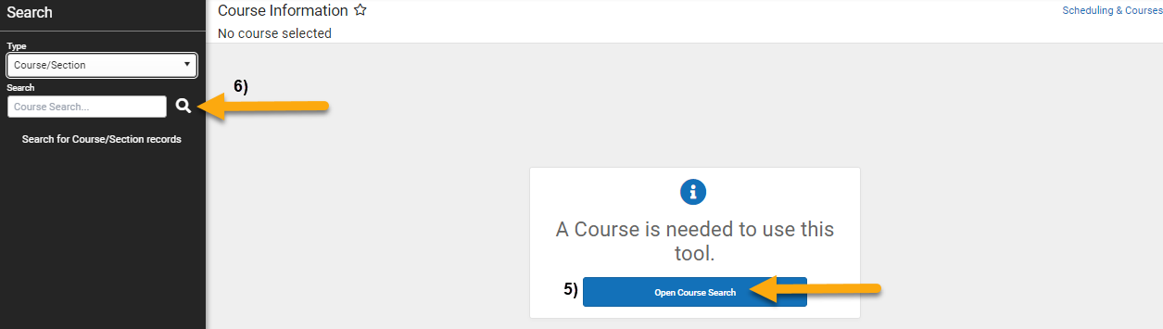

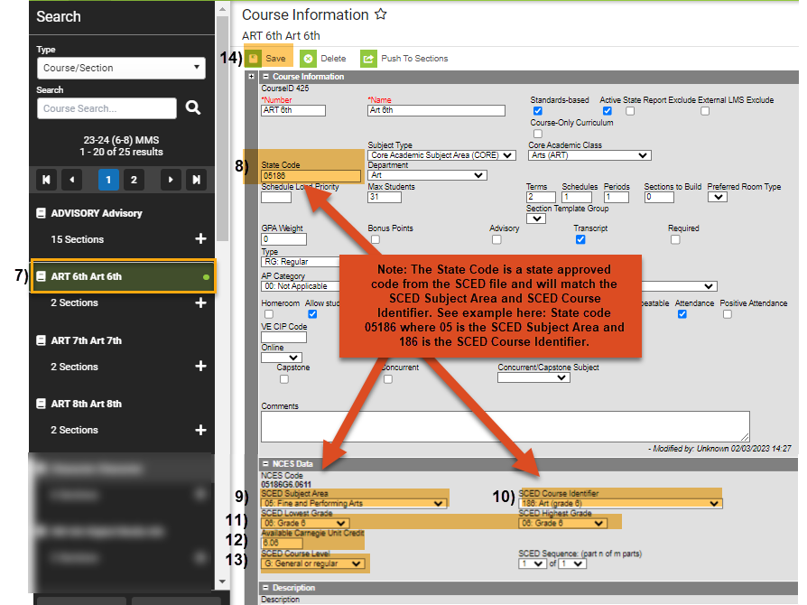

On Course Information Section to update STATE CODE, Grade Level, Credits, and Course Level:

Select: Course to update,
- Enter: State Code. This is a 5-digit State Approved Number (No letters). Find the State Code using SCED Version 11 (or higher) located under “Additional Resources” on https://resources.csi.state.co.us/teacher-student-data-link/,
- Enter: SCED Subject Area. This is the first 2 digits of the 5-digit State Approved State Code,
- Enter: SCED Course Identifier. This is the last 3 digits of the 5-digit State Approved State Code,
- Enter: Lowest and highest grade offered for this course,
- Enter: Credits for high school classes defined by Carnegie Units,
- Enter: SCED Course Level,
- Click: SAVE.

Under Sections to update TERMS:
- Click the “+” to expand sections for each course,
- Click: Section to update,
- Select: Appropriate Term,
- Click: SAVE.

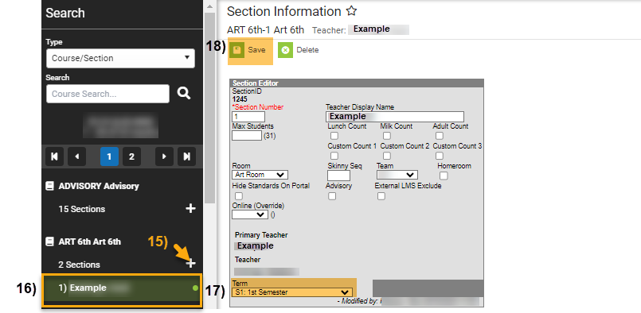

Other Resources:
- For TSDL details, “TSDL File Layout”: https://resources.csi.state.co.us/teacher-student-data-link/
- SCED Version 11 for State Code: https://resources.csi.state.co.us/teacher-student-data-link/

For More Quick Guides:
https://resources.csi.state.co.us/teacher-student-data-link/

- TSDL – Updating Course Information in IC – ORIGINAL View in IC
- TSDL – QR Extract TSDL Files in IC

