Teacher-Student Data Link (TSDL)

Extracting TSDL Files in PowerSchool (PS)

Extract TSDL File –
- Select School: (Some schools will choose “District Office” if pulling data for multiple schools)
- Select the Calendar Year: Current Year

Go to: “Reports”, (NEW VERSION – “Data and Reporting”)

Select: “System Reports, (NEW VERSION – “Reports”)

Go to: “State” tab, (NEW VERSION – “Compliance Reports”)
- Under Interchanges, Select: “TSDL Interchange”

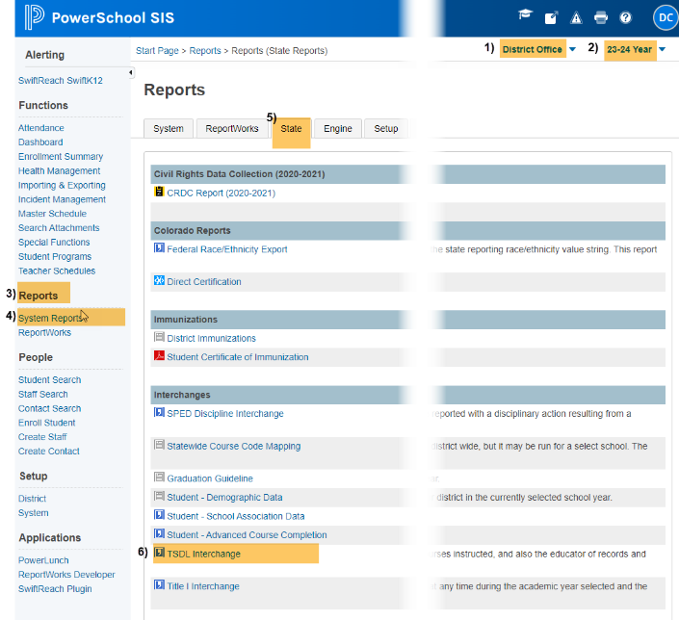
Original View New Version Update
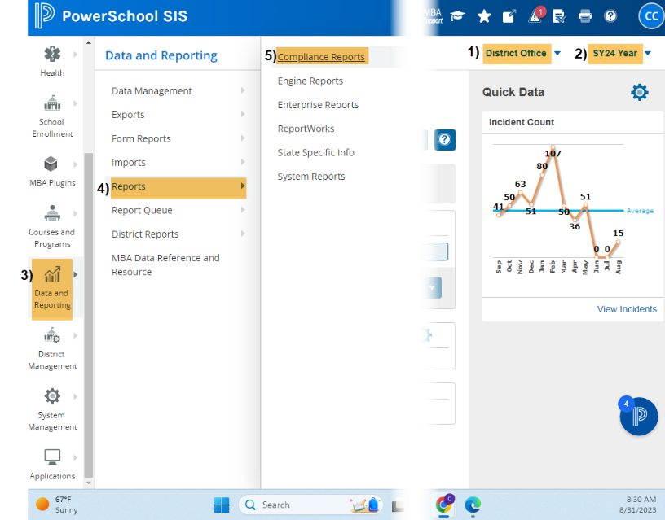

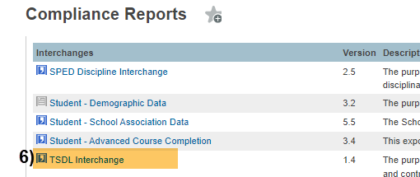

Under Report Parameters:

Select Schools to Include: Choose school/s that you would like to include. Use “Shift /Click” to select multiple,

Select Students to Include: Leave as Default “All Students”,

Enter minimum number of calendar days: Enter “1”

School Year: Use Current School Year,
- Start Date: Leave Blank (this will default to the first day of the school year),
- Snapshot Date/End Date: Use Current Date (date you are running the report),
- Click: Submit
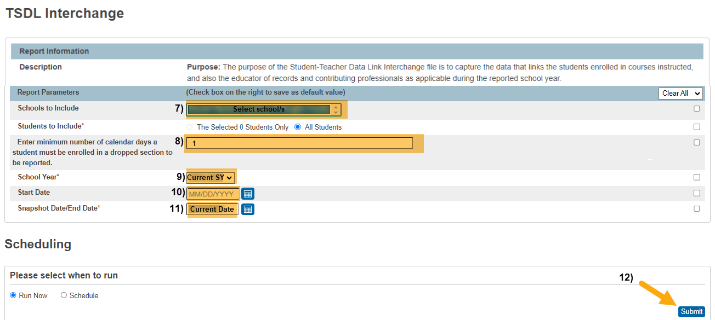
When submitting files to CSI, do NOT open the downloaded file directly and resave, or it will lose critical leading zeros! Instead, save the file first. Then open or submit the saved file.
Submission Steps:
- Save file using the following format: SchoolCode_SchoolAbbreviation_TSDL_MMDDYYYY (no spaces),
- After saving, open and scroll through file to ensure that fields are not blank or incorrect prior to submitting to CSI. Look for:
  - Column E (Course Level) – Not Blank
  - Column F (Credit) – Courses have accurate credit amounts.
  - Column H (Terms) – Not Blank
  - Column I (State Course Code) – Does not contain letters. Is a 5-digit code per state guide. See SCED Version 11 (or higher), located under “Additional resources” on https://resources.csi.state.co.us/teacher-student-data-link/
  - To correct Credits, Terms, and/or State Course codes in PS, see the Quick Reference Guide “Updating Course Information in PS” located under “Quick Reference Guides” on https://resources.csi.state.co.us/teacher-student-data-link/
- Upload to: G-Drive>Submissions>TSDL>(Choose Year)>Files to Run,
- Notify the Data Team of the submission by emailing: Submissions_CSI@csi.state.co.us.

Other Resources:
- For TSDL details, “TSDL File Layout”: https://resources.csi.state.co.us/teacher-student-data-link/
- SCED Version 11 for State Code: https://resources.csi.state.co.us/teacher-student-data-link/
- For more on naming files:https://resources.csi.state.co.us/data-submissions-library/
- Training Submissions Process / “Step 3: Extracting the Files and Submitting to CSI”
- For converting CSV to Excel, Excel Filters, etc: https://resources.csi.state.co.us/data-submissions-library/: “Excel for Data Submissions Contacts (Part 1)”

For More Quick Reference Guides:
https://resources.csi.state.co.us/teacher-student-data-link/

- TSDL – Updating Course Information in PS

