Teacher-Student Data Link (TSDL)

Extracting TSDL Files in Infinite Campus (IC)

Extract TSDL File –

From any calendar year,

Go to: “Index” tab, (New Look View-“Main Menu”)

Select: “CO State Reporting” dropdown, (New Look View-“Reporting”)

Select: “Data Pipeline” dropdown, (New Look View- “CO Data Pipeline”)

Select: “TSDL Interchange”.

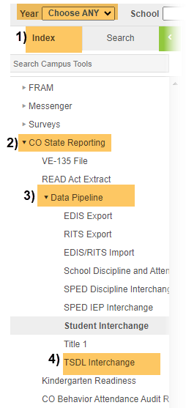
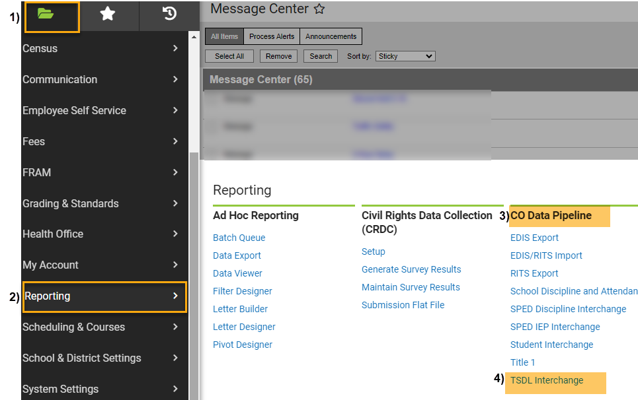
Original View OR “NEW LOOK” View

Under Extract Options:

Ad Hoc Filter: Leave Blank,

Effective Date: Leave as Default Date (Current Date),

Report Legal Name: Check this Box,

Migrant Only: Leave Unchecked,

Report All Credits Granted: Leave Unchecked, (This will auto populate and is needed if migrant status is identified in IC),

Format: Leave as Default “CSV”.
Under Select Calendars:

Choose calendar/s that you would like to include. Use “Shift /Click” to select multiple (Remember for TSDL, you only need to include calendars that include grades 6th-12th),
- Click: Generate Extract.

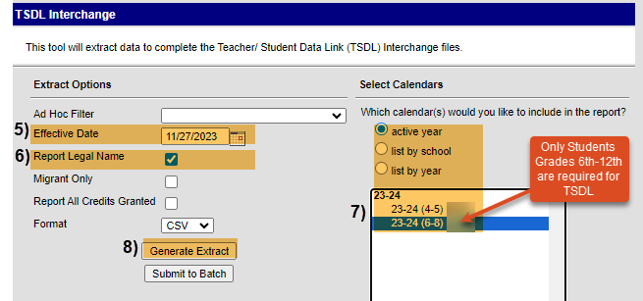
When submitting files to CSI, do NOT open the downloaded file directly and resave, or it will lose critical leading zeros! Instead, save the file first. Then you can open and/or submit the saved file.
Submission Steps:
- Save file using the following format: SchoolCode_SchoolAbbreviation_TSDL_MMDDYYYY (no spaces),
- After saving, open and scroll through file to ensure that fields are not blank or incorrect prior to submitting to CSI. Look for:
  - Column E (Course Level) – Not Blank
  - Column F (Credit) – Courses have accurate credit amounts.
  - Column H (Terms) – Not Blank
  - Column I (State Course Code) – Does not contain letters. Is a 5-digit code per state guide. See SCED Version 11 or above, located under “Additional resources” on https://resources.csi.state.co.us/teacher-student-data-link/
  - To correct Credits, Terms, and/or State Course codes in IC, see the Quick Reference Guide “Updating Course Information in IC” located under “Quick Reference Guides” on https://resources.csi.state.co.us/teacher-student-data-link/
- Upload to: G-Drive>Submissions>TSDL>(Choose Year)>Files to Run,
- Notify the Data Team of the submission by emailing: Submissions_CSI@csi.state.co.us.
Other Resources:
- For TSDL details, “TSDL File Layout”: https://resources.csi.state.co.us/teacher-student-data-link/
- SCED Version 11 for State Code: https://resources.csi.state.co.us/teacher-student-data-link/
- For more on naming files:https://resources.csi.state.co.us/data-submissions-library/
- Training Submissions Process / “Step 3: Extracting the Files and Submitting to CSI”
- For converting CSV to Excel, Excel Filters, etc: https://resources.csi.state.co.us/data-submissions-library/: “Excel for Data Submissions Contacts (Part 1)”

For More Quick Reference Guides:
https://resources.csi.state.co.us/teacher-student-data-link/

- TSDL – QR Updating Course Info in IC – ORIGINAL View in IC
- TSDL – QR Updating Course Info in IC – NEW LOOK View in IC

